**Introduction**

Kili Technology is a software platform designed to simplify and accelerate the process of data labeling, particularly for applications in machine learning and artificial intelligence. It focuses on creating high-quality training datasets, which are critical for training reliable ML models. The platform offers a collaborative, web-based environment where users can annotate various types of data—such as images, text, videos, and audio—with detailed labels and metadata.

**Features**

Key features of Kili Technology include:

1. **Data Annotation**: Kili supports labeling across multiple data formats, including images, text, video, and audio, enabling users to create comprehensive datasets tailored to their ML needs.
2. **Quality Control and Review**: It has built-in tools for managing annotation quality, including review workflows, consensus scoring, and annotation audits to ensure data quality.
3. **Integration and Automation**: Kili can integrate with ML pipelines and supports automation tools for pre-labeling and active learning, reducing manual annotation effort and enabling quicker dataset updates.
4. **Collaboration**: The platform is designed to facilitate collaboration among team members, allowing multiple annotators to work simultaneously on projects, with robust permissions and role management features.
5. **Model-Assisted Labeling**: Kili includes AI-assisted labeling capabilities, where models can generate initial annotations that annotators then refine, saving time and improving efficiency.

**How Kili can help you**

1. Create training datasets quickly

* Create [customized interfaces](https://docs.kili-technology.com/docs/customizing-project-interface)
* [Assign assets](https://docs.kili-technology.com/docs/queue-prioritization#assigning-assets-to-specific-labelers) to specific labelers and add validation rules
* Activate [interactive segmentation](https://docs.kili-technology.com/docs/semantic-segmentation#interactive-segmentation) and [tracking](https://docs.kili-technology.com/docs/labeling-video-assets#creating-annotations) to accelerate labelling
* Leverage your own-model predictions to [pre-label](https://docs.kili-technology.com/docs/model-based-pre-annotation)
* Diagnose productivity with [analytics](https://docs.kili-technology.com/docs/analytics-page)

1. Explore and fix annotation errors

* Use advanced [quality metrics](https://docs.kili-technology.com/docs/best-practices-for-quality-workflow) to get insights on quality problems
* [Focus review](https://docs.kili-technology.com/docs/reviewing-labeled-assets) on data that matters
* Let reviewers [create and track issues](https://docs.kili-technology.com/docs/reviewing-labeled-assets#sending-assets-back-to-labeling) at the finest object level
* Simplify advanced [collaboration workflows](https://docs.kili-technology.com/docs/creating-a-new-project)
* [Explore datasets](https://docs.kili-technology.com/docs/explore-view) and identify the data that matters to improve the model’s performance

1. Simplify your LabelingOps

* Directly integrate [Amazon, Google, and Microsoft cloud storage](https://docs.kili-technology.com/docs/adding-assets-to-project#adding-assets-located-in-remote-storage-integration)
* [Export](https://docs.kili-technology.com/docs/exporting-project-data) versioned data directly in the format of your model
* Ease access rights management with [predefined roles](https://docs.kili-technology.com/docs/user-roles-in-projects)
* Leverage [Kili API](https://docs.kili-technology.com/docs/kili-api) and [Python SDK](https://python-sdk-docs.kili-technology.com/latest/) to connect any ML stack
* Use [webhooks](https://docs.kili-technology.com/docs/python-sdk-tutorials#using-webhooks) and [plugins](https://docs.kili-technology.com/docs/kili-plugins) to automate your MLOps infrastructure

**Architecture**:

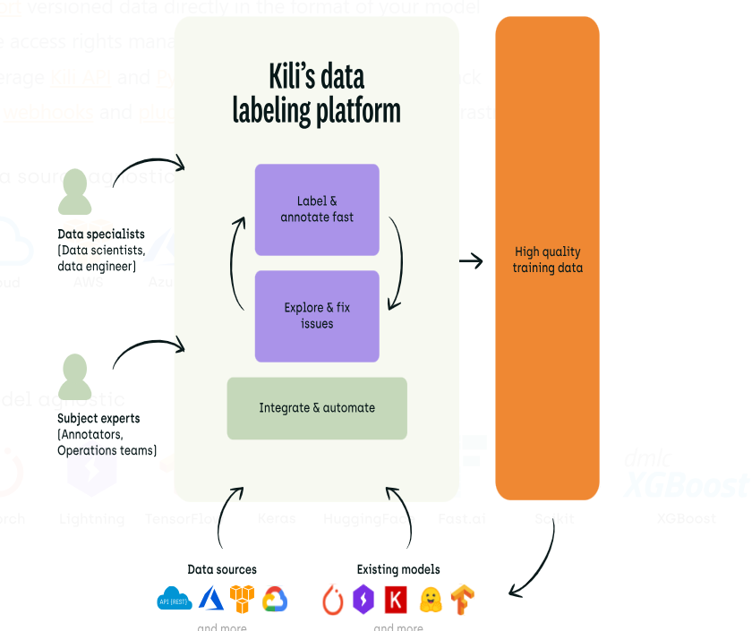

**Tools**

1. [Image Annotation Tool](https://kili-technology.com/platform/label-annotate/image-annotation-tool)
2. [Video Annotation Tool](https://kili-technology.com/platform/label-annotate/video-annotation-tool)
3. [NLP Text Annotation Tool](https://kili-technology.com/platform/label-annotate/nlp-text-annotation-tool)
4. [OCR Annotation Tool](https://kili-technology.com/platform/label-annotate/ocr-annotation-tool)
5. [Geospatial Annotation Tool](https://kili-technology.com/platform/label-annotate/geospatial-annotation-tool)

**Products**

1. [**LLM Evaluation**](https://kili-technology.com/platform/llm-evaluation)**:** Kili Technology delivers actionable and unbiased model evaluation for the world's top LLM builders. It pairs high-quality human feedback with smart model automation and SOTA workflows, all fully managed by an expert team of MLEs, quality analysts, and AI tutors.
2. [**Data Labeling**](https://kili-technology.com/platform/label-annotate): Annotate all types of raw unstructured data rapidly and accurately with customizable annotation tasks & an interface optimized for productivity & quality. Automate labeling to save time with smart tools & model predictions. Leverage an [integrated and fully managed professional workforce](https://kili-technology.com/professional-services/) **covering 100s of** domain expertise and 30 languages.

**Hosting:**

Kili Technology has three deployments options:

* [Kili on Cloud (SaaS) hosted on their infrastructure](https://docs.kili-technology.com/docs/hosting#saas)
* [Kili on Cloud (SaaS) deployed as a managed application in Azure Marketplace](https://docs.kili-technology.com/docs/hosting#azure-marketplace)
* [Kili On-Premise](https://docs.kili-technology.com/docs/hosting#onprem)

**Limitation of using free account:**

1. 2 users can only work as colloborators at a time
2. 100 documents can be annotated
3. We cannot pre -annotates our assets.
4. For video annotations it only provides bounding box feature
5. We cannot integrate to our ML pipelines as it does not provide any API
6. No connection of data cloud storage

**Cost:**

|  |  |  |  |
| --- | --- | --- | --- |
| **Plan** | **Free** | **Grow** | **Enterprise** |
| Target | For individual contributors developing small-scale projects | For companies wishing to invest in their labeling operations | For companies with enterprise needs and specific data security requirements |
| Price | $0/month | *Custom price | *Custom price |
| Features | - Image, video, text, PDFs, large images & rich text labeling interfaces - 2 users max. - 100 annotations - Quality workflows - Quality and productivity metrics - API and Python SDK (rate limited) | -All Free features plus: - Zero-shot Labeling Co-pilot - Instant quality review scores - Upload via URL and Cloud - API and Python SDK (no rate limit) - Plugins - Data cloud storage | - All Grow features plus: - SSO and on-premise hosting - Custom contract & terms - Professional services - Dedicated customer success representative |

*Custom price: no price is available on official site.