Android Testing In The Cloud With
Manymo
&
Appthwack

ManyMo Cloud Based Testing Tool
The Manymo tool is used for:

1. Making in-browser emulators appear as local emulators on your system.
2. Launching headless emulators for automated testing.

Steps to Get Started :

1. Signup for Manymo Account :
Create an account on https://www.manymo.com/.

2. Installer Setup :
Install Manymo from the link : https://www.manymo.com/ManymoSetup.exe . The installer will install the files and update your PATH environment variable to point to the helper.

3. Authentication Token :
An Authentication Token is used to authenticate your command line tool actions. To set it up, open command prompt, type 'manymo token'. Press Enter. Then, paste your <authorization_token> here and press enter. <authorization_token> can be obtained on the user page under client applications tab. (https://www.manymo.com/user/client_applications)
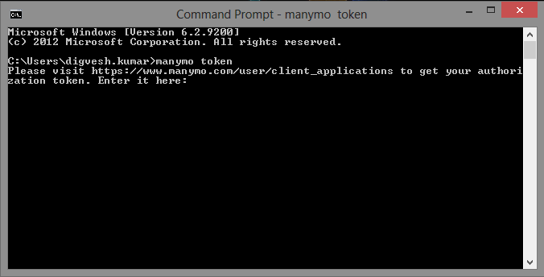
3. Set up Android SDK Platform Tools :
To work properly, the Android SDK platform tools must be installed and be accessible using system's PATH environmet variable. To see if the PATH includes the platform tools open a command prompt and type adb. If the adb tool is found then the PATH is set correctly, otherwise locate the platform-tools directory in your Android SDK installation and add it to your PATH.

Note : PATH environment variable should have now access to the Android SDK path as well as the Manymo installation path.

4. Usage :
Launch an emulator from the Manymo site (https://www.manymo.com/emulators)
On the website you can see different emulator launch options that include different screen sizes, densities,OS versions,etc. Select any of them, and click launch.
Once, the emulator gets started and displayed in the browser. You can use that Emulator as a local emulator by using a tunnel. For that, click the 'Develop' link in the toolbar.
Copy the 'manymo tunnel...' command to your clipboard.
Open a command prompt, paste and execute the command to establish a tunnel. Once the tunnel's set up you'll be able to use it like a local emulator. You can see that emulator listing in the device list either from the Android Studio IDE or from the command line by 'adb devices'.
When you're done, type 'manymo shutdown <EMULATOR_SERIALNUMBER>' to shutdown the tunnel; omit the serial number to shut down all tunnels.
Note:
Remember to shut down tunnels when you're done with them. Otherwise the emulators will keep running, which counts towards your usage and concurrency limits. Type adb devices to see a list of all running emulators and their serial numbers.

Android Testing In The Cloud With Android Studio & Manymo

1. Configuring gradle to run tests in the cloud on Manymo :
Locate the 'build.gradle' file in the Project folder (not the root-level one) and open it for editing. To add the Manymo plugin as a dependency and plugin, and configure the plugin, replace the contents of the file with the following :

buildscript {
repositories {
mavenCentral()
}
dependencies {
classpath 'com.android.tools.build:gradle:0.4'
classpath 'com.manymo:gradle:1.1'
}
}
apply plugin: 'android'
apply plugin: 'manymo'

dependencies {
compile files('libs/android-support-v4.jar')
}

android {
compileSdkVersion 17
buildToolsVersion "17.0.0"

defaultConfig {
minSdkVersion 7
targetSdkVersion 16
}
}

manymo {
// which devices to run the tests on; use "manymo list" to list all available
devices "17_WXGA800-7in_x86", "17_WXGA720_x86"

// how many emulators to run tests on in parallel; use 1 for Free or Basic, 2 for Pro, and 12 for Ultimate
maxThreads 3

timeOut 30
}

2. Configuring Android Studio To Run Tests :
> From the main Android Studio menu click Run > Edit Configurations.
> From the modal dialog, make sure that Android Application is expanded and that app is selected.
> Click the + to Add New Configuration and select Gradle.
> Name the configuration Run Tests On Manymo.
>Select the top/project level build.gradle – not the one we edited in the previous section – for the Gradle project field.
> Enter manymoInstrumentTest in the Tasks field.
>The configuration should look like the image below; click OK to save it.

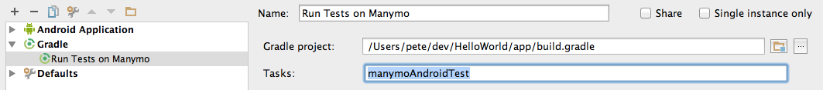
3. Adding A Test Class To The Project
Browse to app → src → androidTest → java → [your_package]. Right click on it. Choose 'New' menu item. Select 'Java class'. Rename it to MyActivityTest , and click OK. Place the following code in your Java class(an example) which would look like :

package com.example.helloworld.test;
import android.test.ActivityInstrumentationTestCase2;
import android.widget.TextView;
import static android.test.ViewAsserts.assertOnScreen;
// Import the activity to test and the app's R
import com.example.helloworld.MyActivity;
import com.example.helloworld.R;
public class MyActivityTest extends ActivityInstrumentationTestCase2<MyActivity> {
private MyActivity mMyActivity;
private TextView mHelloWorldTextView;
// Be careful about letting the IDE create the constructor. As of this writing,
// it creates a constructor that's compiles cleanly but doesn't run any tests
public MyActivityTest() {
super(MyActivity.class);
}
protected void setUp() throws Exception {
super.setUp();
mMyActivity = getActivity();
mHelloWorldTextView = (TextView) mMyActivity.findViewById(R.id.hello_world_text_view);
}
// Methods whose names are prefixed with test will automatically be run
public void testTextView() {
assertOnScreen(mMyActivity.getWindow().getDecorView(), mHelloWorldTextView);
}
}

4. Running The Tests : To run the test, click the Run Configurations drop down and select the Run Tests On Manymo item. Then, click on the green icon to run the test.
5. Reviewing Results :
An HTML report will be compiled in the build/reports/instrumentationTests/device/manymo folder when the run completes. Open index.html in a browser to explore the results.

Issues Faced :

Minor :

While installing up the Manymo, it might be possible that manymo doesn't set path variable in the environment variables list, in order to gain access to its directory. So, you had to manually do that by editing the value of “Path” variable and appending to it, the directory of the manymo.

Major:

Manymo automatically creates the .manymo folder in the user's working directory in order to create auth_token file. This is important as the test cannot be run without authenticating the user's authorization token. If .manymo folder is not created while authorizing the token, you will get the following error :

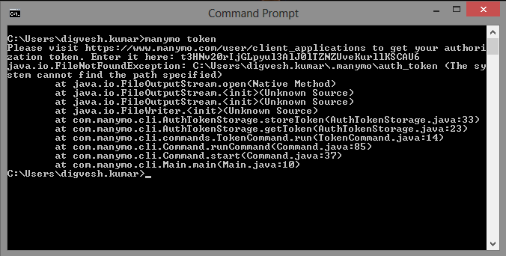
Since the auth_token file is not created by Manymo, the test 'Run Tests On Manymo' will be skipped. And we'll not be able to see the test report.

Pro's N Con's :

Pros

The Manymo testing tool provides a variety of cloud based emulators for testing which can be customised with different OS versions, screen sizes, screen densities,etc.

Cons

It doesn't provide facility to test on real devices connected on the cloud. It provides only one emulator for a free account.

Appthwack Cloud Based Testing Tool
The Appthwack tool is used for:

1. Testing your application on several devices(real) connected to the cloud based Appthwack server.
2. Types of tests supported : Junit, Robotium, Calabash, AppExplorer.

Steps to Get Started :

1. Signup for Appthwack Account :
Create an account on https://www.appthwack.com/.

Android Testing In The Cloud With Android Studio & Appthwack

1. Configuring gradle to run tests in the cloud on Appthwack :
Locate the 'build.gradle' file in the Project folder (not the root-level one) and open it for editing. To add the Appthwack plugin as a dependency and plugin, and configure the plugin, replace the contents of the file with the following :

apply plugin: 'com.android.application'
apply plugin: 'appthwack'
buildscript {
repositories {
mavenCentral()
mavenLocal()
// repository with the output of the appthwack plugin build
//maven { url '../repo' }
}
dependencies {
classpath 'com.sun.jersey:jersey-core:1.8'
classpath 'com.android.tools.build:gradle:0.12.+'
classpath 'com.appthwack:gradle:1.1'
}
}
appthwack {
apiKey='Ap5hwk7ppwU7PtuUEmzlIWOODU3wq6xs4l9d5A70' //See: https://appthwack.com/user/profile
project='CardTestingAppThwack' //project name on website
devicePool='Top 10 devices' //number of devices to test upon
explorer() //type of test
}
android {
compileSdkVersion 17
buildToolsVersion "20.0.0"
defaultConfig {
applicationId "cardshuffle.main.com.cardtestingappthwack"
minSdkVersion 10
targetSdkVersion 17
versionCode 1
versionName "1.0"
}
buildTypes {
release {
runProguard false
proguardFiles getDefaultProguardFile('proguard-android.txt'), 'proguard-rules.pro'
}
}
}
dependencies {
compile fileTree(dir: 'libs', include: ['*.jar'])
compile 'com.android.support:appcompat-v7:19.+'
}

2. Configuring Android Studio To Run Tests :
> From the main Android Studio menu click Run > Edit Configurations.
> From the modal dialog, make sure that Android Application is expanded and that app is selected.
> Click the + to Add New Configuration and select Gradle.
> Name the configuration Run Tests On AppThwack.
>Select the top/project level build.gradle – not the one we edited in the previous section – for the Gradle project field.
> Enter appthwackUpload in the Tasks field.
>The configuration should look like the image below; click OK to save it.
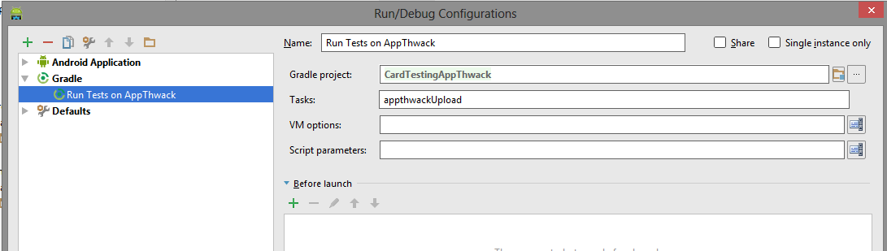

4. Running The Tests : To run the test, click the Run Configurations drop down and select the Run Tests On AppThwack item. Then, click on the green icon to run the test.
5. Reviewing Results :
After successful run, an html report will be compiled, and its link can be seen from the log as shown in the following example :
...
:GradleTestApp:appthwackUpload
[AppThwack] Using Project 'demoproject'.
[AppThwack] Using DevicePool 'Top 10 devices'.
[AppThwack] Uploading apk 'GradleTestApp-debug-unaligned.apk'.
[AppThwack] Uploading test apk 'GradleTestApp-test-unaligned.apk'.
[AppThwack] Scheduling 'explorer' run 'GradleTestApp-debug-unaligned.apk (Gradle)'.
[AppThwack] Congrats! See your test results at https://appthwack.com/project/demoproject/run/24219.

Issues Faced :

Minor :

The AppExplorer test did not work in the current version of the appthwack gradle plugin i.e. com.appthwack:gradle:1.3 . So, If you want to use the AppExplorer test type, you need to use version com.appthwack:gradle:1.1 instead.

Pros N Cons :

Pros
Unlike Manymo, the Appthwack tests the application on real devices connected to the cloud.

Cons
The report is generated on the web instead of the build folder in the project source.

