**Name: Aum Amar Shendge**

**Roll No: BTB17**

**PRN: 2122000270**

**Experiment No. 3: Implement Horizontal and Vertical Fragmentation and perform operations**

CREATE TABLE emp (

eno INT PRIMARY key,

ename VARCHAR(20),

city VARCHAR(20),

salary INT

);

INSERT INTO emp VALUES(1, 'Aum', 'New York', 14000);

INSERT INTO emp VALUES(2, 'Prathamesh', 'Los Angeles', 16000);

INSERT INTO emp VALUES(3, 'Digvijay', 'Chicago', 12000);

INSERT INTO emp VALUES(4, 'Varad', 'Houston', 25000);

INSERT INTO emp VALUES(5, 'Dhairyasheel', 'Phoenix', 30000);

INSERT INTO emp VALUES(6, 'Pranav', 'Philadelphia', 15000);

INSERT INTO emp VALUES(7, 'Sujal', 'San Antonio', 17000);

INSERT INTO emp VALUES(8, 'Devesh', 'San Diego', 13000);

INSERT INTO emp VALUES(9, 'Yash', 'Dallas', 18000);

INSERT INTO emp VALUES(10, 'Aayush', 'Austin', 11000);

SELECT * FROM emp;

CREATE TABLE hfrag1 AS

SELECT * FROM emp WHERE salary <= 15000;

CREATE TABLE hfrag2 AS

SELECT * FROM emp WHERE salary > 15000;

CREATE TABLE vfrag1 AS

SELECT eno, ename FROM emp;

CREATE TABLE vfrag2 AS

SELECT eno, city, salary FROM emp;

1.Find the salary of all employees.

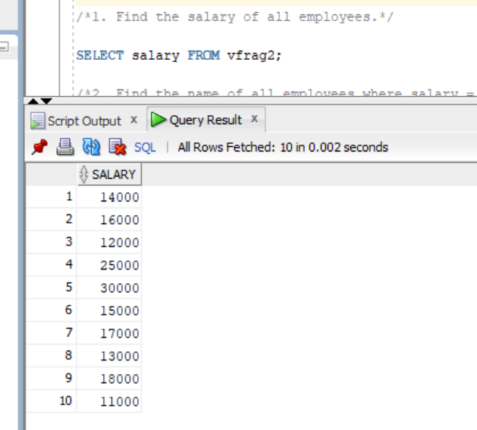

2. Find the name of all employees where salary = 15000.

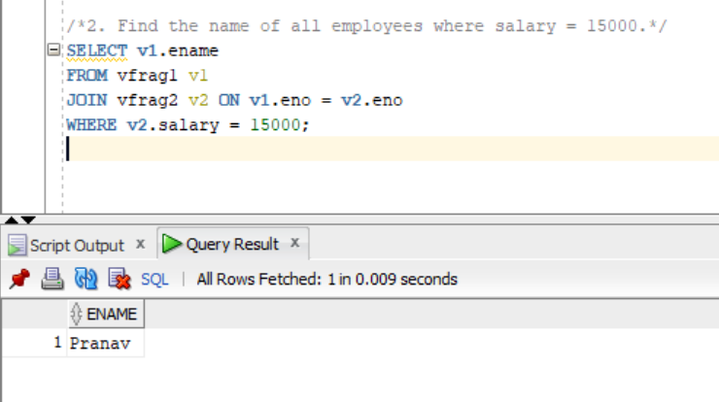

3. Find the employee’s name and city where employee salary is between 15000 to 25000.

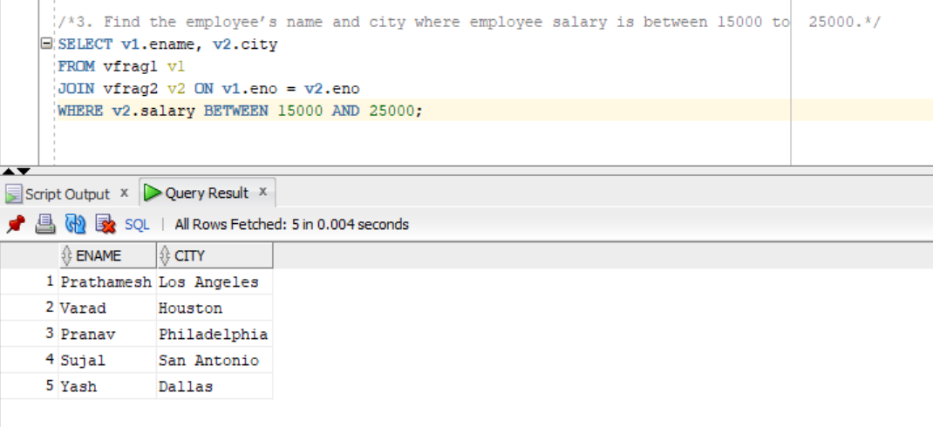

4. Find the employee’s name and city where employee number is known.

