**Name :Aum Shendge**

**Roll no:BTB17**

**PRN:2122000270**

**Experiment No. 7: Install MongoDB Compass. Create and manage NoSQL Databases with MongoDB**

1. Create database: product
2. Create collection: inventory
3. Perform following operations on created collections:

a. Insert documents (one and many).

db.inventory.insertOne({"id": "1",

"nanme": "Abc",

"status": "D",

"qty": "35"}) db.inventory.insertOne({"id": "2",

"nanme": "pbc",

"status": "A",

"qty": "20"})

db.inventory.insertOne({"id": "3",

"nanme": "pqr",

"status": "A",

"qty": "40"}

1. Update documents (one and many).

db.inventory.updateOne({"id":"1"},{$set :{"qty":"10"}})

1. Replace documents (one and many)

.db.inventory.replaceOne({"id":"2"},{"id":"2","name":"rst","status":"C"})

1. Delete documents (one and many)

.db.inventory.deleteOne({"id":"3"})

1. Find documents.

db.inventory.find()

Use filter to find documents in database. Perform following queries in filter on inventory collection. a)

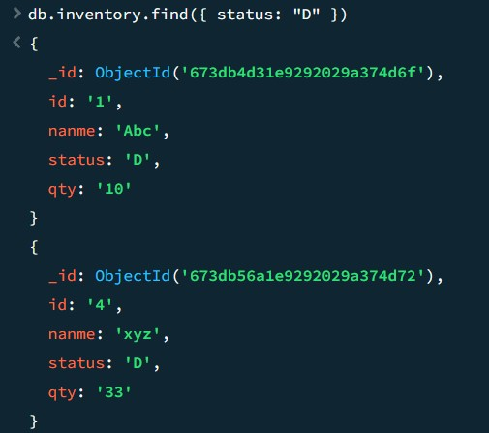

b)

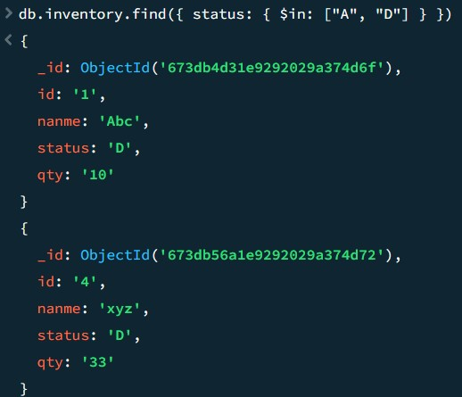

c)db.inventory.find({ status: "A", qty: { $lt: 30 } })

d)db.inventory.find({

$or: [

{ status: "A" },

{ qty: { $lt: 30 } }

]

})

d)db.inventory.find({status:"A",$or:[{qty:{$lt:30}},{name:/^p/}]})

Q2

**Problem Statement 2:**

1. Create collection: books under product database
2. Insert the following documents into a books collection:

{ "title": "1984", "author": "George Orwell", "year": 1949, "genre": "Dystopian" }

{ "title": "To Kill a Mockingbird", "author": "Harper Lee", "year": 1960, "genre": "Fiction" }

{ "title": "The Great Gatsby", "author": "F. Scott Fitzgerald", "year": 1925, "genre": "Fiction" }

{ "title": "Brave New World", "author": "Aldous Huxley", "year": 1932, "genre": "Dystopian" }

Add more such documents.

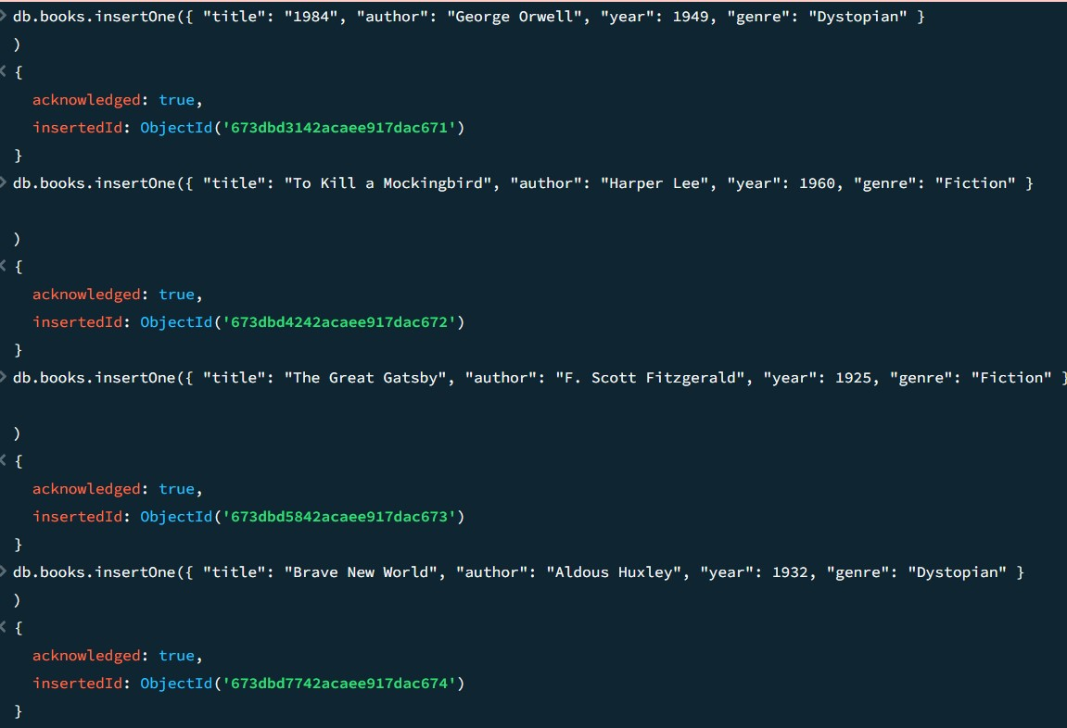

1. Find all books published after the year 1950.

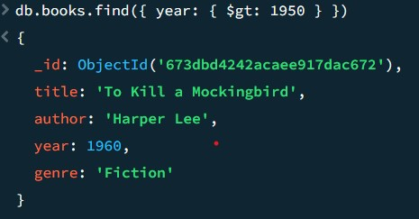

1. Find all Dystopian books published before 1950.

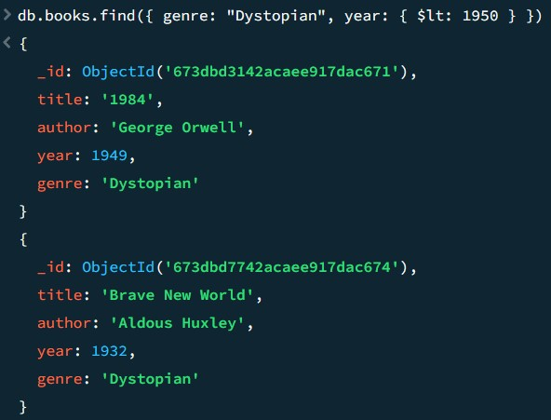

1. Update the genre of "1984" to "Science Fiction".

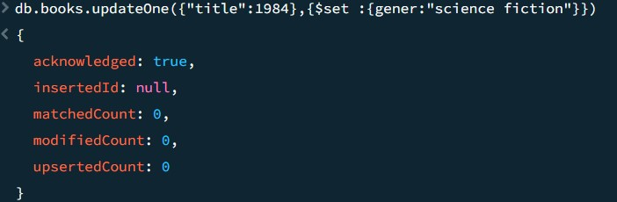

Delete all books in the "Fiction" genre.

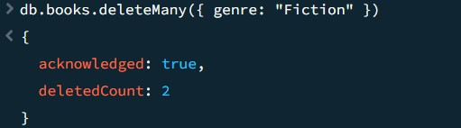

Calculate the total number of books for each genre.

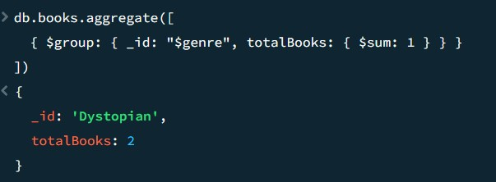

Create an index on the author field to improve query performance.

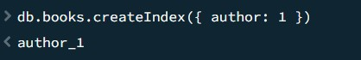

Retrieve all books sorted by year in ascending order.

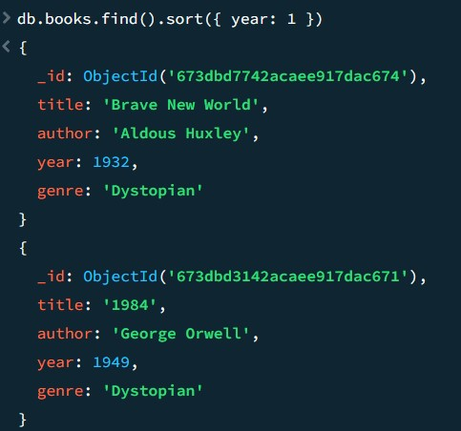

Count the number of books written by "Harper Lee". And Retrieve only the titles and authors of all books.

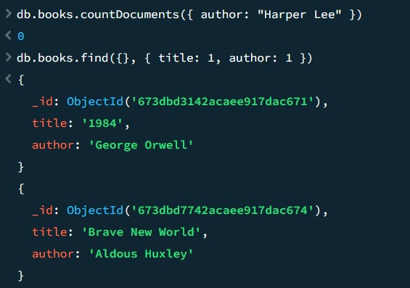

1. Use filter to find documents in database. Perform following queries in filter on inventory collection.

1. Find books published between 1930 and 1960.

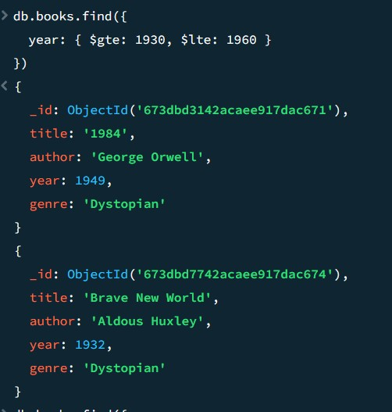

1. Find books with titles containing the word "The".

db.books.find({

title: { $regex: "The", $options: "i" }

})

1. Find all books published before 1950 and in the Fiction genre.

db.books.find({ year: { $lt: 1950 }, genre: "Fiction"

})

1. Find all books not written by Aldous Huxley.

