**Name: Aum Amar Shendge**

**Roll No: BTB17**

**PRN:212000270**

**Experiment No. 4: Implementation of Range and Hash Partitioning**

**Range Partition:**

**Consider a table named employees with schema emp (id int, fname varchar(25) not null, lname varchar(25) not null, store_id int not null, department_id int not null) with id as a primary key and insert 20 records with id ranges from 1 to20.**

**Make 4 partitions by range:**

**P0: id < 5**

**P1: id < 10**

**P2: id < 15**

**P3: id < 20 or Maxvalue.**

create table employees( id int primary key, fname varchar(25) not null, lname varchar(25)not null, store_id int not null, department_id int not null

)

PARTITION BY RANGE (id) (

PARTITION p0 VALUES LESS THAN (5),

PARTITION p1 VALUES LESS THAN (10),

PARTITION p2 VALUES LESS THAN (15),

PARTITION p3 VALUES LESS THAN (20),

PARTITION p4 VALUES LESS THAN (MAXVALUE)

);

INSERT INTO employees (id, fname, lname, store_id, department_id) VALUES (2, 'Jane', 'Smith', 1, 101);

INSERT INTO employees (id, fname, lname, store_id, department_id) VALUES (3, 'Sam', 'Brown', 2, 102);

INSERT INTO employees (id, fname, lname, store_id, department_id) VALUES (4, 'Sue', 'Davis', 2, 102);

INSERT INTO employees (id, fname, lname, store_id, department_id) VALUES (5, 'Tom', 'White', 1, 103);

INSERT INTO employees (id, fname, lname, store_id, department_id) VALUES (6, 'Sara',

'Miller', 1, 103);

INSERT INTO employees (id, fname, lname, store_id, department_id) VALUES (7, 'Tim', 'Wilson', 2, 104);

INSERT INTO employees (id, fname, lname, store_id, department_id) VALUES (8, 'Sophie', 'Taylor', 2, 104);

INSERT INTO employees (id, fname, lname, store_id, department_id) VALUES (9, 'Steve', 'Moore', 3, 105);

INSERT INTO employees (id, fname, lname, store_id, department_id) VALUES (10, 'Jake', 'Thomas', 3, 105);

INSERT INTO employees (id, fname, lname, store_id, department_id) VALUES (11, 'Jess', 'Johnson', 3, 106);

INSERT INTO employees (id, fname, lname, store_id, department_id) VALUES (12, 'Jill', 'Clark', 3, 106);

INSERT INTO employees (id, fname, lname, store_id, department_id) VALUES (13, 'Jim', 'Martinez', 1, 107);

INSERT INTO employees (id, fname, lname, store_id, department_id) VALUES (14, 'Joan', 'Hernandez', 1, 107);

INSERT INTO employees (id, fname, lname, store_id, department_id) VALUES (15, 'Jack', 'Lopez', 2, 108);

INSERT INTO employees (id, fname, lname, store_id, department_id) VALUES (16, 'Jason', 'Gonzalez', 2, 108);

INSERT INTO employees (id, fname, lname, store_id, department_id) VALUES (17, 'Julia', 'Perez', 3, 109);

INSERT INTO employees (id, fname, lname, store_id, department_id) VALUES (18, 'Javier', 'Martinez', 3, 109);

INSERT INTO employees (id, fname, lname, store_id, department_id) VALUES (19,

'Joseph', 'Ramirez', 1, 110);

**1. Retrieve employee details from partition P1 and P2.**

SELECT * FROM employees WHERE id >= 5 AND id < 15;

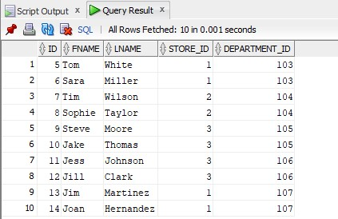

**2.Retrieve employee details from partition P0 and P1 where fname begin with ‘S’.**

**Ans:**

SELECT * FROM employees

WHERE id < 10

AND fname LIKE 'S%';

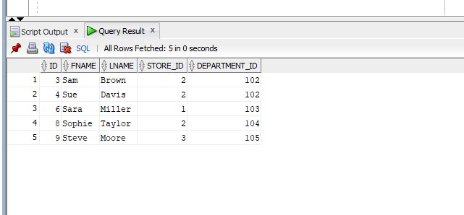

**3.(Count number of employees from each department from p1, p2 and p3.) Ans:**

SELECT department_id, COUNT(*) AS num_employees

FROM employees

WHERE id >= 5 AND id < 20

GROUP BY department_id;

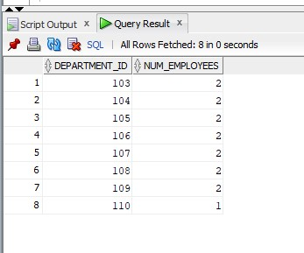

**Hash Partition:**

**Consider a table named sales_hash with schema (salesman_id number(5), salesman_name varchar2(30), sales_amount number(10), week_no number(2)) with salesman_id as primary key and insert at least 10 records.**

**Create 4 partitions using hash partitioning.**

create table sales_hash( salesman_id number(5) primary key, salesman_name varchar2(30), sales_amount number (10), week_no number(2)

)

partition by hash(salesman_id)

PARTITIONS 4;

drop table sales_hash;

INSERT INTO sales_hash (salesman_id, salesman_name, sales_amount, week_no) VALUES (1, 'Arjun Rao', 1500, 1);

INSERT INTO sales_hash (salesman_id, salesman_name, sales_amount, week_no) VALUES (2, 'Priya Sharma', 2000, 2);

INSERT INTO sales_hash (salesman_id, salesman_name, sales_amount, week_no) VALUES (3, 'Ravi Kumar', 3000, 3);

INSERT INTO sales_hash (salesman_id, salesman_name, sales_amount, week_no) VALUES (4, 'Anita Verma', 4000, 4);

INSERT INTO sales_hash (salesman_id, salesman_name, sales_amount, week_no) VALUES (5, 'Sandeep Patel', 2500, 5);

INSERT INTO sales_hash (salesman_id, salesman_name, sales_amount, week_no) VALUES

(6, 'Neha Yadav', 3500, 6);

INSERT INTO sales_hash (salesman_id, salesman_name, sales_amount, week_no) VALUES (7, 'Rajesh Gupta', 2200, 7);

INSERT INTO sales_hash (salesman_id, salesman_name, sales_amount, week_no) VALUES (8, 'Priyanka Mehta', 2700, 8);

INSERT INTO sales_hash (salesman_id, salesman_name, sales_amount, week_no) VALUES (9, 'Amit Singh', 5000, 9);

INSERT INTO sales_hash (salesman_id, salesman_name, sales_amount, week_no) VALUES (10, 'Rohit Kapoor', 1800, 10);

SELECT partition_name, table_name

FROM all_tab_partitions

WHERE table_name = 'SALES_HASH';

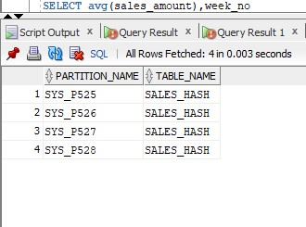

**1.Retrieve sales details from 2nd partition.**

SELECT * FROM sales_hash PARTITION (SYS_P526);

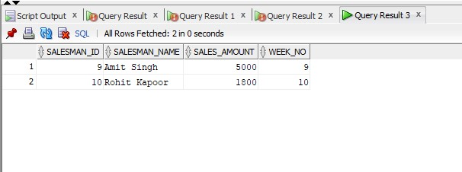

2**.Retrieve name of sales mans and amount from 4th partition where sale amount between 2000 and 5000.**

SELECT salesman_name, sales_amount

FROM sales_hash PARTITION (sys_p528)

WHERE sales_amount BETWEEN 2000 AND 5000;

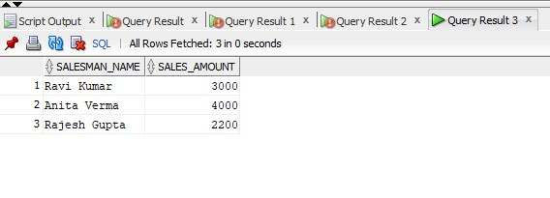

**3.Find average sale amount per week from 3rd partition.**

SELECT avg(sales_amount),week_no from sales_hash PARTITION (sys_p527) group by week_no order by week_no;

