Index.php

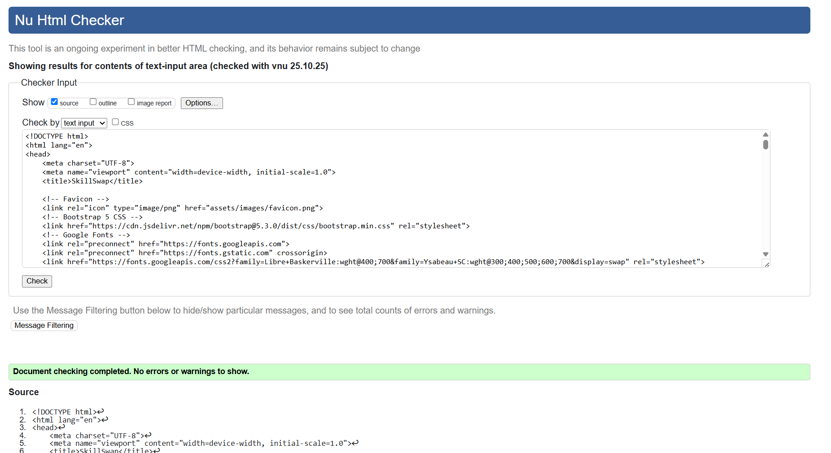

Add.php

Gallery.php

Details.php

Skills.php

Register.php

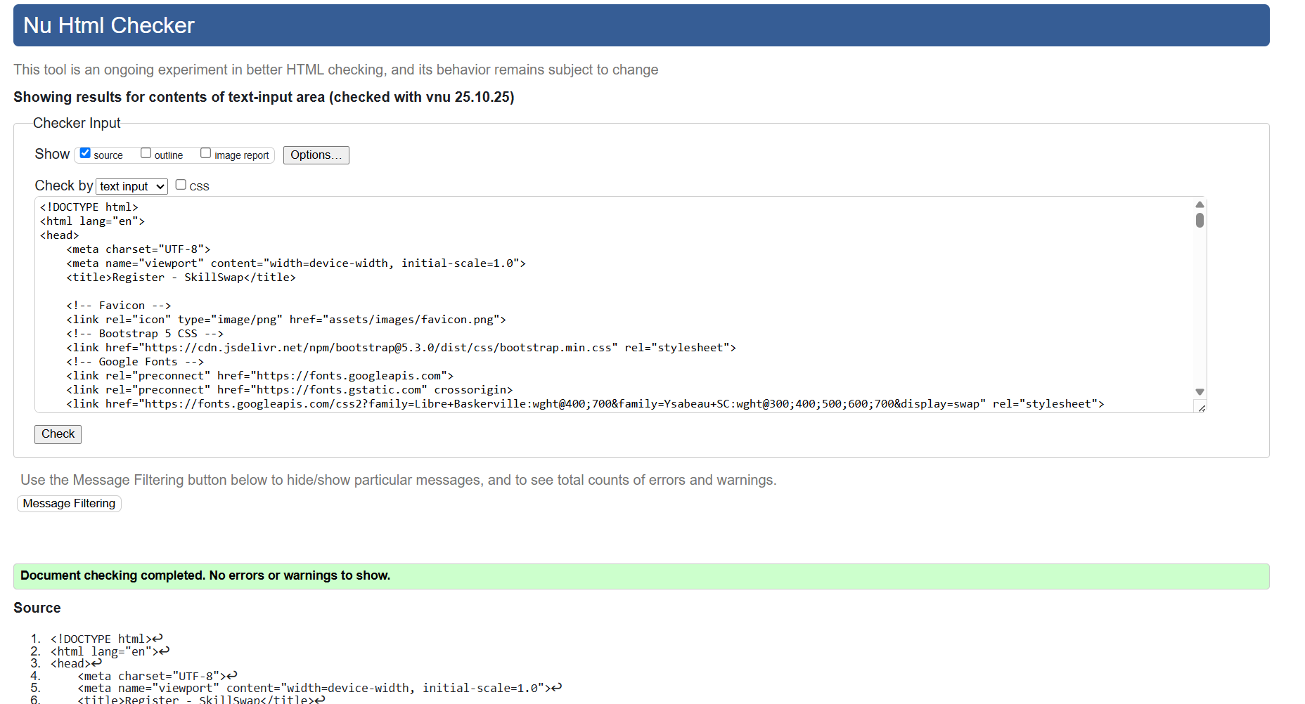

Edit.php

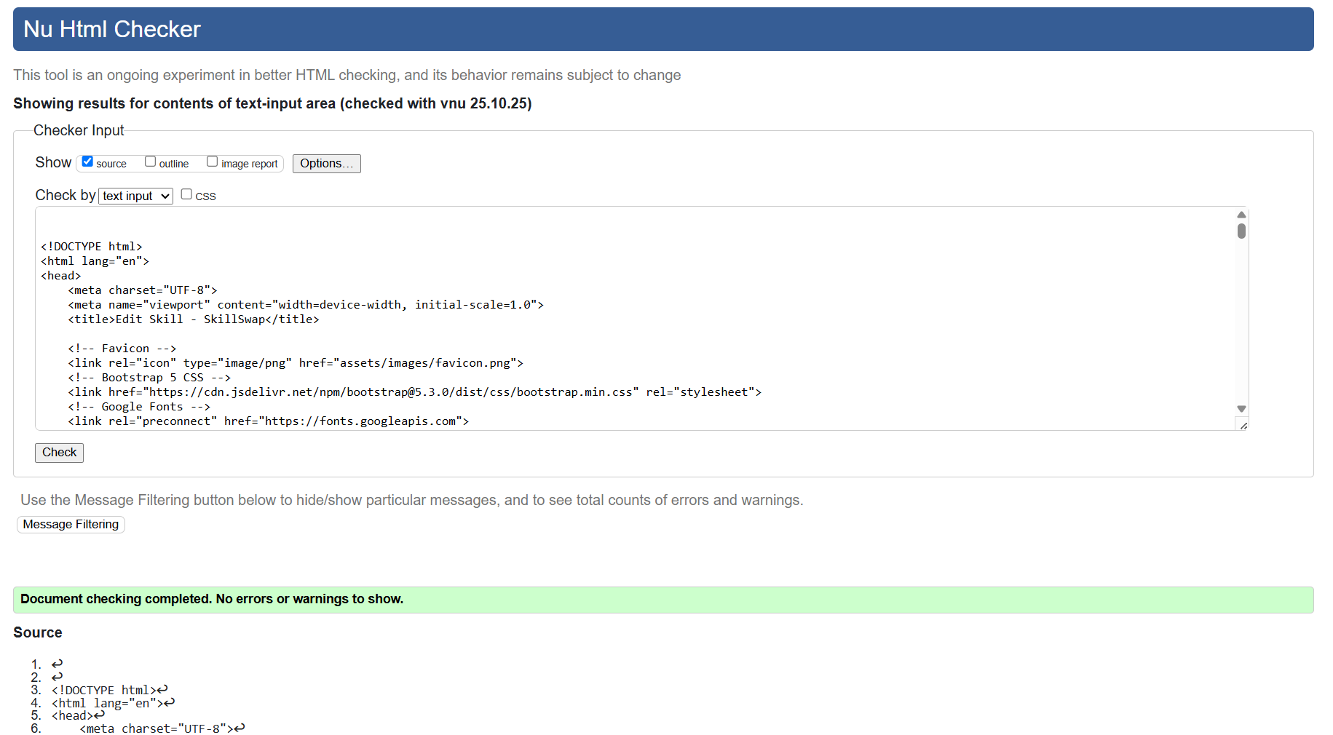

Instructor.php

Search.php

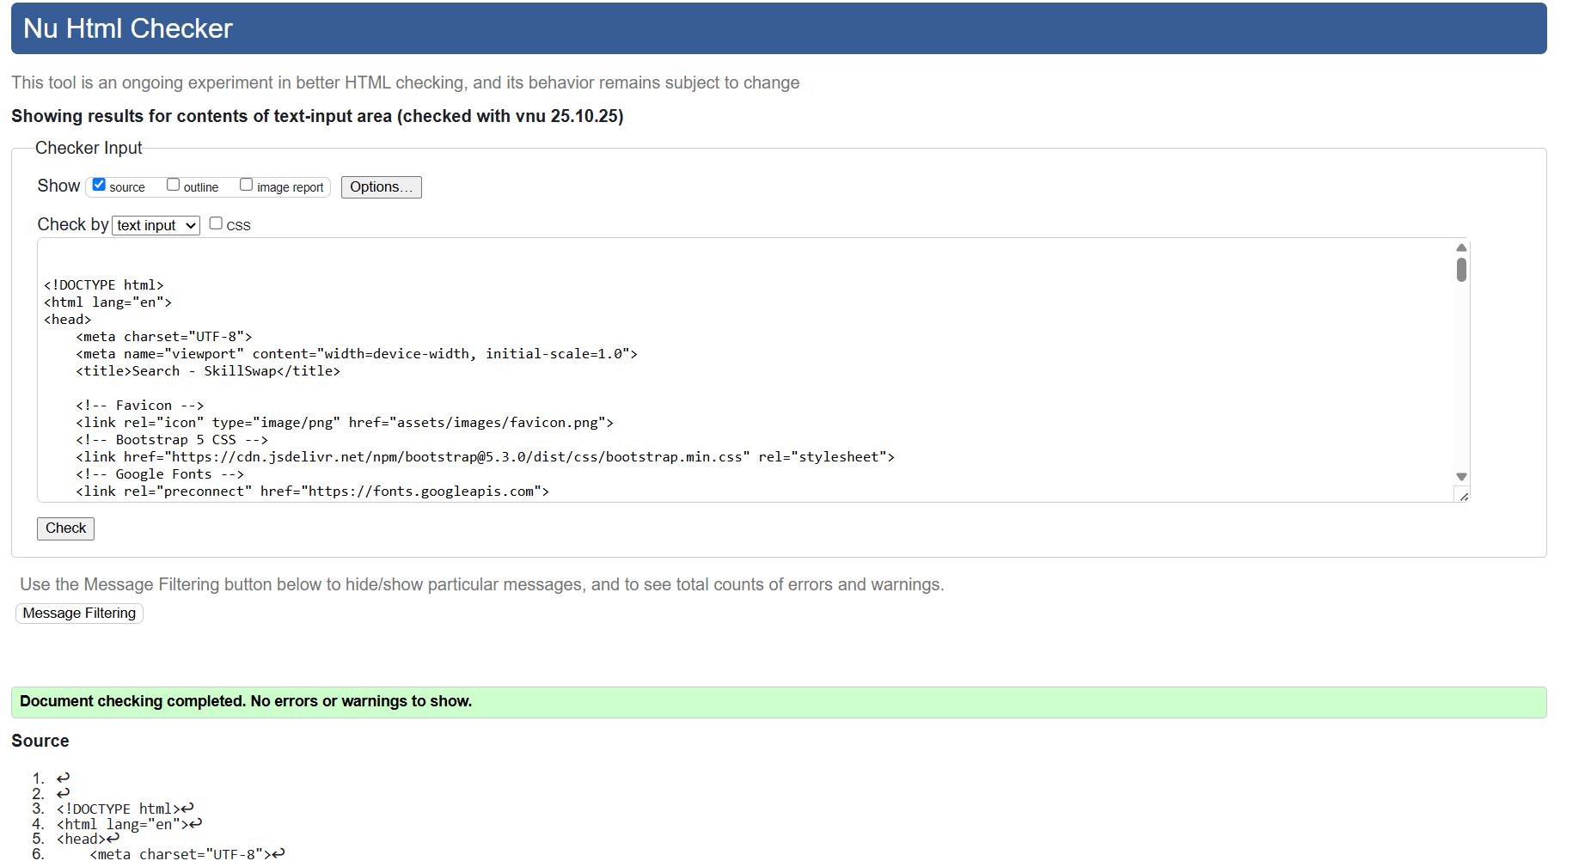

Styles.css

