DESIGN REQUIREMENTS FOR A SUSTAINABLE WEATHER STATION SECURITY SYSTEM.

Julianne SANSA OTIM1, Mary NSABAGWA1, Milton WAISSWA2, Mbabazi AINEKIRABO3, Conrad SUUNA3, Gemmar FREEDOM3, Dihfahsih MUGOYA3, Bjorn PEHRSON2.

1. Makerere University Kampala,

2. Uganda National Meteorological Authority,

3. University of Bergen, Norway.

**Abstract:** This paper discusses the security challenges experienced by weather station implementers. It proposes and analyses a cost-effective weather station security system. Such a system is necessary to curb the high costs of maintenance that result from theft and vandalism of weather station equipment. Our proposed design of the security system is the use of surveillance cameras to surveil the weather station perimeters.

**Keywords:** weather station security, image processing, SurveillanceSystem

# Introduction

Securing of the Automatic Weather Station (AWS) components is a big concern to meteorological services in developing countries. Unlike other components, which are kept under close supervision, AWSs are usually deployed in remote environments [1]. These remote environments especially in Africa are located in off-the-grid locations, leaving the power-dependent AWSs to rely on renewable power supplies [2]. The AWS requires sufficient power for sensors to collect, process and to enable radios transmit the collected weather data. Such power demanding activities may in some instances require big sized solar panels and batteries, which form the main components of AWS power supplies. The solar panels and batteries have found various uses such as lighting and phone charging in many homesteads [3]. Such domestic values of the AWS power supply leads to vulnerability of many AWSs due to vandalism, making them unable to perform the functions they were intended to perform.

AWS Vandalism is the act of deliberately destroying or damaging weather station equipment. Vandalism reduces the number of operational AWSs, hence a reduced amount of weather data collected. Besides weather data loss, the cost of replacing an AWS is prohibitively high. As such, vandalised stations often remain non-operational for quite a long time and sometimes are completely abandoned. The growing number of non-functional AWSs, causes a sparse network of stations, leading to limited weather data collected. Limited weather data affects the accuracy of weather forecasts. Inaccurate weather forecasting negatively affects many sectors including agriculture, construction, entertainment and transport. It is thus important to secure the available AWSs to minimize vandalism.

The meteorological services have been employing a series of mechanisms to enhance AWS security. While many AWSs are installed in remote locations [1], preference has always been given to sites close to communities and especially near police posts, as a way of using communities to monitor the stations. Such a mechanism is only efficient during the day, leaving stations vulnerable at night. In regards to remotely deployed stations, physical security mechanisms such as caging the entire station, using padlocks as well as caging the solar panels have been used. Despite the effort, AWSs are still vandalized, rendering the traditional security mechanisms inefficient.

A few AWS manufacturers have been able to supplement their AWSs with security systems. An example of such stations is the vaisala weather stations [4], which is equipped with motion detection sensors. These motion sensors, on sensing motion near the AWS sound an alarm, which signals persons in charge to check the station. This security mechanism may raise false alarms especially if any object comes in close proximity with the AWS. As false alarms grow in number, important alarms may be ignored. We are proposing a reliable and cost-efficient security system, which shall be based on cameras. The cameras shall be placed at locations, which enable them capture images from the AWS surrounding, process them and raise an alarm. We believe that improved security of the AWSs shall reduce vandalism cases and enable meteorological services maintain the available AWSs, hence enough data for forecasting purposes.

**Background.**

Uganda National Meteorological Authority (formerly Department of Meteorology) under Ministry of Water and Environment is a semi-autonomous government institution for weather and climate services (UNMA Act. 2012) and a focal institution to Inter-Governmental Panel on Climate Change (IPCC), an international body of experts mandated to analyze scientific research findings on climate change. The Government of Uganda (GoU) has always recognized natural resources (including weather and climate) as a basic factor in the country’s national development process. It is well documented and common knowledge that the day to day management and harnessing of all natural resources are largely dependent on the state of the environment, weather and climate. Weather and climate is therefore, an important factor in the social and economic development of the country as it has major influences on the developments of all other sectors of the economy.

**Mandate.**  
To promote, monitor weather and climate as well as provide weather predictions and advisories to Government and other stakeholders for use in sustainable development of the country

**Vision.**  
To be a center of excellence on Weather and climate services for sustainable development of Uganda.

**Mission.**  
To contribute to overall national development through provision of quality customer focused cost effective and timely information for weather and climate services to all users.

The [Uganda National Meteorological Authority (UNMA)](https://www.unma.go.ug/) is responsible for establishing and maintaining weather and climate observing stations network, collection, analysis and production of weather and climate information, (including warnings/advisories) to support social and economic development. The key sectors served by UNMA include; transport (mainly aviation and marine), defence, agriculture, disaster preparedness, environmental and water resources management, tourism and construction industry. UNMA accomplishes these responsibilities in collaboration and coordination with the World Meteorological Organization (WMO) and its Member States and other global and regional meteorological centers.

# Methodology

In order to establish requirements for an AWS security system, we reviewed literature on the status of weather stations in Uganda, visited two weather stations and carried out an interview with three UNMA station network managers. The network station managers are in charge of overseeing the installation and maintenance of weather stations throughout the country. The team keeps records on the status of stations. Among the records provided by the team was a report on vandalism of the weather stations taken between 2005 to 2008 and 2005 to 2013.

We used interviews to establish challenges facing available security mechanisms and the opportunities available for introducing a new security system. While automated systems may be more reliable, their continuous operations are highly dependent on resource allocation and readiness of users. The study set out to establish the readiness of UNMA to embrace the new technology. Below are the feasibility categories that the study was based on:

i) Technology - This tempts to identify the technologies in use, and the willingness of the weather station implementers to adopt to new technologies;

ii) Budget - This focus on the available funds for financing the implementation and installation of the system;

iii) Location - This focuses on the installation points for the system at the weather station.

# Findings

In the survey we carried out, we found out that whereas the AWSs are a good alternative to monitoring weather conditions for 24 hours daily with minimum human supervision, it has been noted that over the years, they have a weakness of being vandalized. Prior to installation of a station, UNMA takes various security precautions. Among them include the following;

* A weather station site is identified within the premises of the hosting organization. The site should be in clear observation of the stakeholders.
* This is followed by construction of a chain link rectangular perimeter fence where the station is installed to keep off intruders. The fence has a lockable gate with strong padlocks.
* The bottom of the chain link is fortified with concrete to avoid intruders getting into the fence from the bottom.
* The main challenge with this sort of security approach (Using locks) is that with time they get compromised due to rusting brought about by the rain water, dew and frost.

**Extent and consequences of vandalism.**

In reference to section 1 (introduction) of this document, the table below gives a brief summary of the consequences of vandalism of the AWSs. In addition to loss of money due to data loss, this vice (vandalism) limits the ability for the organization (UNMA) to make accurate prognoses of changes in weather. This as well affects the organization’s support for social and economic development since there's a need for data to warn and advise different sectors of the economy on environmental changes.

*Table 1: Table showing the monetary value loss due to vandalism from 14 weather stations*

|  |  |  |  |
| --- | --- | --- | --- |
| **UNMA data sell charge** | **Price** | **Years** | **Amount** |
| 5 minute weather data per month per station | 6,000,000 | 5 | 420,000,000 |
| 10 minute weather data per month per station | 5,000,000 | 5 | 350,000,000 |
| 15 minute weather data per month per station | 4,000,000 | 5 | 280,000,000 |
| 30 minute weather data per month per station | 3,000,000 | 5 | 210,000,000 |
| 60 minute weather data per month per station | 2,000,000 | 5 | 140,000,000 |
| **Total amount** | | | **1,400,000,000** |

The map below represents the extent to which the vice of vandalizing weather stations in Uganda has spread in correlation to the different weather stations being affected.

*Figure 1: map showing installed vs vandalized weather stations in Uganda.*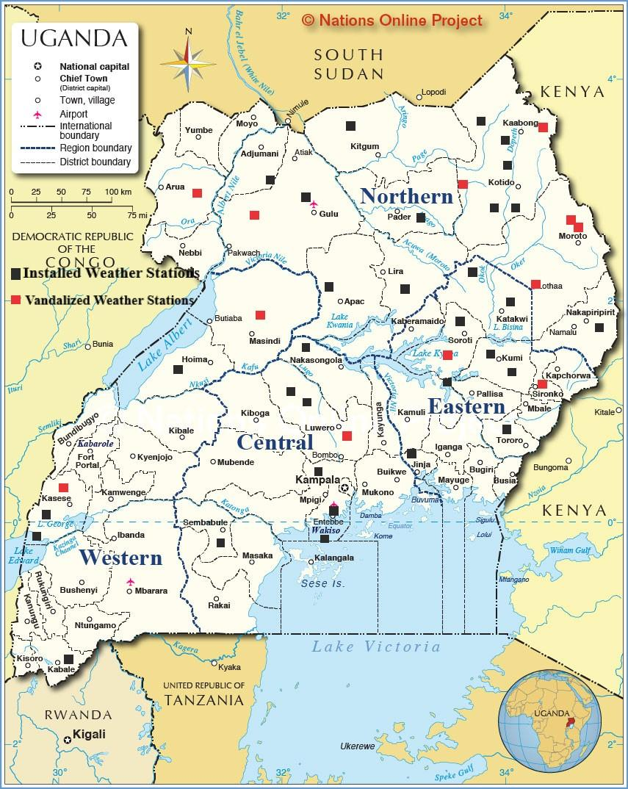Due to the consequences that arise due to vandalism, it is realized that weather stations need a security system to curb the act of vandalizing weather stations in Uganda. That being said, our first approach to solving this problem shall be use of surveillance cameras around the weather stations.

# Available Security Systems.

Several security mechanisms have been used to enhance the security of various AWSs. Some of these systems include;

* The infinity 2020.

Integrated Security Corporation located in Michigan, USA near Detroit manufactured the Infinity 2020 which is the premier fence mounted intrusion detection system [5]. The set back to using such a solution is its cost of installation and maintenance. Costs are even higher compared to replacing a given weather station equipment. We determined this from its long list of specifications [5]. This makes the whole project unjustifiable as well as making the idea non-viable.

* HD 1080P.

The HD 1080P is a Weather Station Security Wi-Fi Camera that has a wide range of features. Such as usage as a normal weather station, remote access on both android and OS, as well as motion detection [6].Using such a solution has several setbacks one being its cost which is at $170.69 amazon price which is relatively high. Another setback is its lack of support for windows phones.

* The Smart Motion Detection System.

This uses a Raspberry Pi and is a system suitable for small personal area surveillance i.e. personal office cabin, bank locker room, parking entrance. Whenever the motion is detected through PIR sensor inside the room the image is captured through a camera and temporarily stored in the raspberry pi module [7]. Internet of things based application can be used remotely to view the activity and get notifications when motion is detected. This solution’s downside is the need for the PIR sensors which cost $10.2 each making the project not viable.

* The Optris PI Lightweights.

This is a security system that uses infrared recordings. Its disadvantage is the camera size which is too big implying that the intruder can easily avoid being captured [8].

* Zoneminder.

This is an integrated set of applications that provide a complete surveillance solution allowing capture, analysis, recording and monitoring of any CCTV cameras.

# Design Requirements

## System Architecture

This paper proposes a “Weather station security system”, which is an embedded system that is to be designed to help weather stations easily monitor and secure weather stations across the country. The system shall capture images of the surrounding, process them and if suspicion is detected, it shall sound an alarm, upload the video to a server and send a notification about the issue to the officer in charge of the station. The system shall contain the log files for future references. This is important for system and user behavior analysis [12] [13]. If system logs are analyzed, important information can be found retrieved. The system shall have cameras, which shall keep in surveillance of the area around the weather station. The image frames are input in to OPENCV, a computer vision algorithm which processes the input image frames for motion. Once motion is detected, the camera is triggered to capture images which are fed into an image classifier to determine the category of the object (cat, dog, or human).  If the image belongs to the human class, then an alarm shall be sounded, the images shall be captured sent as an email attachment. An SMS notification sent to the officer in charge.

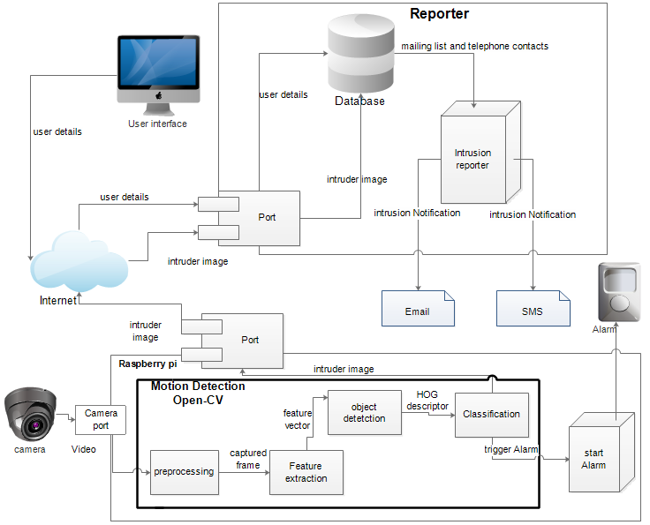

*Figure 2: System Architecture Diagram.*

## Deployment requirements

### Environmental Considerations.

The setting in Figure 3, shows how the different components shall be setup at the station. The cameras are mounted on the pole 7 meters from the ground to ensure full coverage of the surveillance of weather station premises. The pi and the alarm unit have to be connected close to the pi to avoid having long wires between the components which exposes the station to the risk of lightning. The wires are covered with a plastic sheath (halogen free and frost resistant) as additional mechanical protection [14]

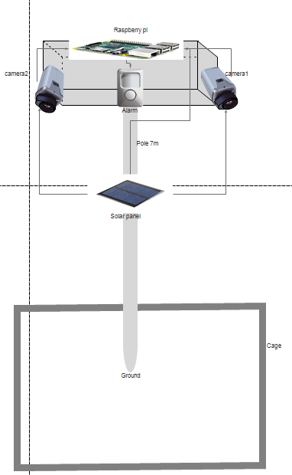

*Figure 3: proposed experiment setup*

*Table 3: equipment specifications*

|  |  |  |  |
| --- | --- | --- | --- |
| **Raspberry Pi** | **Camera** | **Speaker** | **Amplifier** |
| * SoC: Broadcom BCM2837 * CPU: 4× ARM Cortex-A53, 1.2GHz * GPU: Broadcom VideoCore IV * RAM: 1GB LPDDR2 (900 MHz) * Networking: 10/100 Ethernet, 2.4GHz 802.11n wireless * Bluetooth: Bluetooth 4.1 Classic, Bluetooth Low Energy * Storage: microSD * GPIO: 40-pin header, populated * Ports: HDMI, 3.5mm analogue audio-video jack, 4× USB 2.0, Ethernet, Camera Serial Interface (CSI), Display Serial Interface (DSI) | * CCD size: 1/4inch * Aperture (F):1.8 * Focal Length: 3.6MM (adjustable). * Sensor best resolution: 1080p * Raspberry Pi night vision. * 5 Megapixels. * Compatible with all the models of Raspberry Pi. * Supports up to 2 infrared LEDs as well. * 4 screw holes. * 3.3V power output. | * 3" diameter * 4Ω impedance * 3W * 4 handy mounting tabs 60mm apart. | * Output Power: 2.1W at 4Ω, 10% THD, 1.4W at 8Ω, 10% THD, with 5V Supply * PSRR: 77 dB typ @ 217 Hz with 6 dB gain * Designed for use without an output filter, when wires are kept at under 2"-4" long * Four pin-selectable gains: 6dB, 12dB, 18dB and 24dB. Select with the onboard switches or by setting the G0 and G1 breakout pins. |

# Cost Benefit analysis

*Table 4: Financial cost estimates*

|  |  |  |  |
| --- | --- | --- | --- |
| **Item** | **Quantity** | **Unit Price** | **Total** |
| Camera Module | 2 | $30.99 | $61.98 |
| Mounting Screws | 8 | $0.10 | $0.80 |
| Camera casing | 2 | $10 | $20 |
| Camera shipping costs | 2 | $10 | $20 |
| Speaker | 1 | $1.9 | $1.9 |
| Amplifier | 1 | $9.95 | $9.95 |
|  |  | **Total Cost** | $114.63 |

**Price comparison to related works.**

The Infinity 2020 has various components including the sensor cable, the vision board, the sensor interface board, relay output, the processor, Lead cable, junction boxes and tie wraps. They use nylon UV resistant tie wraps but also offer stainless steel. The estimate price is according to these components is around $4000 without considering installation and transportation costs.

The HD 1080P Weather Station Security Wi-Fi Camera can be estimated at $170.69 amazon price without putting into consideration the costs of installation and customization [6].

According to the components of the smart motion detection system [7] [15], it can be estimated at a cost of $3000.

The Optris PI LightWeight has various components which include infrared camera, video cable bridge and rugged outdoor case IP67 [8], depending on all these components, the estimated amount can be $ 3500

*Table 5: comparison with related projects*

|  |  |
| --- | --- |
| **Existing Systems** | **Total Costs** |
| Infinity 2020 | $4000 |
| HD 1080P Weather Station Security Wi-Fi Camera | $170.69 |
| Smart Motion Detection System | $3000 |
| Optris PI LightWeight | $3500 |
| **Our System** | **$114.63** |

**Benefits of the proposed system** (Automatic weather station security)

Automatic weather station security systems provide various benefits [16]

* Securing of the available stations.
* Maintenance cost reduction.
* Security breaches can be easily recorded and used for future investigation purposes.
* Easy access to live streaming of the recordings.

# Recommendations

Due to the large amount of power that is consumed by the cameras, the system will be implemented first on stations with grid power connectivity and also lightning conductor should be installed at the weather station to prevent security components such as cameras being struck by lightning [17]

# Future Work

Due to the remoteness of most stations, tracking motion might not be sufficient to ensure the security of the station. Implementing a GPS tracker would help in the recovery of the equipment as implemented in the bonrix software or the Adafruit Ultimate GPSon theRaspberry Pi [18][19]. It works in such a way that the GPS tracking unit uses the Global Positioning System to determine the precise location of a vehicle, person, or other asset to which it is attached and records the position of the asset at regular time intervals[20][21]

# Conclusions

While it was generally agreed that using advanced technology to ensure security at the various weather stations would provide a better solution, the survey results also indicated that issues concerned with feasibility, manageability, effectiveness and cost should be top of the list before suggesting the kind of solution to implement.

**References**

[1] J. B. M.-A. Maximus B. Byamukama, Mary Nsabagwa, Richard Okou, Julianne Sansa Otim, “Report on the status of weather stations in Uganda,” p. 3, *RC3 survey results conducted between November 2014 and January 2015* .

[2] SSEC, “Automatic Weather Stations 2016,” *Sp. Sci. Eng. Center, UW-Madison*, pp. 13–14, 2016.

[3] C. H. Reichel, “Solar Power for Your Home A Consumer's Guide,” pp-11-16 2015.

[4] R. Performance and A. Environments, “Weather Stations for Meteorological Applications,” *Report*, pp. 1–8. Ref. B211184EN-A ©Vaisala 2012

[5] M. J. Arata, “Perimeter Security,” p. 354, San Francisco 2006.

[6] U. Manual, “HD 1080P Weather Station Security Wi-Fi Camera User Manual,” 2016.

[7] P. B. Patel, “Smart Motion Detection System using Raspberry Pi,” vol. 10, no. 5, pp. 37–40, ISSN : 2249-0868 Foundation of Computer Science FCS, New York, USA Volume 2016.

[8] Ferdinand-Buisson “optris ® PI LightWeight kit.” pp. 13-21, Str. 14 D – 13127 Berlin Germany

[9] J. T. Snow *et al.*, “A New Vision for Weather and Climate Services in Africa,” pp.3-4, Zurich 2016.

[10] New vision “THE REPUBLIC OF UGANDA NATIONAL METEOROLOGICAL AUTHORITY CELEBRATES WORLD INTERNATIONAL METEOROLOGICAL DAY,” Monday, March 21, 2016, C. H. Road,

[11] A. B. of Meteorology, “Guidelines for the Siting and Exposure of Meteorological Instruments and Observing Facilities,” *Obs. Specif. No. 2013.1*, p. 92, Australia, 1997.

[12] A. Bruckman, “Analysis of Log File Data to Understand Behaviour and Learning in an Online Community,” *Int. Handb. Virtual Learn. Environ.*, pp. 1449–1465, Georgia Institute of Technology 2006.

[13] M. Ranum, “System Logging and Log Analysis,” *Wp-Th3M3Kan1C.Rhcloud.Com*, pp. 2–3.

[14] D. Conductor and I. L. Protection, “Lightning Protection / Earthing,” pp.27 Dehn Academy 2015.

[15] A. Abduelhadi and M. Elnour, “Smart Motion Detection,” *IOSR J. Electr. Electron. Eng.*, vol. 12, no. 3, pp. 53–58, [www.iosrjournals.org](http://www.iosrjournals.org) 2017.

[16] F. Sabatini, “Renewing Local Planning to Face Climate Change in the Tropics,” pp. 21–40, National Research Council—Institute of BioMeteorology (IBIMET), Via Giovanni Caproni 8, 50145 Florence, Italy 2017.

[17] M. H. R. Weather, C. At, and Y. Location, “Weather Station With Lightning Sensor and Ptz HD Camera Measure Hyper-Local Real-Time Weather Conditions At Your Location.” TJ Winkelmann, Hillcrest STEAM Academy, 2017.

[18] B. S. Systems, “Introduction To GPS Based Vehicle and Person Tracking System,” Samudra Complex, Near Classik Gold Hotel, Off G.G.Road, Ahmedaba, Gujarat, India. 2012.

[19] K. T. Last and a M. EDT, “Adafruit Ultimate GPS on the Raspberry Pi,” pp. 1–11, 2013.

[20] F. Sabatini, “Renewing Local Planning to Face Climate Change in the Tropics,” pp. 21–40, University of Tasmania in conjunction with Geoscience Australia as part of the AuScope GPS in Schools Project – 2014.

[21] B. S. Jonathan vail, mel Parsons, “Global Positioning System,” *Glob. Position. Syst. US environmental protection agency science and ecosystems support division Athens, Georgia pp.7-9,* 2015.