26th August 2022

Mr. Dihfahsih Mugoya

# [dihfahsihm@gmail.com](mailto:dihfahsihm@gmail.com)

Contact: 0751612792 Kampala.

# Dear Mr. Mugoya

## Re: Employment Contract

On behalf of the National TB Reference Laboratory (NTRL) and Board of Directors of Makerere University Joint AIDS Program, I am pleased to offer you employment supporting the Connectivity Solutions Project effective **5th September 2022** and this letter constitutes the Employment Contract between yourself and MJAP, on the following terms and conditions:

* Your job title is **Software Developer.**
* Your immediate supervisor will be the **Project Manager** and your duty station will be

## National TB Reference Laboratory, Butabika.

* Your probation will be for the **first three (3) months** of this contract during which your work performance will be observed. After probation, you will be appraised and confirmed as an employee of Makerere University Joint AIDS Program, upon satisfactory performance.
* Your job description, which may be amended or altered from time to time to suit the needs of the Program, is attached.
* Your contract expires on **30th November 2022** and may be renewed based on:
  + satisfactory performance of your duties
  + availability of funds in the Organization; and
  + Strategic direction of the organization.
* Your monthly salary package will be **United States Dollars (USD) 1,500 (gross**); at 100% level of effort time, per month payable in Uganda Shillings at the prevailing market rate. You will be entitled to benefits in accordance with Makerere University Joint AIDS Program’s Human Resource Manual

## /……2

* Other terms and conditions of service are as contained in the current Makerere University Joint AIDS Program Human Resource Manual.
* Your appointment is at the sole discretion of the Makerere University Joint AIDS Program and can be terminated for causes such as but not limited to unsatisfactory performance, absence without leave, misconduct, requesting or receiving bribes, disclosure or misuse of client information, bankruptcy or criminal conviction, reduction of staff or completion of a specified activity, termination or suspension of funding to Makerere University Joint AIDS Program.

If you agree to the above terms and conditions of service, please sign the copies attached as shown below.

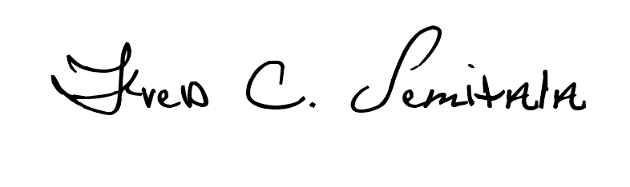Yours Sincerely,

Dr. Fred Semitala

## EXECUTIVE DIRECTOR.

**c.c**: - Finance & Operations Manager

- Human Resource Manager

I , accept my appointment on the terms and conditions of service as specified above.

**Mugoya Dihfahsih**

**Mugoya Dihfahsih**

Name:

Signature:  Date: _______

**31st August, 2022**

Witnessed by immediate Supervisor:

Name:

Signature: Date: