Name Mugoya Dihfahsih Student no. 2100702353 Github link Link to GitHub Project Repository
Abstractions
An approach to complex problems in which the solution is built in layers. The structures needed to solve the problem (algorithms and data structures) are implemented using lower-level capabilities and given names that can then be used as if they were primitive facilities
The abstractions can be categorized into four levels that is; Bottom level, Second level, Third level and Top level depending on the program, some have one level others two or three while others have all levels
Bottom level; This is a level at which the selectors are being implemented; it is sometimes called the level of pairs. The procedures cons, car and cdr which have been used in the project extensively are already provided by the language. The actual implementation of pairs is hidden at this level
Second level; This is the level of data-science as data objects, at this level the constructors and selectors of cons, car and cdr have been used as procedures and it is at this level where wishful thinking starts because the program does not show how these procedures will be implemented or represented. The implementation of data-science programs at this level is hidden.
Third level; This is the level of service procedures to the data-science program, it is at this level where the procedures such as linear-model, list→sentiment, read-csv, qq-plot, hist and all procedures made available using provide keyword are defined. The implementation of these procedures are hidden from the main program or in the code block where they are used.
Top Level; Data-Science is now being implemented at a program level, the procedures defined in the program are now being used as if they were ordinary primitives of data.
Each level has been designed to hide the implementation details from the higher-level procedures known as abstraction barriers.
QTN.1 Abstractions and procedure levels identified in the data-science-master project
The following are diagrams showing abstractions found in each of the identified linear-model, hist, hist→sentiment, qq-plot* and csv-reader abstractions. I have clear identified them in the file called abstractions_in_data_science_master.scm in the End_of_semester_project folder. These are the abstraction and procedure levels in the data-science-master project, the lines on each end show that there are more abstraction implementation hidden at each level
The Linear-model Abstractions
Top level
Linear-model

Third level
list*→matrix →col-matrix matrix-inverse matrix* matrix->list
Second level
X Y xs coef residuals n p mse root-mse

Bottom level
let* build-list flatten list const map length hash

The histogram Abstractions
Top level
hist

Third level
discrete-histogram sorted-counts

The list→ sentiment abstractions
Top level
list->sentiment

Third level
token→sentiment

Second level
pack-sentiment lexicon result sentiment lst

Bottom level
apply append map let list length if

The qq-plot* abstractions
Top level
qq-plot*

Third level
qq-plot plot

Second level
lst scale?

QTN.2 The New Abstractions
1. OAuth 1.0a for Twitter API authentication and data fetching
The following abstractions are found in the file pick_data_from_twitter.rkt in the project directory.The new abstractions start with picking data from twitter using the Twitter API abstraction. The authentication to use the twitter API starts with submitting the API request through http://developer.twitter.com.
Top level
Program level: oauth-single-user

Third level
Init-field, number→string, string-append, make-pseudo-random-generator

Second level
Signature-method, oauth-version, get-key-as-string, add-params-to-url

Bottom level
cons, car, cdr, map, list, lambda

The new abstractions use oauth-single-user procedures to initiate the connection to twitter using the access keys and tokens are abstractions that were received from twitter developer account. The init-field service package from racket makes these abstractions available and ready to be used in the program

Abstractions and procedures for authenticating the program to twitter API
Top level
Program level: twitter-oauth

Bottom level
oauth-single-user%,

Abstractions and procedures for querying twitter for specific data
Top level
Program level: tweeterdata

Third level
get-request, twitter-oauth, send

Second level
toDate, fromDate, query, maxResults

Bottom level
cons, list

Abstractions and procedures of saving the twitter data into a json file
Top level
Program level: writing_to_json_file

Bottom level
tweeterdata, write, open-output-file, close-output-port

tweeterdata procedure uses twitter-oauth get-request abstractions to fetch 12 months data from twitter and query parameters such as place_country, maxResult, fromDate and toDate are used to limit the data to only Uganda and in a specified period of time as appended to the url request abstractions.
Procedure writing_to_json_file uses the open-output-file abstraction from racket to create a new file called data.json, the write abstraction then implements the tweeterdata procedure to save the fetched data to the json file that was created by writing_to_json_file procedures. Using close-output-port abstractions releases lower-level resources such as file handle to be used by the rest of the program at the analysis stage.
2. Analyzing the data picked from twitter
The following are the new levels of abstractions and procedures that I came up with while building on the data-science-master project. These are found in the file twitter_mode_analysis.scm in the project directory,
New abstractions and procedures for inputting the twitter json data into the program
Top level
Program level: input_tweets

Bottom level
port→string, open-input-file

New abstractions and procedures for cleaning and normalizing twitter json data
Top level
Program level: cleaned_input_data

string-normalize-spaces, remove-punctuation, remove-false
remove-true, remove-sensitive, remove-favorite,
remove-urls, remove-favorited, input_tweets
Bottom level

The abstractions remove-punctuation and remove-url have their procedures implemented in the data-science-master project and in this cleaned_input_data new abstraction they have been used with other new remove abstractions to clean the json twitter data.
Abstractions and Procedures for aggregating the cleaned twitter data
Top level
Program Level: sentimize_twitter_data
Third level
sentiment

Bottom level
aggregate, sum

New abstractions and procedures for analyzing sentimental polarity using lexicon
Top level
Program level: sentimental_polarity

Third level

parameterize, discrete-histogram, better_histogram

Bottom Level
plot

New abstractions and procedures for determining which word is most polarized
Top level
Program level: Word Polarity Contribution

Third level

n(negative-tokens), p(positive tokens),
parameterize, plot-width, discrete-histogram,

‘

Bottom Level
plot, list

With motivation and design of remove procedures from the data-science-master project, I came up with the procedures to remove “false” “true” “favorite” “sensitive” key words from raw twitter file and replace them with an empty string “ ”. This was done so that the data analyzed is not affected by outliers.
After Normalizing the data, I used the open-input-file abstraction to create a procedure input-tweets to read the json file that has data to be analyzed
I used the procedure cleanedinputdata to combine the remove procedures as abstractions at this level to implement the cleaning of data in input-tweet
The cleanedinputdata procedure outputs quoted strings in the list. The order of the strings is not maintained from input to output, further cleaning is done by removing stop words using the defaults lexicon, cleanedinputdata1 which returns a list of pairs, each pair consisting of a unique word or token from str with its frequency the number of times the word occurs in the tweets selected.
With the motivation from data-science-master project of data sentiment, I created a procedure called sentimentize_twitter_data that implements cleanedinputdata1 procedures to return the aggregated twitter data which can now be visualized using various plotting tools . The following are the graphs visuaizing the cleaned twitter data using the new abstractions and procedures
Figure 2, shows the a bar plot of abstractions using bing lexicon to determine the ratio of positive words to the negative ones
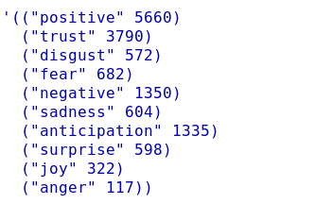Figure 1: Sentimental word analysis
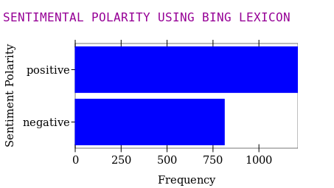Figure 2: Using the bing lexicon to determine the ratio of positive-to-negative words
Figure1 shows the sentiment for each word in the json file that have been aggregated and summed using same sentimental label

Figure3 shows a discrete histogram that visualizes the sentimental data abstractions using the automatic means of picking the bins which is an improvement on the hist abstractions implemented in the project.
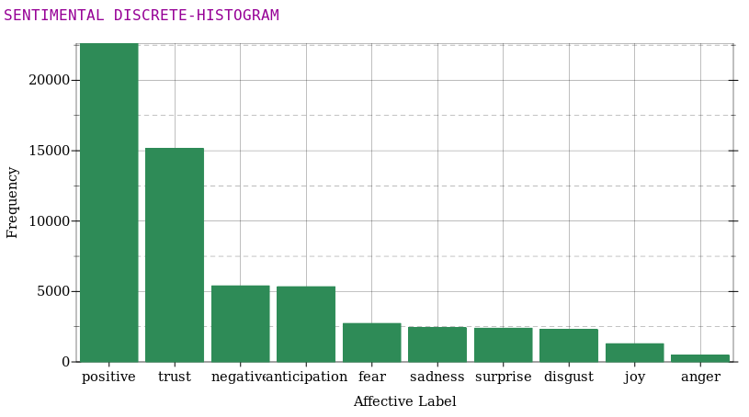Figure 3: Visualizing the results as a barplot (discrete-histogram), a better hist
Figure 4 shows a plot of data abstractions of words that are mostly contributing to negative and positive
sentimental scores, a sample of 20 influential positive and negatives were analyzed from data abstractions.
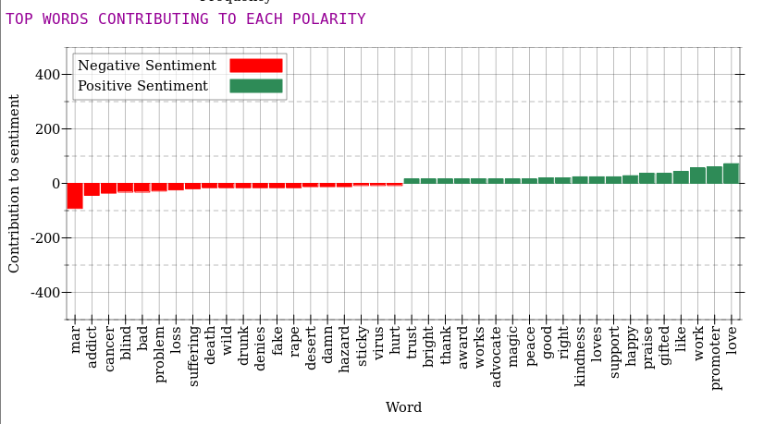Figure 4: 20 positive and negative influential words contributing most to sentiment scores

