**UNITED CHRISTIAN CENTER**

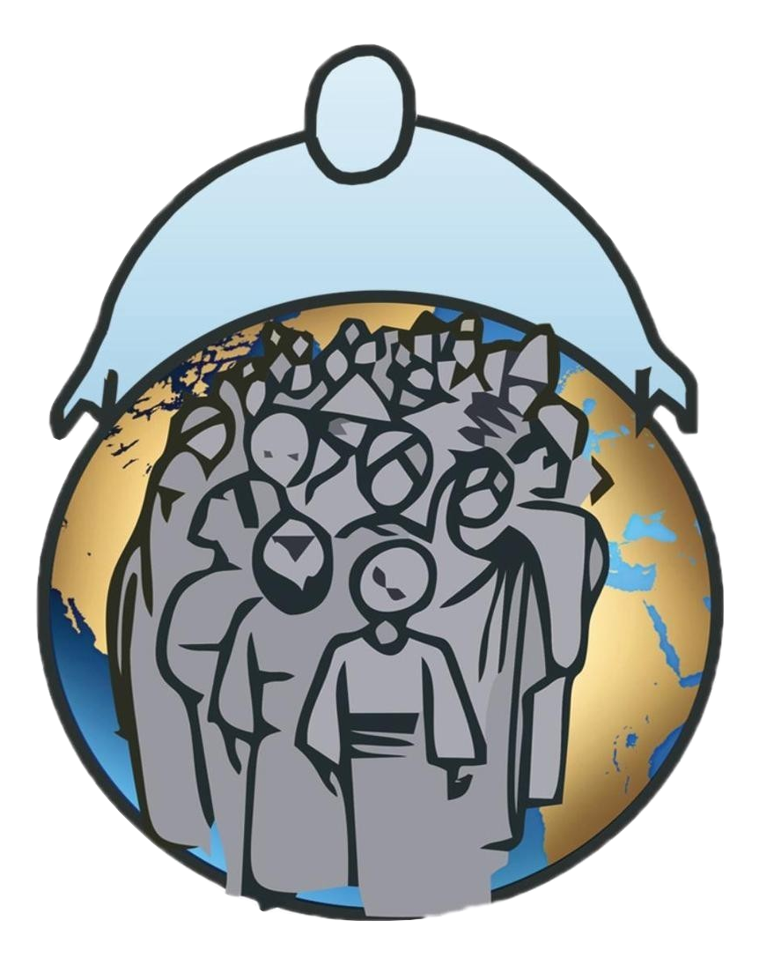

**LWAKI OLI MULAMU MINISTRIES**

**MINISTERS OF MINISTERS LEVEL ONE**

Teachers/Instructors

Pr. Joshua Zake

Mrs. Walusimbi Sarah

Mrs. Grace Kikanzira

Student Name:

MUGOYA DIHFAHSIH

Question 1. How Would a loving God send people to hell?

1. **Preamble**

Who is God?

God is a supernatural being who created the heavens and the earth as well as everything in it. God is love and in him there’s no hatred (1 John 4:8).

God is the Alpha and Omega, the beginning and the end, he who was, he who is and he who is to come (Revelation 1:8)

We as Christians believe that our God is who he says he is and he will always be what he says he will be to us his people (Exodus 3:14).

What is Hell?

When Lucifer the Angel of Light who used to lead other angels in heaven in worshipping God decided to exalt himself above the almighty God, God commanded angel Michael to drive Lucifer and his angels out of heaven and he was hurled to earth and he lost his place in heaven (Revelations 12:7).

The Angels who sinned were chained and bound into darkness until the day of Judgement which is hell (2Peter 2:4). **So, hell is a place where sinners go after dying and they will be there with the devil or Satan until the day of judgement.**

There’s no way a loving God can send people that he loves to hell, God created man in his own image and likeness (Genesis 2:27).

So, what exactly takes people to hell is **sin** (Romans 6:23) “for the wages of sin is death, but the gift of God is Eternal life through Christ our Lord” In this verse we see death as hell because that’s where all sinners go.

What is Sin?

Sin is violation of perfect holiness of God, it is any act done against God’s commandments (1John 3:4), It is that nature in us that causes us to do evil or wrong. Sin is the root cause of all kinds of mankind’s problems such as wars, corruption Poverty and immorality. Sin is active rebellion or transgression of God’s will (Proverbs 28:13).

The Extent of sin is that it affects our will, our mind, our emotions, our thoughts, our behavior and the way we speak.

The consequences of sin are Death (Genesis 2:16-17), this means that man was separated from God when he sinned, but after the day of judgement this death means that man will be cast in eternal death or hell that was prepared for all sinners.

Solution to sin is that Jesus Christ become a curse of sin and took all the inequities that were brought by sin and nailed them on the cross so whoever accepts and believes in him shall not perish but have everlasting life (John 3:16).

1. **Ways in Which Sin takes people to hell.**

2.1 Through not acknowledging the word of God about sin.

If a person doesn’t acknowledge his or her sin when God through his word speaks to him or her due to pride and ego, that person will surely die (2Samuel 12:13). If David hadn’t acknowledged his sin when God sent his word through Nathan, David would have perished in his sin.

2.2 Through not taking God’s Warnings about sin.

Ezekiel 3:21 and Ezekiel 18:24

God sends his warnings about sin through his people, if people believe in these warnings and don’t sin, then they will live but if they don’t listen to these warnings and sin, they will surely die because doesn’t entertain sin.

2.3 Through not turning away from sins (Ezekiel 33:14)

When Adam sinned, everyone who is born of man is destined to die and perish in that seed of sin that was inherited from Adam, but when a person turns away from doing wickedness and starts doing what is right then he or she won’t die but live. In other words, all people are born with that seed of sin but it takes one’s deeds to turn away from sinning and then start to live right in the eyes of God.

2.4 Through not people not cutting themselves off all things that make them sin (Mathew 5:29-30).

Jesus says if any part of your body causes you to sin, cut it off for its better to go to heaven without those parts than going to hell with all of those parts. In this context Jesus meant that in life there are many things that people cling onto in their lives because they give them comfort but cause them to sin unless such people get rid of such things, they are destined for hell.

2.5 By Blaspheming the Spirit of God (Mathew 12:31).

Many people speak falsely on the spirit of the Lord and Jesus said all sins can be forgiven but those that blasphemes the Spirit of God won’t be forgiven so such people who are not forgiven for blaspheming the Spirit of God are destined for eternal sin which is death in hell.

2.6 By not dying to sins (Romans 6:1-14)

This means believing that when Jesus was crucified on the cross, all our sins were crucified with him so we were baptized together with him in his death and resurrected with him into a new life of living a sinless life. So, sinning is crucifying Christ again on the cross and such people who continuously sin have no place in heaven but rather eternal death which is hell.

Question 2.) Can all religions be true?

1. **Preamble**

1.1 Meaning of Religion

* + 1. According to me

Religion is the set of rules and regulations people have to follow so as to live right before God. It is a set of DOs and DON’Ts that human beings have to abide by so as to please their God, bleach of these rules is seen as a sign of rebellion towards one’s religion. Religion is a standard measure on which people gauge others spiritually towards their divine affiliation. Sometimes Religion is referred to as people’s devotion towards their God or god.

* + 1. According to the Bible

Religion is considered as a shadow of things that were to come, things such as sabbath day, religious festivals, eating and not eating somethings, these were all done in preparation of the kingdom of God to come but the reality of everything is found in Jesus Christ (Colossians 2:16-17).

James 1:26-27, here James shows us what true religion should be and how people who consider themselves religious should behave such as caring for the orphans, helping the widows and not to be taken up by worldly things.

1. **Examples of Religions and what they believe in**

There are some people who just talk about things of the religion to others but they act totally different to what they teach, this is not right and it breeds false teaching and cultism of religion.

To understand the pure religion depends upon which God do people of that specific religion believe in.

* 1. Moslems

They believe in Muhammed as a messenger of Allah whom they consider as their God and everything they have the dos and don’ts in regard to their religion. According to Christians they believe Islamic Religion is not true religion because of what they do that contradicts with Christianity like polygamy.

* 1. Adventists.

These are a sect of Christians who clearly follow the old testament and they still practice what exactly what the children of Israel used to do in the old testament such us observing the Sabbath. They don’t celebrate religious festivals like other Christians. To them their religion is the right one because they say that they obey all the 10 commandments specifically observing the Sabbath and they see other Christian sects as cults.

* 1. Catholics.

These also claim to be Christians as they follow exactly the Bible teachings and the events of Christianity. To them they consider Mary the mother of Jesus as a mediator between them and God and they often make their supplications and prayer requests through her. They also have Roseries with the image of Jesus on the cross. To them all these are right according to their biblical understanding of the Christianity and they believe they are right but to other Christians, they see Catholicism as a cult of worshipping idols.

* 1. Born Again Faith.

We believe that no religion can take man back to God but rather his or her personal relationship with Jesus Christ. This is because since Adam sinned man has devised several means to reach God but all were not fruitful that’s why God sent his only begotten son Jesus to die for our sins and we who believe in him shall not perish but have everlasting life (John 3:16-18). It is only the blood of Jesus that can take away our sin not people’s religious beliefs.

Therefore, Christianity is the only true faith or Religion that can take back man to God because Christians are people who have died to their sinful nature through death of Jesus and have resurrected to new life through the resurrection of the savior and there are doctrines that uphold what the true religion should uphold and these are the essential teachings of Christian faith and any person who doesn’t uphold or take heed to these teachings, he or she is considered to be following a cult not a true religion

1. **Essential teachings of the Christian faith**