Q1. I establish a data library in one PC at our center with contents shown below:

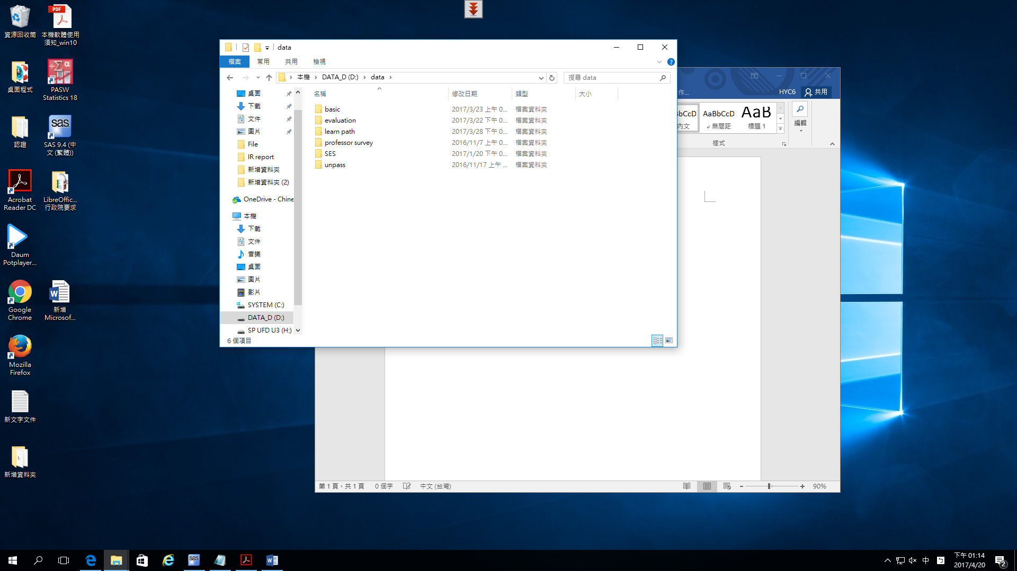

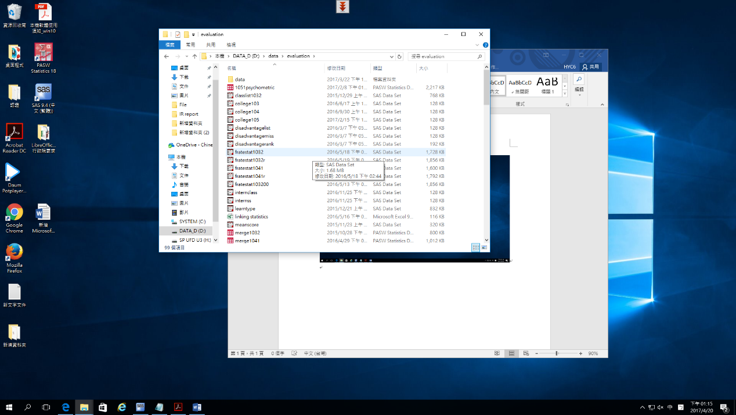

Created SAS data sets are stored in files classified based on their research purpose or requests.

My IT teacher in my home country told to manage them through SQL. I understand power of SQL, but I only have one month training of MS-SQL, and I do not have capacity to use SQL to manage them. Do you have any suggestions just using SAS programming to effectively manage created data sets, and easily to be extracted by users?

2. I have written some MACROs. However, I am the only person knowing programming at our center. When I am not there, my colleagues do not know how to compile codes and run them. My question is how a person without SAS knowledge processes MACRO without compiling it. I mean she just type nnnn(var=xx)% and SAS automatically run it. What is an effective way to manage MACRO into a library?