|  |  |  |  |
| --- | --- | --- | --- |
| Earnings Regression | | | |
| Variable | Description | Average Coefficient | Average t-value |
| Int |  | 0.390184 | 4.280002e-01 |
| E+ | Earnings per share | 1.428238 | -1.673483e+10 |
| NEGE | Loss indicator | -0.476264 | 1.590384e+10 |
| ACC+ | Pos. accruals | -0.433514 | 6.221681e-02 |
| AG | Asset growth | 0.222872 | 4.018561e-01 |
| DD | Dividend indicator | 0.442000 | 4.095029e+07 |
| BTM | BTM | -0.105567 | 2.470709e-02 |
| PRICE | Share price | -0.522839 | 1.614232e-01 |
| DIV | Dividend per share | -0.375794 | 1.327756e+07 |

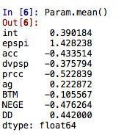 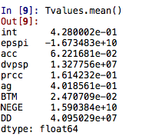

|  |  |  |  |  |
| --- | --- | --- | --- | --- |
| Correlations and average forecast errors | | | | |
|  | **Corr(Forecast,RE)** | **Corr(CF,AF)** | **Mean error** | **t-statistic** |
| CF |  | 0.39 | 4.2801 |  |
| AF |  | 1.38 | -1.6710 |  |