PYTHON

SOLUSI STUDI KASUS

lembar solusi ini sebagai salah satu tugas dalam

mata kuliah Dasar Pemrograman

dosen pengampu

Indira Syawanodya, M.Kom.

Yulia Retnowati, S.Pd., M.T.



disusun oleh

Andika Eka Kurnia 2306033/1A RPL

PROGRAM STUDI REKAYASA PERANGKAT LUNAK

KAMPUS UPI DI CIBIRU

UNIVERSITAS PENDIDIKAN INDONESIA

**2023**

File main.py

import os

import andika

from andika import kucing

*# Membuka dan Membaca File*

file = open("./data/admin.txt", "r")

print(file.read())

file.close()

file = open("./data/admin.txt", "r")

print(file.read(10))

file.close()

with open("./data/admin.txt", "r") as file:

    print(file.read())

file = open("./data/admin.txt", "r")

print(file.readline())

file.close()

with open("./data/admin.txt", "r") as file:

    for line in file:

        print(line)

*# Menulis File*

with open("./data/hello.txt", "w") as file:

    file.write("Hello File!")

with open("./data/hello.txt", "w") as file:

    file.write("Halo (dalam bahasa Indonesia) File!")

with open("./data/hello.txt", "r") as file:

    print(file.read())

with open("./data/hello.txt", "a") as file:

    file.write("Hello File! v2")

with open("./data/hello.txt", "r") as file:

    print(file.read())

*# Menulis File (File tidak ada)*

with open("./data/append.txt", "a") as file:

    file.write("Append!")

with open("./data/append.txt", "r") as file:

    print(file.read())

*# Menulis menggunakan List*

with open("./data/hello.txt", "w") as file:

    lines = ["Hello\n", "World\n", "from\n", "Python\n"]

    file.writelines(lines)

with open("./data/hello.txt", "r") as file:

    print(file.read())

*# Mengecek keberadaan File*

is_exist = os.path.exists("./data/hello.txt")

if is_exist:

    print("File ada")

else:

    print("File tidak ada")

is_file = os.path.isfile("./data/hello.txt")

if is_file:

    print("ini adalah file")

else:

    print("ini bukan file atau file tidak ada")

*# File dan List*

file_path = "./data/file_list.txt"

if os.path.exists(file_path):

    with open(file_path, "r") as file:

        lines = file.readlines()

    list_data = []

    for line in lines:

        list_data.append(line.strip().split())

    for item in list_data:

        print(item)

else:

    print(*f*"Maaf file untuk {file_path} tidak ditemukan")

list_buah = ["mangga", "strawberry", "pisang", "anggur",

             "salak", "apel", "jeruk", "semangka", "durian"]

with open("./data/list_to_file.txt", "w") as file:

    file.write(" ".join(list_buah))

*# Import Module*

andika.sapa("Asep")

peliharaan = andika.kucing["nama"]

print(peliharaan)

peliharaan = kucing["nama"]

print(peliharaan)

Terminal main.py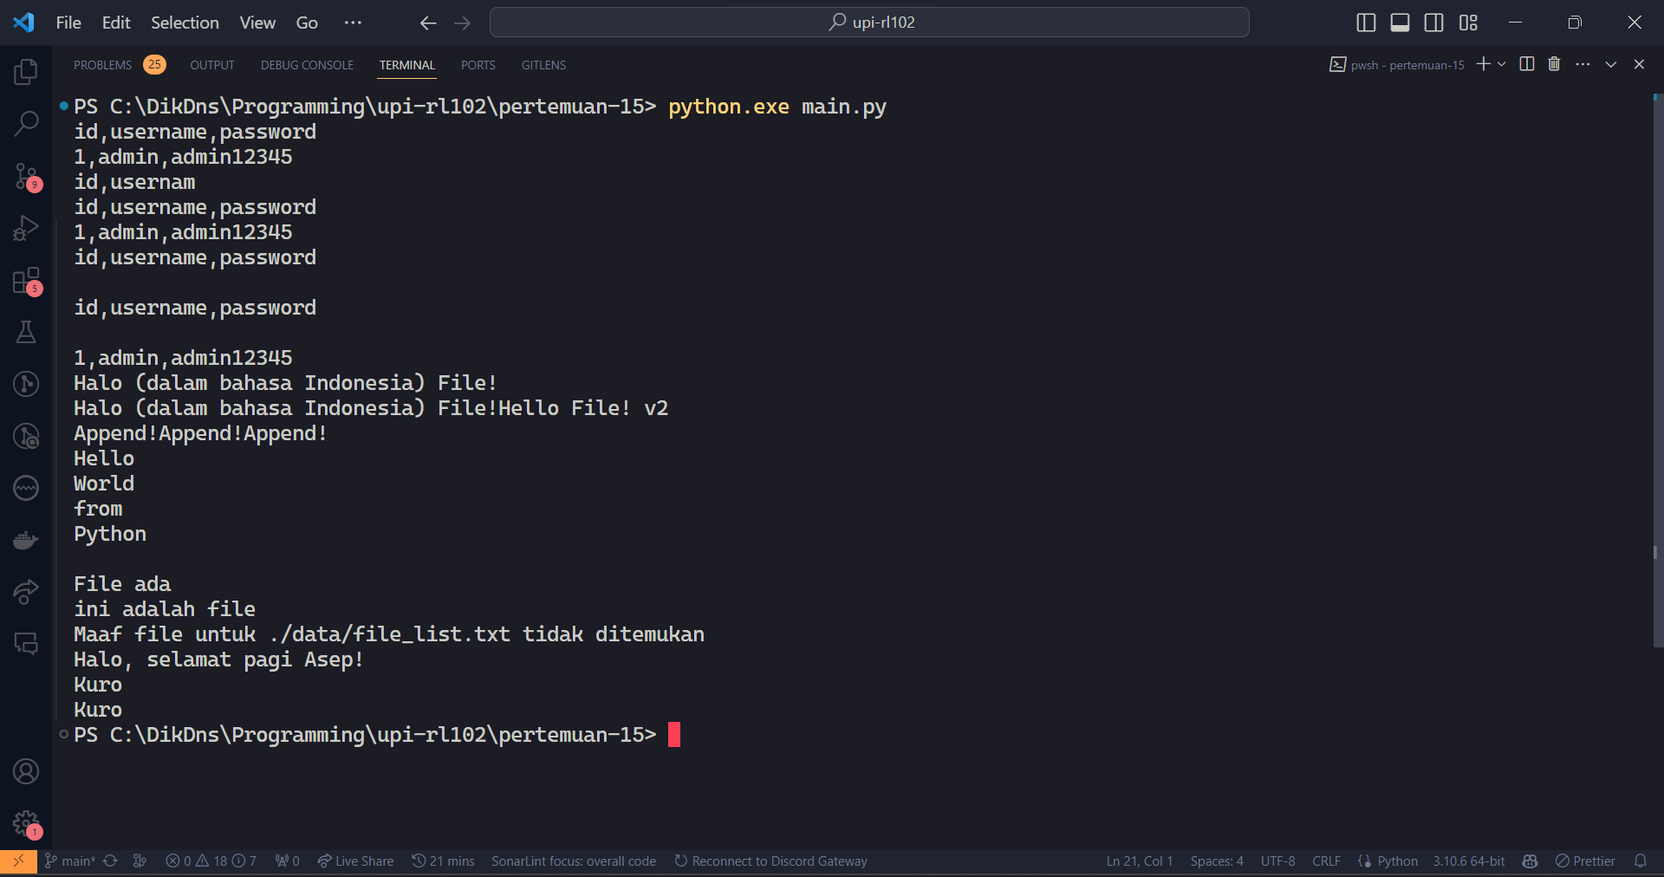

File andika.py

*def* sapa(*nama*):

    print(*f*'Halo, selamat pagi {nama}!')

kucing = {

    "nama": "Kuro",

    "umur": 2.5,

    "jenis_kelamin": "Jantan",

    "warna": ["hitam", "putih"]

}