# Lab 3. Färg

# Del 3- Laboration Svarsdokument

**Spara detta dokument som .pdf dokument innan ni lämnar in det på Lisam.**

*Studenternas namn och LiU-ID: (Max 2 studenter per grupp):*

*1. Emil Alsbjer, emial133*

*2. Saga Nyman, sagny722*

*Inlämningsdatum:*

*Version 1*

1. **Working with Spectral Power Distribution**

**Uppgift 1.1)**

XYZ values for CIED65:

X= 95.0437

Y= 100

Z= 108.8818

**Uppgift 1.2)**

**XYZ values for R1, under CIED65:** X=40.0489, Y=49.7395, Z=26.6104

**XYZ values for R2, under CIED65:** X= 40.0489, Y=49.7395, Z=26.6104

**Uppgift 1.3)**

**XYZ values for R1, under f11:** X= 41-6587, Y=53.3569, Z=16.3345

**XYZ values for R2, under f11:** X= 53.9818, Y=63.4675, Z=20.7173

**Uppgift 1.4)**

In 1.2: The phenomenon is called metamerism. Its perceived as the same color under different reflectance while using the same illumination CIED65.

In 1.3: The same is not for the color using the f11 illumination

**Uppgift 1.5)**

Insert the figure here: (You can save this figure using File in the window, and then save as…, *yourfilename.png*. It is ok to scale down the image after inserting it in words)

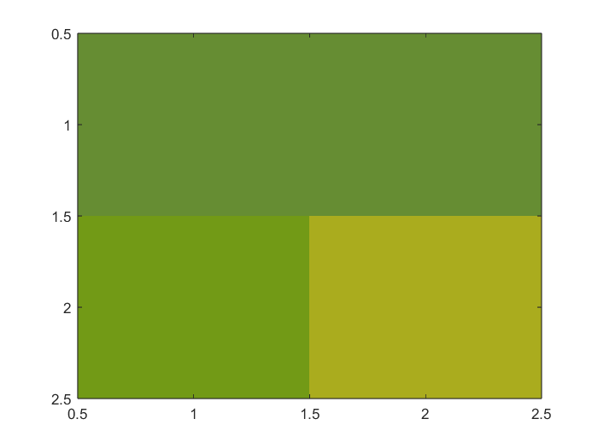

What has happened to the white point in the xy chromaticity diagram when changing the light source?

The white point moves depending on the light source. Generally the white point moves closer to the blue/violet part of the chromaticity diagram in correspondence to higher temperatures.

Does that show in the colors?

Yes, the CIED65 illumination resulted in a darker color in comparison to the f11 illumination.

**Uppgift 1.6)**

Explain briefly what color matching functions (, and ) are and what they represent.

They represent the color matching sensitivities of a standard observer. They are the spectral sensitivity curves of three linear lights yielding the tristimulus values X, Y and Z. Its used because the sensitivity of the L, M and S cones aren’t known exactly.

**Uppgift 1.7)**

Explain why the CIEY-value of a light source is always equal to 100 by referring to Equation 1.4 in the theory document.

The illumination is normalized so that the completely white surface always gives Y = 100.

1. **Dot-on-Dot and Dot-off-Dot Halftoning**

**Uppgift 2.1)**

Write the XYZ-values for dot-on-dot and dot-off-dot in the below table:

|  |  |  |  |
| --- | --- | --- | --- |
|  | X | Y | Z |
| Dot-on-dot | 43.915 | 44.89 | 68.43 |
| Dot-off-dot | 31.60 | 30.48 | 54.20 |

**Uppgift 2.2)**

Insert the figure here: (You can save this figure using File in the window, and then save as…, *yourfilename.png*. It is ok to scale down the image after inserting it in words)

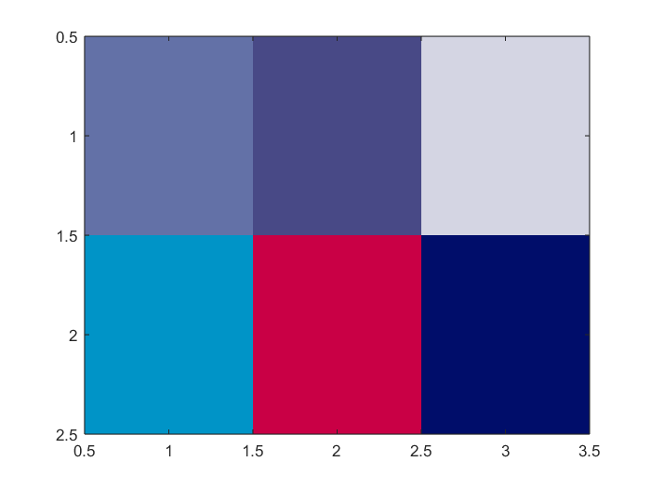

Is there a noticeable difference between dot-on-dot and dot-off-dot? For example, which one is darker? Why?

Dot-off-dot is darker because it doesn’t leave any space for the none values to show (white/paper).

**Uppgift 2.3)**

Could you use this function in all applications? Is this function device independent?

No, as the white spot for different devices can vary the RGB values would then also vary. Meaning that the function is device dependent.

1. **Color Halftoning According to Demichel**

**Uppgift 3.1)**

**Notice,** Column 1 in the below table should be filled by your calculations in **uppgift 4** in the preparation part of this lab.

Fill column 2, Test 1, by your results using C1, M1, Y1 and K1.

Fill column 3, Test 2, by your results after simulating misregistration.

**Describe also** which channels and how many pixels and in each direction, you chose to simulate misregistration.

|  |  |  |  |
| --- | --- | --- | --- |
| **Ink** | **Demichel** | **Test 1** | **Test 2** |
| *None* |  | 0,1628 | 0,1662 |
| *Only C* |  | 0,0765 | 0,0752 |
| *Only M* |  | 0,1351 | 0,1327 |
| *Only Y* |  | 0,2090 | 0,2031 |
| *Only K* |  | 0,0191 | 0,0183 |
| *Only C & M (Blue)* |  | 0,0648 | 0,0584 |
| *Only C & Y (Green)* |  | 0,0858 | 0,0895 |
| *Only C & K* |  | 0,0096 | 0,0101 |
| *Only M & Y (Red)* |  | 0,1126 | 0,1172 |
| *Only M & K* |  | 0,0185 | 0,0198 |
| *Only Y & K* |  | 0,0120 | 0,0100 |
| *C & M & Y* |  | 0,0509 | 0,0514 |
| *C & M & K* |  | 0,0021 | 0,0018 |
| *C & Y & K* |  | 0,0206 | 0,0225 |
| *M & Y & K* |  | 0,0201 | 0,0233 |
| *C & M & Y & K* |  | 0,0007 | 0,0002 |

**Uppgift 3.2)**

Now, compare column 1, 2 and 3 in this table. Are Demichel’s equations a good model of the reality? Does it work reasonably well even when misregistration occurs?

**Uppgift 3.3)**

What would have happened in case of misregistration if all the four printing colors had had the same screen angle? Would Demichel’s equation be applicable? Why not?

1. **Color Adjustment in CIELAB**

**Uppgift 4.1)**

Why do the images seem to be inverted?

**Uppgift 4.2)**

Insert the image corresponding to L+20 here: (ok to scale down the image)

Insert the image corresponding to L-20 here: (ok to scale down the image)

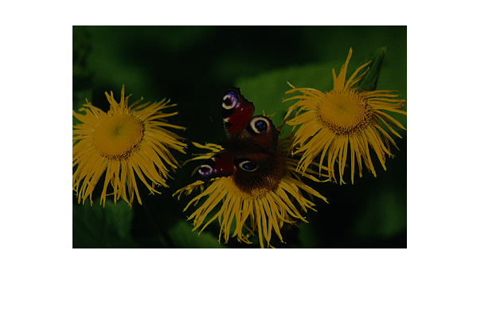

What attribute (among lightness, contrast, hue, and saturation) has been changed.

**Uppgift 4.3)**

Insert the image when you change the sign of **a\*** here: (ok to scale down the image)

Insert the image when you set **a*=0** here: (ok to scale down the image)

Did you expect the results? (answer by looking at Fig. 1.5 in the theory document to see what the a-axis represents).

What attribute (among lightness, contrast, hue, and saturation) of the color do we change when switching sign of **a\*** or **b\***?

**Uppgift 4.4)**

Insert the image when you multiply **a\*** and **b\*** by 0.5here: (ok to scale down the image)

Insert the image when you multiply **a\*** and **b\*** by 3here: (ok to scale down the image)

What attribute (among lightness, contrast, hue, and saturation) of the color do we change when scaling **a\*** and **b\***?

1. **Light sources, CIEXYZ and CIELAB**

**Uppgift 5.1)**

XYZ values for CIED65:

X= 95,0437

Y= 100

Z= 108,8818

XYZ values for Tungsten60W:

X= 112,9853

Y= 100

Z= 28,5810

XYZ values for plank90k:

X= 97,0578

Y= 100

Z= 141.1759

Insert the figure showing the color of these three light sources here: (ok to scale down the image)

Are the colors of these three light sources what you expected?

**Uppgift 5.2)**

Insert Figure 1 here: (ok to scale down the image)

What light source it seems to have been used in the above figure?

Insert Figure 2 here and specify: (ok to scale down the image)

What light source it seems to have been used in the above figure?

Insert Figure 3 here: (ok to scale down the image)

What light source it seems to have been used in the above figure?

**Uppgift 5.3)**

Why are the color differences between the color of the objects under **Tungsten** and **plank90k** larger than those under the other two pairs of light sources?

**Uppgift 5.4)**

You can see in the plot that all light sources have the same Y-value. What is this value?

**Uppgift 5.5)**

How do the positions of the color (XYZ) of the objects move when the illumination is changed? Do you agree that, when the illumination is changed, we get completely different positions in the XYZ space?

**Uppgift 5.6)**

What is the CIELab values of light sources and why?

**Uppgift 5.7)**

How do the positions of the color (Lab) of the objects move when the illumination is changed? Do you agree that the position of each object is almost constant independent of the illumination?

**Uppgift 5.8)**

Discuss at least two differences between CIEXYZ and CIELAB.

**Glöm inte att spara dokumentet som *.pdf* innan ni lämnar in det på Lisam.**