Employee onboarding where the agent never sees the employee
T3N Agent Build Challenge submission for Terminal 3 Network
Repository | https://github.com/DikaCream/T3N-Challenge
DID | did:t3n:50a04efc91641528919da135e31d8995fcd642b3
Network | testnet (cn-api.sg.testnet.t3n.terminal3.io)
SDK | @terminal3/t3n-sdk@5.2.0 (pinned)
Contract | z:50a04efc91641528919da135e31d8995fcd642b3:employee-onboarding v0.1.2
Date | 2026-09-13
Intention | continue running it; happy to hand over. See Section 7

1. What was built
hr-onboard: an enterprise employee-onboarding agent where the AI never sees the employee's data.
The agent plans which onboarding steps to run using only an internal employee reference, a role, a department and a start date. A T3N TEE contract then does the work, creating the HRIS record and enrolling the hire with payroll, and the employee's legal name, national id, address and personal email are substituted by the host inside the enclave, at the moment the outbound request is built. They are never function arguments, never local variables, and never bytes in the application's process.
Three components, all in the repo:
TEE contract | contracts/employee-onboarding/: Rust → wasm32-wasip2, five functions over WIT, 15 unit tests that run without a TEE
Agent + CLI | src/: TypeScript, zero build step (Node ≥ 22.18 native type stripping), 12 commands
Web console | app/: Next.js App Router. The SDK runs only in server route handlers
Tests + CI | npm test: 58 TypeScript unit tests plus 15 contract tests, no network or credentials. CI runs both, plus both builds, on Linux and macOS at Node 22.18 and 24
The CLI and the console call the same src/services/ functions, so the safety rules are implemented once rather than re-derived per surface.
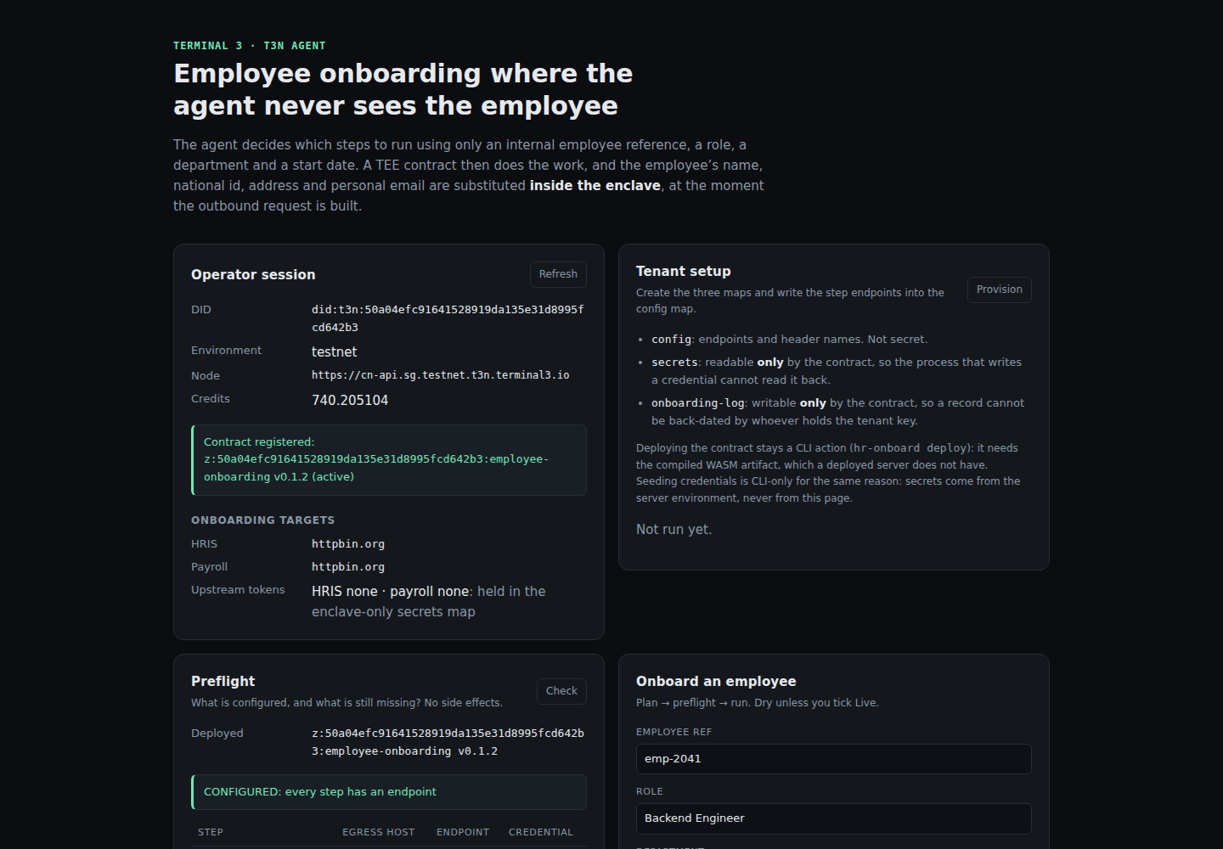

Why this use case
Onboarding is the moment an enterprise moves a new hire's most sensitive data between systems, and it is the flow where "the app must hold the PII to do its job" is normally taken as given. It also contains a genuinely useful agent decision: should this person go through payroll enrolment at all? That needs no sensitive data to answer. That combination makes it a fair test of the T3N privacy model rather than a demo of it.

2. The privacy claim, enforced rather than asserted
Path | What stops PII from travelling
Agent → contract | StartInput has no field to put it in. employee_ref is HR-internal and validated to 64 chars of [A-Za-z0-9._/-]
Contract body | Built with literal {{profile.*}} markers; those bytes are the payload, not a redaction applied for display
Outbound call | http-with-placeholders resolves markers host-side, after the bytes leave WASM
Upstream response | The body is discarded; only the status code is read, because an upstream can echo back what it received
Stored record | Holds status only, and carries contains_pii: false as a field rather than a promise
Credentials | secrets map readers are { only: [contractId] }; the process that writes a key cannot read it back
The strongest evidence is the dry run. onboard without --live prints the exact bodies the enclave would send, with the markers still unresolved. If a name or an account number appeared there, the design would have failed visibly.
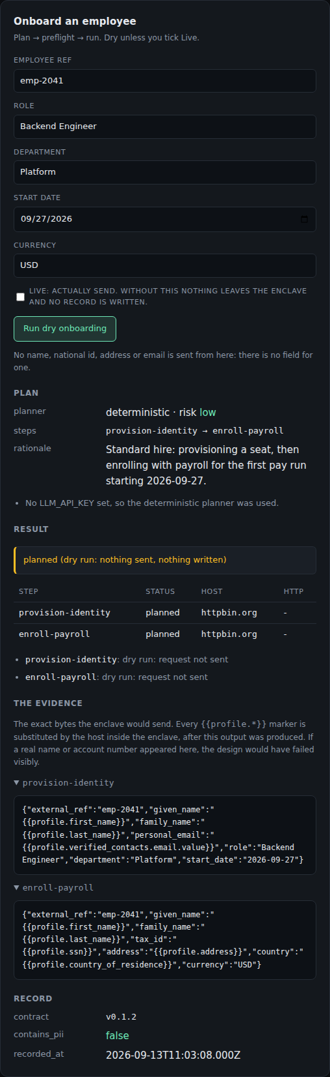 Those two bodies are the entire payload. {{profile.ssn}} and {{profile.address}} are substituted by the host inside the enclave, and I have never seen the values.

3. T3N features used
- T3nClient: handshake + Ethereum auth → did:t3n:… tenant identity
- fetchTrustedManifest: attested trust anchor; the client refuses to construct without it
- TenantClient for the control plane: maps, contract registration, invocation
- TEE contract: Rust → wasm32-wasip2, WIT world, five exported functions
- host:interfaces/http-with-placeholders: the privacy mechanism
- Its typed errors (egress-denied, placeholder-denied, placeholder-unknown, placeholder-no-user-context) are surfaced verbatim rather than flattened
- host:interfaces/kv-store: config, secrets, onboarding-log maps
- Tenant KV maps with contract-scoped ACLs
- getMemberDelegation / addMemberDelegationGrants for scoped delegation with allowed_hosts
- submitUserInput: the calling user's profile that placeholders resolve against
- setDescriptor: publish the contract descriptor, without which a registered contract is not dispatchable
- getActivityLog: the ledger's host-stamped record of dispatches
- serverExternalPackages (Next.js): keeps the SDK's runtime .wasm load out of the bundler
Not used: host:interfaces/authorisation. It is the natural way to ask "may this host be reached?" before acting, but importing it makes the contract un-instantiable. See Section 6.

4. What actually happened on testnet
Run on 2026-09-13 against testnet with a real DID and key. Every step succeeded.
Step | Result
whoami | did:t3n:50a04efc…d642b3, node cn-api.sg.testnet
build:contract | hr_onboard.wasm, 217 723 bytes, target wasm32-wasip2
npm test | typecheck clean, 58/58 TypeScript unit tests, 15/15 Rust unit tests
init | config, secrets, onboarding-log created
deploy | registered v0.1.2, contract_id 1005, descriptor published, ACLs re-pointed
info | full self-description returned from inside the enclave
preflight | both steps configured; egress explicitly reported as unknown-by-design
onboard (dry) | plan + both request bodies with {{profile.*}} unresolved
grant | self-bound delegation, allowed_hosts: [httpbin.org]
onboard --live | provision-identity → HTTP 200 and enroll-payroll → HTTP 200
status | record completed, contains_pii: false
audit | 32 ledger entries: 9 error (all from the broken import), then 23 success
Web console | all six routes return live data; T3N_API_KEY absent from the client bundle
Both steps are real HTTPS POSTs that left the enclave with the employee's name, national id, address, country and personal email substituted by the host, after the bytes left WASM. Those values never existed in the application process, and the upstream response bodies are discarded rather than forwarded, because an upstream can echo back what it received.
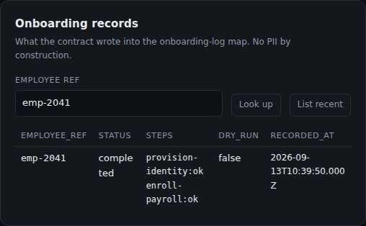 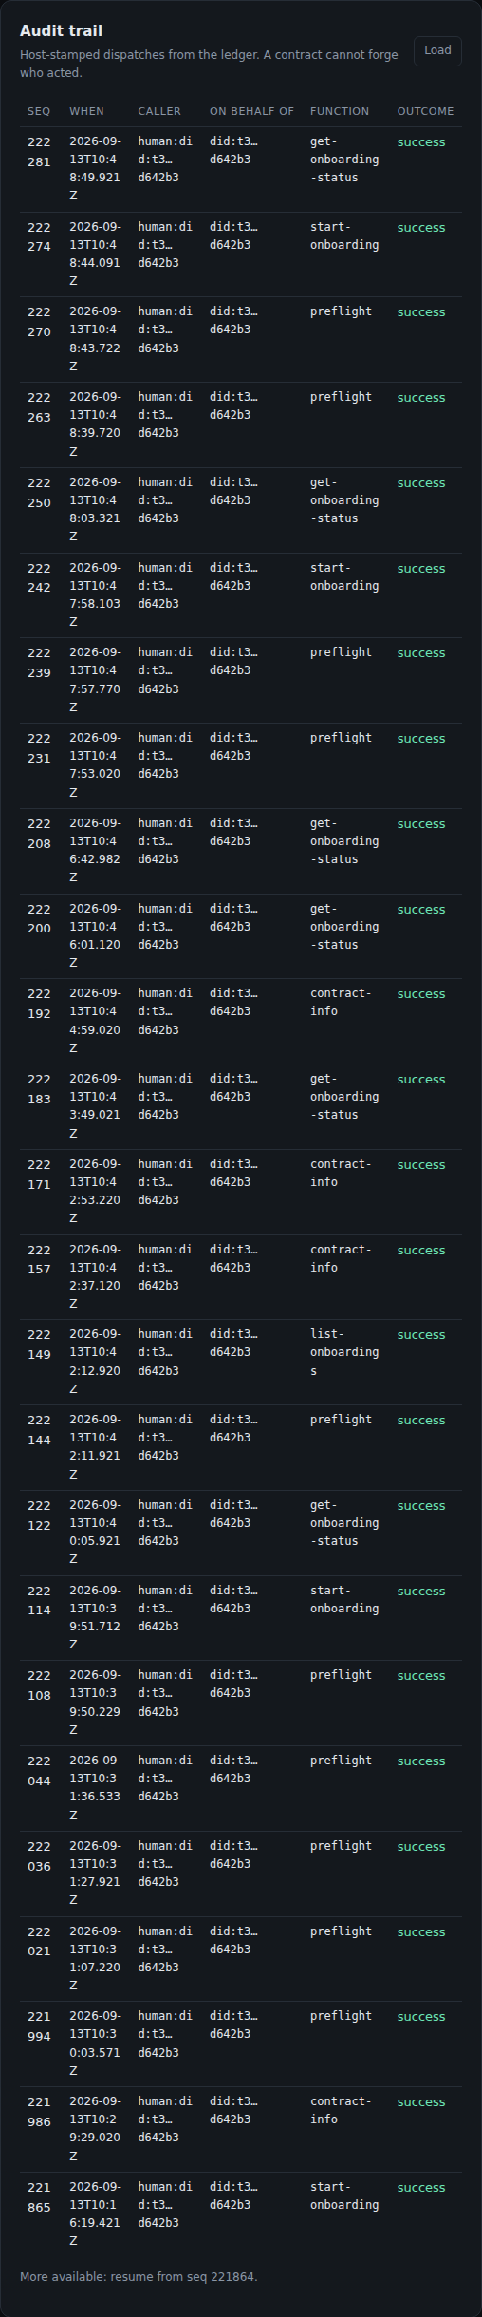 The audit panel is not the application's log. These rows are what the network recorded, host-stamped from the verified dispatch context, so a contract cannot forge who acted. start-onboarding completing success while provision-identity failed inside it is the correct distinction: the dispatch succeeded, the business step did not.

5. Screenshots
All in the repository under screenshots/. The browser set is generated rather than hand-taken: node scripts/capture-console.mjs drives Chrome over the DevTools Protocol, measures the real content height, and clips each panel to its own box. It also presses the buttons on the two panels that are idle until asked, so those two images show a real run instead of an empty form, and writes console-text.txt, the same content as text, so a reader can grep it rather than squint at a PNG.
File | Shows
15-01-operator-session.png | live DID, node, credit balance, contract status
15-02-tenant-setup.png | the three maps and their access story
15-03-preflight.png | per-step configuration, egress stated as unknown-by-design
15-04-onboard-an-employee.png | plan, dry-run bodies with {{profile.*}} unresolved, contains_pii: false
15-05-onboarding-records.png | the stored record: emp-2041, completed, both steps ok
15-06-audit-trail.png | host-stamped dispatches from the ledger
15-07-why-the-privacy-claim-holds.png | the five claims, each tied to a mechanism
terminal captures | whoami, build:contract, npm test, init, deploy, info, preflight, dry run, grant, live run, status, audit
The three that matter most are the dry run, the live run, and the audit trail: they show the privacy mechanism, a real outbound call, and the failure-then-fix in the network's own record.

6. Issues encountered
Fourteen items in docs/BUGS.md. The three critical ones were found by running the thing, and each is reproducible.
- Importing host:interfaces/authorisation@2.1.0 makes a contract un-instantiable, and the error says nothing. Every dispatch returns a bare RPC Error: Internal error with no field, no component, no hint. The raw JSON-RPC response is {"code": -32603, "message": "Internal error"} plus a correlation id, and contracts.logs() is empty, so there is nothing to cross-check. Established by bisection: the same crate, differing by that one import, goes from failing every call to returning its full contract-info. The interface is declared in the host's world interfaces, and it is the one interface that would let a contract ask "may I egress?" before acting, so the design the docs encourage is the one that silently bricks the build.
- register reports success but the contract is not dispatchable until setDescriptor is called. listDetailed reports status: "active" with descriptor: null, and every call fails with that same content-free error. Nothing in the Quickstart or Walkthrough mentions the descriptor; the only pointer is a doc comment about the "MCP dispatch funnel". A deployment that skips it looks completely successful.
- The descriptor schema is undocumented. Eight required fields per function, recovered one validator error at a time, and two are counter-intuitive: returns (the obvious guess, returns_schema, is rejected) and examples. The SDK type is explicitly open-ended, so it offers no help either.
- The WIT spec calls nested placeholders "malformed"; they are not, and the email only resolves at a nested path. The spec defines placeholder-denied as covering a "malformed marker (nested / non-snake-case field)". But the email is not on the top-level profile the way first_name is; the host keeps it under the verified-contacts structure, so the resolvable marker is {{profile.verified_contacts.email.value}}. Terminal 3's own reference contract (z-tenant-flight/src/booking.rs) uses exactly that while using flat names for every other field.
Both directions were tested against testnet with the same contract, differing only in the marker:
Marker | Result
{{profile.email_address}} | placeholder-unknown: "the calling profile is missing field 'email_address'" → step fails
{{profile.verified_contacts.email.value}} | resolves → HTTP 200, status: completed
That combination is what makes it expensive: the spec's wording steers you to flat names, user-upsert accepts the flat email_address without complaint (it is a documented Level-1 field), and the failure arrives as a missing field rather than a wrong name, so the natural next move is to bind the field harder rather than rename it. This one wrong signal cost more wall-clock time than anything else in the build.
Also notable: deny-all egress has no documented path for an individual tenant. The SDK's only egress API, OrgDataClient.setAgentEgress, requires an org and is org-admin only, and what worked was a member-delegation grant bound to your own DID. user-upsert accepts fields that are not resolvable as placeholders, so the mismatch surfaces later as a step failure mid-run. And a contract's numeric id cannot be read back: not from list, listDetailed, maps, or the ledger, even though map ACLs are keyed on it, which meant a second init could resolve those ACLs to deny-all and silently revoke the deployed contract's access to its own maps.

7. Post-challenge maintenance
The intention is to keep running it, and I am happy to hand it over.
This is a standalone integration on the public testnet. Nothing depends on a hosted service, a private endpoint, or a machine that exists only during the challenge. It runs from a checkout with one key in .env, and the contract is config-driven: retargeting a step to a real HRIS or payroll provider is a config map write, not a redeploy.
Running it in two ways is a hedge: the CLI suits a scheduled job or a single operator, the web console suits an HR team that will not open a terminal. Neither carries its own copy of the logic.
Component | Ongoing cost
TEE contract | Low. 1 389 lines of Rust plus a 94-line WIT world, 15 unit tests with no network dependency. A new step is one StepSpec entry plus one build_body arm
Shared services + CLI | Low. Zero build step, no bundler, one runtime dependency
Web console | Low, because it holds no rules of its own: a panel calls a route, a route calls an existing service
Upstream integration | The real work, and it lives in configuration plus whichever HRIS/payroll schemas are targeted
SDK upgrades | Two isolated spots: the register/publish fallback in deploy, and the ACL rewiring in mapSpecs
Tests and CI | npm test needs no credentials and no network, and runs on Linux and macOS at Node 22.18 and 24. A new rule lands as a unit test beside the module it constrains

If it is handed over instead
The handover is a repository, a tenant, and six steps. There is no state outside the tenant's own maps and the network ledger, so nothing needs migrating.
- Access. The tenant is owned by did:t3n:50a04efc91641528919da135e31d8995fcd642b3 and holds contract hr-onboard v0.1.2 (contract_id 1005). Either transfer that key, or claim a fresh tenant and re-register.
- Re-register, only if a fresh tenant. npm run build:contract && npm run deploy builds the wasm and publishes the descriptor. deploy is safe to re-run: same version reconciles, a higher one registers, a downgrade is reported in one line.
- Egress. A fresh tenant starts deny-all, so a live run is refused until hr-onboard grant --agent <did> --hosts <hosts> names the endpoints. The grant is bound to a DID and must be re-issued if the DID changes (Section 6, finding 4).
- Configuration. init writes step endpoints into the config map; seed writes upstream credentials into the secrets map, which only the contract reads. Retargeting a step is a config write, not a redeploy.
- Credentials to rotate. T3N_API_KEY signs the login challenge, so treat it as a wallet key. Rotate it together with HRIS_API_KEY, PAYROLL_API_KEY and LLM_API_KEY, all of which live only in the gitignored .env.
- Running cost. The tenant's credit balance pays for dispatch, and the console's session panel shows what is left. Top up at the claim page.
One caveat about hosting: the console is not deployed publicly, and there is a reason beyond time: a public deployment holds T3N_API_KEY in its environment, and any caller who finds the URL can spend the tenant's credits. Putting it online should wait for a separate sandbox key, with ONBOARD_ALLOW_LIVE left unset so the deployment can plan but not act. The code supports that mode today.

8. Submission form answers
- Email address: TODO
- DID generated from the page: did:t3n:50a04efc91641528919da135e31d8995fcd642b3
- Continue running this, or pass it to us to run it: Continue running it, and equally happy to hand it over. It is a standalone testnet integration with no hosted dependencies; the handover process is Section 7.

