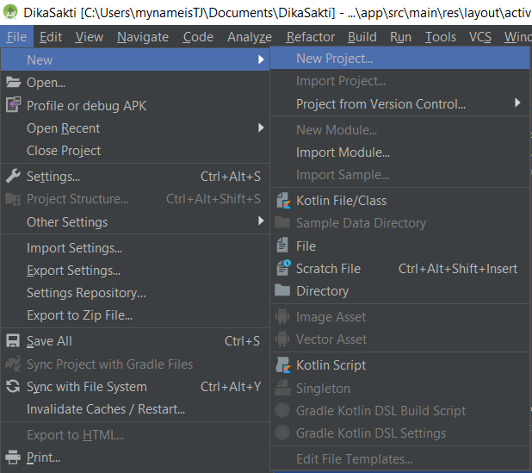

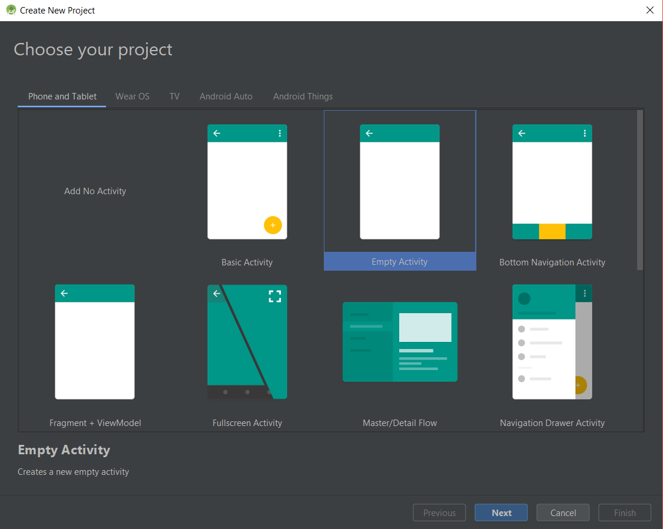

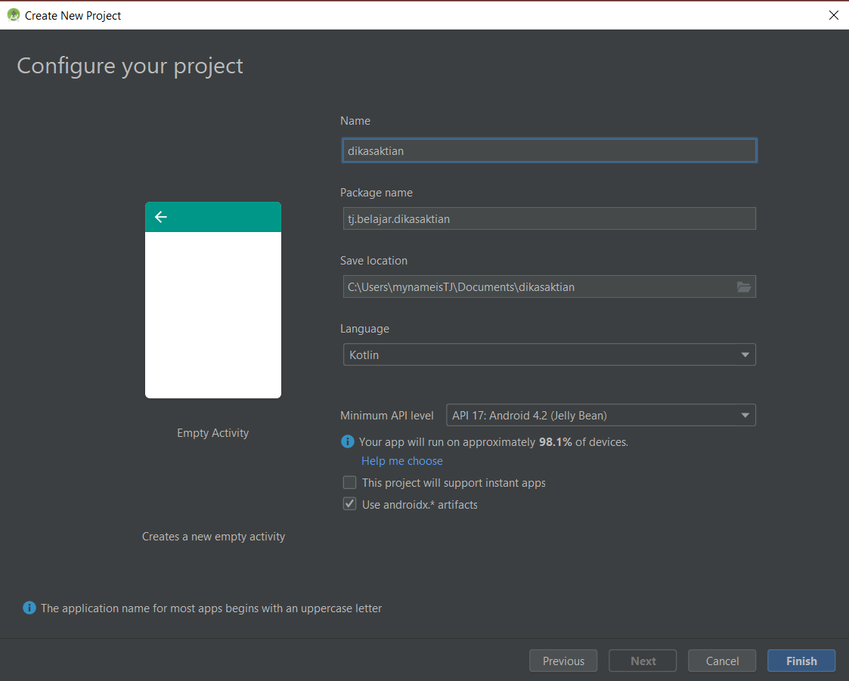

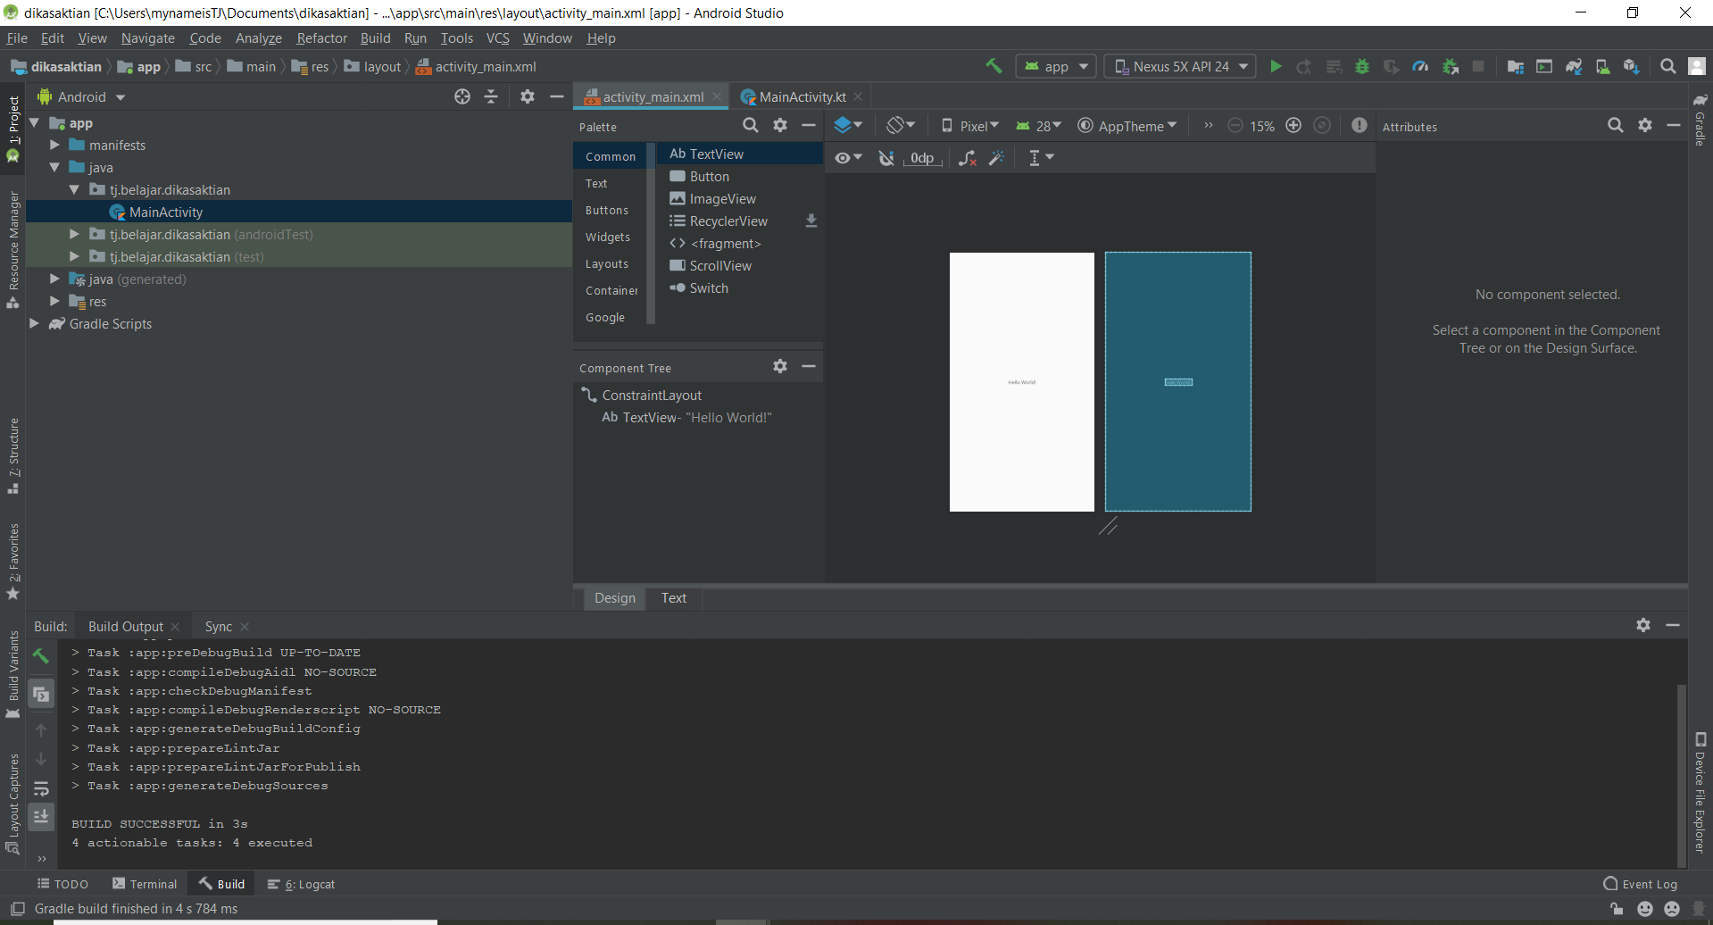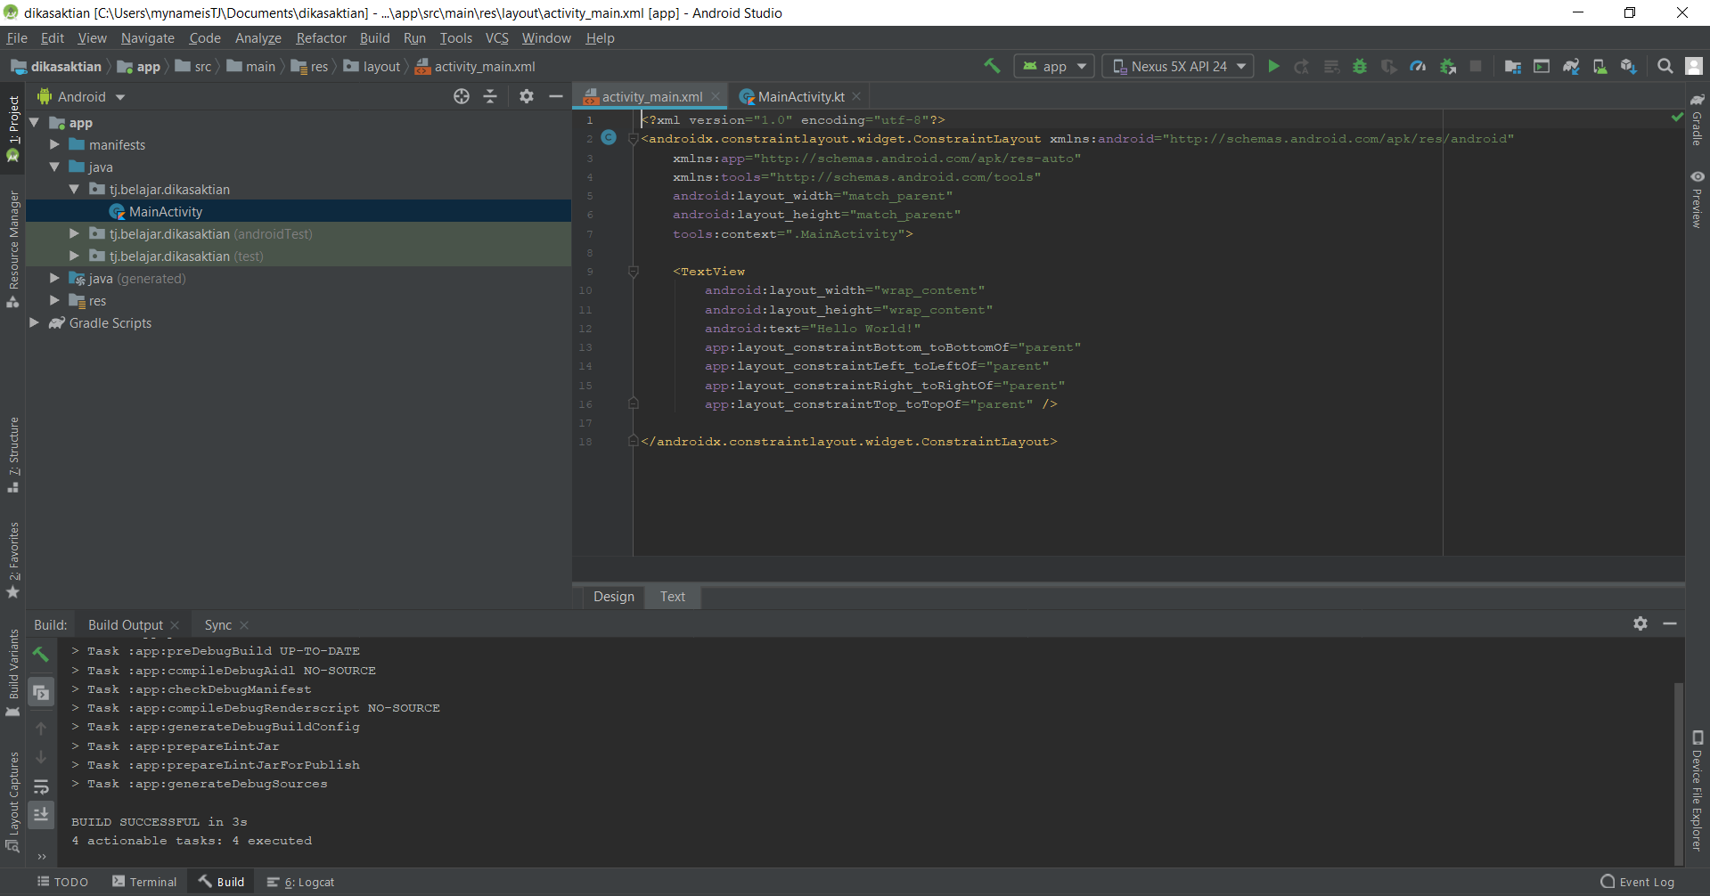

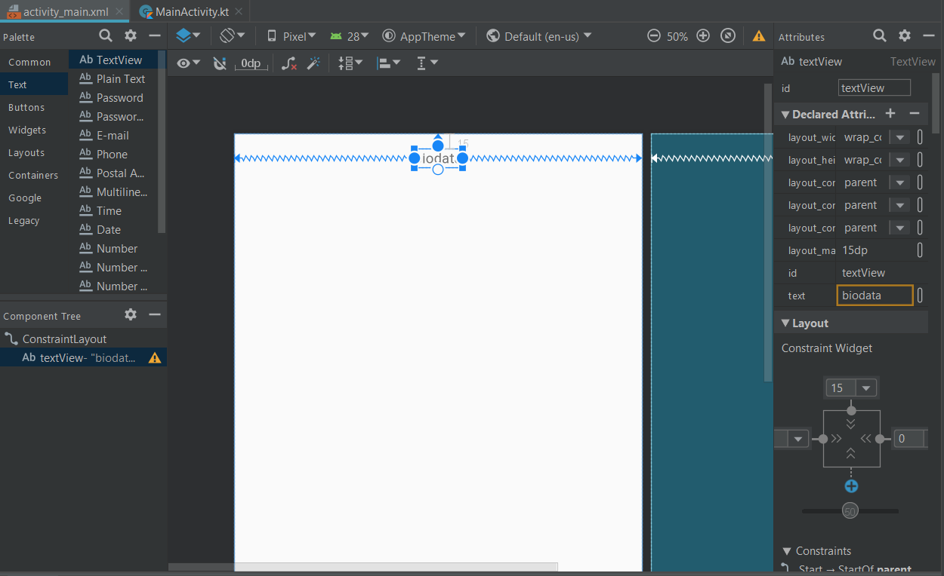

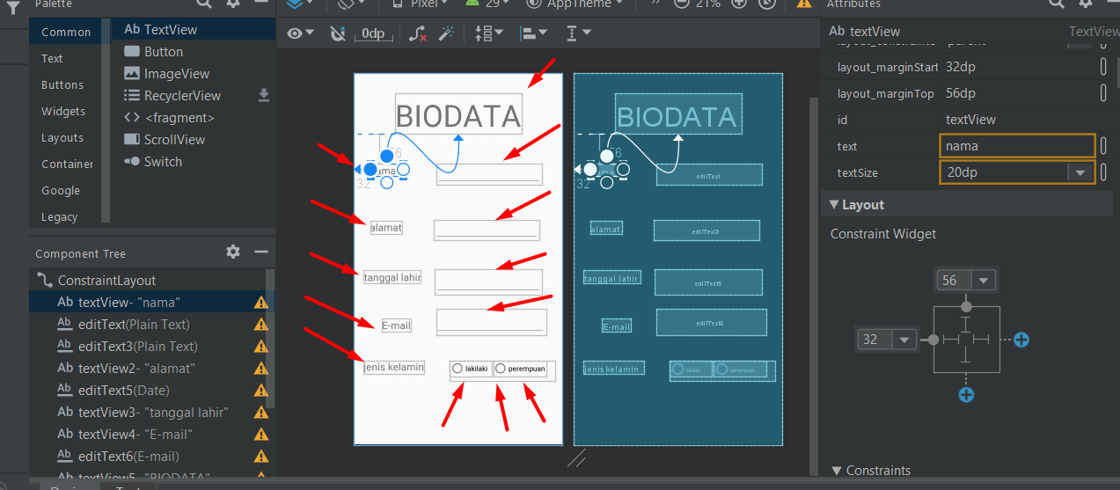

<?xml version="1.0" encoding="utf-8"?>

<androidx.constraintlayout.widget.ConstraintLayout xmlns:android="http://schemas.android.com/apk/res/android"

xmlns:app="http://schemas.android.com/apk/res-auto"

xmlns:tools="http://schemas.android.com/tools"

android:layout_width="match_parent"

android:layout_height="match_parent"

tools:context=".MainActivity">

<TextView

android:id="@+id/textView"

android:layout_width="65dp"

android:layout_height="24dp"

android:layout_marginStart="32dp"

android:layout_marginTop="56dp"

android:text="nama"

android:textSize="20dp"

app:layout_constraintStart_toStartOf="parent"

app:layout_constraintTop_toBottomOf="@+id/textView5" />

<EditText

android:id="@+id/editText"

android:layout_width="207dp"

android:layout_height="42dp"

android:layout_marginStart="60dp"

android:layout_marginTop="56dp"

android:ems="10"

android:inputType="textPersonName"

app:layout_constraintEnd_toEndOf="parent"

app:layout_constraintHorizontal_bias="0.127"

app:layout_constraintStart_toEndOf="@+id/textView"

app:layout_constraintTop_toBottomOf="@+id/textView5" />

<EditText

android:id="@+id/editText3"

android:layout_width="207dp"

android:layout_height="42dp"

android:layout_marginStart="56dp"

android:layout_marginTop="68dp"

android:ems="10"

android:inputType="textPersonName"

app:layout_constraintEnd_toEndOf="parent"

app:layout_constraintHorizontal_bias="0.145"

app:layout_constraintStart_toEndOf="@+id/textView2"

app:layout_constraintTop_toBottomOf="@+id/editText" />

<TextView

android:id="@+id/textView2"

android:layout_width="wrap_content"

android:layout_height="wrap_content"

android:layout_marginStart="32dp"

android:layout_marginTop="88dp"

android:text="alamat"

android:textSize="20dp"

app:layout_constraintStart_toStartOf="parent"

app:layout_constraintTop_toBottomOf="@+id/textView" />

<EditText

android:id="@+id/editText5"

android:layout_width="210dp"

android:layout_height="50dp"

android:layout_marginStart="28dp"

android:layout_marginTop="56dp"

android:ems="10"

android:inputType="date"

app:layout_constraintEnd_toEndOf="parent"

app:layout_constraintHorizontal_bias="0.0"

app:layout_constraintStart_toEndOf="@+id/textView3"

app:layout_constraintTop_toBottomOf="@+id/editText3" />

<TextView

android:id="@+id/textView3"

android:layout_width="wrap_content"

android:layout_height="wrap_content"

android:layout_marginStart="20dp"

android:layout_marginTop="72dp"

android:text="tanggal lahir"

android:textSize="20dp"

app:layout_constraintStart_toStartOf="parent"

app:layout_constraintTop_toBottomOf="@+id/textView2" />

<TextView

android:id="@+id/textView4"

android:layout_width="wrap_content"

android:layout_height="wrap_content"

android:layout_marginStart="32dp"

android:layout_marginTop="64dp"

android:text="E-mail"

android:textSize="20dp"

app:layout_constraintStart_toStartOf="parent"

app:layout_constraintTop_toBottomOf="@+id/textView3" />

<EditText

android:id="@+id/editText6"

android:layout_width="216dp"

android:layout_height="52dp"

android:layout_marginStart="68dp"

android:layout_marginTop="44dp"

android:ems="10"

android:inputType="textEmailAddress"

app:layout_constraintEnd_toEndOf="parent"

app:layout_constraintHorizontal_bias="0.023"

app:layout_constraintStart_toEndOf="@+id/textView4"

app:layout_constraintTop_toBottomOf="@+id/editText5" />

<TextView

android:id="@+id/textView5"

android:layout_width="wrap_content"

android:layout_height="wrap_content"

android:layout_marginTop="40dp"

android:text="BIODATA"

android:textSize="60dp"

app:layout_constraintEnd_toEndOf="parent"

app:layout_constraintStart_toStartOf="parent"

app:layout_constraintTop_toTopOf="parent" />

<TextView

android:id="@+id/textView7"

android:layout_width="wrap_content"

android:layout_height="wrap_content"

android:layout_marginTop="28dp"

android:text="jenis kelamin"

android:textSize="20dp"

app:layout_constraintEnd_toEndOf="parent"

app:layout_constraintStart_toStartOf="parent"

app:layout_constraintTop_toBottomOf="@+id/editText6" />

<RadioGroup

android:layout_width="174dp"

android:layout_height="71dp"

android:layout_marginTop="12dp"

app:layout_constraintBottom_toBottomOf="parent"

app:layout_constraintEnd_toEndOf="parent"

app:layout_constraintHorizontal_bias="0.497"

app:layout_constraintStart_toStartOf="parent"

app:layout_constraintTop_toBottomOf="@+id/textView7"

app:layout_constraintVertical_bias="0.081">

<RadioButton

android:id="@+id/radioButton3"

android:layout_width="match_parent"

android:layout_height="wrap_content"

android:text="lakilaki" />

<RadioButton

android:id="@+id/radioButton4"

android:layout_width="match_parent"

android:layout_height="wrap_content"

android:text="perempuan" />

</RadioGroup>

</androidx.constraintlayout.widget.ConstraintLayout>

**Output**

