**WeatherApp (webapp)**

This web app was written in python with django. It asks for a city, or a city and a country if there is more than one of the given city. The program references a weather API, OpenWeatherMap, and outputs the main weather with a brief description, and the temperature in celsius. Not Fahrenheit, because we all use Celsius on the other side of the world. This can be easily improved especially with user interface, allowing the user to see more than one weather report at a time, giving more info about the weather etc.

**LiveStockIndia**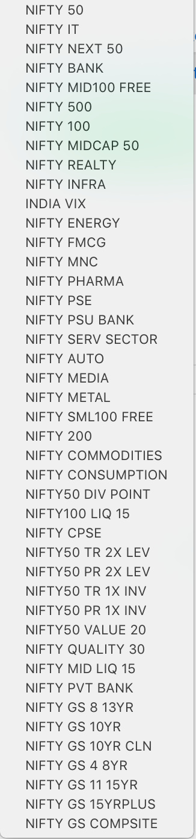

If this was an android app, this would be close to being its backend. It gathers names of Indian stocks and shows their prices. It is really slow, because it uses web scraping, and web scraping with Java has a very rough time complexity. It runs through thousands of lines of html code from finance sites and uses a very simple intelligence to decipher which data (name of the company, and price) to display. This can be easily improved with an API like the YahooFinance. For some reason, it wasn’t compatible on my eclipse. But if I get it fixed. The code would execute 100 times faster than it does now. It also allows the user to store the info it has scraped in a hashmap class called “StockStore”, so if needed again, can be loaded in O(1) time. This has to be run with eclipse or some other java platform because there is no android interface yet. On the left are example “indices” the program is familiar with.