Andrei Donchenko **Advanced software development**

**Assignment 4**

Information Technologies

T5614SN 9.09.2016

Timo Mynttinen

**JS and jQuery theory**

JavaScript is a scripting language that was designed for use within a web browser. Typically, JavaScript is used for interface interactions. Slideshows and other interactive components are typically done using JavaScript.

The uses of JavaScript don’t stop there, however. JavaScript has also been used for server-side programming, game development, and even creating desktop applications. Years ago, JavaScript was popular but web developers were not entirely sold on the idea of using it simply because every web browser would render JavaScript content in a different manner. Newer standards now force all web browsers to implement JavaScript uniformly; saving developers time and frustration trying to debug code for a specific web browsing client.

Dynamic content is the hot topic in web development right now. Dynamic content refers to content that constantly changes and adapts to specific users whenever possible. For example, JavaScript can be used to determine if a website visitor is using a computer or a mobile device before deciding whether or not to render the mobile version of the website. It’s these small things behind the scenes that create genuine value in using JavaScript to create dynamic web pages.

Before jQuery was developed, web developers created their own custom frameworks in JavaScript. This allowed them to work around specific bugs without wasting time debugging common features. This led to groups of developers creating JavaScript libraries that were open source and free to use.

JQuery is simply a specific library of JavaScript code. There are many other JavaScript code libraries such as MooTools, but jQuery has become the most popular because it is so easy to use and extremely powerful.

Professional web developers spend a lot of time debating whether JavaScript or jQuery is appropriate in a given situation. The truth is that there is no correct answer. Either option can be used to create the exact same effects, but often jQuery can do it with fewer lines of code.

As a general rule, jQuery is sufficient for most web development projects. There will be some projects that require traditional JavaScript; however, these are few and far between as of late. Although jQuery maybe the better choice in most scenarios, as a novice web developer you should still take the time to learn both JavaScript and jQuery.

**Screenshots of source code and website**

JS

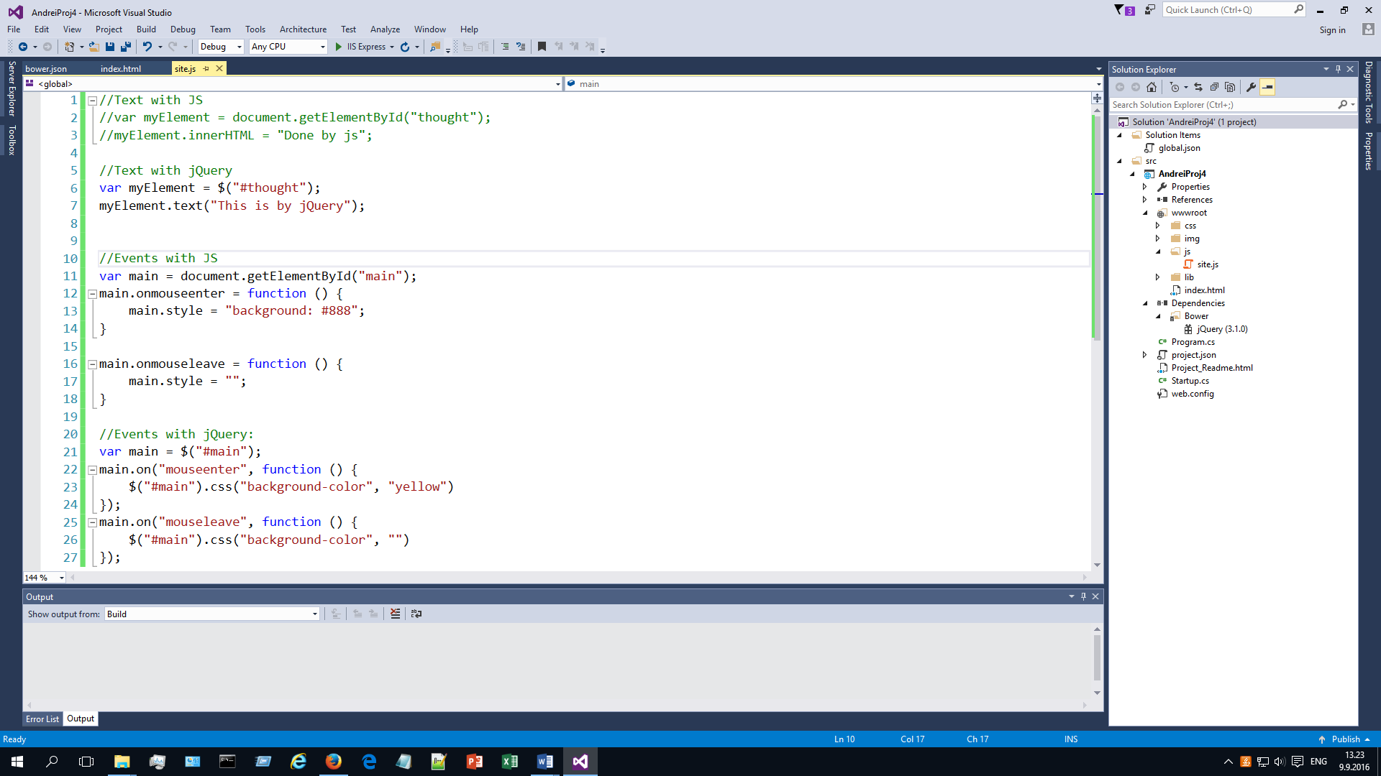

HTML:

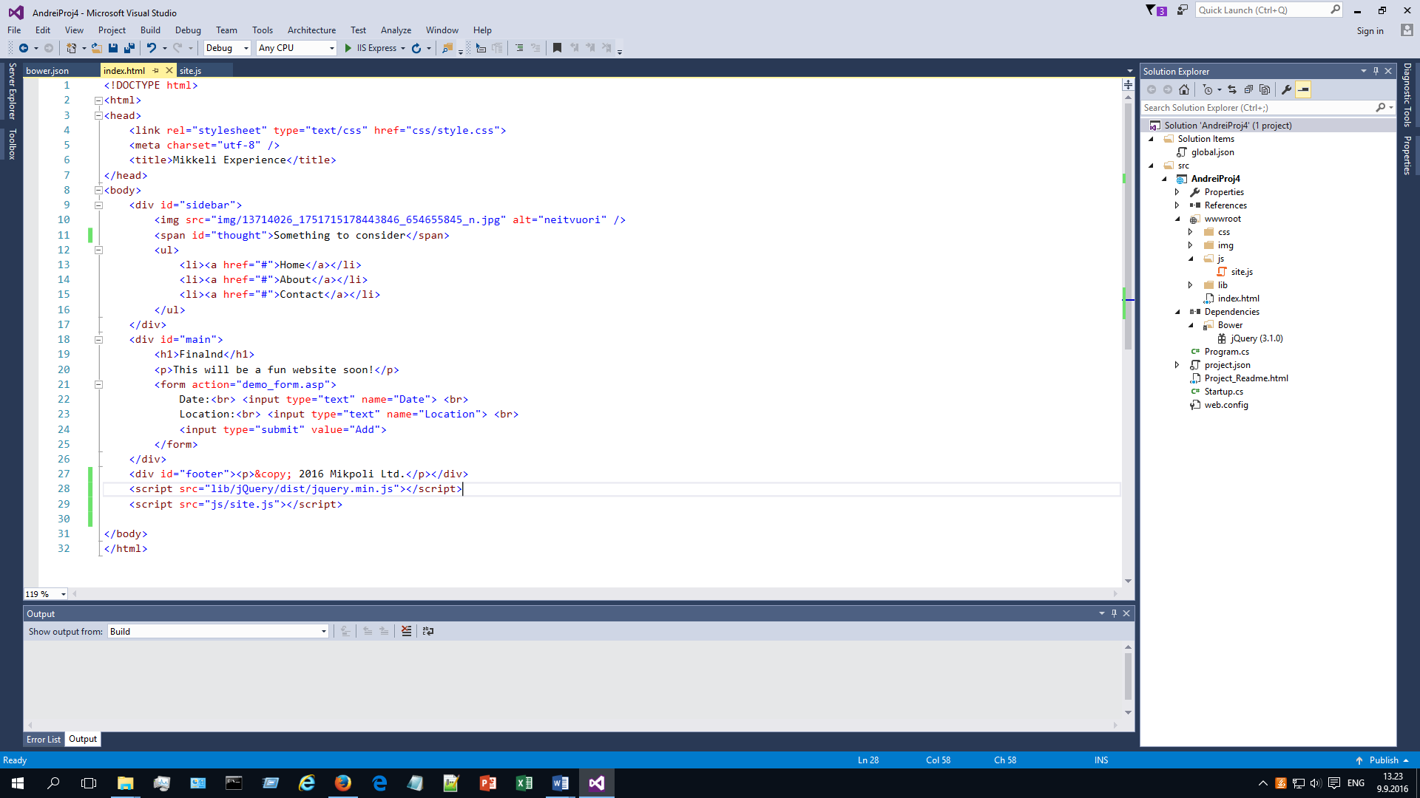

CSS remained the same

Also some lines in bower.json:

{

"name": "asp.net",

"private": true,

"dependencies": {

"jQuery": "~3.1.0"

}

}

The website

1. Done with JS without mouse on:

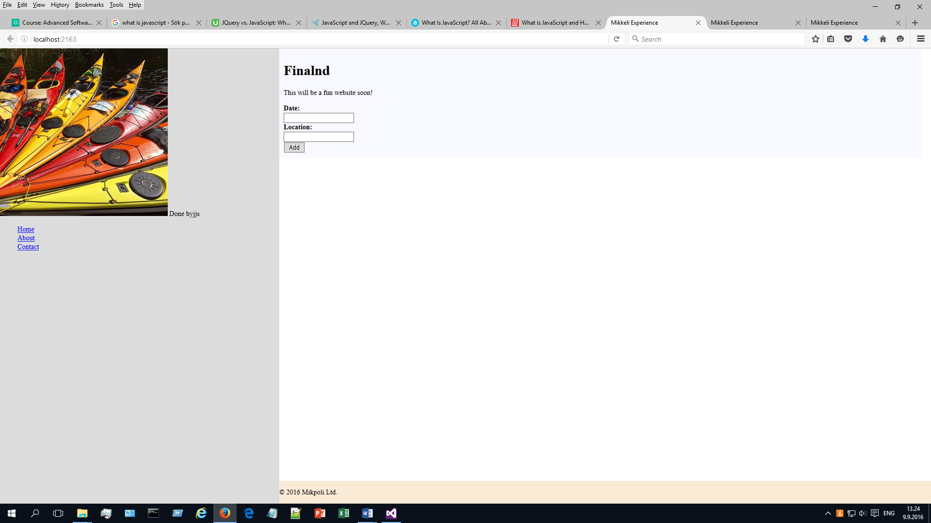

With mouse on:

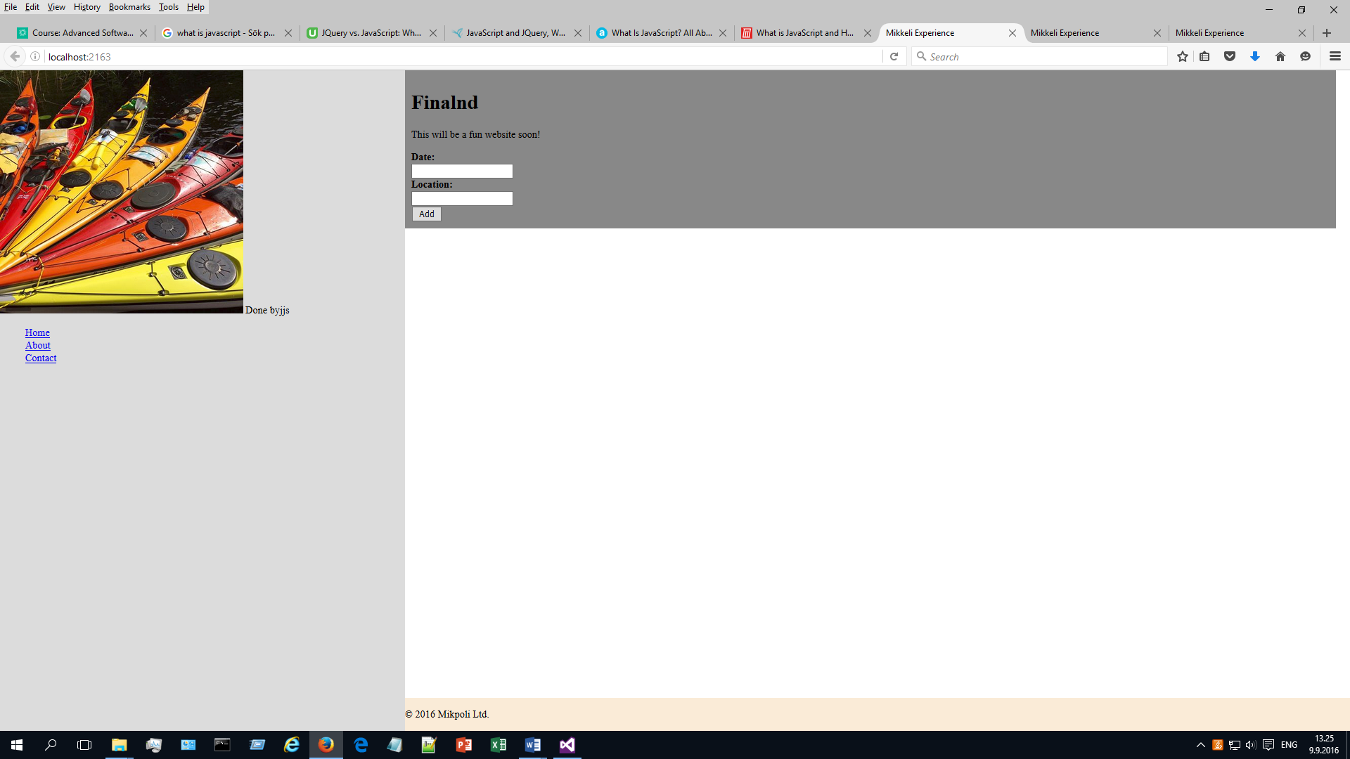

2) Done with jQuery

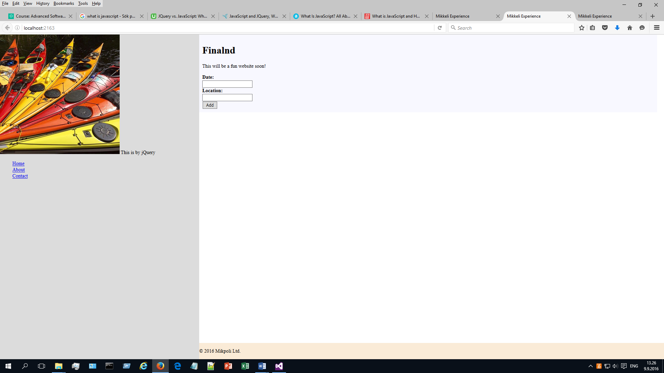

3) Yellow background when mouse enters with jQuery

