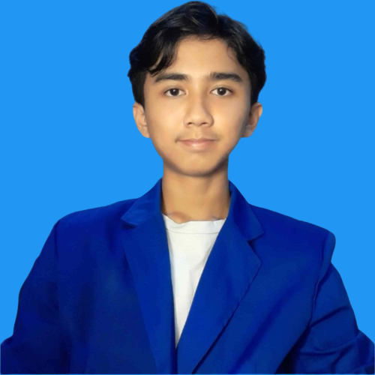

### CONTACT



+62 85738369074



[gusdiksa02@gmail.com](mailto:gusdIksa02@gmail.com)

 [Diksa Ardana](https://www.linkedin.com/in/diksa-ardana-540665226/)

 [Diksa Portfolio](https://diksaardana.github.io/)



**[Introduction Video](https://youtu.be/4Lr6O50ms1U )**

**IDA BAGUS GDE DIKSA ARDANA**

**Higher School Certificate**

Science

**- SMAN 1 Mengwi**

(2020)

**EDUCATION HISTORY**

**Diploma In**

Software Engineer

* **ITB STIKOM Bali**

(2020 - Present)

* **Lithan Pvt. Ltd**

(2022 - Present)

**BALI, INDONESIA**

## ABOUT

I am a student of software engineering. My passion is developing innovative solutions to complex problems. With several years of experience and knowledge in software development, I am capable of developing and implementing end-to-end software projects, from project planning and architecture design to coding and testing.

I am passionate about developing efficient and user-friendly web applications, and I am committed to keeping current on industry trends in order to apply my skills and experience in a challenging and dynamic environment where I can make a significant contribution.

My aspiration is to work as a software engineer with a focus on web development, utilizing my knowledge of front-end and back-end technologies.

## SKILLS

### Languages

**Indonesian English**

### Technical Skills

**HTML CSS**

**Javascript React js**

**SQL Angular js**

### Soft Skills

**Communication Creative**

**ACADEMIC PROJECTS**

# **ABC Job Portal Oct 2022**

* **Website for networking and career development. Allows job seekers to post their profile, apply for a job, post a thread and comment, and administrator able to post jobs opportunity.**
* **Develop this project using Java, Spring, SQL, Javascript.**

# **ABC Car Portal Dec 2022**

* **Website for selling used car. Allows user to post their used car, bidding the car, and apply for test drive date.**
* **Develop this project using Java, Spring boot, SQL, Javascript.**

# **Know Your Neighborhood Dec 2022**

* **Website for network between neighborhood. Allows user add new neighborhood, register and, login using Facebook account.**
* **Develop this project using Java, Spring boot, SQL, Javascript, React js**

**CERTIFICATE**

# **Linkedin Certificate**

* **“Building RealTime Web Apps with Spring Boot and WebSockets” by Shonna Smith.**
* **“Business Analysis Foundations Enterprise” by Vincent Mirabell**
* **“Learning REST APIs” by Morten Rand-Hendriksen**
* **“React.js Essential Training 2020” by Eve Porcello**
* **“Spring Spring MVC 2018” by Shonna Smith**