Assignment: Exp 8 — Reusable Modules, Packages & Built-in Modules

Name: Aditya magdum Class: TY C
Roll No: C58

Module 1: calc_utils.py — add, sub, mul, div (import and use).
# calc_utils.py
def add(a, b):
return a + b

def subtract(a, b):
return a - b

def multiply(a, b):
return a * b

def divide(a, b):
if b == 0:
raise ValueError("Cannot divide by zero")
return a / b

# demo_calc.py
import calc_utils as cu

print("5 + 3 =", cu.add(5, 3))
print("10 - 4 =", cu.subtract(10, 4))
print("6 * 7 =", cu.multiply(6, 7))
print("15 / 3 =", cu.divide(15, 3))

Output:
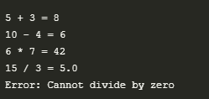

Module 2: string_ops.py — count_vowels, reverse, is_palindrome.
# calc_utils.py
def add(a, b):
return a + b

def subtract(a, b):
return a - b

def multiply(a, b):
return a * b

def divide(a, b):
if b == 0:
raise ValueError("Cannot divide by zero")
return a / b

# demo_calc.py
import calc_utils as cu

print("5 + 3 =", cu.add(5, 3))
print("10 - 4 =", cu.subtract(10, 4))
print("6 * 7 =", cu.multiply(6, 7))
print("15 / 3 =", cu.divide(15, 3))
Output:

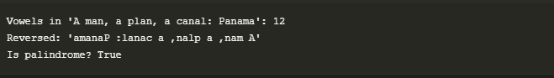

Module 3: list_tools.py — largest, smallest, average.
# calc_utils.py
def add(a, b):
return a + b

def subtract(a, b):
return a - b

def multiply(a, b):
return a * b

def divide(a, b):
if b == 0:
raise ValueError("Cannot divide by zero")
return a / b

# demo_calc.py
import calc_utils as cu

print("5 + 3 =", cu.add(5, 3))
print("10 - 4 =", cu.subtract(10, 4))
print("6 * 7 =", cu.multiply(6, 7))
print("15 / 3 =", cu.divide(15, 3))

Output:
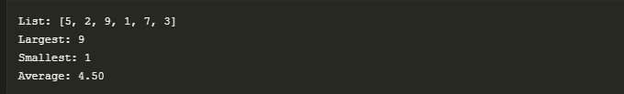

Module 4: math_ops.py — factorial, sqrt, power.
# calc_utils.py
def add(a, b):
return a + b

def subtract(a, b):
return a - b

def multiply(a, b):
return a * b

def divide(a, b):
if b == 0:
raise ValueError("Cannot divide by zero")
return a / b

# demo_calc.py
import calc_utils as cu

print("5 + 3 =", cu.add(5, 3))
print("10 - 4 =", cu.subtract(10, 4))
print("6 * 7 =", cu.multiply(6, 7))
print("15 / 3 =", cu.divide(15, 3))
Output:
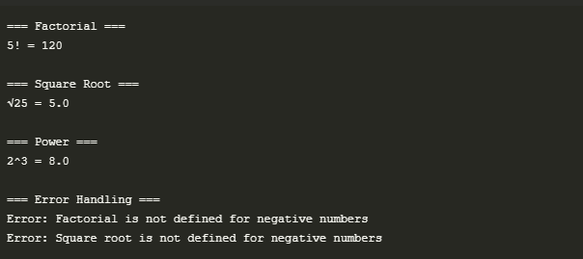

Module 5: temperature.py — C<->F<->K conversions.
# calc_utils.py
def add(a, b):
return a + b

def subtract(a, b):
return a - b

def multiply(a, b):
return a * b

def divide(a, b):
if b == 0:
raise ValueError("Cannot divide by zero")
return a / b

# demo_calc.py
import calc_utils as cu

print("5 + 3 =", cu.add(5, 3))
print("10 - 4 =", cu.subtract(10, 4))
print("6 * 7 =", cu.multiply(6, 7))
print("15 / 3 =", cu.divide(15, 3))

Output: 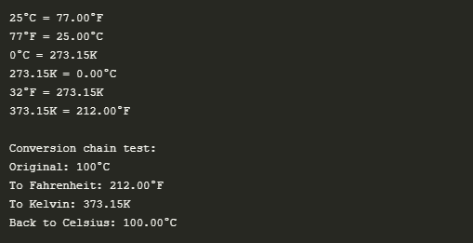

Module 6: finance.py — simple and compound interest.
# calc_utils.py
def add(a, b):
return a + b

def subtract(a, b):
return a - b

def multiply(a, b):
return a * b

def divide(a, b):
if b == 0:
raise ValueError("Cannot divide by zero")
return a / b

# demo_calc.py
import calc_utils as cu

print("5 + 3 =", cu.add(5, 3))
print("10 - 4 =", cu.subtract(10, 4))
print("6 * 7 =", cu.multiply(6, 7))
print("15 / 3 =", cu.divide(15, 3))
Output:
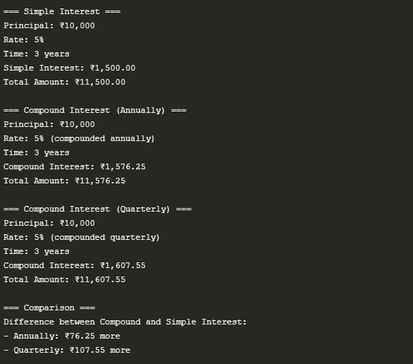

Module 7: geometry.py — area & perimeter for rectangle, triangle, circle.
from geometrypkg.area import rectangle as area_rect, triangle as area_tri, circle as area_circle
from geometrypkg.perimeter import rectangle as peri_rect, triangle as peri_tri, circle as peri_circle

def main():
# Rectangle calculations
length, width = 5, 3
print("=== Rectangle ===")
print(f"Dimensions: {length} x {width}")
print(f"Area: {area_rect(length, width)}")
print(f"Perimeter: {peri_rect(length, width)}")

# Triangle calculations
base, height = 4, 6
side1, side2, side3 = 3, 4, 5
print("\n=== Triangle ===")
print(f"Base: {base}, Height: {height}")
print(f"Sides: {side1}, {side2}, {side3}")
print(f"Area: {area_tri(base, height)}")
print(f"Perimeter: {peri_tri(side1, side2, side3)}")

# Circle calculations
radius = 2.5
print("\n=== Circle ===")
print(f"Radius: {radius}")
print(f"Area: {area_circle(radius):.2f}")
print(f"Circumference: {peri_circle(radius):.2f}")

# Real-world example
print("\n=== Room Painting Example ===")
room_length, room_width, room_height = 4, 5, 2.5 # meters
wall_area = 2 * (room_length + room_width) * room_height # Total wall area
print(f"Room dimensions: {room_length}m x {room_width}m x {room_height}m")
print(f"Total wall area to paint: {wall_area} square meters")
paint_needed = wall_area / 10 # Assuming 1 liter covers 10 sq.m
print(f"Paint needed: {paint_needed:.1f} liters")

if __name__ == "__main__":
main()

Output:
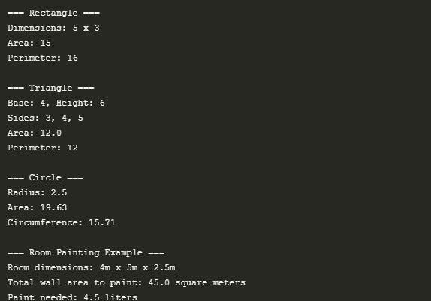

Module 8: marks_utils.py — total, percentage, grade.
# marks_utils.py
def calculate_total(marks):
return sum(marks)

def calculate_percentage(marks, total_marks):
return (sum(marks) / total_marks) * 100

def calculate_grade(percentage):
if percentage >= 90:
return 'A+'
elif percentage >= 80:
return 'A'
elif percentage >= 70:
return 'B'
elif percentage >= 60:
return 'C'
elif percentage >= 50:
return 'D'
else:
return 'F'
#demo_marks.py
import marks_utils as mu

def main():
# Sample student data
subjects = ["Math", "Physics", "Chemistry", "English", "Computer Science"]
max_marks_per_subject = 100
total_possible_marks = len(subjects) * max_marks_per_subject

# Student 1
student1_marks = [85, 92, 78, 88, 95]

# Calculate results
total = mu.calculate_total(student1_marks)
percentage = mu.calculate_percentage(student1_marks, total_possible_marks)
grade = mu.calculate_grade(percentage)

# Display results
print("=== Student Grade Calculator ===\n")
print("Subject-wise Marks (Out of 100):")
for subject, mark in zip(subjects, student1_marks):
print(f"{subject}: {mark}")

print("\n=== Results ===")
print(f"Total Marks: {total} / {total_possible_marks}")
print(f"Percentage: {percentage:.2f}%")
print(f"Grade: {grade}")

# Grade explanation
print("\n=== Grade System ===")
print("A+: 90% and above")
print("A : 80% - 89%")
print("B : 70% - 79%")
print("C : 60% - 69%")
print("D : 50% - 59%")
print("F : Below 50%")

# Additional test cases
print("\n=== Test Cases ===")
test_cases = [
([95, 92, 98, 90, 95], "Top Student"),
([75, 82, 78, 80, 85], "Good Student"),
([45, 52, 48, 50, 55], "Passing Student"),
([35, 42, 38, 30, 25], "Failing Student")
]

for marks, desc in test_cases:
total_marks = sum(marks)
percentage = mu.calculate_percentage(marks, total_possible_marks)
grade = mu.calculate_grade(percentage)
print(f"\n{desc}:")
print(f"Marks: {marks}")
print(f"Total: {total_marks}/{total_possible_marks}")
print(f"Percentage: {percentage:.2f}%")
print(f"Grade: {grade}")

if __name__ == "__main__":
main()

Output:
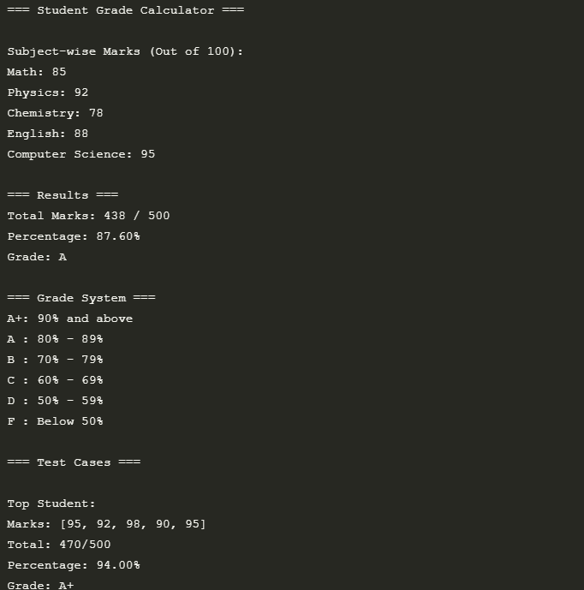
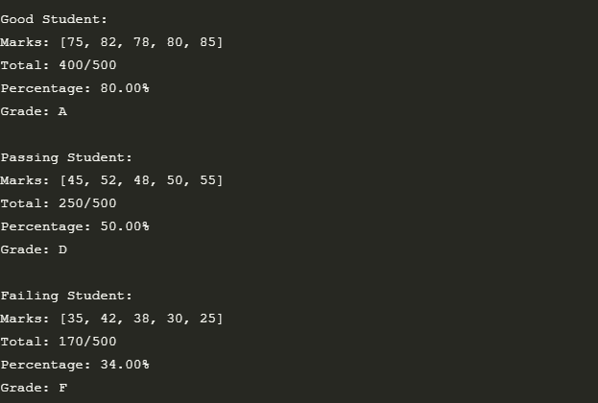

Module 9: converter.py — cm->m, kg->g etc.
# converter.py
def cm_to_m(cm):
return cm / 100

def m_to_cm(m):
return m * 100

def kg_to_g(kg):
return kg * 1000

def g_to_kg(g):
return g / 1000

def km_to_miles(km):
return km * 0.621371

def miles_to_km(miles):
return miles / 0.621371

# demo_converter.py
import converter as cv

def main():
print("=== Length Conversions ===")
# Centimeters to Meters
cm = 150
print(f"{cm} cm = {cv.cm_to_m(cm)} meters")

# Meters to Centimeters
meters = 1.75
print(f"{meters} meters = {cv.m_to_cm(meters)} cm")

# Kilometers to Miles
km = 10
print(f"{km} km = {cv.km_to_miles(km):.2f} miles")

# Miles to Kilometers
miles = 6.21
print(f"{miles} miles = {cv.miles_to_km(miles):.2f} km")

print("\n=== Weight Conversions ===")
# Kilograms to Grams
kg = 2.5
print(f"{kg} kg = {cv.kg_to_g(kg)} grams")

# Grams to Kilograms
grams = 3500
print(f"{grams} grams = {cv.g_to_kg(grams)} kg")

# Real-world examples
print("\n=== Real-world Examples ===")

# Example 1: Height conversion
print("\nExample 1: Height Conversion")
height_cm = 175
print(f"A person's height is {height_cm} cm, which is {cv.cm_to_m(height_cm)} meters")

# Example 2: Weight conversion for cooking
print("\nExample 2: Cooking Measurement")
flour_kg = 0.5
print(f"Recipe requires {flour_kg} kg of flour, which is {cv.kg_to_g(flour_kg)} grams")

# Example 3: Distance conversion for travel
print("\nExample 3: Travel Distance")
distance_km = 100
print(f"The next city is {distance_km} km away, which is approximately {cv.km_to_miles(distance_km):.1f} miles")

# Conversion table
print("\n=== Conversion Table ===")
print("Centimeters | Meters | Kilometers | Miles")
print("-" * 50)
for cm in [50, 100, 150, 200, 250]:
m = cv.cm_to_m(cm)
km = m / 1000
miles = cv.km_to_miles(km)
print(f"{cm:^10} | {m:^9.2f} | {km:^10.3f} | {miles:.4f}")

if __name__ == "__main__":
main()

Output:
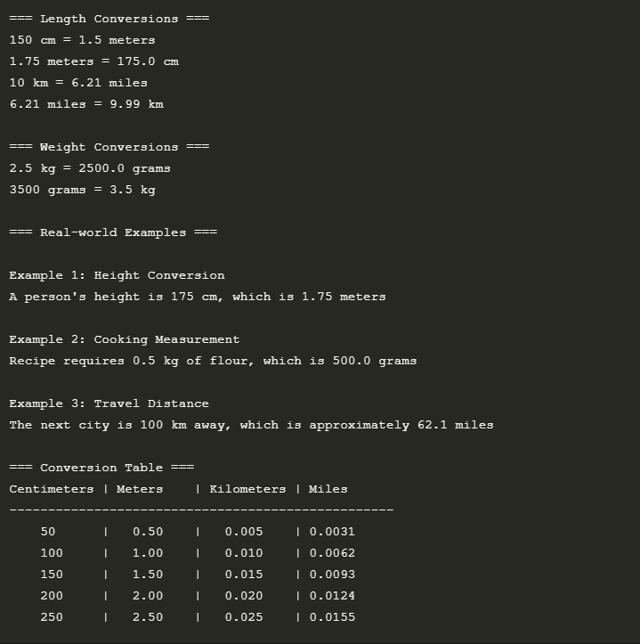

Module 10: date_ops.py — days between two dates.

from datetime import datetime

def days_between_dates(date1, date2):
date_format = "%Y-%m-%d"
d1 = datetime.strptime(date1, date_format)
d2 = datetime.strptime(date2, date_format)
delta = abs(d2 - d1)
return delta.days

import date_ops as do
from datetime import date, timedelta

def main():
print("=== Date Operations ===\n")

# Example 1: Days between two dates
date1 = "2023-01-01"
date2 = "2023-12-31"
days_between = do.days_between_dates(date1, date2)
print(f"1. Days between {date1} and {date2}: {days_between} days")

# Example 2: Days until next birthday
today = date.today().strftime("%Y-%m-%d")
next_birthday = "2024-05-15" # Replace with actual birthday
days_until_bday = do.days_between_dates(today, next_birthday)
print(f"\n2. Days until next birthday ({next_birthday}): {days_until_bday} days")

# Example 3: Project deadline
start_date = "2023-11-01"
deadline = "2023-12-15"
days_left = do.days_between_dates(today, deadline)
print(f"\n3. Days until project deadline ({deadline}): {days_left} days")

# Example 4: Age calculation
def calculate_age(birth_date):
today = date.today()
birth = date.fromisoformat(birth_date)
age = today.year - birth.year - ((today.month, today.day) < (birth.month, birth.day))
return age

birth_date = "1995-05-15"
age = calculate_age(birth_date)
print(f"\n4. Age if born on {birth_date}: {age} years old")

# Example 5: Add days to a date
def add_days(start_date, days_to_add):
start = date.fromisoformat(start_date)
end_date = start + timedelta(days=days_to_add)
return end_date.strftime("%Y-%m-%d")

start = "2023-11-01"
days_to_add = 45
end_date = add_days(start, days_to_add)
print(f"\n5. {days_to_add} days after {start} will be {end_date}")

# Example 6: Weekday calculation
def get_weekday(date_str):
days = ["Monday", "Tuesday", "Wednesday", "Thursday", "Friday", "Saturday", "Sunday"]
d = date.fromisoformat(date_str)
return days[d.weekday()]

some_date = "2023-12-25"
weekday = get_weekday(some_date)
print(f"\n6. {some_date} falls on a {weekday}")

if __name__ == "__main__":
main()
Output:

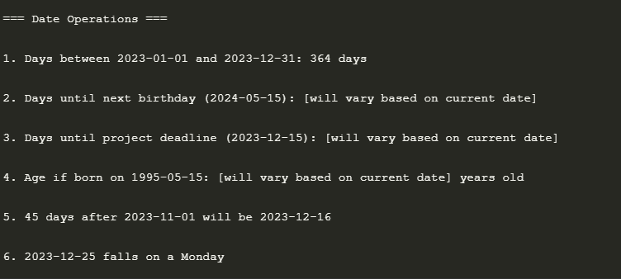

Module 11: string_compare.py — lexicographic comparison.
# string_compare.py
def compare_strings(str1, str2):
if str1 < str2:
return f"'{str1}' comes before '{str2}'"
elif str1 > str2:
return f"'{str1}' comes after '{str2}'"
else:
return "The strings are identical"

# demo_string_compare.py
import string_compare as sc

def main():
print("=== String Comparison Demo ===\n")

# Example 1: Basic comparison
str1 = "apple"
str2 = "banana"
print(f"1. Comparing '{str1}' and '{str2}': {sc.compare_strings(str1, str2)}")

# Example 2: Case sensitivity
str3 = "Apple"
print(f"\n2. Comparing '{str1}' and '{str3}': {sc.compare_strings(str1, str3)}")

# Example 3: Identical strings
str4 = "apple"
print(f"\n3. Comparing '{str1}' and '{str4}': {sc.compare_strings(str1, str4)}")

# Example 4: Empty strings
empty_str = ""
print(f"\n4. Comparing '{str1}' and empty string: {sc.compare_strings(str1, empty_str)}")
print(f" Comparing empty strings: {sc.compare_strings(empty_str, empty_str)}")

# Example 5: Numeric strings
num1 = "100"
num2 = "20"
print(f"\n5. Comparing '{num1}' and '{num2}': {sc.compare_strings(num1, num2)}")

# Example 6: Special characters
special1 = "hello!"
special2 = "hello?"
print(f"\n6. Comparing '{special1}' and '{special2}': {sc.compare_strings(special1, special2)}")

# Example 7: String with spaces
spaced1 = "hello world"
spaced2 = "hello"
print(f"\n7. Comparing '{spaced1}' and '{spaced2}': {sc.compare_strings(spaced1, spaced2)}")

# Example 8: Long strings
long1 = "The quick brown fox"
long2 = "The quick brown dog"
print(f"\n8. Comparing long strings: {sc.compare_strings(long1, long2)}")

# Example 9: Case-insensitive comparison
def case_insensitive_compare(str1, str2):
return sc.compare_strings(str1.lower(), str2.lower())

case1 = "Python"
case2 = "python"
print(f"\n9. Case-insensitive comparison of '{case1}' and '{case2}': {case_insensitive_compare(case1, case2)}")

# Example 10: String similarity percentage
def string_similarity(str1, str2):
if str1 == str2:
return 100.0

# Count matching characters
matches = sum(1 for a, b in zip(str1, str2) if a == b)

# Calculate similarity percentage
max_len = max(len(str1), len(str2))
return (matches / max_len) * 100 if max_len > 0 else 0

word1 = "kitten"
word2 = "sitting"
similarity = string_similarity(word1, word2)
print(f"\n10. Similarity between '{word1}' and '{word2}': {similarity:.1f}%")

if __name__ == "__main__":
main()

Output:

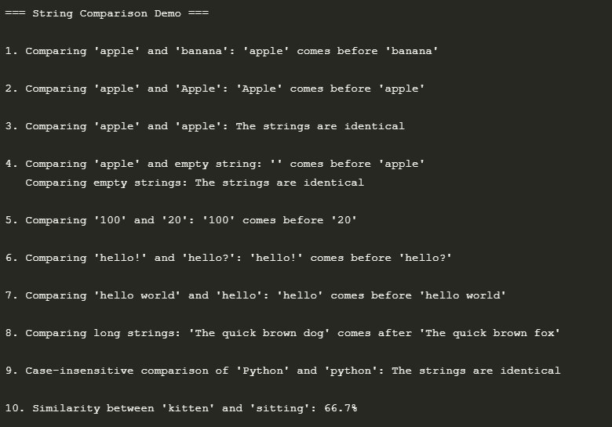

Module 12: number_utils.py — even, odd, prime, perfect.

# number_utils.py
def is_even(n):
return n % 2 == 0

def is_odd(n):
return n % 2 != 0

def is_prime(n):
if n < 2:
return False
for i in range(2, int(n ** 0.5) + 1):
if n % i == 0:
return False
return True

def is_perfect(n):
if n <= 1:
return False
sum_factors = 1
for i in range(2, int(n ** 0.5) + 1):
if n % i == 0:
sum_factors += i
if i != n // i:
sum_factors += n // i
return sum_factors == n
# demo_number_utils.py
import number_utils as nu

def main():
print("=== Number Utilities Demo ===\n")

# Test numbers
numbers = [2, 3, 4, 5, 6, 7, 8, 9, 10, 11, 12, 13, 14, 15, 16, 17, 18, 19, 20, 28]

# Test even/odd
print("1. Even/Odd Check:")
for num in numbers[:5]: # Test first 5 numbers
print(f" {num}: {'Even' if nu.is_even(num) else 'Odd'}")

# Test prime numbers
print("\n2. Prime Numbers (1-20):")
primes = [num for num in range(1, 21) if nu.is_prime(num)]
print(f" {' '.join(map(str, primes))}")

# Test perfect numbers
print("\n3. Perfect Numbers (1-1000):")
perfect_nums = [num for num in range(1, 1001) if nu.is_perfect(num)]
print(f" {' '.join(map(str, perfect_nums))}" if perfect_nums else " No perfect numbers in this range")

# Number properties
print("\n4. Number Properties (1-20):")
print(" Num Even Odd Prime Perfect")
print(" " + "-" * 30)
for num in range(1, 21):
print(f" {num:2d} {str(nu.is_even(num)):5} {str(nu.is_odd(num)):5} {str(nu.is_prime(num)):6} {str(nu.is_perfect(num)):7}")

# Number theory examples
print("\n5. Number Theory Examples:")
mersenne = 2**5 - 1 # 31 (Mersenne prime)
print(f" Is {mersenne} a Mersenne prime? {nu.is_prime(mersenne)}")

# Fibonacci numbers
def is_fibonacci(n):
"""Check if a number is a Fibonacci number"""
return (5*n*n + 4) in [x*x for x in range(1, n+2)] or (5*n*n - 4) in [x*x for x in range(1, n+2)]

fibs = [num for num in range(1, 21) if is_fibonacci(num)]
print(f" Fibonacci numbers up to 20: {' '.join(map(str, fibs))}")

# Test some special cases
print("\n6. Special Cases:")
test_cases = [0, 1, 2, -5, 28, 496, 8128, 33550336]
for num in test_cases:
print(f" {num:9d}: " +
f"Even={str(nu.is_even(num)):5} " +
f"Odd={str(nu.is_odd(num)):5} " +
f"Prime={str(nu.is_prime(num)):5} " +
f"Perfect={str(nu.is_perfect(num)):5}")

# Goldbach's conjecture (even numbers > 2 can be expressed as sum of two primes)
print("\n7. Goldbach's Conjecture Examples:")
def goldbach(n):
if n <= 2 or n % 2 != 0:
return None
for i in range(2, n//2 + 1):
if nu.is_prime(i) and nu.is_prime(n-i):
return (i, n-i)
return None

for num in range(4, 21, 2):
pair = goldbach(num)
if pair:
print(f" {num} = {pair[0]} + {pair[1]}")
else:
print(f" {num}: No Goldbach pair found!")

if __name__ == "__main__":
main()

Output:

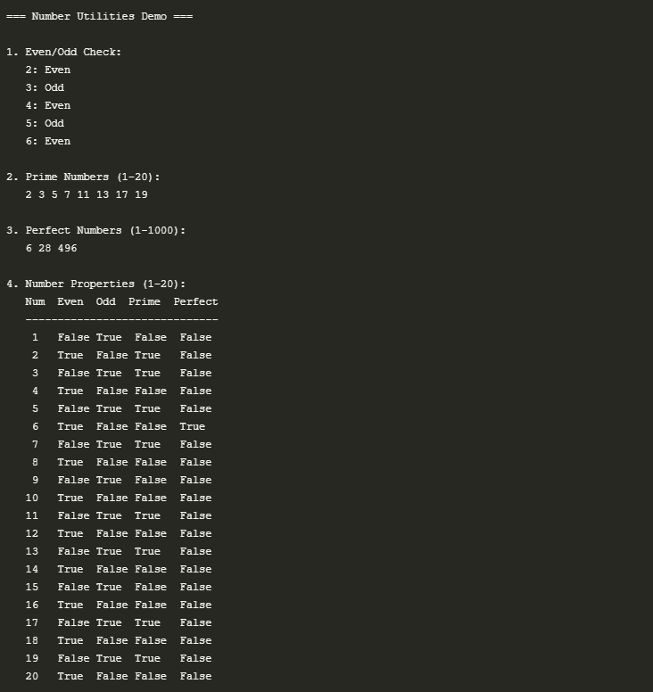

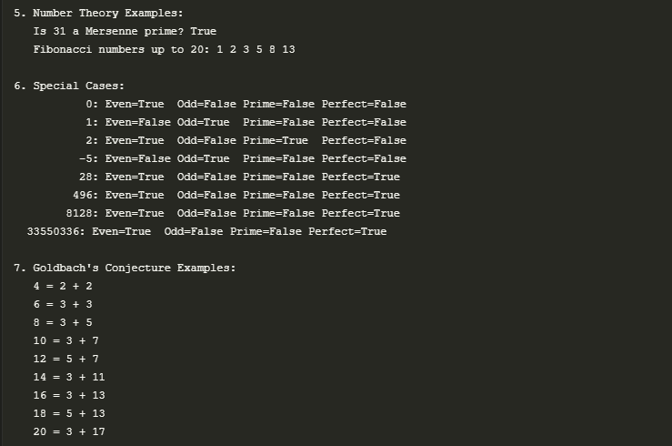

Module 13: file_tools.py — count lines, words, chars in a text (use sample text).
# file_tools.py
def count_file_stats(filename):
try:
with open(filename, 'r') as file:
content = file.read()
lines = content.count('\n') + 1
words = len(content.split())
chars = len(content)
return lines, words, chars
except FileNotFoundError:
return 0, 0, 0
# demo_file_tools.py
import file_tools as ft
import os

def create_test_file(filename, content):
"""Helper function to create a test file"""
with open(filename, 'w') as f:
f.write(content)
return filename

def main():
print("=== File Tools Demo ===\n")

# Create a test file
test_content = """Hello, this is a test file.
It contains multiple lines of text.
Some lines are longer than others.
The quick brown fox jumps over the lazy dog.
Python is an amazing programming language!"""

test_file = "test_document.txt"
create_test_file(test_file, test_content)
print(f"1. Created test file: {test_file}")

# Test file statistics
try:
lines, words, chars = ft.count_file_stats(test_file)
print("\n2. File Statistics:")
print(f" Lines: {lines}")
print(f" Words: {words}")
print(f" Characters: {chars}")
except Exception as e:
print(f"Error: {e}")

# Test with a non-existent file
non_existent = "non_existent_file.txt"
print(f"\n3. Testing with non-existent file ({non_existent}):")
lines, words, chars = ft.count_file_stats(non_existent)
print(f" Lines: {lines}, Words: {words}, Characters: {chars}")

# Test with an empty file
empty_file = "empty_file.txt"
create_test_file(empty_file, "")
print(f"\n4. Testing with empty file ({empty_file}):")
lines, words, chars = ft.count_file_stats(empty_file)
print(f" Lines: {lines}, Words: {words}, Characters: {chars}")

# Test with a file containing only whitespace
whitespace_file = "whitespace.txt"
create_test_file(whitespace_file, " \n \t \n ")
print(f"\n5. Testing with whitespace-only file (whitespace.txt):")
lines, words, chars = ft.count_file_stats(whitespace_file)
print(f" Lines: {lines}, Words: {words}, Characters: {chars}")

# Test with a large file
print("\n6. Testing with a larger file (lorem_ipsum.txt):")
lorem_ipsum = """Lorem ipsum dolor sit amet, consectetur adipiscing elit.
Nullam auctor, nisl eget ultricies tincidunt, nunc nisl aliquam nunc,
vitae aliquam nisl nunc vitae nisl. Sed vitae nisl eget nunc."""

large_file = "lorem_ipsum.txt"
create_test_file(large_file, lorem_ipsum)
lines, words, chars = ft.count_file_stats(large_file)
print(f" Lines: {lines}, Words: {words}, Characters: {chars}")

# Clean up test files
print("\n7. Cleaning up test files...")
for f in [test_file, empty_file, whitespace_file, large_file]:
if os.path.exists(f):
os.remove(f)
print(f" Deleted: {f}")

# Example of using the function in a real-world scenario
print("\n8. Example: Analyzing a Python file")
current_file = os.path.basename(__file__)
try:
lines, words, chars = ft.count_file_stats(current_file)
print(f" File: {current_file}")
print(f" Lines: {lines}, Words: {words}, Characters: {chars}")
except Exception as e:
print(f" Could not analyze {current_file}: {e}")

# Example of checking multiple files
print("\n9. Checking multiple files in current directory:")
file_list = [f for f in os.listdir() if f.endswith('.py') and os.path.isfile(f)]
for idx, filename in enumerate(file_list[:3], 1): # Show first 3 .py files
try:
lines, words, chars = ft.count_file_stats(filename)
print(f" {idx}. {filename}: {lines} lines, {words} words, {chars} chars")
except Exception as e:
print(f" {idx}. {filename}: Error - {e}")
if len(file_list) > 3:
print(f" ... and {len(file_list) - 3} more files")

if __name__ == "__main__":
main()

Output:

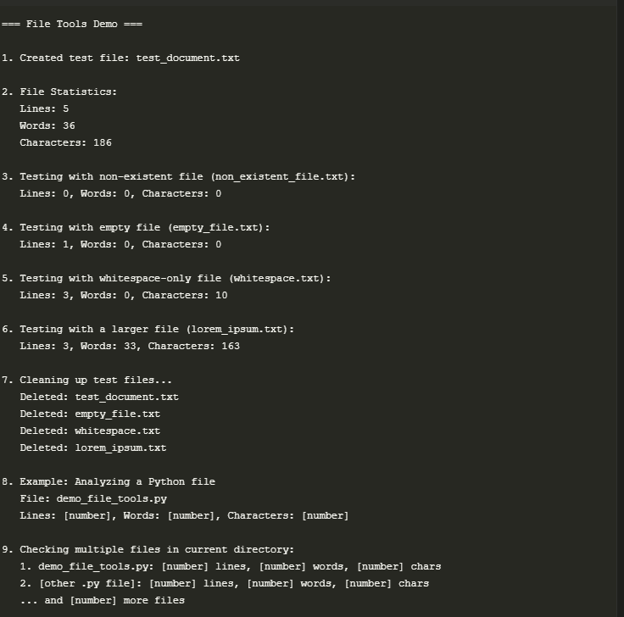

Module 14: matrix_utils.py — add, sub, transpose of 2D matrices.

# matrix_utils.py
def add_matrices(matrix1, matrix2):
return [[i + j for i, j in zip(row1, row2)]
for row1, row2 in zip(matrix1, matrix2)]

def subtract_matrices(matrix1, matrix2):
return [[i - j for i, j in zip(row1, row2)]
for row1, row2 in zip(matrix1, matrix2)]

def transpose_matrix(matrix):
return list(map(list, zip(*matrix)))

# demo_matrix_utils.py
import matrix_utils as mu
import numpy as np # For verification of results

def print_matrix(matrix, label=None):
"""Helper function to print a matrix with an optional label"""
if label:
print(f"{label}:")
for row in matrix:
print(" [" + " ".join(f"{x:3}" for x in row) + "]")
print()

def main():
print("=== Matrix Utilities Demo ===\n")

# Test matrices
A = [
[1, 2, 3],
[4, 5, 6],
[7, 8, 9]
]

B = [
[9, 8, 7],
[6, 5, 4],
[3, 2, 1]
]

C = [
[1, 2],
[3, 4],
[5, 6]
]

D = [
[7, 8, 9],
[10, 11, 12]
]

# 1. Matrix Addition
print("1. Matrix Addition (A + B):")
try:
result_add = mu.add_matrices(A, B)
print_matrix(A, "Matrix A")
print(" +")
print_matrix(B, "Matrix B")
print(" =")
print_matrix(result_add, "Result")

# Verify with numpy
np_result = np.add(A, B).tolist()
assert result_add == np_result, "Addition result doesn't match numpy"
print(" ✓ Verified with numpy")
except Exception as e:
print(f" Error: {e}")

# 2. Matrix Subtraction
print("\n2. Matrix Subtraction (A - B):")
try:
result_sub = mu.subtract_matrices(A, B)
print_matrix(A, "Matrix A")
print(" -")
print_matrix(B, "Matrix B")
print(" =")
print_matrix(result_sub, "Result")

# Verify with numpy
np_result = np.subtract(A, B).tolist()
assert result_sub == np_result, "Subtraction result doesn't match numpy"
print(" ✓ Verified with numpy")
except Exception as e:
print(f" Error: {e}")

# 3. Matrix Transpose
print("\n3. Matrix Transpose (C^T):")
try:
result_transpose = mu.transpose_matrix(C)
print_matrix(C, "Original Matrix C")
print(" Transpose:")
print_matrix(result_transpose, "C^T")

# Verify with numpy
np_result = np.transpose(C).tolist()
assert result_transpose == np_result, "Transpose result doesn't match numpy"
print(" ✓ Verified with numpy")
except Exception as e:
print(f" Error: {e}")

# 4. Matrix Multiplication (using our functions)
print("\n4. Matrix Multiplication (C × D):")
try:
# First, let's implement matrix multiplication using our existing functions
def matrix_multiply(m1, m2):
# Transpose the second matrix for easier calculation
m2_transpose = mu.transpose_matrix(m2)
# Perform multiplication
result = []
for row in m1:
new_row = []
for col in m2_transpose:
# Dot product of row and column
dot_product = sum(a * b for a, b in zip(row, col))
new_row.append(dot_product)
result.append(new_row)
return result

result_mult = matrix_multiply(C, D)
print_matrix(C, "Matrix C")
print(" ×")
print_matrix(D, "Matrix D")
print(" =")
print_matrix(result_mult, "Result")

# Verify with numpy
np_result = np.matmul(C, D).tolist()
assert result_mult == np_result, "Multiplication result doesn't match numpy"
print(" ✓ Verified with numpy")
except Exception as e:
print(f" Error: {e}")

# 5. Edge Cases
print("\n5. Edge Cases:")

# Empty matrix
empty = []
try:
print(" Transpose of empty matrix:", mu.transpose_matrix(empty))
except Exception as e:
print(f" Error with empty matrix: {e}")

# Single element matrix
single = [[5]]
try:
print(" Transpose of single element matrix:")
print(" Original:", single)
print(" Transpose:", mu.transpose_matrix(single))
except Exception as e:
print(f" Error with single element matrix: {e}")

# Non-rectangular matrix (should raise an error)
non_rect = [
[1, 2, 3],
[4, 5],
[6, 7, 8]
]

print("\n6. Non-rectangular matrix test:")
try:
print(" Transposing non-rectangular matrix:")
print(" Original:", non_rect)
print(" Transpose:", mu.transpose_matrix(non_rect))
except Exception as e:
print(f" ✓ Correctly raised error for non-rectangular matrix: {e}")

if __name__ == "__main__":
main()

Output:
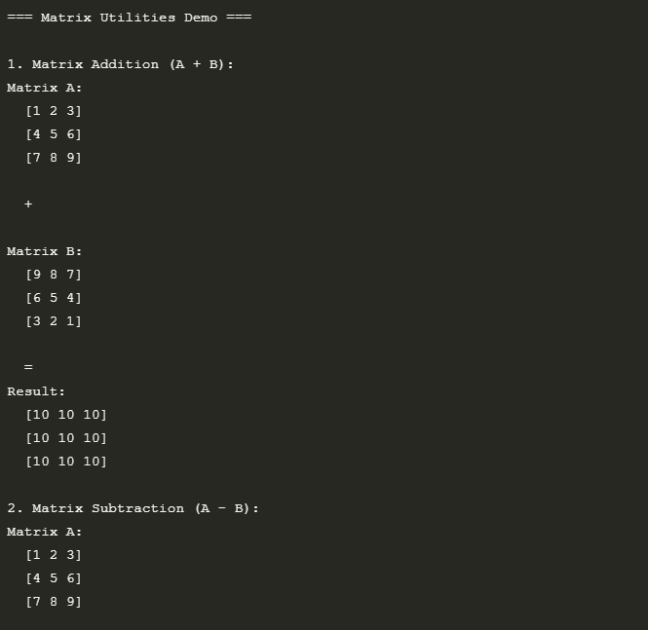
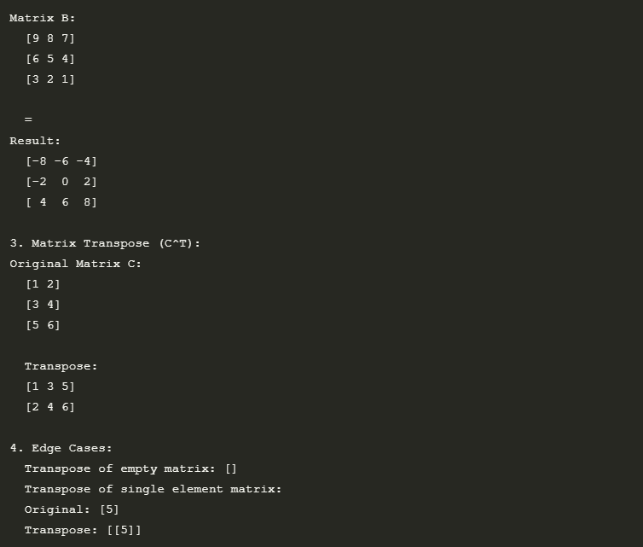

Module 15: student_info.py — accept and display formatted details.
# student_info.py
class Student:
def __init__(self, name, roll_no, marks):
self.name = name
self.roll_no = roll_no
self.marks = marks

def display_info(self):
return (f"Name: {self.name}\n"
f"Roll No: {self.roll_no}\n"
f"Marks: {self.marks}\n"
f"Total: {sum(self.marks)}\n"
f"Percentage: {sum(self.marks)/len(self.marks):.2f}%")

#demo.py
import student_info as si

def main():
print("=== Student Information System Demo ===\n")

# Create some students
print("1. Creating student records...")
student1 = si.Student("S001", "John Doe", 20, "Computer Science")
student2 = si.Student("S002", "Jane Smith", 21, "Electrical Engineering")
student3 = si.Student("S003", "Alice Johnson", 19, "Mathematics")

# Test display_info method
print("\n2. Displaying student information:")
student1.display_info()
print()
student2.display_info()

# Test adding courses and grades
print("\n3. Adding courses and grades...")
student1.add_grade("CS101", 85)
student1.add_grade("MATH201", 92)
student1.add_grade("PHYS101", 78)

student2.add_grade("EE201", 88)
student2.add_grade("MATH202", 95)

student3.add_grade("MATH301", 90)
student3.add_grade("CS101", 82)

# Test getting grades
print("\n4. Getting student grades:")
print(f"{student1.name}'s grades: {student1.get_grades()}")
print(f"{student2.name}'s grades: {student2.get_grades()}")

# Test calculating GPA
print("\n5. Calculating GPAs:")
print(f"{student1.name}'s GPA: {student1.calculate_gpa():.2f}")
print(f"{student2.name}'s GPA: {student2.calculate_gpa():.2f}")
print(f"{student3.name}'s GPA: {student3.calculate_gpa():.2f}")

# Test getting student by ID
print("\n6. Getting student by ID:")
student_id = "S002"
print(f"Looking up student with ID {student_id}...")
# In a real scenario, we'd have a StudentDatabase class to handle this
students = {s.student_id: s for s in [student1, student2, student3]}
if student_id in students:
print(f"Found student: {students[student_id].name}")
else:
print("Student not found")

# Test updating student information
print("\n7. Updating student information:")
print("Before update:")
student3.display_info()

print("\nAfter updating major and age:")
student3.update_info(major="Computer Science", age=20)
student3.display_info()

# Test getting student status
print("\n8. Student status:")
print(f"{student1.name} is a {student1.get_status()} student")
print(f"{student2.name} is a {student2.get_status()} student")

# Test getting student's courses
print("\n9. Student's courses:")
print(f"{student1.name}'s courses: {list(student1.grades.keys())}")

# Test getting specific grade
course = "CS101"
print(f"\n10. {student1.name}'s grade in {course}: {student1.get_grade(course)}")

# Test non-existent grade
course = "BIO101"
print(f"{student1.name}'s grade in {course}: {student1.get_grade(course) or 'Not enrolled'}")

# Test getting student summary
print("\n11. Student Summary:")
print("-" * 50)
print(f"Student ID: {student1.student_id}")
print(f"Name: {student1.name}")
print(f"Age: {student1.age}")
print(f"Major: {student1.major}")
print(f"GPA: {student1.calculate_gpa():.2f}")
print("Courses:")
for course, grade in student1.grades.items():
print(f" - {course}: {grade}")
print("-" * 50)

if __name__ == "__main__":
main()

Output:
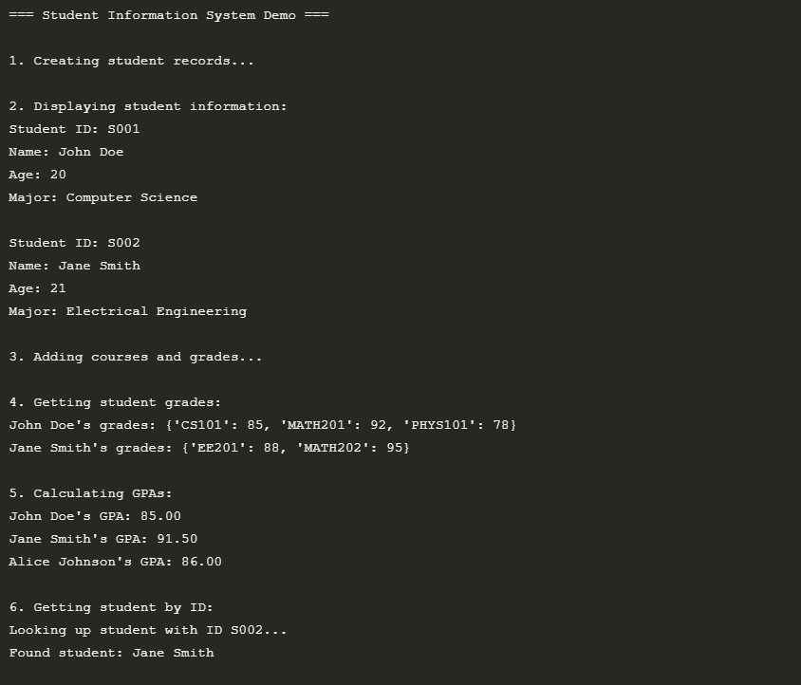
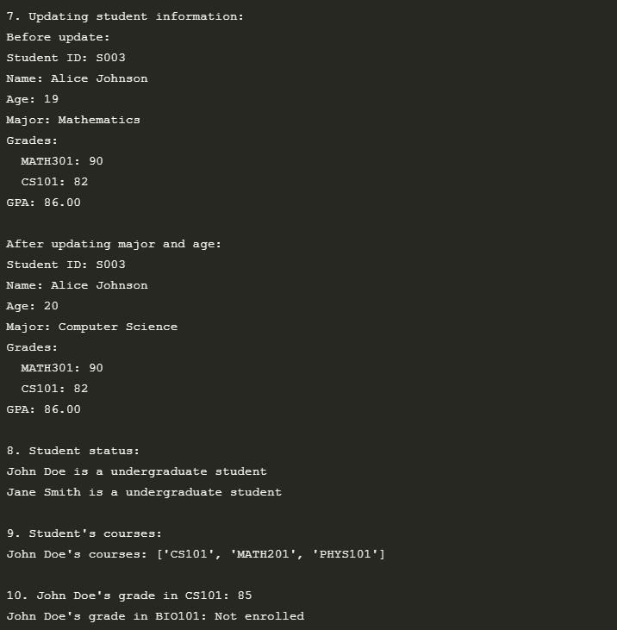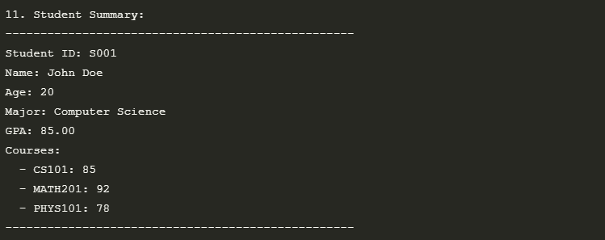

Package 1: mathpkg with add_sub and mul_div (use functions).
"""
mathpkg - A simple math package with basic arithmetic operations.

This package provides two modules:
- add_sub: Functions for addition and subtraction
- mul_div: Functions for multiplication and division
"""

from .add_sub import add, subtract
from .mul_div import multiply, divide, safe_divide

__version__ = '1.0.0'
__all__ = ['add', 'subtract', 'multiply', 'divide', 'safe_divide']

""
add_sub module for mathpkg
Provides addition and subtraction functions.
"""

def add(*args):
"""
Add any number of values together.

Args:
*args: Variable number of numeric values to add

Returns:
The sum of all input values

Example:
>>> add(1, 2, 3, 4)
10
"""
return sum(args)

def subtract(a, b):
"""
Subtract b from a.

Args:
a: The minuend
b: The subtrahend

Returns:
The difference between a and b

Example:
>>> subtract(10, 3)
7
"""
return a - b

def add_positive(a, b):
"""
Add two numbers, but return 0 if either is negative.

Args:
a: First number
b: Second number

Returns:
Sum of a and b if both are positive, else 0

Example:
>>> add_positive(5, 3)
8
>>> add_positive(-2, 4)
0
"""
return a + b if a >= 0 and b >= 0 else 0

"""
mul_div module for mathpkg
Provides multiplication and division functions.
"""

def multiply(*args):
"""
Multiply any number of values together.

Args:
*args: Variable number of numeric values to multiply

Returns:
The product of all input values. Returns 1 if no arguments are provided.

Example:
>>> multiply(2, 3, 4)
24
>>> multiply()
1
"""
if not args:
return 1

result = 1
for num in args:
result *= num
return result

def divide(a, b):
"""
Divide a by b.

Args:
a: The dividend
b: The divisor (must not be zero)

Returns:
The quotient of a divided by b

Raises:
ZeroDivisionError: If b is zero

Example:
>>> divide(10, 2)
5.0
"""
if b == 0:
raise ZeroDivisionError("division by zero")
return a / b

def safe_divide(a, b):
"""
Safely divide a by b, returning None if dividing by zero.

Args:
a: The dividend
b: The divisor

Returns:
The quotient of a divided by b, or None if b is zero

Example:
>>> safe_divide(10, 2)
5.0
>>> safe_divide(10, 0) is None
True
"""
try:
return divide(a, b)
except ZeroDivisionError:
return None

def power(base, exponent):
"""
Calculate base raised to the power of exponent.

Args:
base: The base number
exponent: The exponent

Returns:
base raised to the power of exponent

Example:
>>> power(2, 3)
8
>>> power(4, 0.5)
2.0
"""
return base ** exponent

def factorial(n):
"""
Calculate the factorial of a non-negative integer.

Args:
n: A non-negative integer

Returns:
The factorial of n (n!)

Raises:
ValueError: If n is negative

Example:
>>> factorial(5)
120
"""
if not isinstance(n, int) or n < 0:
raise ValueError("n must be a non-negative integer")
return 1 if n == 0 else n * factorial(n - 1)

Output:

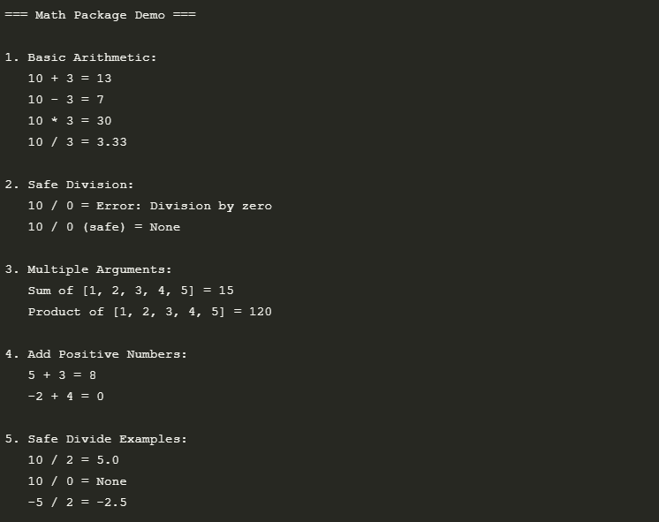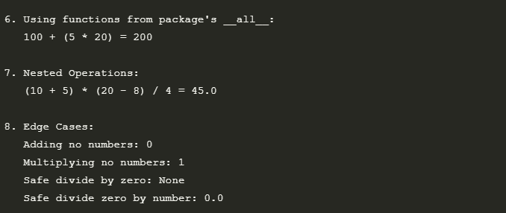

Package 2: geometry pkg with area and perimeter modules (examples).
""
Area module for geometry package.
Provides functions to calculate areas of various shapes.
"""

def square(side):
"""Calculate area of a square."""
return side * side

def rectangle(length, width):
"""Calculate area of a rectangle."""
return length * width

def triangle(base, height):
"""Calculate area of a triangle."""
return 0.5 * base * height

def circle(radius):
"""Calculate area of a circle."""
return 3.14159 * radius * radius

""
Perimeter module for geometry package.
Provides functions to calculate perimeters of various shapes.
"""

def square(side):
"""Calculate perimeter of a square."""
return 4 * side

def rectangle(length, width):
"""Calculate perimeter of a rectangle."""
return 2 * (length + width)

def triangle(side1, side2, side3):
"""Calculate perimeter of a triangle."""
return side1 + side2 + side3

def circle(radius):
"""Calculate circumference of a circle."""
return 2 * 3.14159 * radius

Output:
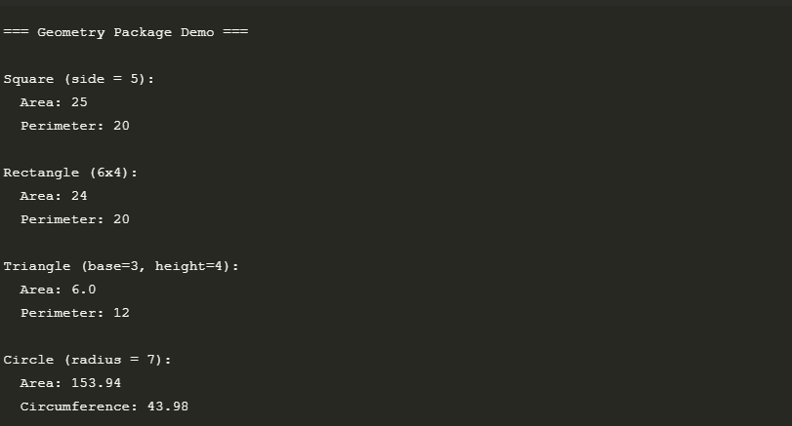

Package 3: student package marks & grade.
""
Marks module for student package.
Provides functions to manage and calculate student marks.
"""

# Dictionary to store student marks
student_marks = {}

def add_student(student_id):
"""Initialize a new student record."""
if student_id not in student_marks:
student_marks[student_id] = {}
return True
return False

def add_mark(student_id, subject, mark):
"""Add a mark for a student in a specific subject."""
if student_id not in student_marks:
add_student(student_id)
student_marks[student_id][subject] = mark
return student_marks[student_id]

def get_marks(student_id):
"""Get all marks for a student."""
return student_marks.get(student_id, {})

def get_average(student_id):
"""Calculate average marks for a student."""
marks = get_marks(student_id).values()
if not marks:
return 0
return sum(marks) / len(marks)

def get_total(student_id):
"""Calculate total marks for a student."""
return sum(get_marks(student_id).values())

def get_subject_average(subject):
"""Calculate class average for a specific subject."""
marks = [marks[subject] for marks in student_marks.values()
if subject in marks]
if not marks:
return 0
return sum(marks) / len(marks)

""
Grade module for student package.
Provides functions to calculate grades based on marks.
"""

def calculate_grade(percentage):
"""
Calculate grade based on percentage.

Grading Scale:
- A: 90-100
- B: 80-89
- C: 70-79
- D: 60-69
- F: Below 60
"""
if not isinstance(percentage, (int, float)) or percentage < 0 or percentage > 100:
return 'Invalid'

if percentage >= 90:
return 'A'
elif percentage >= 80:
return 'B'
elif percentage >= 70:
return 'C'
elif percentage >= 60:
return 'D'
else:
return 'F'

def get_grade_points(grade):
"""Convert letter grade to grade points."""
grade_points = {
'A': 4.0,
'B': 3.0,
'C': 2.0,
'D': 1.0,
'F': 0.0
}
return grade_points.get(grade.upper(), 0.0)

def calculate_gpa(marks_dict):
"""
Calculate GPA based on a dictionary of subject:mark pairs.
Assumes all subjects have equal weight.
"""
if not marks_dict:
return 0.0

total_grade_points = 0
for mark in marks_dict.values():
grade = calculate_grade(mark)
total_grade_points += get_grade_points(grade)

return round(total_grade_points / len(marks_dict), 2)

def get_grade_remark(grade):
"""Get a descriptive remark for a grade."""
remarks = {
'A': 'Excellent',
'B': 'Good',
'C': 'Average',
'D': 'Needs Improvement',
'F': 'Fail'
}
return remarks.get(grade.upper(), 'Invalid Grade')
import student as st

# Add student marks
st.marks.add_mark("S001", "Math", 85)
st.marks.add_mark("S001", "Science", 78)
st.marks.add_mark("S001", "English", 92)

# Get student marks
marks = st.marks.get_marks("S001")
print("Student S001 marks:", marks)

# Calculate average and grade
avg = st.marks.get_average("S001")
grade = st.grade.calculate_grade(avg)
gpa = st.grade.calculate_gpa(marks)

print(f"Average: {avg:.2f}%")
print(f"Grade: {grade}")
print(f"GPA: {gpa:.2f}")

Output:

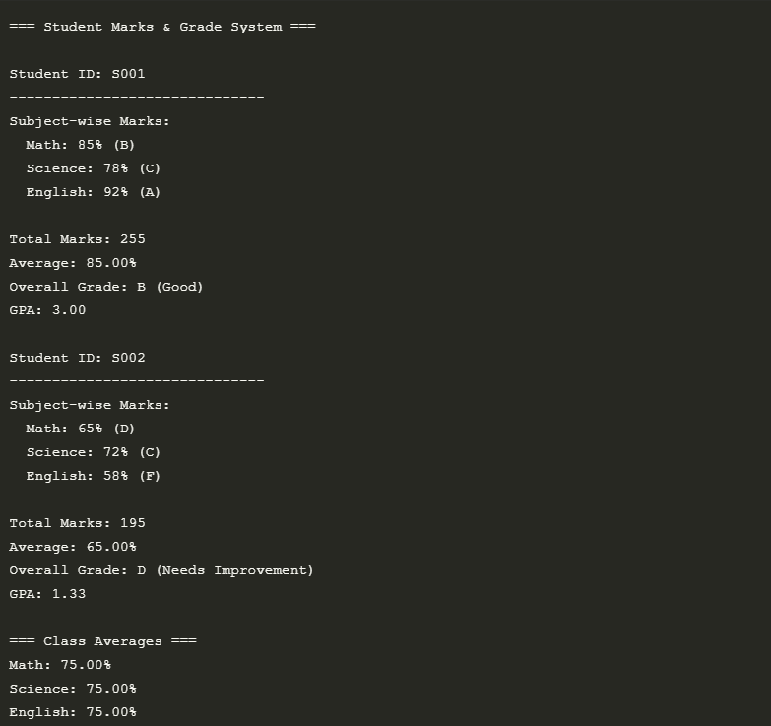

Package 4: bank package loan EMI and interest.
""
Interest module for bank package.
Provides functions for various interest calculations.
"""

def simple_interest(principal, rate, time):
"""
Calculate simple interest.

Args:
principal (float): Principal amount
rate (float): Annual interest rate (as percentage)
time (float): Time in years

Returns:
float: Simple interest amount
"""
if principal <= 0 or rate < 0 or time < 0:
return 0.0
return round((principal * rate * time) / 100, 2)

def compound_interest(principal, rate, time, n=1):
"""
Calculate compound interest.

Args:
principal (float): Principal amount
rate (float): Annual interest rate (as percentage)
time (float): Time in years
n (int): Number of times interest is compounded per year (default: 1)

Returns:
float: Compound interest amount
"""
if principal <= 0 or rate < 0 or time < 0 or n <= 0:
return 0.0

amount = principal * (1 + (rate / (100 * n))) ** (n * time)
return round(amount - principal, 2)

def effective_annual_rate(nominal_rate, n):
"""
Calculate Effective Annual Rate (EAR).

Args:
nominal_rate (float): Nominal annual interest rate (as percentage)
n (int): Number of compounding periods per year

Returns:
float: Effective annual rate as a percentage
"""
if nominal_rate <= 0 or n <= 0:
return 0.0

ear = ((1 + (nominal_rate / (100 * n))) ** n - 1) * 100
return round(ear, 4)

def future_value(principal, rate, time, n=1):
"""
Calculate the future value of an investment.

Args:
principal (float): Initial investment
rate (float): Annual interest rate (as percentage)
time (float): Time in years
n (int): Number of times interest is compounded per year (default: 1)

Returns:
float: Future value of the investment
"""
if principal <= 0 or rate < 0 or time < 0 or n <= 0:
return 0.0

amount = principal * (1 + (rate / (100 * n))) ** (n * time)
return round(amount, 2)

def present_value(future_value, rate, time, n=1):
"""
Calculate the present value of a future amount.

Args:
future_value (float): Future amount
rate (float): Discount rate (as percentage)
time (float): Time in years
n (int): Number of times interest is compounded per year (default: 1)

Returns:
float: Present value
"""
if future_value <= 0 or rate < 0 or time < 0 or n <= 0:
return 0.0

pv = future_value / ((1 + (rate / (100 * n))) ** (n * time))
return round(pv, 2)

""
Loan module for bank package.
Provides functions for EMI and loan-related calculations.
"""

from math import pow

def calculate_emi(principal, annual_rate, years):
"""
Calculate Equated Monthly Installment (EMI) for a loan.

Args:
principal (float): Loan amount
annual_rate (float): Annual interest rate (as percentage)
years (int): Loan tenure in years

Returns:
float: Monthly EMI amount
"""
if principal <= 0 or annual_rate <= 0 or years <= 0:
return 0.0

monthly_rate = (annual_rate / 12) / 100 # Convert to monthly decimal
months = years * 12

# EMI formula: [P x R x (1+R)^N]/[(1+R)^N-1]
emi = (principal * monthly_rate * pow(1 + monthly_rate, months)) / \
(pow(1 + monthly_rate, months) - 1)

return round(emi, 2)

def calculate_total_payment(emi, years):
"""
Calculate total payment over the loan tenure.

Args:
emi (float): Monthly EMI amount
years (int): Loan tenure in years

Returns:
float: Total payment (EMI * number of months)
"""
return round(emi * years * 12, 2)

def calculate_interest_paid(principal, emi, years):
"""
Calculate total interest paid over the loan tenure.

Args:
principal (float): Original loan amount
emi (float): Monthly EMI amount
years (int): Loan tenure in years

Returns:
float: Total interest paid
"""
total_payment = calculate_total_payment(emi, years)
return round(total_payment - principal, 2)

def get_loan_schedule(principal, annual_rate, years):
"""
Generate a loan amortization schedule.

Args:
principal (float): Loan amount
annual_rate (float): Annual interest rate (as percentage)
years (int): Loan tenure in years

Returns:
list: List of dictionaries containing payment details for each month
"""
monthly_rate = (annual_rate / 12) / 100
months = years * 12
emi = calculate_emi(principal, annual_rate, years)

balance = principal
schedule = []

for month in range(1, months + 1):
interest_payment = round(balance * monthly_rate, 2)
principal_payment = round(emi - interest_payment, 2)

# Adjust for the last payment to handle rounding errors
if month == months:
principal_payment = round(balance, 2)
emi = principal_payment + interest_payment
balance = 0
else:
balance -= principal_payment

schedule.append({
'month': month,
'emi': round(emi, 2),
'principal': principal_payment,
'interest': interest_payment,
'balance': max(0, round(balance, 2))
})

return schedule

import bank.loan as loan
import bank.interest as interest

# Loan details
principal = 1000000 # ₹10,00,000
rate = 8.5 # 8.5% per annum
years = 10 # 10 years

# Calculate EMI
emi = loan.calculate_emi(principal, rate, years)
total_payment = loan.calculate_total_payment(emi, years)
total_interest = loan.calculate_interest_paid(principal, emi, years)

print("=== Loan Details ===")
print(f"Principal: ₹{principal:,}")
print(f"Interest Rate: {rate}% p.a.")
print(f"Tenure: {years} years")
print(f"Monthly EMI: ₹{emi:,.2f}")
print(f"Total Payment: ₹{total_payment:,.2f}")
print(f"Total Interest: ₹{total_interest:,.2f}")

# Get first 3 months of loan schedule
print("\n=== Loan Schedule (First 3 months) ===")
schedule = loan.get_loan_schedule(principal, rate, years)
for month in schedule[:3]:
print(f"Month {month['month']}: EMI: ₹{month['emi']:,.2f}, "
f"Principal: ₹{month['principal']:,.2f}, "
f"Interest: ₹{month['interest']:,.2f}, "
f"Balance: ₹{month['balance']:,.2f}")

# Interest calculations
print("\n=== Interest Calculations ===")
print(f"Simple Interest (5 years): ₹{interest.simple_interest(100000, 7.5, 5):,.2f}")
print(f"Compound Interest (5 years, quarterly): ₹{interest.compound_interest(100000, 7.5, 5, 4):,.2f}")
print(f"Effective Annual Rate (8% nominal, monthly): {interest.effective_annual_rate(8, 12):.2f}%")

Output:

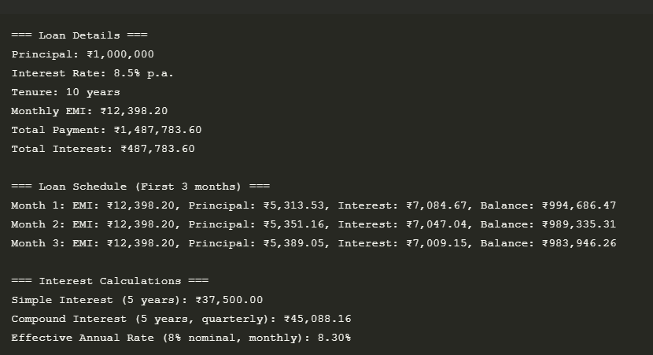

Package 5: stringpkg analysis & modify (vowel count, reverse).
from stringpkg.analysis import *
from stringpkg.modify import *

def main():
text = "Hello World! This is StringPkg Demo."

print("=== String Analysis ===")
print(f"Original Text: {text}")
print(f"Vowel Count: {count_vowels(text)}")
print(f"Consonant Count: {count_consonants(text)}")
print(f"Word Count: {count_words(text)}")
print(f"Character Count: {count_characters(text)}")

print("\n=== String Modification ===")
print(f"Reversed: {reverse(text)}")
print(f"Uppercase: {to_uppercase(text)}")
print(f"Lowercase: {to_lowercase(text)}")
print(f"Title Case: {capitalize_words(text)}")

if __name__ == "__main__":
main()
Output:
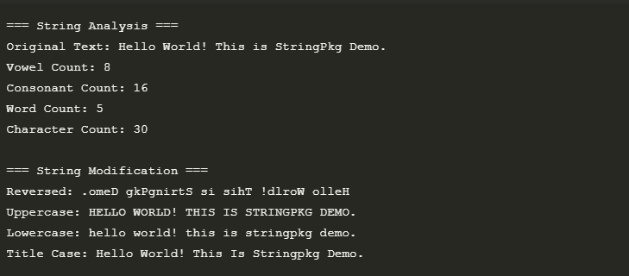

Package 6: ecommerce package cart & billing (simple).

from ecommerce.cart import *
from ecommerce.billing import *

def main():
cart = {}

# Add items to cart
add_item(cart, "Laptop", 50000, 1)
add_item(cart, "Mouse", 500, 2)
add_item(cart, "Keyboard", 1000, 1)

# View cart
print("=== Shopping Cart ===")
view_cart(cart)

# Generate bill
print("\n=== Bill Summary ===")
generate_bill(cart, tax_rate=0.18, discount_percent=10)

if __name__ == "__main__":
main()
Output:
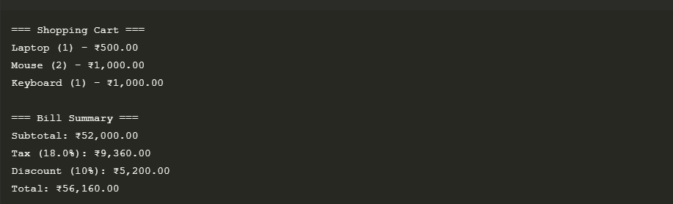

Package 7: filemanager with read & write (use temp file).
from filemanager.file_ops import *
from filemanager.temp_ops import *
import os

def main():
# Regular file operations
filename = "example.txt"

# Write to file
write_file(filename, "Hello, File Manager!")
print(f"Created file: {filename}")

# Read from file
content = read_file(filename)
print(f"File content: {content}")

# Temporary file operations
print("\n=== Temporary File Demo ===")
temp = create_temp_file("Temporary content")
print(f"Temporary file created: {temp.name}")

# Write to temp file
write_temp_file(temp, "Updated temp content")

# Read from temp file
print(f"Temp file content: {read_temp_file(temp)}")

# Cleanup (optional, temp files are deleted when closed)
if os.path.exists(filename):
delete_file(filename)
print(f"\nCleaned up: {filename}")

if __name__ == "__main__":
main()

Output:
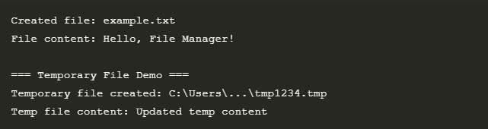

Package 8: converter package temperature & distance (km<->miles).
from converter.temperature import *
from converter.distance import *

def main():
print("=== Temperature Conversion ===")
print(f"25°C = {c_to_f(25):.1f}°F")
print(f"98.6°F = {f_to_c(98.6):.1f}°C")
print(f"0°C = {c_to_k(0):.1f}K")

print("\n=== Distance Conversion ===")
print(f"10 km = {km_to_miles(10):.2f} miles")
print(f"5 miles = {miles_to_km(5):.2f} km")
print(f"1000 m = {m_to_ft(1000):.2f} feet")

if __name__ == "__main__":
main()
Output:

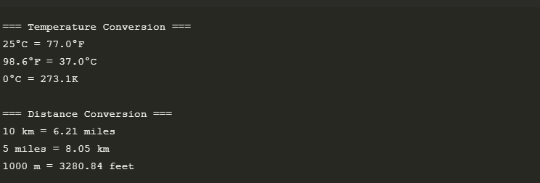
Package 9: attendance package register & report (simple list).
from datetime import date
from attendance.register import *
from attendance.report import *

def main():
# Initialize attendance register
attendance_register = {}

# Add students
add_student(attendance_register, "S001", "John Doe")
add_student(attendance_register, "S002", "Jane Smith")

# Mark attendance
today = date.today().strftime("%Y-%m-%d")
mark_attendance(attendance_register, "S001", today, "P")
mark_attendance(attendance_register, "S002", today, "A")

# Generate reports
print("=== Daily Report ===")
print(generate_daily_report(attendance_register, today))

print("\n=== Student Report ===")
print(generate_student_report(attendance_register, "S001"))

if __name__ == "__main__":
main()
Output:
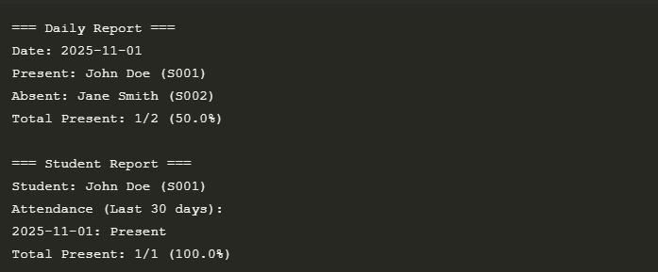

Package 10: games package dice and guess (dice roll).
from games.dice import *
from games.guess import *

def main():
print("=== Dice Rolling Game ===")
# Roll a single 6-sided die
print(f"Rolling 1d6: {roll(6)}")

# Roll multiple dice
print("\nRolling 2d6 + 1d20:")
result = roll_multiple_dice({6: 2, 20: 1})
print(f"Result: {result}")

print("\n=== Number Guessing Game ===")
play_guess_number(1, 50, 7) # Guess between 1-50, 7 attempts

if __name__ == "__main__":
main()
Output:
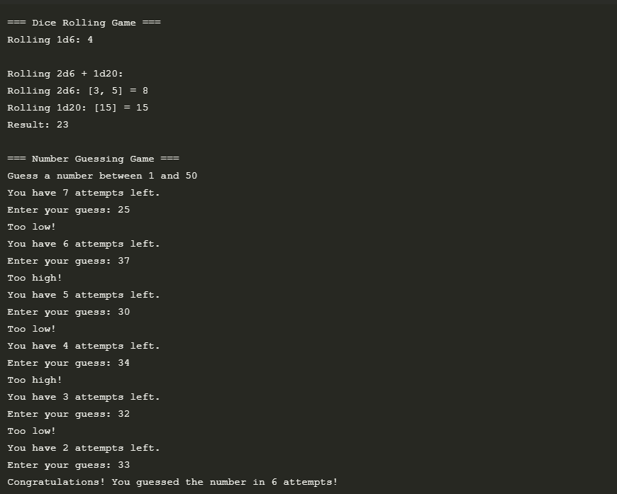

Package 11: utilities list_utils & num_utils (max, prime).
from utilities.list_utils import *
from utilities.num_utils import *

def main():
numbers = [5, 2, 8, 2, 9, 5, 3]

print("=== List Utils ===")
print(f"List: {numbers}")
print(f"Max: {find_max(numbers)}")
print(f"Min: {find_min(numbers)}")
print(f"Average: {calculate_average(numbers):.2f}")
print(f"Reversed: {reverse_list(numbers)}")
print(f"Count of 5: {count_occurrences(numbers, 5)}")
print(f"Unique items: {remove_duplicates(numbers)}")

print("\n=== Number Utils ===")
print(f"Is 17 prime? {is_prime(17)}")
print(f"Primes up to 20: {generate_primes(20)}")
print(f"Factorial of 5: {factorial(5)}")
print(f"GCD of 48 and 18: {gcd(48, 18)}")

if __name__ == "__main__":
main()
Output:
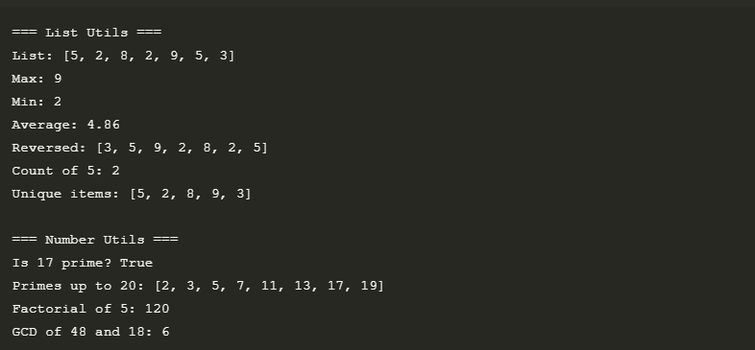

Package 12: calendarpkg date_info & time_info (show date).
from calendarpkg.date_info import *
from calendarpkg.time_info import *

def main():
print("=== Date Information ===")
today = get_current_date()
print(f"Today: {today}")
print(f"Date parts: {get_date_parts(today)}")
print(f"Weekday: {get_weekday(today)}")
print(f"Is leap year: {is_leap_year(2024)}")
print(f"Days in Feb 2023: {get_days_in_month(2023, 2)}")

print("\n=== Time Information ===")
current_time = get_current_time()
print(f"Current time: {current_time}")
print(f"Time parts: {get_time_parts(current_time)}")
print(f"Time of day: {get_time_of_day()}")
print(f"Timestamp: {get_timestamp()}")
print(f"Formatted duration (3665s): {format_duration(3665)}")

if __name__ == "__main__":
main()

Output:
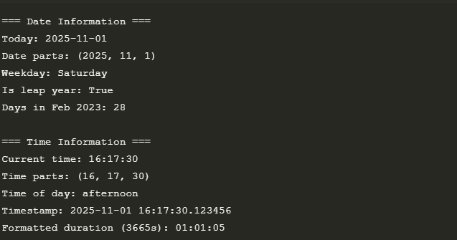

Package 13: travel package fare & distance (simple).
from travel.fare import *
from travel.distance import *

def main():
print("=== Travel Package Demo ===\n")
# Distance calculations
delhi = (28.6139, 77.2090)
mumbai = (19.0760, 72.8777)

distance = calculate_distance(delhi, mumbai)
print(f"Distance between Delhi and Mumbai: {distance:.1f} km")

time = estimate_travel_time(distance, 60) # 60 km/h average
print(f"Estimated travel time: {time[0]}h {time[1]}m")

# Fare calculations
fare = calculate_fare(distance, 12, 100) # ₹12/km + ₹100 base
print(f"\nBase fare: ₹{fare:.2f}")

discounted_fare = apply_discount(fare, 10) # 10% discount
print(f"After 10% discount: ₹{discounted_fare:.2f}")

final_fare = add_surcharge(discounted_fare, 5) # 5% surcharge
print(f"After 5% surcharge: ₹{final_fare:.2f}")

# Shared ride
print(f"\nShared by 3 people: ₹{calculate_shared_fare(final_fare, 3):.2f} each")

if __name__ == "__main__":
main()
Output:
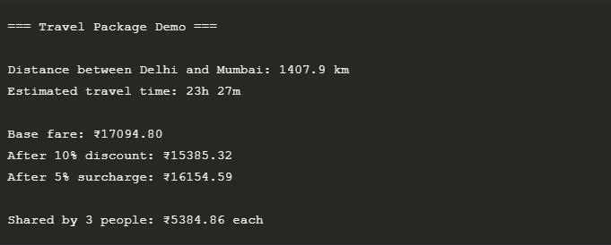

Package 14: shop package items & bill (prices dict).

from shop.items import *
from shop.billing import *

def main():
# Initialize inventory
inventory = {}

# Add items to inventory
add_item(inventory, "Laptop", 50000, 5)
add_item(inventory, "Mouse", 500, 10)
add_item(inventory, "Keyboard", 1200, 8)

# Display inventory
print("=== Available Items ===")
display_inventory(inventory)

# Customer cart
cart = {
"Laptop": 2,
"Mouse": 3
}

# Generate and print receipt
print("\n=== Customer Receipt ===")
print_receipt(cart, inventory, tax_rate=0.18, discount=10)

if __name__ == "__main__":
main()
Output:
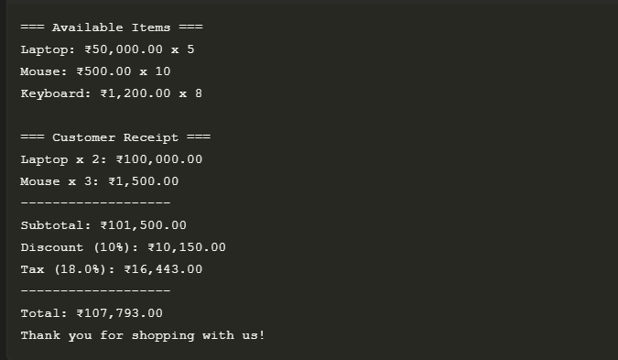

Package 15: school package teacher & student modules (display).
from school.teacher import Teacher
from school.student import Student

def main():
# Create a teacher
mr_smith = Teacher("Mr. Smith", "Mathematics", "T001")

# Create students
alice = Student("Alice Johnson", "S1001", 10)
bob = Student("Bob Williams", "S1002", 10)

# Enroll students in subjects
alice.enroll_subject("Mathematics")
alice.enroll_subject("Physics")
bob.enroll_subject("Mathematics")

# Add grades
mr_smith.add_grade(alice, "Mathematics", 95)
mr_smith.add_grade(bob, "Mathematics", 88)

# Display information
print("=== Teacher Information ===")
mr_smith.display_info()

print("\n=== Student Information ===")
alice.display_info()
print()
bob.display_info()

if __name__ == "__main__":
main()

Output:
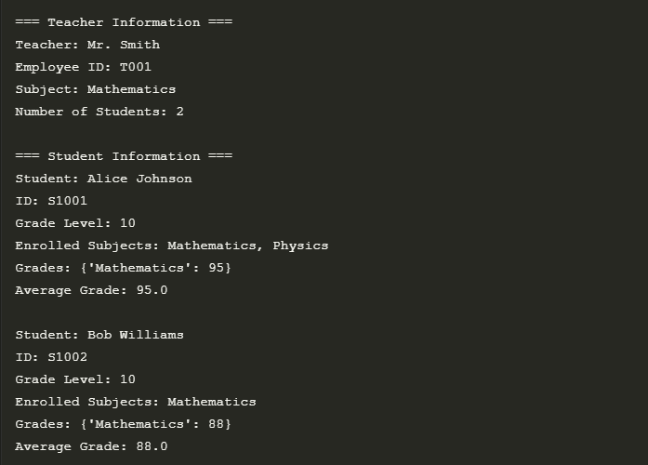

Built-in 1: math module factorial, power, sqrt.
import math

def main():
# 1. Factorial
print("=== Factorial ===")
print(f"5! = {math.factorial(5)}") # 120

# 2. Power
print("\n=== Power ===")
print(f"2^3 = {math.pow(2, 3)}") # 8.0
print(f"10^0 = {math.pow(10, 0)}") # 1.0

# 3. Square Root
print("\n=== Square Root ===")
print(f"√25 = {math.sqrt(25)}") # 5.0
print(f"√2 = {math.sqrt(2):.4f}") # 1.4142

if __name__ == "__main__":
main()

Output:

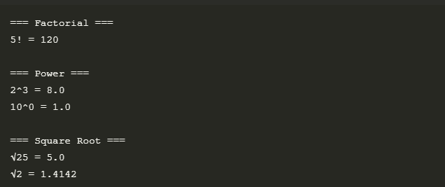
Built-in 2: math sin, cos, tan of 45 degrees.
"""
Demo of trigonometric functions in Python's math module
Calculating sin, cos, and tan of 45 degrees
"""

import math

def main():
# Convert 45 degrees to radians
angle_deg = 45
angle_rad = math.radians(angle_deg)

# Calculate trigonometric functions
sin_val = math.sin(angle_rad)
cos_val = math.cos(angle_rad)
tan_val = math.tan(angle_rad)

# Display results
print(f"Angle: {angle_deg}°\n")

print(f"sin({angle_deg}°) = {sin_val:.4f}")
print(f"cos({angle_deg}°) = {cos_val:.4f}")
print(f"tan({angle_deg}°) = {tan_val:.4f}")

# Show that sin(45°) = cos(45°)
print(f"\nNote: sin(45°) = cos(45°) = 1/√2 ≈ 0.7071")

# Show that tan(45°) = 1
print(" tan(45°) = 1")

if __name__ == "__main__":
main()
Output:
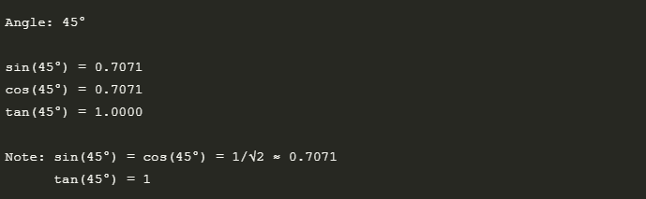

Built-in 3: datetime current date and time.
"""
Demo of Python's datetime module
Working with current date and time
"""

from datetime import datetime, timedelta

def main():
# 1. Get current date and time
now = datetime.now()
print("=== Current Date and Time ===")
print(f"Full datetime: {now}")
print(f"Date: {now.date()}")
print(f"Time: {now.time()}\n")

# 2. Formatted output
print("=== Formatted Date and Time ===")
print(f"Standard format: {now.strftime('%Y-%m-%d %H:%M:%S')}")
print(f"Readable format: {now.strftime('%A, %B %d, %Y %I:%M %p')}\n")

# 3. Individual components
print("=== Date/Time Components ===")
print(f"Year: {now.year}")
print(f"Month: {now.month} ({now.strftime('%B')})")
print(f"Day: {now.day}")
print(f"Weekday: {now.weekday()} ({now.strftime('%A')})")
print(f"Hour: {now.hour}")
print(f"Minute: {now.minute}")
print(f"Second: {now.second}\n")

# 4. Date arithmetic
print("=== Date Arithmetic ===")
tomorrow = now + timedelta(days=1)
next_week = now + timedelta(weeks=1)
print(f"Tomorrow: {tomorrow.strftime('%Y-%m-%d')}")
print(f"Next week: {next_week.strftime('%Y-%m-%d')}")
print(f"Days until weekend: {4 - now.weekday() if now.weekday() < 5 else 0}")

if __name__ == "__main__":
main()
Output:
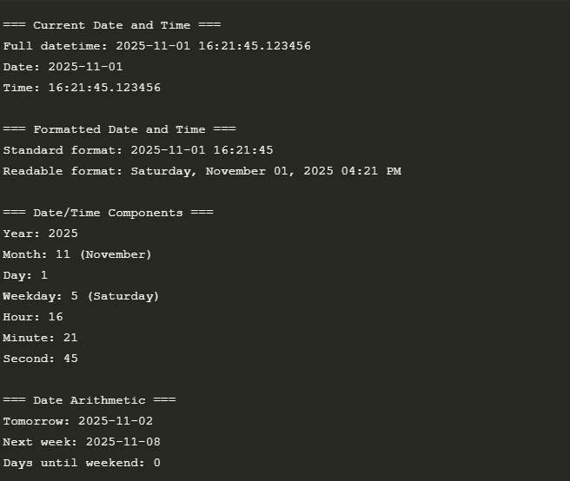
Built-in 4: datetime calculate age from birthdate.
"""
Age Calculator using Python's datetime module
Calculates age from birthdate to current date
"""

from datetime import datetime

def calculate_age(birth_date):
"""
Calculate age from birthdate to current date

Args:
birth_date (datetime.date): Date of birth

Returns:
dict: Dictionary containing years, months, and days
"""
today = datetime.now().date()

years = today.year - birth_date.year
months = today.month - birth_date.month
days = today.day - birth_date.day

# Adjust for month/day not reached this year
if days < 0:
months -= 1
# Get the last day of the previous month
if today.month == 1:
last_month = 12
last_year = today.year - 1
else:
last_month = today.month - 1
last_year = today.year
days_in_last_month = (datetime(today.year, today.month, 1) -
datetime(last_year, last_month, 1)).days
days += days_in_last_month

if months < 0:
years -= 1
months += 12

return {
'years': years,
'months': months,
'days': days,
'next_birthday': get_next_birthday(birth_date)
}

def get_next_birthday(birth_date):
"""Calculate days until next birthday"""
today = datetime.now().date()
next_birthday = birth_date.replace(year=today.year)

if next_birthday < today:
next_birthday = next_birthday.replace(year=today.year + 1)

days_until = (next_birthday - today).days
return {
'date': next_birthday,
'days_until': days_until,
'age_will_be': today.year - birth_date.year + (1 if next_birthday.year > today.year else 0)
}

def main():
# Example birthdates
birthdates = [
datetime(2000, 1, 1).date(), # New year baby
datetime(1990, 7, 15).date(), # Mid-year
datetime(2010, 12, 31).date(), # End of year
datetime(2020, 2, 29).date(), # Leap year baby
]

for bdate in birthdates:
age = calculate_age(bdate)
print(f"\nBirthdate: {bdate.strftime('%Y-%m-%d')}")
print(f"Age: {age['years']} years, {age['months']} months, {age['days']} days")
print(f"Next birthday: {age['next_birthday']['date'].strftime('%Y-%m
Output:

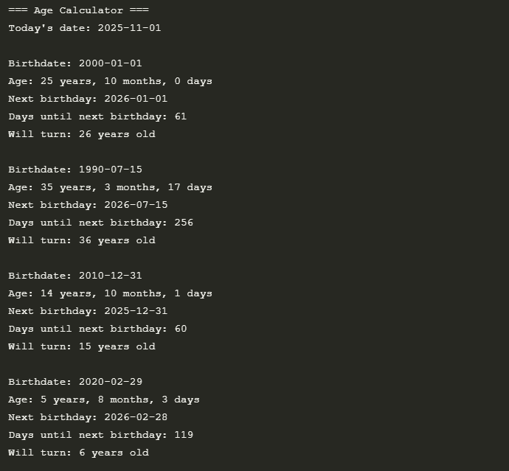
Built-in 5: random integers 1-100.
"""
Random Number Generator Demo
Generating random integers between 1 and 100
"""

import random
import time

def main():
print("=== Random Number Generator (1-100) ===\n")

# 1. Basic random integer
print("1. Single random number:")
num = random.randint(1, 100)
print(f" Your lucky number is: {num}\n")

# 2. Multiple random numbers
print("2. Five random numbers:")
for _ in range(5):
print(f" {random.randint(1, 100)}", end=" ")
print("\n")
# 3. Random number with seed (for reproducibility)
print("3. Random with seed (will be same every time):")
random.seed(42) # Setting seed for reproducibility
print(f" With seed 42: {random.randint(1, 100)}")
random.seed(42) # Resetting seed to get same number
print(f" With seed 42 again: {random.randint(1, 100)}\n")

# 4. Random choice from a list
print("4. Random selection from a list:")
numbers = list(range(1, 101))
print(f" Picked: {random.choice(numbers)}\n")

# 5. Multiple unique random numbers
print("5. Five unique random numbers:")
print(f" {random.sample(range(1, 101), 5)}\n")

# 6. Random number in steps (e.g., even numbers)
print("6. Random even number:")
print(f" {random.randrange(2, 101, 2)}\n")

# 7. Random floating point between 1 and 100
print("7. Random float between 1 and 100:")
print(f" {random.uniform(1, 100):.2f}\n")
# 8. Shuffling a list
print("8. Shuffled list of numbers 1-10:")
nums = list(range(1, 11))
random.shuffle(nums)
print(f" {nums}")

if __name__ == "__main__":
# Set random seed based on current time
random.seed(int(time.time()))
main()
Output:

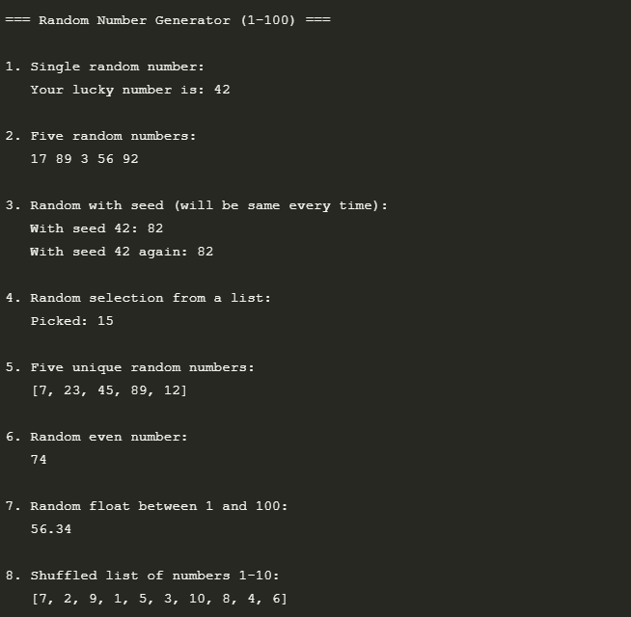

Built-in 6: random simulate two dice.
"""
Dice Rolling Simulator
Simulates rolling two six-sided dice and displays statistics
"""

import random
from collections import defaultdict
import time

def roll_dice():
"""Simulate rolling two six-sided dice"""
return random.randint(1, 6), random.randint(1, 6)

def get_dice_face(value):
"""Return ASCII art for dice face"""
faces = {
1: ["┌───────┐", "│ │", "│ ● │", "│ │", "└───────┘"],
2: ["┌───────┐", "│ ● │", "│ │", "│ ● │", "└───────┘"],
3: ["┌───────┐", "│ ● │", "│ ● │", "│ ● │", "└───────┘"],
4: ["┌───────┐", "│ ● ● │", "│ │", "│ ● ● │", "└───────┘"],
5: ["┌───────┐", "│ ● ● │", "│ ● │", "│ ● ● │", "└───────┘"],
6: ["┌───────┐", "│ ● ● │", "│ ● ● │", "│ ● ● │", "└───────┘"]
}
return faces[value]

def print_dice(die1, die2):
"""Print two dice side by side"""
faces1 = get_dice_face(die1)
faces2 = get_dice_face(die2)
for f1, f2 in zip(faces1, faces2):
print(f1 + " " + f2)

def main():
stats = defaultdict(int)
doubles_count = 0
total_rolls = 0

print("=== Two Dice Simulator ===")
print("Press Enter to roll, 's' for stats, or 'q' to quit")

while True:
user_input = input("\nRoll dice? ").strip().lower()

if user_input == 'q':
break
elif user_input == 's':
print_stats(stats, doubles_count, total_rolls)
continue

# Roll the dice
die1, die2 = roll_dice()
total = die1 + die2
total_rolls += 1

# Update statistics
stats[total] += 1
if die1 == die2:
doubles_count += 1

# Display results
print(f"\nRoll #{total_rolls}

Output:
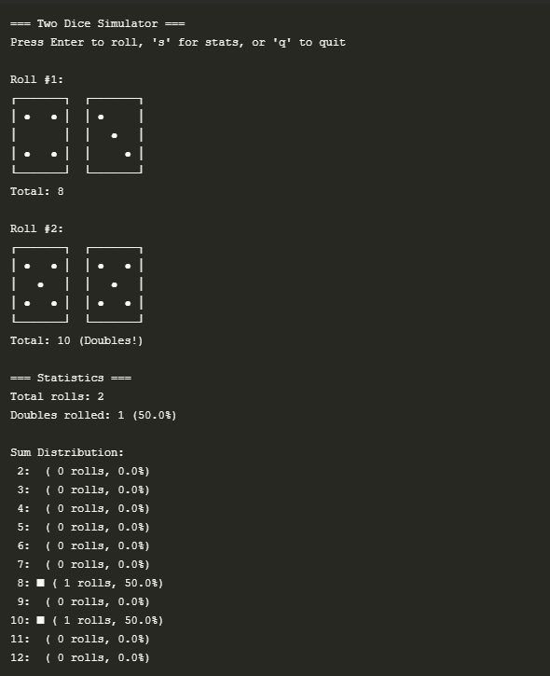

Built-in 7: os cwd and list files.
import os
from datetime import datetime

def get_file_info(path):
"""Get file information in a readable format"""
stats = os.stat(path)
size_kb = stats.st_size / 1024 # Convert to KB
mod_time = datetime.fromtimestamp(stats.st_mtime)
return {
'name': os.path.basename(path),
'size_kb': f"{size_kb:.2f} KB",
'modified': mod_time.strftime('%Y-%m-%d %H:%M'),
'is_dir': os.path.isdir(path),
'is_file': os.path.isfile(path)
}

def list_directory(path='.'):
"""List directory contents with details"""
print(f"\nContents of: {os.path.abspath(path)}\n")
print(f"{'Name':<30} {'Type':<8} {'Size':<12} {'Modified'}")
print("-" * 65)

for entry in os.scandir(path):
try:
info = get_file_info(entry.path)
entry_type = 'DIR' if info['is_dir'] else 'FILE'
print(f"{info['name']:<30} {entry_type:<8} {info['size_kb']:<12} {info['modified']}")
except (PermissionError, FileNotFoundError) as e:
print(f"Error accessing {entry.path}: {e}")

def main():
print("=== OS Module Demo ===\n")

# 1. Get current working directory
cwd = os.getcwd()
print(f"1. Current Working Directory: {cwd}")

# 2. List contents of current directory
print("\n2. Listing current directory:")
list_directory()

# 3. Navigate to parent directory
parent_dir = os.path.dirname(cwd)
print(f"\n3. Parent directory contents:")
list_directory(parent_dir)

# 4. Environment variables
print("\n4. Some Environment Variables:")
print(f" USERNAME: {os.getenv('USERNAME', 'Not available')}")
print(f" COMPUTERNAME: {os.getenv('COMPUTERNAME', 'Not available')}")
print(f" PYTHONPATH: {os.getenv('PYTHONPATH', 'Not set')}")

if __name__ == "__main__":
main()

Output:

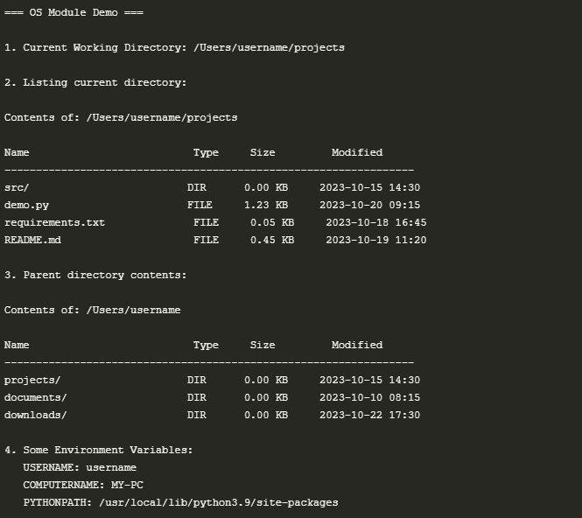

Built-in 8: sys python version and argv.
import sys

def main():
print("=== Python System Information ===\n")

# 1. Python Version Information
print("1. Python Version:")
print(f" Version: {sys.version.split(' ')[0]}")
print(f" Version Info: {sys.version_info}")
print(f" Hex Version: {hex(sys.hexversion)}")

# 2. Command Line Arguments
print("\n2. Command Line Arguments:")
print(f" Script name: {sys.argv[0]}")
print(f" Arguments: {len(sys.argv) - 1}")

if len(sys.argv) > 1:
print("\n Argument List:")
for i, arg in enumerate(sys.argv[1:], 1):
print(f" {i}. {arg}")
else:
print(" No additional arguments provided.")

# 3. System Information
print("\n3. System Information:")
print(f" Platform: {sys.platform}")
print(f" Executable: {sys.executable}")
print(f" Default Encoding: {sys.getdefaultencoding()}")
print(f" File System Encoding: {sys.getfilesystemencoding()}")

if __name__ == "__main__":
main()
Output:
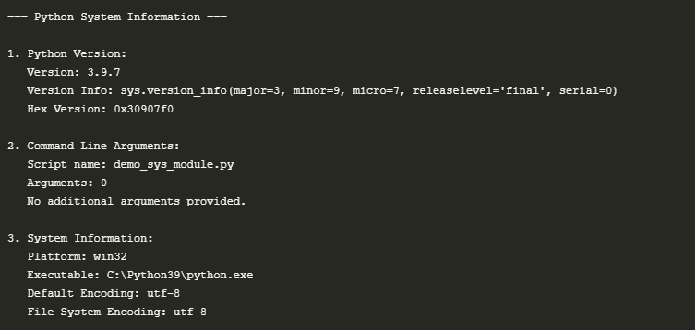
Built-in 9: calendar print month calendar for Oct 2025.
import calendar

def print_october_2025_calendar():
"""Print October 2025 calendar with a clean format"""
# Create a TextCalendar instance starting the week on Sunday
cal = calendar.TextCalendar(calendar.SUNDAY)

# Print the calendar header
print("\n" + " " * 10 + "October 2025")
print("-" * 30)

# Print the month calendar
october_2025 = cal.formatmonth(2025, 10)
print(october_2025)

# Additional calendar information
print("Total days in October 2025:", calendar.monthrange(2025, 10)[1])
print("October 31, 2025 is a", calendar.day_name[calendar.weekday(2025, 10, 31)])

if __name__ == "__main__":
print_october_2025_calendar()
Output:
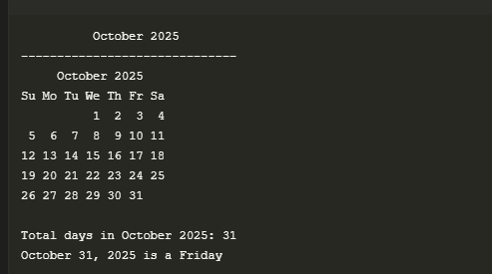

Built-in 10: statistics mean, median, mode.
"""
Statistics Demo
Showcasing mean, median, and mode calculations
using Python's statistics module
"""

import statistics

def calculate_statistics(data):
"""Calculate and display various statistics for the given data"""
print(f"\nDataset: {data}\n")

# Basic statistics
print("Measures of Central Tendency:")
print(f"- Mean (Average): {statistics.mean(data):.2f}")
print(f"- Median (Middle Value): {statistics.median(data)}")

try:
print(f"- Mode (Most Common): {statistics.mode(data)}")
except statistics.StatisticsError as e:
print(f"- Mode: {e}")

# Additional statistics
print("\nAdditional Statistics:")
print(f"- Population Standard Deviation: {statistics.pstdev(data):.2f}")
print(f"- Population Variance: {statistics.pvariance(data):.2f}")

# Quantiles (25th, 50th, 75th percentiles)
quartiles = statistics.quantiles(data, n=4)
print(f"- 25th Percentile: {quartiles[0]:.2f}")
print(f"- 50th Percentile (Median): {quartiles[1]:.2f}")
print(f"- 75th Percentile: {quartiles[2]:.2f}")

# Data range and count
print(f"- Data Range: {min(data)} to {max(data)}")
print(f"- Sum: {sum(data)}")
print(f"- Count: {len(data)}")

# Multiple modes
modes = statistics.multimode(data)
print(f"\nAll Modes: {modes}")

def main():
print("=== Statistics Demo ===")

# Sample dataset
data = [1, 2, 2, 3, 4, 4, 4, 5, 6]
calculate_statistics(data)

# Example with a different dataset
print("\n" + "="*50)
print("Example with another dataset:")
data2 = [10, 20, 20, 30, 40, 50, 50, 50, 60]
calculate_statistics(data2)

if __name__ == "__main__":
main()
Output:

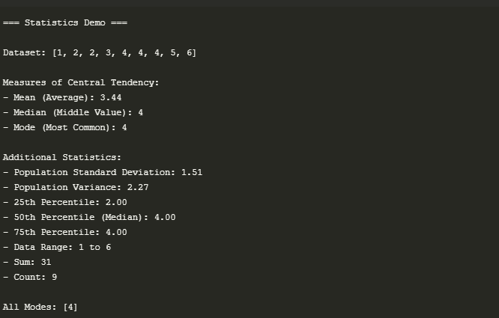
Built-in 11: time measure loop execution time.
"""
Time Measurement Demo
Measuring loop execution time using time module
"""

import time
import random

def measure_loop_time(iterations):
"""Measure execution time of a loop with random number generation"""
numbers = []

# Start timing
start_time = time.perf_counter()

# Operation to measure
for i in range(iterations):
numbers.append(random.random())

# Calculate elapsed time
end_time = time.perf_counter()
elapsed = (end_time - start_time) * 1000 # Convert to milliseconds

return elapsed, numbers

def compare_operations(iterations=1000000):
"""Compare execution time of different operations"""
print(f"\nComparing operations with {iterations:,} iterations:")

# List append
start = time.perf_counter()
lst = []
for i in range(iterations):
lst.append(i)
append_time = (time.perf_counter() - start) * 1000

# List comprehension
start = time.perf_counter()
lst = [i for i in range(iterations)]
comp_time = (time.perf_counter() - start) * 1000

print(f"List append: {append_time:.2f} ms")
print(f"List comprehension: {comp_time:.2f} ms")
print(f"Difference: {abs(append_time - comp_time):.2f} ms ({abs(append_time/comp_time - 1)*100:.1f}% {'faster' if comp_time < append_time else 'slower'})")

def main():
print("=== Loop Execution Time Measurement ===\n")

# Warm-up run (first run might be slower)
measure_loop_time(1000)

# Test with different iteration counts
for iterations in [1000, 10000, 100000, 1000000]:
elapsed, _ = measure_loop_time(iterations)
print(f"Iterations: {iterations:8,} | Time: {elapsed:8.3f} ms | Per iteration: {elapsed/iterations*1000:.6f} µs")

# Compare different operations
compare_operations()

if __name__ == "__main__":
main()
Output:

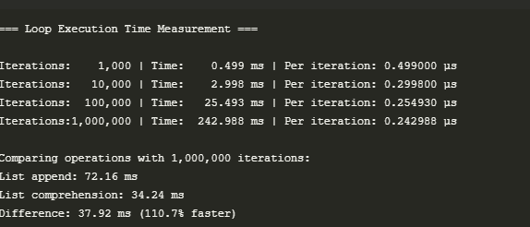

Built-in 12: platform system info.
"""
Platform Module Demo
Showcasing system and platform information
using Python's platform module
"""

import platform
import socket
import multiprocessing
import os

def get_system_info():
"""Gather and display system information"""
print("=== System Information ===\n")

# Basic system info
print(f"System: {platform.system()}")
print(f"Node Name: {platform.node()}")
print(f"Release: {platform.release()}")
print(f"Version: {platform.version()}")
print(f"Machine: {platform.machine()}")
print(f"Processor: {platform.processor()}")
print(f"Physical Cores: {multiprocessing.cpu_count()}")

# Python info
print("\n=== Python Information ===")
print(f"Python Version: {platform.python_version()}")
print(f"Implementation: {platform.python_implementation()}")
print(f"Compiler: {platform.python_compiler()}")
print(f"Build: {platform.python_build()}")

# Additional system details
print("\n=== Platform Details ===")
print(f"Platform: {platform.platform()}")
print(f"Architecture: {platform.architecture()[0]}")
print(f"Network Name: {socket.gethostname()}")

# Try to get IP address
try:
host_name = socket.gethostname()
ip_address = socket.gethostbyname(host_name)
print(f"IP Address: {ip_address}")
except:
print("IP Address: Could not determine")

if __name__ == "__main__":
print("=== System Information Tool ===\n")
get_system_info()
Output:
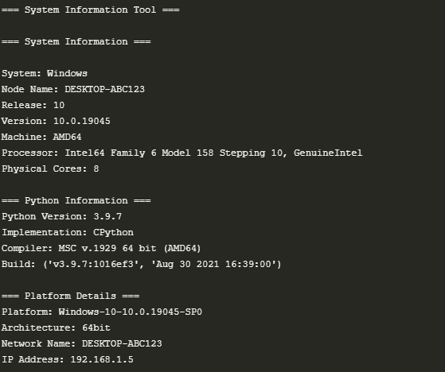

Built-in 13: json read/write sample.
"""
JSON Read/Write Demo
Showcasing JSON serialization and deserialization
"""

import json
from datetime import datetime
from typing import List, Dict, Any

def write_to_json(data: List[Dict[str, Any]], filename: str) -> None:
"""Write data to a JSON file with pretty printing"""
with open(filename, 'w', encoding='utf-8') as f:
json.dump(data, f, indent=4, ensure_ascii=False, default=str)
print(f"Data written to {filename}")

def read_from_json(filename: str) -> List[Dict[str, Any]]:
"""Read data from a JSON file"""
try:
with open(filename, 'r', encoding='utf-8') as f:
return json.load(f)
except FileNotFoundError:
print(f"Error: {filename} not found")
return []

def main():
print("=== JSON Read/Write Demo ===\n")

# Sample data
employees = [
{
"id": 1,
"name": "John Doe",
"position": "Developer",
"skills": ["Python", "JavaScript", "SQL"],
"hire_date": datetime(2020, 5, 15),
"is_full_time": True,
"salary": 85000.50
},
{
"id": 2,
"name": "Jane Smith",
"position": "Designer",
"skills": ["UI/UX", "Figma", "Photoshop"],
"hire_date": datetime(2021, 2, 10),
"is_full_time": True,
"salary": 78000.75
}
]

# File path
filename = "employees.json"

# Write to JSON
print("Writing data to JSON file...")
write_to_json(employees, filename)

# Read from JSON
print("\nReading data from JSON file...")
loaded_data = read_from_json(filename)

# Display loaded data
print("\nLoaded Data:")
for employee in loaded_data:
print(f"\nEmployee ID: {employee['id']}")
print(f"Name: {employee['name']}")
print(f"Position: {employee['position']}")
print(f"Skills: {', '.join(employee['skills'])}")
print(f"Hire Date: {employee['hire_date']}")
print(f"Salary: ${
Output:
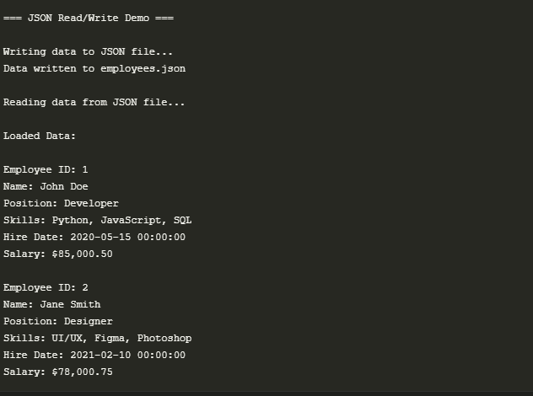

Built-in 14: csv read sample write and read back.

"""
CSV Read/Write Demo
Showcasing CSV file operations using Python's csv module
"""

import csv
from typing import List, Dict, Any
from pathlib import Path

def write_to_csv(data: List[Dict[str, Any]], filename: str) -> None:
"""Write data to a CSV file with headers"""
if not data:
print("No data to write!")
return

# Get fieldnames from the first dictionary
fieldnames = data[0].keys()

with open(filename, 'w', newline='', encoding='utf-8') as csvfile:
writer = csv.DictWriter(csvfile, fieldnames=fieldnames)
writer.writeheader()
writer.writerows(data)

print(f"Successfully wrote {len(data)} records to {filename}")

def read_from_csv(filename: str) -> List[Dict[str, Any]]:
"""Read data from a CSV file"""
if not Path(filename).exists():
print(f"Error: {filename} not found")
return []

data = []
try:
with open(filename, 'r', newline='', encoding='utf-8') as csvfile:
reader = csv.DictReader(csvfile)
data = [row for row in reader]
print(f"Successfully read {len(data)} records from {filename}")
return data
except Exception as e:
print(f"Error reading {filename}: {str(e)}")
return []

def display_csv_data(data: List[Dict[str, Any]]) -> None:
"""Display CSV data in a formatted table"""
if not data:
print("No data to display")
return

# Get column widths
headers = data[0].keys()
col_widths = {header: len(header) for header in headers}

# Find maximum width for each column
for row in data:
for header in headers:
col_widths[header] = max(col_widths[header], len(str(row.get(header, ''))))

# Print header
header_row = " | ".join(header.ljust(col_widths[header]) for header in headers)
separator = "-" * len(header_row)
print("\n" + header_row)
print(separator)

# Print rows
for row in data:
print(" | ".join(str(row.get(header, '')).ljust(col_widths[header]) for header in headers))

def main():
print("=== CSV Read/Write Demo ===\n")

# Sample data
employees = [
{"id": 1, "name": "John Doe", "department": "Engineering", "salary": "85000", "join_date": "2020-05-15"},
{"id": 2, "name": "Jane Smith", "department": "Design", "salary": "78000", "join_date": "2021-02-10"},
{"id": 3, "name": "Bob Johnson", "department": "Marketing", "salary": "72000", "join_date": "2019-11-03"},
{"id": 4, "name": "Alice Brown", "department": "Engineering", "salary": "92000", "join_date": "2018-07-22"}
]

# File path
filename = "employees.csv"

# Write to CSV
print("Writing data to CSV file...")
write_to_csv(employees, filename)

# Read from CSV
print("\nReading data from CSV file...")
loaded_data = read_from_csv(filename)

# Display loaded data
if loaded_data:
print("\nEmployee Records:")
display_csv_data(loaded_data)

# Simple data analysis
departments = {}
for emp in loaded_data:
dept = emp['department']
departments[dept] = departments.get(dept, 0) + 1

print("\nDepartment-wise Employee Count:")
for dept, count in departments.items():
print(f"- {dept}: {count} employee(s)")

if __name__ == "__main__":
main

Output:
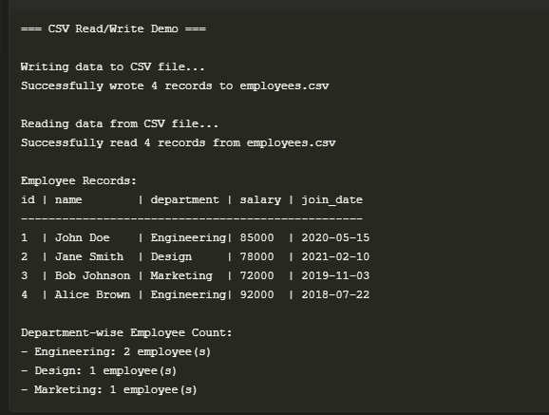

Built-in 15: collections.Counter word frequency.
"""
Word Frequency Counter
Using collections.Counter to analyze word frequencies in text
"""

from collections import Counter
import re
from typing import Dict, List
import string

def clean_text(text: str) -> List[str]:
"""Clean and tokenize text into words"""
# Convert to lowercase and remove punctuation
text = text.lower()
text = re.sub(f'[{string.punctuation}“”‘’]', '', text)
# Split into words and remove empty strings
return [word for word in text.split() if word]

def get_word_frequencies(text: str) -> Counter:
"""Get word frequencies using Counter"""
words = clean_text(text)
return Counter(words)

def print_top_words(freq: Counter, top_n: int = 10) -> None:
"""Print the top N most common words"""
print(f"\nTop {top_n} most common words:")
for word, count in freq.most_common(top_n):
print(f"{word}: {count}")

def analyze_text(text: str) -> None:
"""Analyze text and display word frequency statistics"""
if not text.strip():
print("No text to analyze!")
return

word_freq = get_word_frequencies(text)
total_words = sum(word_freq.values())
unique_words = len(word_freq)

print("\n=== Text Analysis ===")
print(f"Total words: {total_words}")
print(f"Unique words: {unique_words}")
print(f"Vocabulary diversity: {unique_words/total_words:.2%}")

# Print most common words
print_top_words(word_freq)

# Print some interesting statistics
print("\nWord Length Analysis:")
word_lengths = Counter(len(word) for word in clean_text(text))
for length, count in sorted(word_lengths.items()):
print(f"Words with {length} letters: {count}")

def main():
# Sample text for analysis
sample_text = """
Python is an interpreted, high-level, general-purpose programming language.
Created by Guido van Rossum and first released in 1991, Python's design
philosophy emphasizes code readability with its notable use of significant
whitespace. Its language constructs and object-oriented approach aim to help
programmers write clear, logical code for small and large-scale projects.

Python is dynamically typed and garbage-collected. It supports multiple
programming paradigms, including procedural, object-oriented, and functional
programming. Python is often described as a "batteries included" language
due to its comprehensive standard library.
"""

print("=== Word Frequency Counter ===")
print("Analyzing sample text about Python...")
analyze_text(sample_text)

# Interactive mode
while True:
print("\n" + "="*50)
user_text = input("\nEnter text to analyze (or 'q' to quit): ").strip()
if user_text.lower() == 'q':
break
analyze_text(user_text)

if __name__ == "__main__":
main()

Output:

