**SketchSquad**

**Introduction:**

SketchSquad, with real-time collaboration using cloud computing is a multiplayer drawing game where players take turns drawing an object while others try to guess what it is. The game would be developed using cloud computing to handle the real-time processing and communication requirements of the game. Cloud-based servers would allow for easy scaling of computing resources based on demand, and provide a high level of reliability and uptime for players. To ensure a seamless and engaging multiplayer experience, the game would need to provide low latency and smooth gameplay. This would be achieved by leveraging cloud-based infrastructure and real-time processing to reduce lag and provide real-time collaboration features. Overall, this game can provide an engaging and challenging multiplayer experience for players, while also offering a cost-effective and scalable solution for game developers.

**Problem Statement:**

Traditional real-time collaboration games are often limited in terms of the number of players that can participate in a single match, as the game engine and network infrastructure struggle to handle the processing and communication requirements. This limits the scope of the game and makes it difficult for players to enjoy a truly engaging and challenging multiplayer experience. Additionally, traditional server infrastructure can be costly to operate and maintain, particularly for small game development teams with limited resources.

**Why cloud deployment is necessary for the solution of the problem:**

Cloud deployment enables game developers to create a real-time collaboration game that is scalable, reliable, cost-effective, globally accessible, and able to handle the real-time processing and communication requirements of the game. By leveraging cloud-based infrastructure and real-time processing, game developers can create games that are able to handle the demands of real-time collaboration, enabling players to work together effectively and efficiently in a way that is not possible with traditional server infrastructure.

**Literature review:**

The emergence of cloud computing has revolutionized the gaming industry, enabling game developers to create games with a level of scalability, reliability, and cost-effectiveness that was not previously possible. Real-time collaboration games are a particular area where cloud computing is having a significant impact, as it enables large numbers of players to work together seamlessly and in real-time.

One study by Ye et al. (2017) explored the use of cloud computing for multiplayer online games and found that cloud-based infrastructure was able to provide a high level of reliability, scalability, and cost-effectiveness for game developers. The authors also noted that real-time collaboration was an area where cloud computing could have a significant impact, enabling players to work together in real-time and share resources seamlessly.

Another study by Xu et al. (2019) examined the use of cloud computing for real-time multiplayer games and found that cloud-based infrastructure was able to provide a high level of performance and reliability for game developers. The authors noted that real-time collaboration was a key area where cloud computing was having a significant impact, enabling players to work together seamlessly and in real-time.

Overall, the literature suggests that cloud-based infrastructure is a promising solution for creating real-time collaboration games that are scalable, reliable, and cost-effective. By leveraging cloud-based infrastructure and real-time processing, game developers can create games that are able to handle the demands of real-time collaboration, enabling players to work together effectively and efficiently in a way that is not possible with traditional server infrastructure. With the right implementation, cloud-based real-time collaboration games have the potential to provide an engaging and challenging multiplayer experience for players, while also offering a cost-effective and scalable solution for game developers.

**Working of the game:**

* **Connect to game:** Players would first connect to the game's cloud-based servers, through a web browser. The servers would be responsible for managing player accounts, matchmaking, and game sessions.
* **Team up:** Once the player is connected, he can make a team or group and once all the players are matched together, they would be placed in a game session and given a prompt for what to draw. One player would be chosen to start drawing, while the other players would try to guess what the drawing represents.
* **Draw and Guess:** As the first player draws, the other players would be able to see the drawing as it progresses in real-time. Players would also be able to contribute to the drawing in real-time, either by adding to the drawing or by typing in their guesses for what the drawing represents. The cloud-based servers would handle real-time communication and processing between the players, ensuring that the gameplay is smooth and that latency is minimized. The servers would also handle the storage and retrieval of drawing data, ensuring that the data is stored securely and efficiently.
* **Scores:** As the game progresses, players would be awarded points for correctly guessing the drawing and for contributing to the drawing. The player with the most points at the end of the game session would be declared the winner.
* **Leave the game:** Once the game session ends, players would have the option to start a new game or leave the game. The cloud-based servers would handle the cleanup of the game session, ensuring that resources are released and that the session data is properly archived.

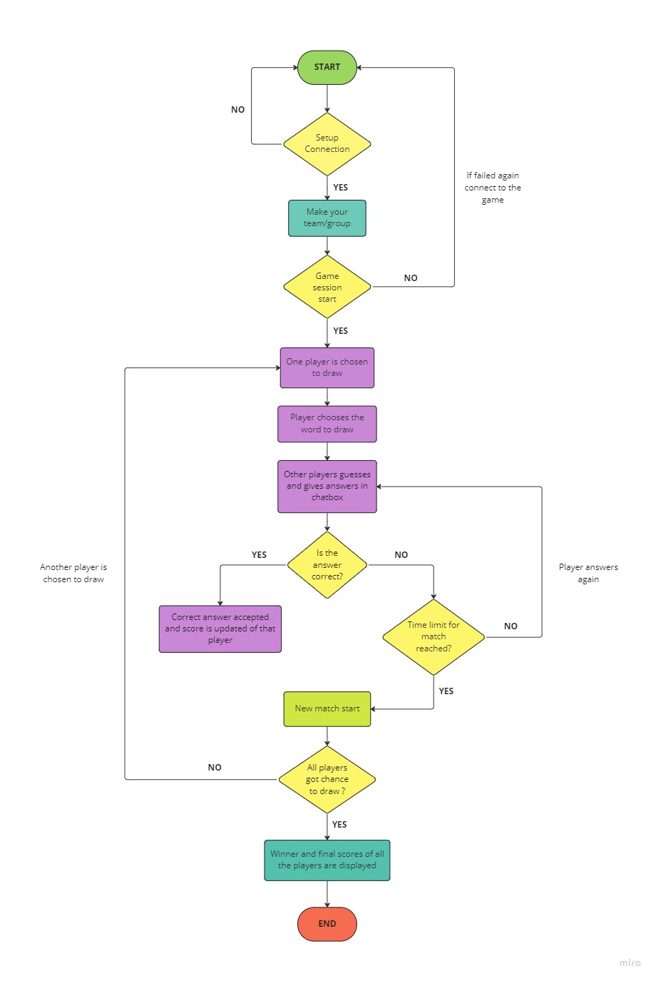**Flowchart:**