**SketchSquad**

**Architectural style the application follows:**

In a MIMD architecture, multiple processing units are available to execute multiple instructions simultaneously on multiple data sets. In the context of a cloud-based game, this means that each user's device can act as a processing unit, with instructions and data being transmitted to and from the cloud server. This architecture allows for parallelism, where multiple users can interact with the game environment simultaneously, and the cloud server can manage the coordination and synchronization of these interactions. This results in a seamless and real-time gaming experience for users, as each user's device can process its own instructions and data independently. Moreover, MIMD architecture can also provide scalability and performance advantages. As more users join the game, more processing units can be utilized to handle the increased load, leading to better performance and user experience.

One possible MIMD architecture for this project could involve a load balancer that distributes incoming requests to multiple backend servers, each running a separate instance of the game server. Each game server would be responsible for processing and responding to the requests received from a specific set of players, working independently of the other servers. Overall, MIMD architecture is a suitable choice for a cloud-based real-time collaboration game as it provides parallelism, scalability, and performance advantages necessary for a seamless gaming experience in a distributed computing environment.

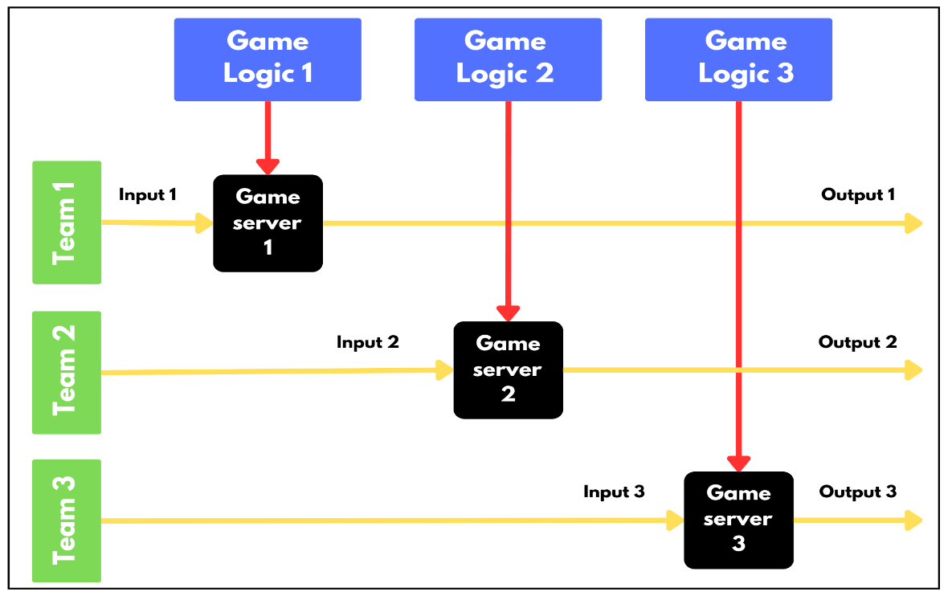

Fig-01: MIMD Architectural Style

**Cloud platform to be used:**

Microsoft Azure is a cloud computing platform and set of services offered by Microsoft. Azure provides a wide range of cloud services including virtual machines, storage, databases, analytics, and more. These services can be used to build, deploy, and manage various types of applications, including web apps, mobile apps, and enterprise solutions. Azure is known for its scalability, reliability, and security. It allows businesses and organizations to easily scale up or down their infrastructure as needed, pay only for the services they use, and access their applications and data from anywhere in the world. Azure also provides a range of tools and services for developers, including Visual Studio integration, Git repositories, continuous integration and delivery (CI/CD), and more. These tools help developers to build and deploy their applications quickly and easily, while also ensuring high levels of quality and security.

Therefore, Microsoft Azure is a popular choice for cloud-based application development and deployment. Azure can play a key role in the development and deployment of a cloud-based real-time collaboration game, SketchSquad.

Here are some of the benefits of using Azure for this application:

* **Cloud hosting:** Azure can be used to host the game servers and databases, allowing players to connect and collaborate in real-time. Azure provides a range of scalable and reliable hosting options, including Azure Virtual Machines, Azure Kubernetes Service, and Azure App Service.
* **Real-time communication:** Azure provides several communication services that can be used to support real-time collaboration, such as Azure SignalR Service and Azure Event Grid. These services allow developers to easily send messages and notifications to players in real-time, helping to ensure a smooth and responsive user experience.
* **Storage and database services:** Azure provides several storage and database services that can be used to store game data, such as player profiles, game statistics, and chat logs. Azure Blob Storage, Azure Table Storage, and Azure Cosmos DB are just a few examples of the storage options available on Azure.
* **Security and compliance:** Azure provides a range of security and compliance features, including Azure Security Center, Azure Active Directory, and Azure Policy, that can help ensure that the game is secure and compliant with relevant regulations and standards.
* **Monitoring and analytics:** Azure provides several monitoring and analytics services, such as Azure Monitor and Azure Application Insights, that can be used to monitor the game's performance and user engagement. These services provide insights into key metrics such as server response times, player activity, and user retention, helping developers to optimize the game for maximum player satisfaction.
* **Integration with other Microsoft tools:** If the development team is already familiar with Microsoft tools such as Visual Studio, .NET, and SQL Server, they may find it easier to integrate these tools with Azure. Azure provides excellent support for these tools and has strong integration with other Microsoft products, making it easier to develop and deploy applications.
* **Free Student Account:** Azure provides a free student account that gives you access to a limited amount of free resources, such as virtual machines, storage, databases and many more. This can help you reduce the cost of developing and hosting your game.

Here are some Azure services useful for this application:

* **Azure App Service:** Azure App Service can be used9/ to host your game server and web application.
* **Azure SignalR Service**: You can use Azure SignalR Service to implement real-time communication between clients and the game server.
* **Azure Cosmos DB:** You can use Azure Cosmos DB to store and manage game data, such as player information, game state, and leaderboard data.
* Azure Functions: You can use Azure Functions to implement serverless code that responds to events, such as game events or HTTP requests.

and many more.