Name-diksha
Roll no.-18114019
Ques 1.
algorithms used:

in the first method,decryption key,a,b and n are defined. For encrypted-array
,an array is created using dynamic memory allocation and i values are given using loop ,then j values are obtained and for every loop of n numbers ,the encrypted array is obtained from initial array.
Similar is done for the decrypted array.then,in the main function ,file pointer is called ,then file named inputfile.txt containing the input to be encoded and decoded is read,its length is obtained and then,the number of null characters to be added in the input is determined ,depending upon whether the length is a multiple of n or not.
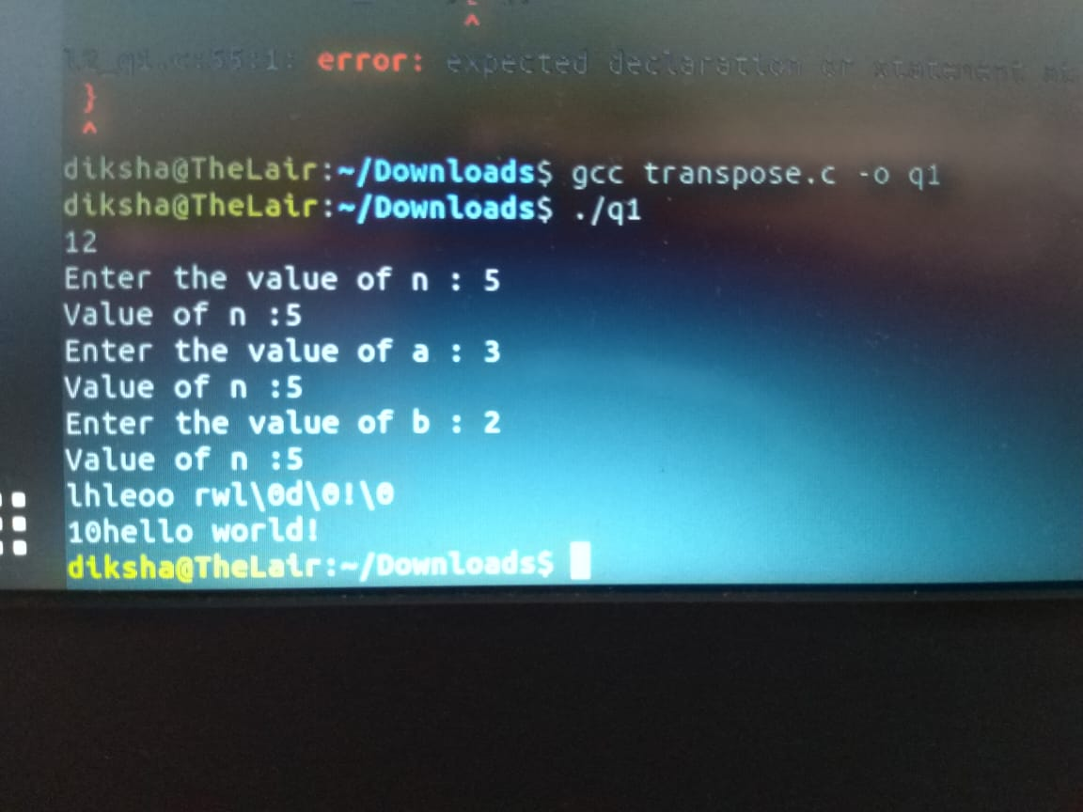

Ques2
algorithm used:
in the first method ,the input file is read and stored in an array.
Then,the size of array is changed to power of 2.then a method checks for same bits in all possible square submatrices in the matrix .then the mximal array is formed .
