width: 100% and width: 100vw may look similar, but they work differently.
width: 100%
- Takes 100% of the width of its parent element.
- Depends on the parent's size.
.container {
width: 500px;
}

.box {
width: 100%;
}
Here .box will be 500px wide because its parent is 500px.

width: 100vw
- vw = viewport width.
- 100vw means 100% of the browser window width.
- Ignores the parent's width.
.container {
width: 500px;
}

.box {
width: 100vw;
}
Here .box will be as wide as the entire browser window, even if the parent is only 500px wide.

Visual Example
Browser width = 1200px
<div class="parent">
<div class="child"></div>
</div>
.parent {
width: 800px;
}

.child {
width: 100%;
}
➡️ Child width = 800px

.child {
width: 100vw;
}
➡️ Child width = 1200px (full browser width)

Common Use Cases
✅ width: 100%
- Forms
- Cards
- Images inside containers
- Most layout elements
✅ width: 100vw
- Full-screen hero sections
- Landing page banners
- Background sections that must span the entire screen

Important Gotcha
100vw can sometimes create horizontal scrolling because it includes the scrollbar width.
body {
margin: 0;
}

.hero {
width: 100vw;
}
Many developers use:
.hero {
width: 100%;
}
instead of 100vw when they just want a full-width section inside the page.
Rule of thumb:
- Want the element to match its parent? → width: 100%
- Want the element to match the browser window? → width: 100vw

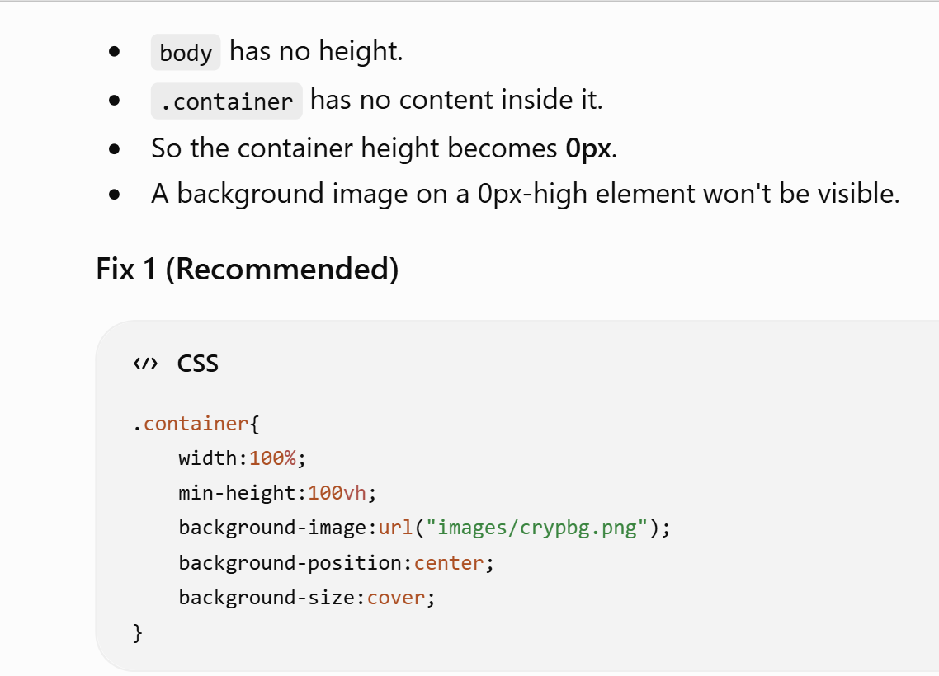

It means an HTML heading:
<h3>$00</h3>
- <h3> = a level-3 heading (smaller than <h1> and <h2>)
- $00 = the text displayed inside it
- </h3> = closes the heading
So on the webpage it will show something like:
$00
In an expense tracker, this is usually the starting value for a balance, income, or expense:
<h3>$00</h3>
Later JavaScript can change it dynamically:
balanceElement.innerText = "$500";
Then the page would show:
$500

