Presented by: - Diksha Sanjay Dhoke

Date: - 17 May 2025

Task 01

Implement Caesar Cipher

Create a Python program that can encrypt and decrypt text using the Caesar Cipher algorithm. Allow users to input a message and a shift value to perform encryption and decryption.

**Introduction: -**

**Encryption** and **Decryption** are fundamental processes in **cryptography**, used to secure information and protect it from unauthorized access.

* Encryption is the process of transforming readable data (plaintext) into an unreadableformat (ciphertext) using a mathematical algorithm and a key.  
  This protects the original data from being understood by unauthorized parties.
* **Purpose:** To ensure confidentiality
* Decryption is the process of converting the encrypted data (ciphertext) back into its original readable form (plaintext) using a key.
* **Purpose:** To allow authorized users to access the original information.

Decryption

Encryption

**Plaintext**

**Ciphertext**

**Plaintext**

The **Caesar cipher** is one of the simplest and earliest methods of encryption and demonstrates the basic principles of cryptography: substitution and key-based transformation.

**Working of Caesar Cipher**

Each letter in the plaintext is shifted a fixed number of positions down or up the alphabet.

The number of positions to shift is called the key.

**Example (with a key of +3):**

* Plaintext: **HELLO**
* Ciphertext: **KHOOR**

**Implementation of *Caesar Cipher* code in Python**

**Steps: -**

1. Choose a code editor or IDE

It’s best to not use the basic Python shell or notepad.

1. Install and set up **VS code (**Note: - here I have used VS code and because of that I’m mentioning it’s process**)**

Download: Visit <https://code.visualstudio.com/> and install VS Code.

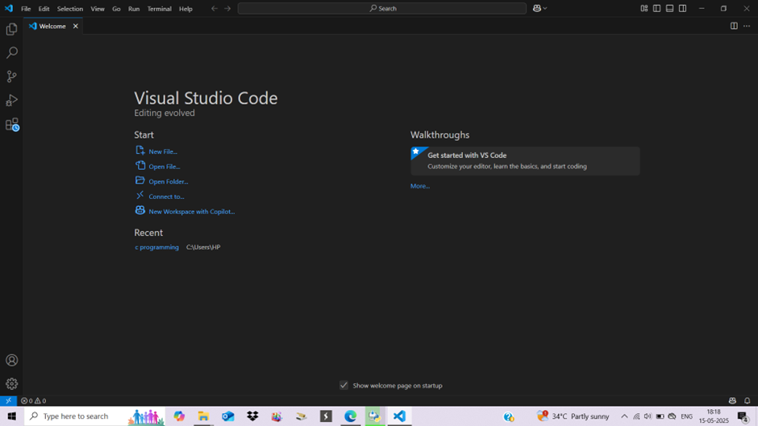

The interface shown above will be visible to you.

Go to extension tab (ctrl+ shift+ x) and search for Python. Click install on the official Microsoft Python extension.

Choose python interpreter (I have selected Python 3.13)

1. Create and save a python file (file having extension .py)

In VS Code: File 🡪 New File.

And, Save the file extension .py

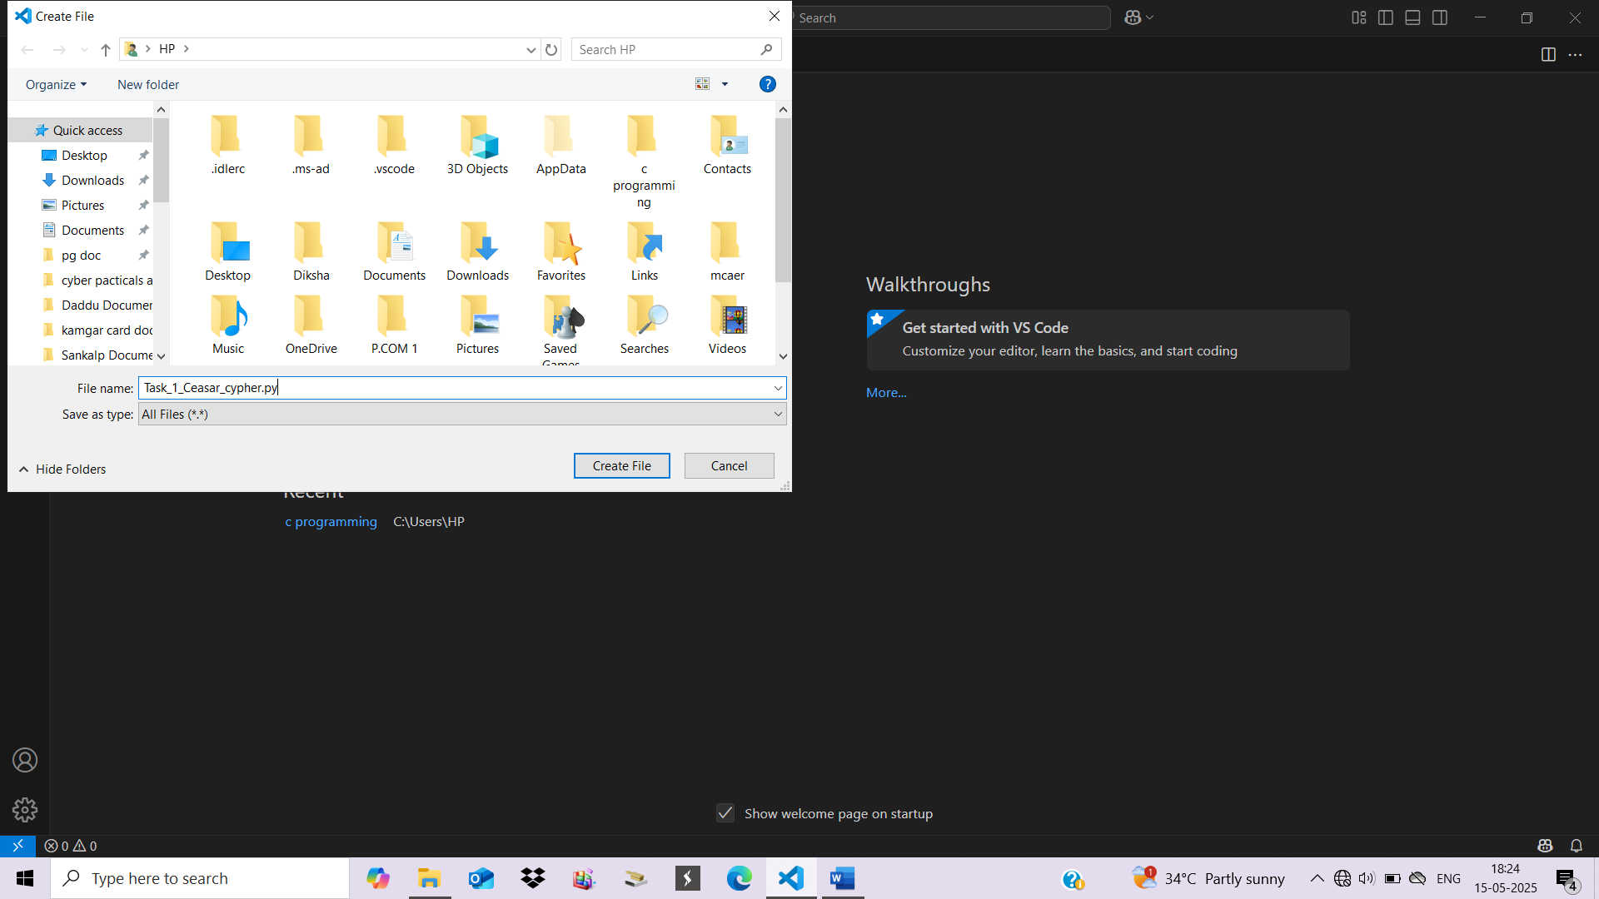

1. Start writing your program.

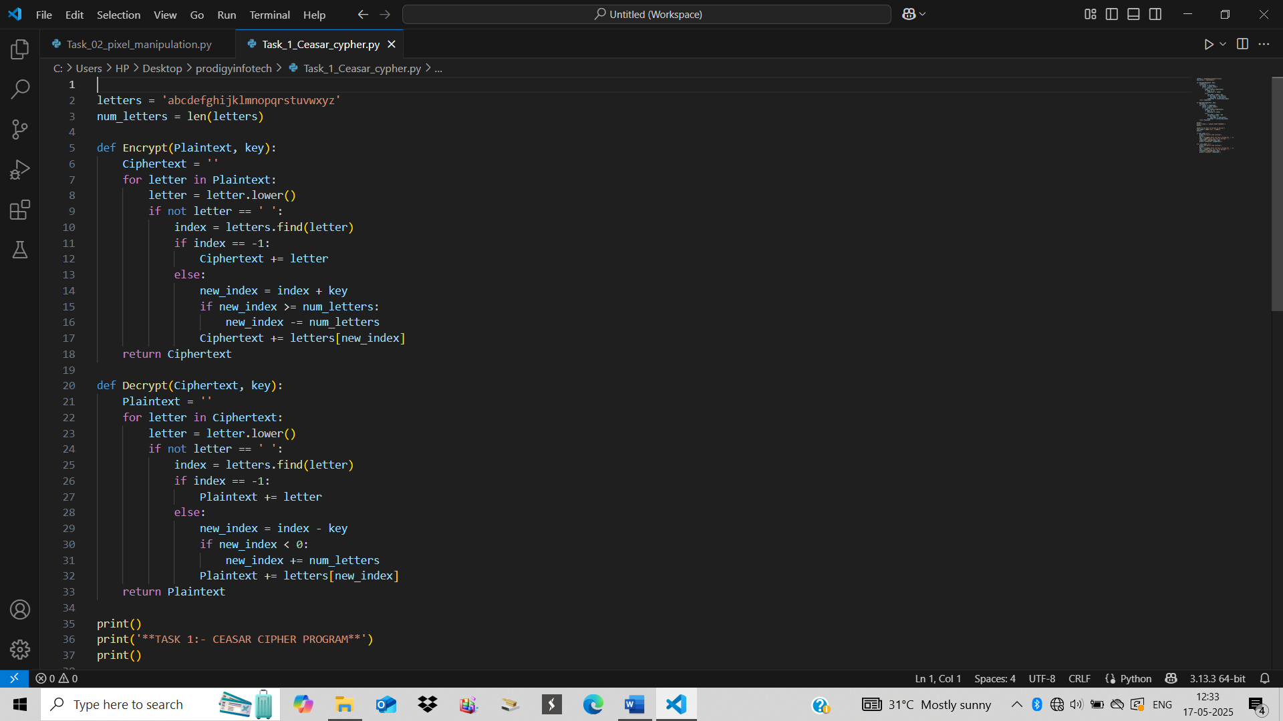 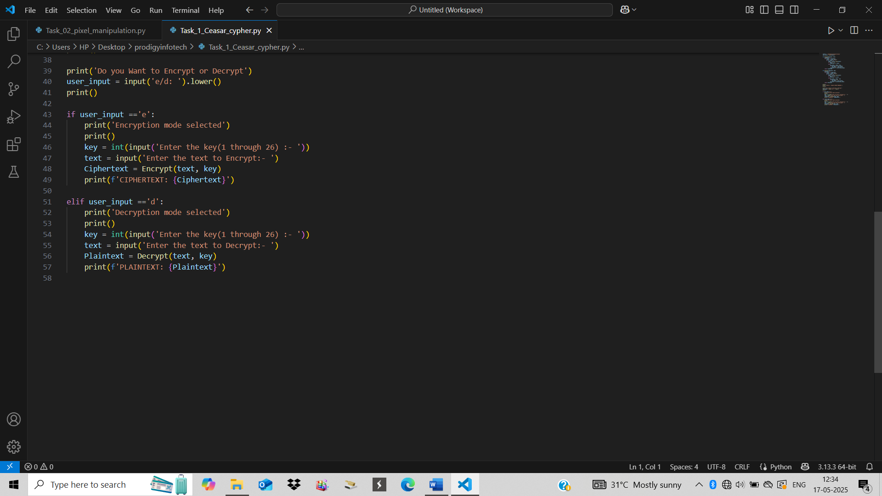

1. Run the program

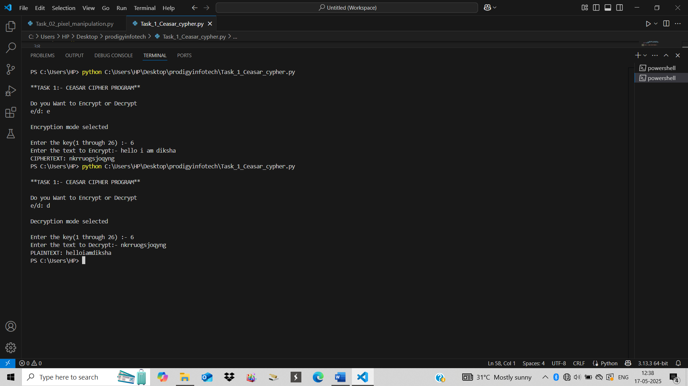

1. Debug and test your program

Successful running of program with the result shows the correct program.

**Significance of Caesar cipher technique on encryption decryption of text: -**

The Caesar Cipher, with its straightforward approach of shifting letters, serves as an excellent introduction to the world of cryptography. While it is easy to understand and implement, its simplicity also makes it vulnerable to basic attacks. Despite these limitations, the Caesar Cipher’s historical role is significant, it represents the early efforts to secure communication and has made the way for the more advanced encryption methods used today. Understanding the Caesar Cipher helps us appreciate the evolution of cryptographic techniques and the ongoing quest to protect information in our digital age.