**Create ASP.Net Core Application Using CLI**

**Step 1:**Open Windows Powershell at your machine.

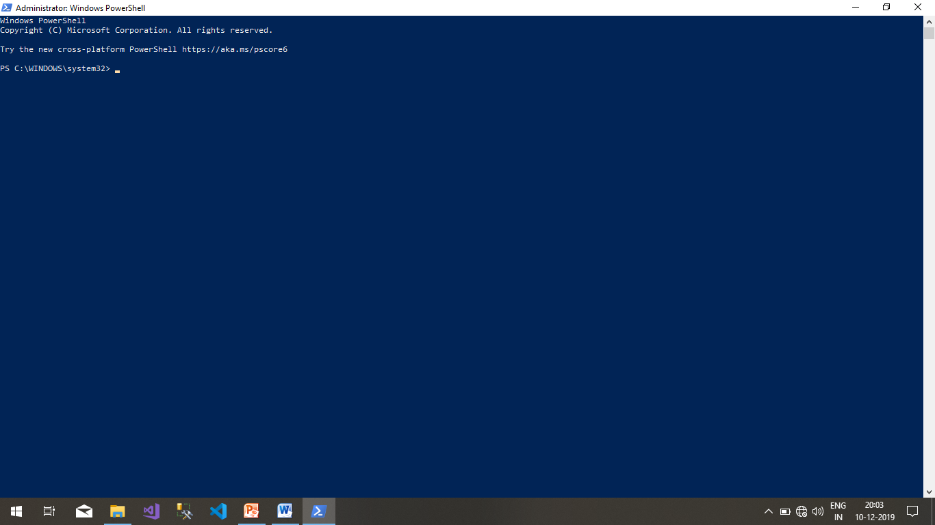

**Step 2:**Check application info with this command(dotnet new --list)

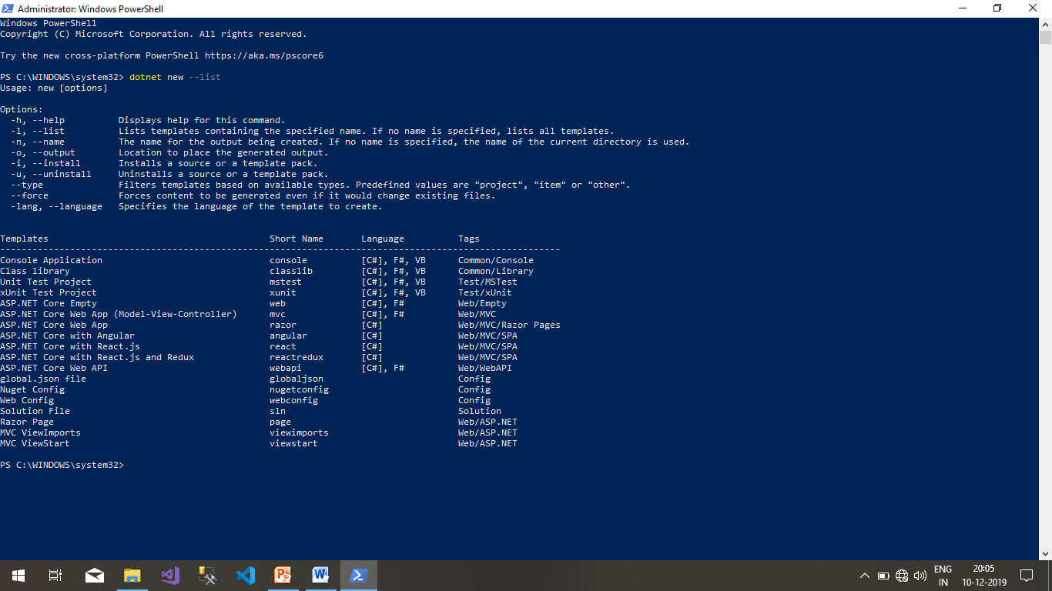

**Step 3:**Check the listing and go with your suitable requirement to create your application. Before running the below command go in your respective directory.

Command: **dotnet new sln**

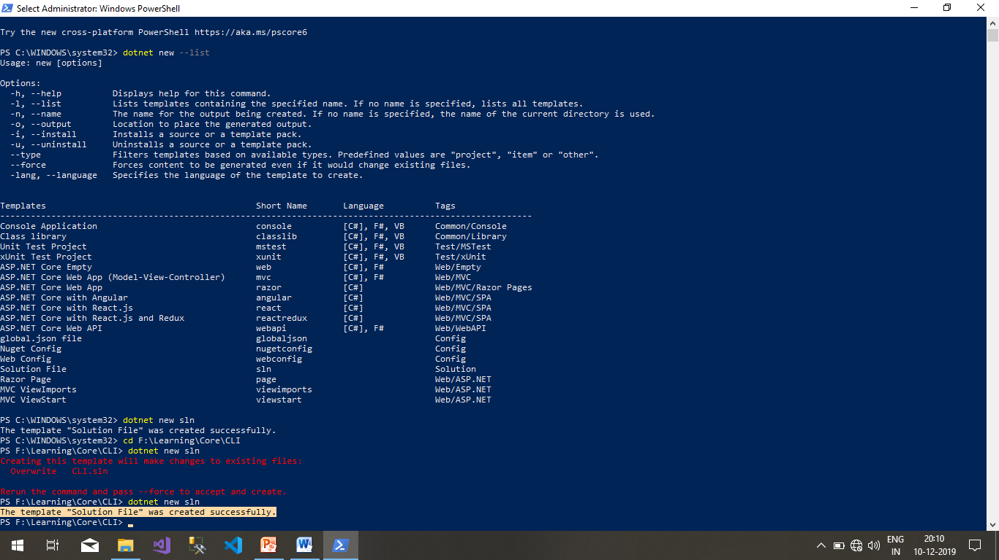

**Step 4:**After adding solution, we are going to add console application using below command.

**dotnet new console**

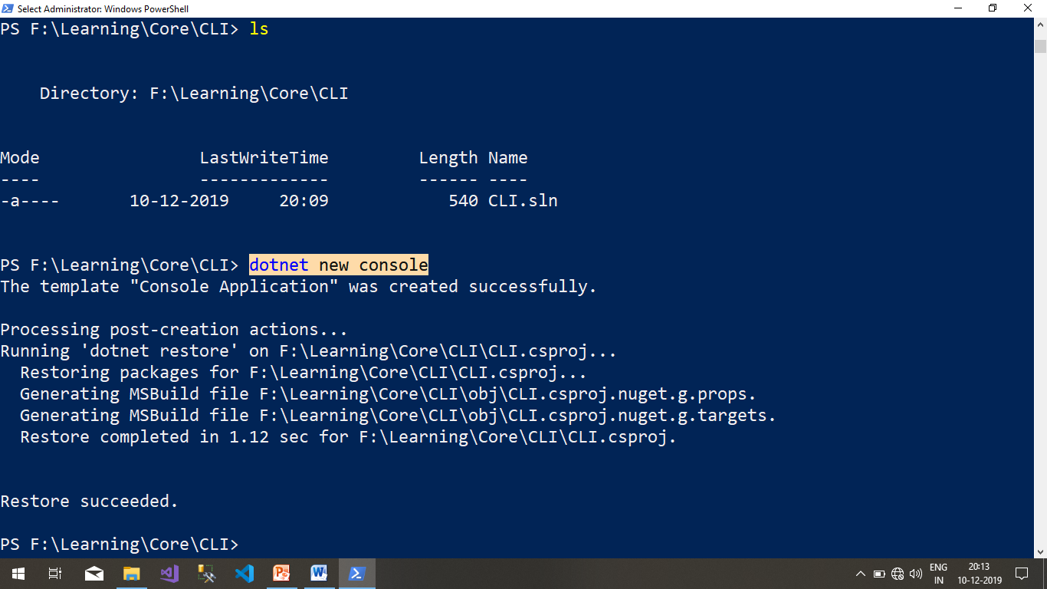

**Step 5:**Now we will add csproj into our solution using this command.

**dotnet sln add .\{CURRENT_DIRECTORY}.csproj**

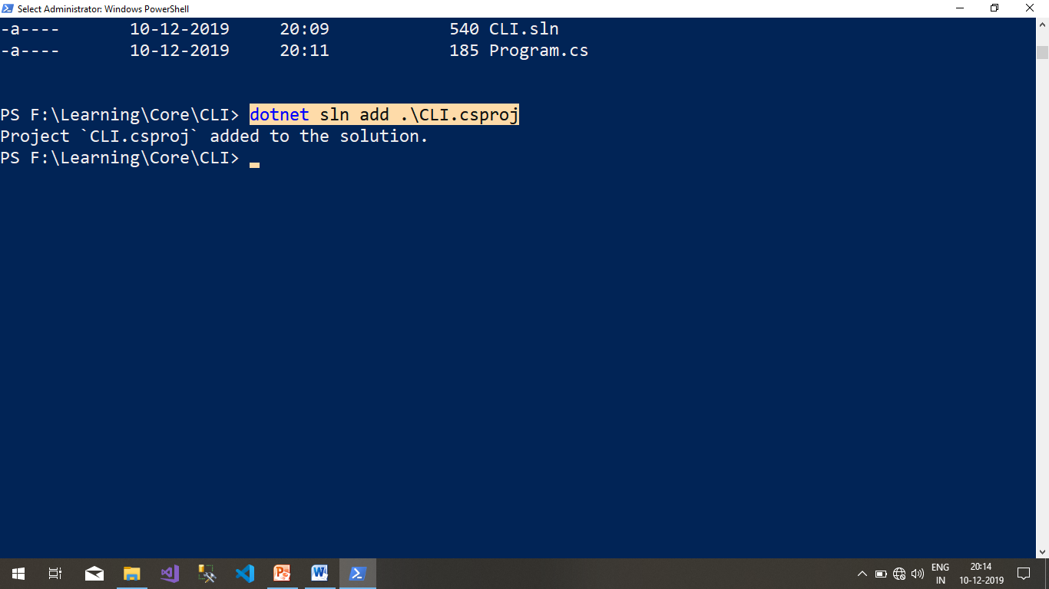

**Step 6:**Open the created solution in Visual Code by this command and check dotnet core CLI version.

**code .**

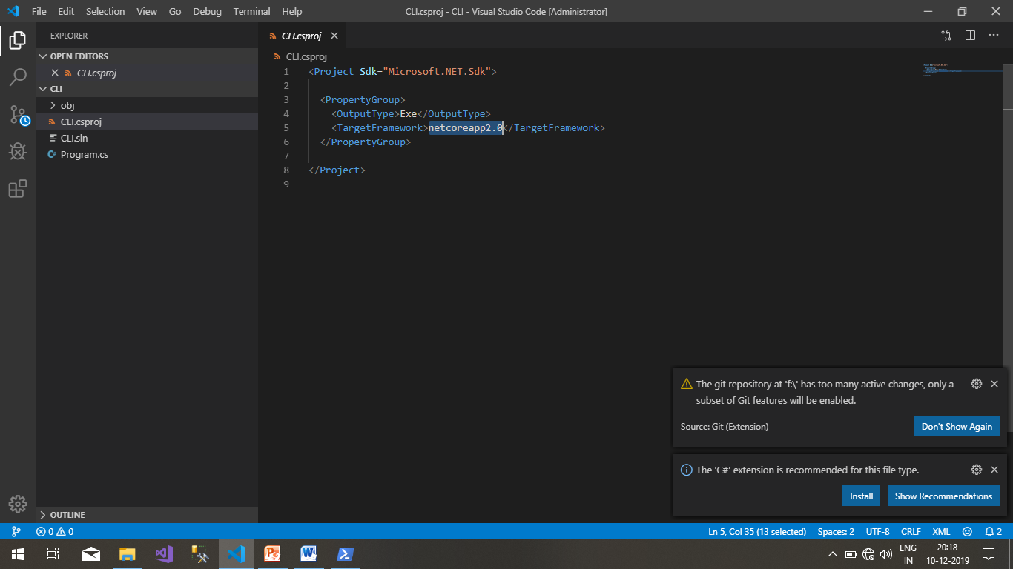

**Step 7:**Now you can build your application with below command.

**dotnet build**

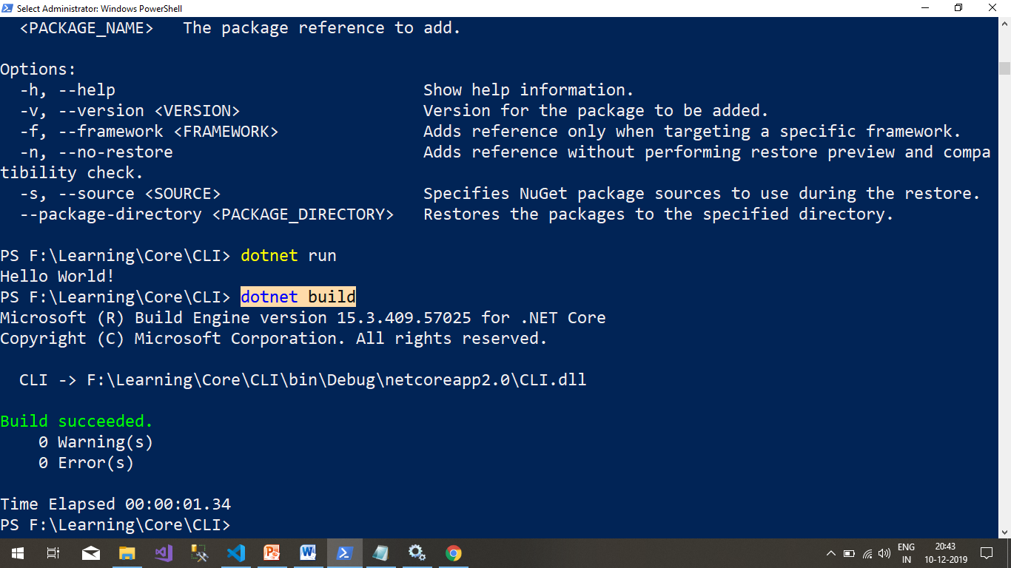

**Step 8:**Run below command to publish your console application.

**dotnet publish -c release -r win10-x64 -o publish**

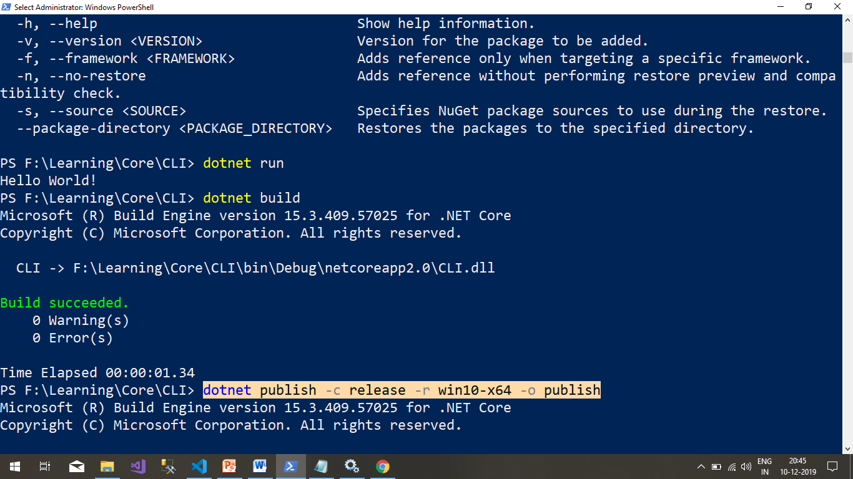

**Step 8:**Now we are ready to run our application that we have created. So you can move to the publish folder and search exe file and run with **.exe** command or you can directly run with **dotnet run** command.

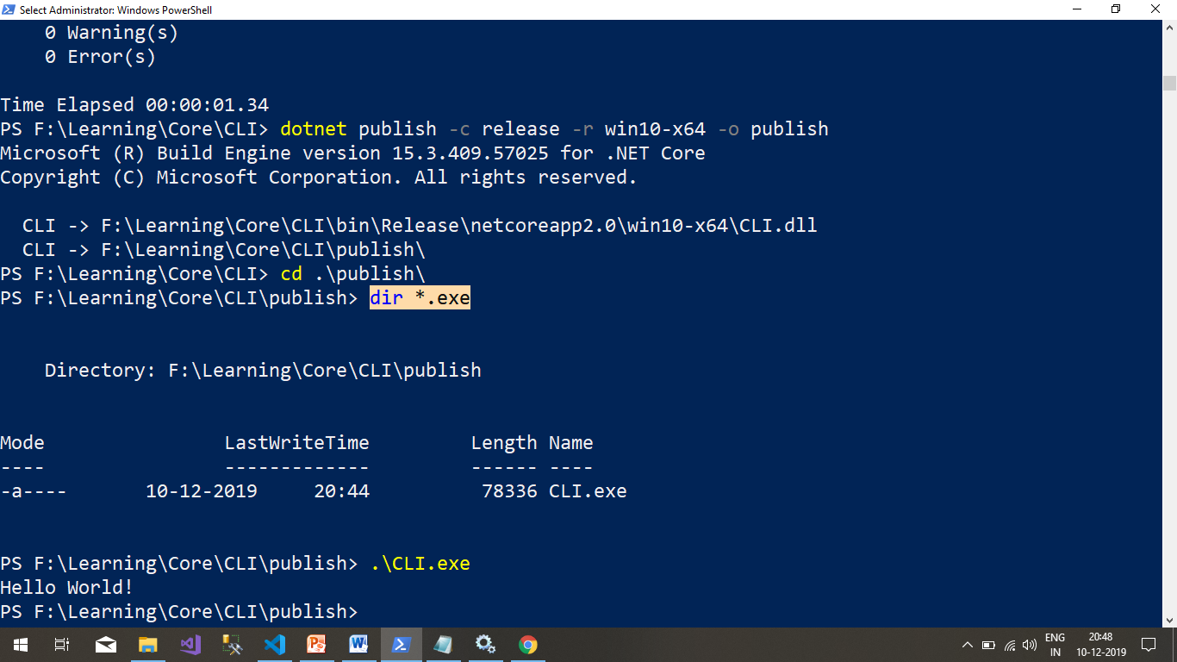

**Some useful CLI command that will help you to create, build & deploy**

|  |  |
| --- | --- |
| **Commands** | **Description** |
| dotnet --help | Show all important CLI command |
| dotnet --version | To check dotnet CLI version |
| dotnet new --list | Show all .net core project type |
| dotnet new console | To create console application |
| dotnet sln add <csproject file path> | Add project in solution file |
| dotnet restore | Restore all packages |
| dotnet add package <package name> -v | Add packages in your project |
| dotnet --info | To check dotnet sdk |
| dotnet build | Build you application |
| dotnet publish | To make your application for deployment |
| dotnet run | To directly run your application |

<https://powershell.myget.org/F/powershell-core/api/v3/index.json>

***************************End**********************************