

PROJECT REPORT ON
SOFTWARE DEVELOPMENT

NAME: Diksha Jha
UNIVERSITY:Kalinga institute of industrial technologies

SIGNATURE OF MENTOR
ACKNOWLEDGEMENT

I would like to express my special thanks of gratitude to my teacher USHA VOLETI, DGM (C&IT) as well as ALKA MAAM who gave me the golden opportunity to do this wonderful project , which also helped me in doing a lot of Research and i came to know about so many new things I am really thankful to them.
Secondly i would also like to thank my parents and friends who helped me a lot in finalizing this project within the limited time frame

INDEX

- INTRODUCTION
- ABOUT SAIL
- FEASIBILITY STUDY
- SYSTEM REQUIREMENT SPECIFICATION
- SOFTWARE AND HARDWARE SPECIFICATION
- SOFTWARE AND SYSTEM ATTRIBUTES
- SPECIFIC REQUIREMENT
- SYSTEM DESIGN
- FORMS USED
- LANGUAGES USED
- SYSTEM DESIGN
- SYSTEM DOCUMENTATION
- CODING
- CONCLUSION
- APPENDIX
- BIBLIOGRAPHY
INTRODUCTION

Steel Authority of India Limited (SAIL) is an Indian state-owned steel making company based in New Delhi, India. It is a public sector undertaking, owned and operated by the Government of India with an annual turnover of INR 44,452 Crore (US$6.83 Billion) for fiscal year 2016-17. Incorporated on 24 January 1973, SAIL has 72,004 employees (as of 01-May-2019). With an annual production of 14.38 million metric tons, SAIL is the largest steel producer in India and one of the largest steel producers in the world. The Hot Metal production capacity of the company will further increase and is expected to reach a level of 50 million tonnes per annum by 2025. Sri Anil Kumar Chaudhary is the current Chairman of SAIL.
SAIL operates and owns 5 integrated steel plants at Bhilai, Rourkela, Durgapur, Bokaro and Burnpur(Asansol) and 3 special steel plants at Salem, Durgapur and Bhadravathi. It also owns a Ferro Alloy plant at Chandrapur. As a part of its global ambition, the company is undergoing a massive expansion and modernisation programme involving upgrading and building new facilities with emphasis on state of the art green technology. According to a recent survey, SAIL is one of India's fastest growing Public Sector Units. Besides, it has R&D centre for Iron & Steel (RDCIS), centre for Engineering in Ranchi, Jharkand.

ABOUT SAIL

The Ministry of Steel and Mines drafted a policy statement to evolve a new model for managing industry. The policy statement was presented to the Parliament on 2 December 1972. On this basis the concept of creating a holding company to manage inputs and outputs under one roof was mooted. This led to the formation of The Steel Authority of India Ltd. The company, incorporated on 24 January 1973 with an authorised capital of ₹2,000 crore (US$290 million), was made responsible for managing five integrated steel plants at Bhilai, Bokaro, Durgapur, Rourkela and Burnpur, the Alloy Steel Plant and the Salem Steel Plant. In 1978 SAIL was restructured as an operating company.[8]

Major Units

SAIL Integrated Steel Plants
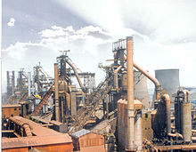

Durgapur Steel plant
- Rourkela Steel Plant (RSP) in Odisha set up with German collaboration (The first integrated steel plant in the Public Sector in India, 1959)
- Bhilai Steel Plant (BSP) in Chhattisgarh set up with Soviet collaboration (1959)
- Durgapur Steel Plant (DSP) at Durgapur, West Bengal set up with British collaboration (1965)
- Bokaro Steel Plant (BSL) in Jharkhand (1965) set up with Soviet collaboration (The Plant is hailed as the country's first Swadeshi steel plant, built with maximum indigenous content in terms of equipment, material and know-how)
- IISCO Steel Plant (ISP) at Burnpur in Asansol, West Bengal (Plant equipped with Largest Blast Furnace of country, Modernized in 2015 with investment of 16000 crore which will yield total production of 2.9 Million Ton annually )
Special Steel Plants
- Alloy Steel Plant (ASP), Durgapur, West Bengal
- Salem Steel Plant (SSP), Maramangalathupatti, Salem
- Visvesvaraya Iron and Steel Limited (VISL), at Bhadravathi, Karnataka

Ferro Alloy Plant
- Chandrapur Ferro Alloy Plant (CFP) in Maharashtra
Refractory Plants - SAIL Refractory Unit (SRU)
- SAIL Refractory Unit, Bhandaridah in Jharkhand
- SAIL Refractory Unit, Bhilai in Chhattisgarh
- SAIL Refractory Unit, IFICO, Ramgarh in Jharkhand
- SAIL Refractory Unit, Ranchi Road in Jharkhand

Central Units
- Centre for Engineering and Technology
- Research and Development Centre for Iron and Steel
- SAIL Consultancy Organisation
- Environment Management Division

Feasibility Study

A feasibility study is an analysis that takes all of a project's relevant factors into account—including economic, technical, legal, and scheduling considerations—to ascertain the likelihood of completing the project successfully.a feasibility study is performed, which determines whether the solution considered to accomplish the requirements is practical and workable in the software. Information such as resource availability, cost estimation for software development, benefits of the software to the organization after it is developed and cost to be incurred on its maintenance are considered during the feasibility study. The objective of the feasibility study is to establish the reasons for developing the software that is acceptable to users, adaptable to change and conformable to established standards.
It should be :
- Economical Feasibility
- Technical Feasibility
- Operational Feasibility

Economical Feasibility
Economic feasibility determines whether the required software is capable of generating financial gains for an organization. It involves the cost incurred on the software development team, estimated cost of hardware and software, cost of performing feasibility study.Once the technical feasibility is established, it is important to consider the monetary factors also. Since it might happen that developing a particular system may be technically possible but it may require huge investments and benefits may be less. For evaluating this, economic feasibility of the proposed system is carried out.

Technical Feasibility

Assessing technical feasibility includes evaluating the ability of computer hardware and software to handle workloads adequately. Figure below shows the steps the systems analyst takes in ascertaining hardware and software needs. First, all current computer hardware the organization owns must be inventoried to discover what is on hand and what is usable.
The systems analyst needs to work with users to determine what hardware will be needed. Hardware determinations can come only in conjunction with determining human information requirements. Knowledge of the organizational structure. and how users interact with technologies in an organizational setting can also be helpful in hardware decisions.

Operational Feasibility
Operational feasibility is mainly concerned with issues like whether the system will be used if it is developed and implemented. Whether there will be resistance from users that will effect the possible application benefits? The essential questions that help in testing the operational feasibility of a system are following.Does management support the project?Are the users not happy with current business practices? Will it reduce the time (operation) considerably? If yes, then they will welcome the change and the new system.
Have the users been involved in the planning and development of the project? Early involvement reduces the probability of resistance towards the new system.

SYSTEM REQUIREMENT SPECIFICATION

- Software and Hardware specification
- Project Planning
- Topic understanding
- Database requirements
- Modular break-up of the system

Programming language and tools

Environment: Introducing the .NET platform
Technology: The ASP.NET, COMMAND PROMPT
Programming language: C#,SQL

SOFTWARE AND HARDWARE SPECIFICATION

To round out your system’s final design, we specify the hardware and software that will be critical components of your OT (operational technology) infrastructure. In today’s modern automation systems, hardware and software are closely coupled to provide agile integration as well as the ability to quickly harvest data, transforming it into actionable intelligence through advanced software platforms.

MINIMUM REQUIREMENT

RAM : 150 MB
HARD DISK: 20 GB
OPERATING SYSTEM:WINDOWS 10

PROJECT PLANNING

I took a project for developing a computerized system of “cpgram entries”. Planning of this project will include:

- Topic understanding
- Modular break-up of the system
- Process logic of database
- Database requirements

ASSUMPTION AND DEPENDENCIES

You need to make assumptions in a project to be able to move forward with it. As we’ve established, planning is never certain and there are many external factors you can’t control or anticipate. But you can’t just wait and delay the start of a project until you have all necessary information and certainty – because that will never happen.

- It is assumed that the user is familiar with the basic computer needs
- Floppies and other removable devices should be scanned for viruses before use
- The use of pirated software should be avoided as it may lead to data loss and system crashes.
- Only authorized person is allowed inside the server room

SOFTWARE AND SYSTEM ATTRIBUTES

SAFETY :

Software system safety is a subset of system safety and system engineering and is synonymous with the software engineering aspects of Functional Safety. As part of the total safety and software development program, software cannot be allowed to function independently of the total effort. A software specification error, design flaw, or the lack of generic safety-critical requirements can contribute to or cause a system failure or erroneous human decision. To achieve an acceptable level of safety for software used in critical applications, software system safety engineering must be given primary emphasis early in the requirements definition and system conceptual design process.

SECURITY:

Database system will provide the security ie. Is internal provided by the database

SPECIFIC REQUIREMENTS

FORMS:

The best possible result will be made to design the form and reports
FOLLOWING ACTION WILL TAKE PLACE IN THE S/W DURING THE ACCEPTANCE PROCESSING THE INPUT AND IN PROCESSING AND GENERATING THE OUTPUT

Validation checks on inputs:

The input should be checked for its validity. For example the the cpgrams registration date should be valid , this validity is checked before creating the database

Response of abnormal situation:

The system will convey the message to the user if the error occurs

Error handling and recovery :

Error messages will occur if wrong data has been entered , warnings might also come

Relation of output and input :

The information regarding various activities will be entered in the database through input forms will be having text boxes and other manipulation things like buttons and labels are used . the output is generated according to the input

SYSTEM DESIGN

- Design methodology
- Design principles
- Phase of design
- Database design
- Detailed design
Modules description
Process logic for each modules

System design :

Systems design is the process of defining the architecture, modules, interfaces, and data for a systemto satisfy specified requirements. Systems design could be seen as the application of systems theory to product development.

Design Methodology:

A structured approach that uses procedures, techniques, tools, and documentation aids to support and facilitate the process of design. Adesign methodology consists of phases each containing a number of steps, which guide the designer in the techniques appropriate at each stage of the project.

Design principles:

These database design principles are basis for any good database and should be kept in mind always while designing database systems.
- Usability.
- Extensibility.
- Data Integrity.
- Performance.
- Availability.
- Security.

PHASE DESIGN:

Database design is a framework that the database uses for planning, storing and managing data in companies and organizations. Data and database design are the lifeblood of every company.

DATABASE DESIGN:

Database design is a framework that the database uses for planning, storing and managing data in companies and organizations. Data and database design are the lifeblood of every company.

Conceptual Database Design

To build the conceptual representation of the database,which includes identification of the important entities,relationships, and attributes.

Logical database design

To translate the conceptual representation to the logical structure of the database, which includes designing the relations.

Physical database design

To decide how the logical structure is to be physically implemented (as base relations) in the target Database Management System (DBMS)

- Table name : cpgrams_entries
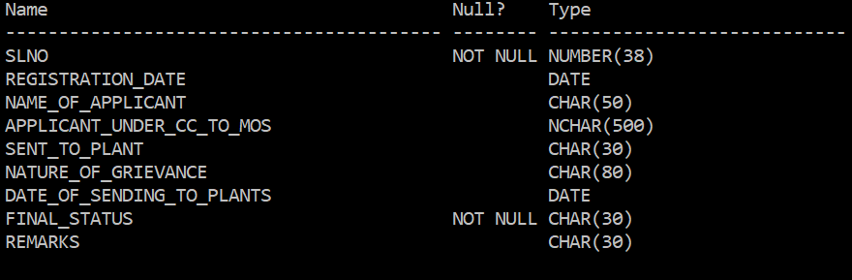
This table stores : SLNO, REGISTRATION DATE , NAME OF APPLICANT, APPLICANT UNDER CC TO MOS, SENT TO PLANT, NATURE OF GRIEVANCE, DATE OF SENDING TO PLANTS, FINAL STATUS, REMARKS.

- Table name : final

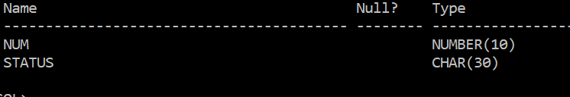

This table contains : NUMBER , STATUS
TOTAL NUMBER OF ROWS CREATED =61

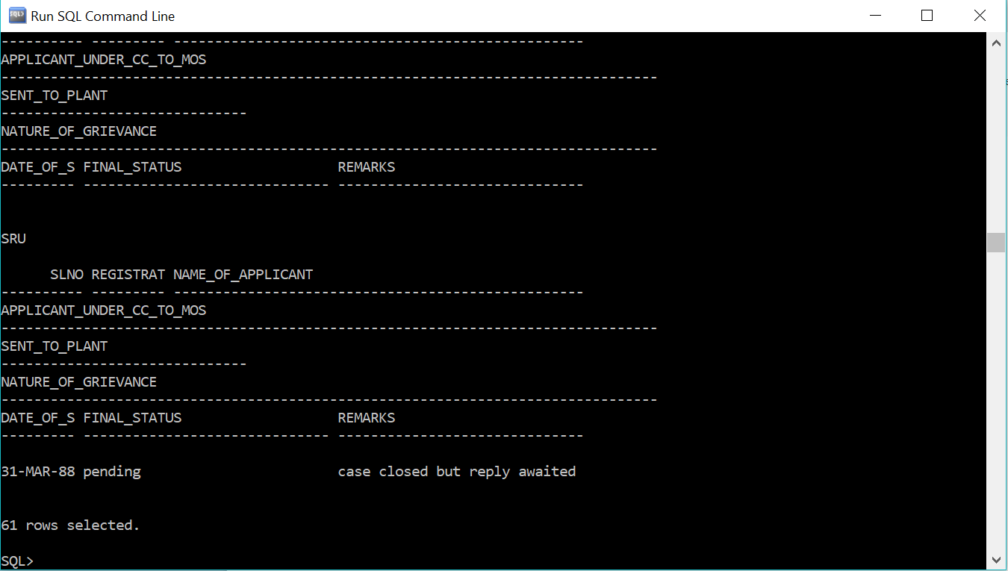

FORMS USED

LOGIN FORM :

It is a form used through which the employee can login . Here an option of change password is also present , by using change password method the password is changed

PASSWORD CHANGE :

Its is used to change password , if the employee wants to change password they can use change password method. This is only for security reasons

INSERT INTO :

To insert the the records the authorized employee can use this form.

VIEW DETAILS:

By this form they can view the details but updating is not possible

LANGUAGE USED :

- C#
- Oracle sql

C#

C# is a general-purpose, modern and object-oriented programming language pronounced as “C Sharp”. It was developed by Microsoft led by Anders Hejlsberg and his team within the .NET initiative and was approved by the European Computer Manufacturers Association (ECMA) and International Standards Organization (ISO). C# is among the languages for Common Language Infrastructure. C# is a lot similar to Java syntactically and is easy for users who have knowledge of C, C++ or Java.

C# | .NET Framework (Basic Architecture and Component Stack)
.NET is a software framework which is designed and developed by Microsoft. The first version of .Net framework was 1.0 which came in the year 2002. In easy words, it is a virtual machine for compiling and executing programs written in different languages like C#, VB.Net etc.
It is used to develop Form-based applications, Web-based applications and Web services. There is a variety of programming languages available on the .Net platform, VB.Net and C# being the most common ones are . It is used to build applications for Windows, phone, web etc. It provides a lot of functionalities and also supports industry standards.

Advanatages

Advantages of C# language must be known by every programmer or those who interested in a programming language. There are many advantages and features of C# language that makes it a more useful programming language than other programming languages like Java, C, C++ etc. In this article, I am going to tell about the advantages of C# language. But before starting this topic let’s understand what C# language actually is.

FEATURES :

There are many important Features of C# language that make it more useful and unique compare to other languages.
- Fast Speed
- Simple
- Object Oriented
- Modern Programming Language
- Type Safe
- Interoperability
- Scalable and Updateable
- Structured Programming Language
- Rich Library
- Component Oriented

ORACLE DATABSE
An Oracle database is a collection of data treated as a unit. The purpose of a database is to store and retrieve related information. A database server is the key to solving the problems of information management. In general, a server reliably manages a large amount of data in a multiuser environment so that many users can concurrently access the same data. All this is accomplished while delivering high performance. A database server also prevents unauthorized access and provides efficient solutions for failure recovery.
Oracle Database is the first database designed for enterprise grid computing, the most flexible and cost effective way to manage information and applications. Enterprise grid computing creates large pools of industry-standard, modular storage and servers. With this architecture, each new system can be rapidly provisioned from the pool of components. There is no need for peak workloads, because capacity can be easily added or reallocated from the resource pools as needed.
The database has logical structures and physical structures. Because the physical and logical structures are separate, the physical storage of data can be managed without affecting the access to logical storage structures.

Oracle Grid Architecture
Grid computing is a new IT architecture that produces more resilient and lower cost enterprise information systems. With grid computing, groups of independent, modular hardware and software components can be connected and rejoined on demand to meet the changing needs of businesses.
The grid style of computing aims to solve some common problems with enterprise IT: the problem of application silos that lead to under utilized, dedicated hardware resources, the problem of monolithic, unwieldy systems that are expensive to maintain and difficult to change, and the problem of fragmented and disintegrated information that cannot be fully exploited by the enterprise as a whole.
The data types used In this project are :
CHAR(size) |  |  | A FIXED length string (can contain letters, numbers, and special characters). The size parameter specifies the column length in characters - can be from 0 to 255. Default is 1
DATE |  |  | A date. Format: YYYY-MM-DD. The supported range is from '1000-01-01' to '9999-12-31'
nchar | Fixed width Unicode string | 4,000 characters |  | Defined width x 2
INT(size) |  |  | A medium integer. Signed range is from -2147483648 to 2147483647. Unsigned range is from 0 to 4294967295. The size parameter specifies the maximum display width (which is 255)

SYSTEM DOCUMENTATION

System documentation: The collection of documents that describes the requirements, capabilities, limitations, design, operation, and maintenance of a system, such as a communications, computing, or information processing system.

Standard database consoles like SQL Server Management Studio (SQL Server), Oracle SQL Developer (Oracle) or MySQL Workbench (MySQL) support some basic database schema and modeldocumentation and generation. Those features might include: Commenting data elements (tables, columns, views etc.)

They are of two types :

- INTERNAL DOCUMENTATION
- EXTERNAL DOCUMENTATION

- INTERNAL DOCUMENTATION :
Computer software is said to have Internal Documentation if the notes on how and why various parts of code operate is included within the source code as comments. It is often combined with meaningful variable names with the intention of providing potential future programmers a means of understanding the workings of the code.
This contrasts with external documentation, where programmers keep their notes and explanations in a separate document.
Internal documentation has become increasingly popular as it cannot be lost, and any programmer working on the code is immediately made aware of its existence and has it readily available.
- External Documentation:

External documentation is written in a place where people who need to use the software can read about how to use the software. External documentation can be broken down into library documentation, which describes tools that a programmer can use, and user documentation, which is intended for users of an application.
External documentation explains why a particular solution is chosen and implemented in the software. It also includes formulas, conditions, and references from where the algorithms or documentation are derived. External documentation makes the user aware of the errors that occur while running the software code. For example, if an array of five numbers is used, it should be mentioned in the external documentation that the limit of the array is five.

CODING

Login page :

using System;
using System.Data;
using System.Data.Odbc;
using System.Collections;
using System.Configuration;
using System.Web;
using System.Web.Security;
using System.Web.UI;
using System.UI.WebControls.WebParts;
using System.UI.HtmlControls;

public partial class login : System.Web.UI.Page
{
OdbcConnection con;
OdbcDataAdapter da;

protected void Page_Load(object sender, EventArgs e)
{
if (textBox1.text == "")||(textBox2.text == "")
{
Label3.Visible = true;
Label3.text = "cant be null";

}
else
{
da = new OdbcDataAdapter("SELECT * FROM cpgrams_entries WHERE SAIL slno='" + textBox1.Text.ToString().Trim() + "'and password='" + textBox2.Text.ToString()
.Trim() + "'", con);
da = new DataSet();
da.Fill(ds, cpgrams_entries);
int n = da.Tables["cpgrams_entries"].Rows.count;
if (n != 1)
{
Label3.Visible = true;
Label3.text = "wrong user id or password"
textBox1.text = "";
textBox2.text = "";
}
else
{
DateTime dn = DataTime.Now;
String s = DataSet.Tables["cpgrams_entries"].Rows[0][5].ToString();
if (s != "")
DateTime.Parse(s.ToString().Trim());
if (dn > dt)
{
Label3.Visible = true;
Label3.Text = "you are not a member at this time";
}
else
{
Session["UID"] = ds.Tables["cpgrams_entries"].Rows[0][1].ToString();
Response.redirect("name_of_applicant.aspx");
}
}
else
{
Session["UID"] = ds.Tables["cpgrams_entries"].Rows[0][1].ToString();
Response.redirect("name_of_applicant.aspx");
}

}
}
}

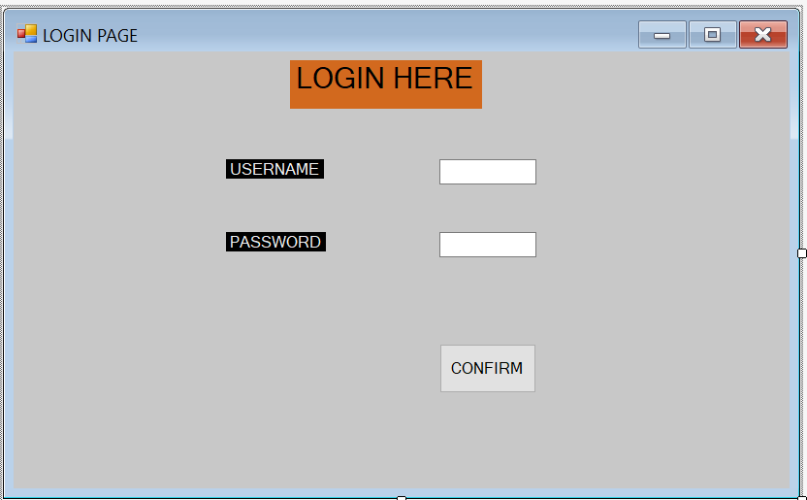

PASSWORD CHANGE :

using System;
using System.Data;
using System.Data.Odbc;
using System.Configuration;
using System.Collections;
using System.Web;
using System.Web.Security;
using System.Web.UI;
using System.UI.WebControls.WebParts;
using System.UI.HtmlControls;

public partial final_proj:System.Web.UI.Page

{
OdbcConnection con;
OdbcDataAdapter da;
DataSet ds;
protected void Page_Load(object sender, EventArgs e)
{
con = new
OdbcConnection(@"ORACLE_CONNECTION_DATA;Initial Catalog=project;Integrated Security=True");
}
protected void Button1_Click(object sender, EventArgs e)
{
if ((TextBox1_Text == "") || (TextBox2.Text == "") || (TextBox3.Text == "") || (TextBox4.Text == ""))
{
label6.Visible = true;
label6.text = "cannot be null";
}
else
{
da = new OdbcDataAdapter("SELECT * FROM cpgrams_entries WHERE SAIL slno='" + TextBox1.Text.ToString().Trim() + "'and password='" + TextBox2.Text.ToString()
.Trim() + "'", con);
ds = new DataSet();
da.Fill(ds, cpgrams_entries);
int n = ds.Tables["cpgrams_entries"].Rows.Count;
if (n != 1)
{
label6.Visible = true;
label6.Text = "wrong userid or password";
TextBox1.Text = "";
TextBox2.Text = "";
TextBox3.Text = "";
TextBox4.Text = "";
}
else
if (TextBox3.Text == TextBox4.Text)
{
string password = TextBox3.Text.ToString.Trim();
da.SelectCommand.CommandText = "update cpgrams_entries set password='" + password + "' where slno='" +
TextBox1.Text + "' and password='" + TextBox2.Text + "'";
ds = new DataSet();
da.Fill(ds);
label6.visible = true;
label6.Text = "password is changed succesully";
}
else
{
label6.Visible = true;
label6.Text = "mismatch in new password";

}
}

}
}

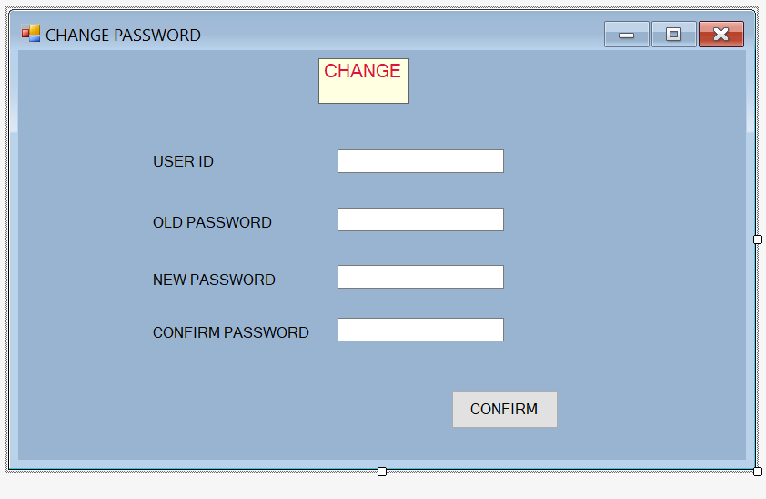

INSERTING

using System;
using System.Data;
using System.Data.OracleClient;
using System.Configuration;
using System.Collections;
using System.Web;
using System.Web.Security;
using System.Web.UI;
using System.UI.WebControls;
using System.UI.WebControls.WebParts;
using System.UI.HtmlControls;

public partial final_proj:System.Web.UI.Page

{
OracleConnection con=new OracleConnection(@"ORACLE_CONNECTION_DATA;Initial Catalog=project;Integrated Security=True");
OracleCommand Command = new OracleCommand();
OracleDataReader reader;
OracleDataAdapter da;
DataSet ds;

object TextBox4 { get; private set; }

protected void Page_Load(object sender, EventArgs e)
{
}
protected void Button1_Click(object sender, EventArgs e)
{
try
{
String Slno = TextBox1.Text.ToString().Trim();
String registration_date = DateTime Parse(TextBox2.Text.ToString().Trim());
String name_of_applicant = TextBox3.Text.ToString().Trim();
String applicant_under_cc_to_mos = TextBox4.Text.ToString().Trim();
String sent_to_plant = TextBox5.Text.ToString().Trim();
String Nature_of_grievance = TextBox6.Text.ToString().Trim();
String Date_of_sending = DateTime Parse(TextBox7.Text.ToString().Trim());
String Final_status = TextBox8.Text.ToString().Trim();
String remarks = TextBox9.Text.ToString().Trim();

if (Date_of_sending != "")
{
DateTime dt = DateTime.Parse(Date_of_sending.ToString().Trim());
DateTime df = DateTime.Parse(registration_date.ToString().Trim());

if (df < dt)
{

Da = new OracleDataAdapter("insert into insertHere" VALUES('" + Slno +"', '"+ registration_date +"',
'"+ name_of_applicant +"', '"+ applicant_under_cc_to_mos +"', '"+ sent_to_plant +"', '"+ Nature_of_grievance +"',
'"+ Date_of_sending +"', '"+ Final_status +"', '"+ remarks +"'),con);

ds = new DataSet();
da.Fill(ds);
label13.Visible = true;
label13.Text = "saved successfully";
TextBox1.Text = "";
TextBox2.Text = "";
TextBox3.Text = "";
TextBox4.Text = "";
TextBox5.Text = "";
TextBox6.Text = "";
TextBox7.Text = "";
TextBox8.Text = "";
TextBox9.Text = "";
}
else
{
label13.Visible = true;
label13.Text = "sending date is greater than registration date";

}
}

else
{
Da = new OracleDataAdapter("insert into insertHere" VALUES('" + Slno +"','"+ registration_date +"',
'"+ name_of_applicant +"','"+ applicant_under_cc_to_mos +"','"+ sent_to_plant +"', '"+ Nature_of_grievance +"',
'"+ Date_of_sending +"','"+ Final_status +"','"+ remarks +"'),con);

ds = new DataSet();
da.Fill(ds);
label13.Visible = true;
label13.Text = "saved successfully";
TextBox1.Text = "";
TextBox2.Text = "";
TextBox3.Text = "";
TextBox4.Text = "";
TextBox5.Text = "";
TextBox6.Text = "";
TextBox7.Text = "";
TextBox8.Text = "";
TextBox9.Text = "";
}
}
catch (Exception ex)
{
label10.Visible = true;
label10.Text = ex.Message;
}
}
protected void Button2_Click(object sender,EventArgs e)
{
TextBox1.Text = "";
TextBox2.Text = "";
TextBox3.Text = "";
TextBox4.Text = "";
TextBox5.Text = "";
TextBox6.Text = "";
TextBox7.Text = "";
TextBox8.Text = "";
TextBox9.Text = "";
}
protected void dtValidate(object source, ServerValidateEventArgs args)
{
string test;
test = "";
command.Connection = Con;
con.Open();
Command.CommandType = CommandType.Text;
Command.CommandType = "select check_data('" + args.Value + "')from dual";
reader = Command.ExecuteReader();

while (reader.Read())
{
test = Convert.ToString(reader.GetValue(0));
if (test == "y")
{
args.IsValid = true;
}
else
{
args.IsValid = false;
}
reader.Close();
con.Close();
} }

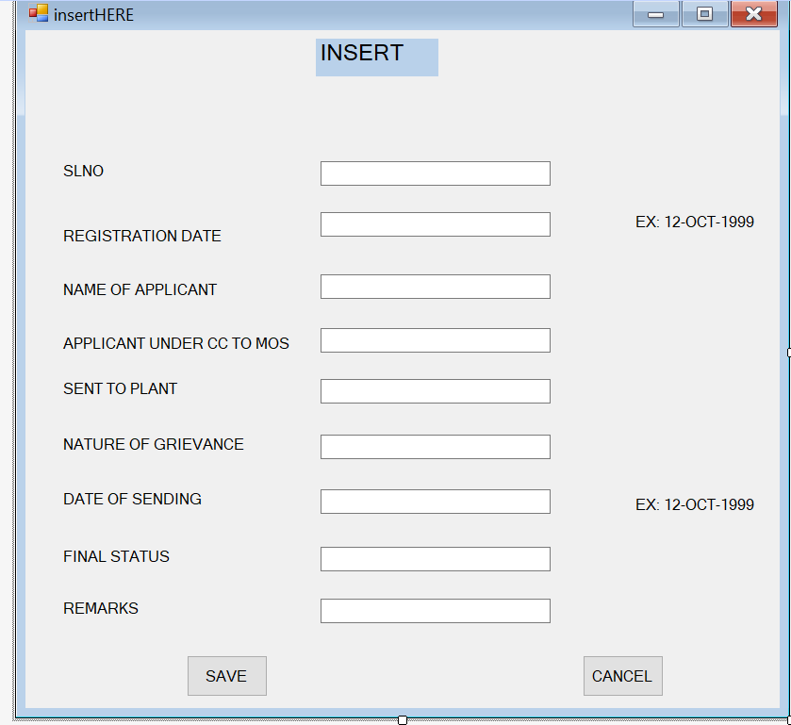

VIEW REPORT

using System;
using System.Data;
using System.Data.Odbc;
using System.Collections;
using System.Configuration;
using System.Web;
using System.Web.Security;
using System.Web.UI;
using System.UI.WebControls.WebParts;
using System.UI.HtmlControls;

public partial final_proj:System.Web.UI.Page
{
protected void Page_Load(object sender, EventArgs e)
{

}
protected Gridview1_selected index changing(object sender, GridviewSelectEventArgs e)
{
GridViewRow gvr = GridView1.Rows[e.NewSelectedIndex];
session["slno"];
Int32.Parse(gvr.Cells[0].Text.ToString().Trim);
session["registration_date"];
Int32.Parse(gvr.Cells[0].Text.ToString().Trim);
}
}

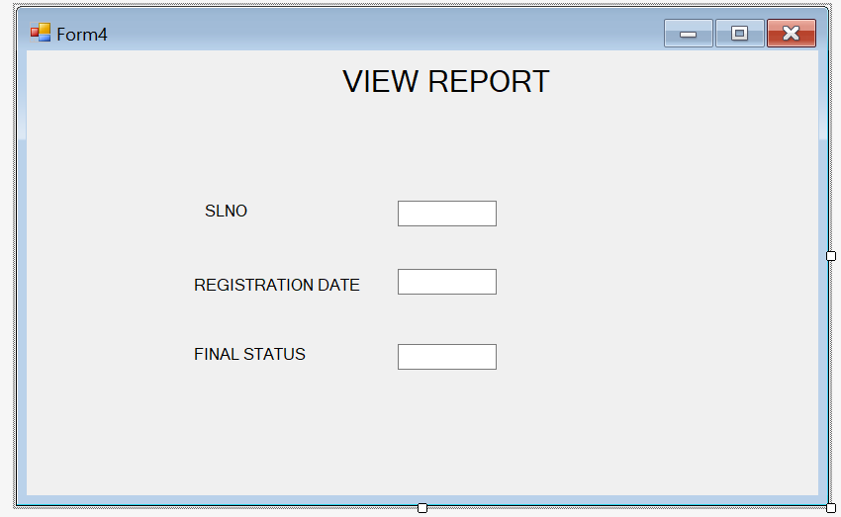

CONCLUSION

Towards the end of the period of my stay at SAIL (Lodhi Road ) Delhi, I would say that the target that was intially setup has achieved to a good extent. The project made me realize the significance of developing a software for a client where all the eventualities have to be taken care of unlike educational institutions, where the soul aim is to learn. Though it seemed tough at first, I realized the pressure was go added on us, to develop better application.

During this project the real importance for following all the principles of system analysis design drowned on me. I felt the necessity of going through the several stages because only such a process could makes one understand the problem at hand , more so due to enormous size of data stores involves and their manipulations.

In retrospect , I would like to say company provided me with ample opportunities to learn ASP.NET also succeeded in understanding a number of tricky concepts of database. I hope this stint at SALE would stand me in good stead in future endeavors.

APPENDIX

TEXT BOX:
A text box controls , sometimes called an edit field or edit control. Displays information entered at designated time.

COMMAND BUTTON :
A command button is a clickable image object used with graphical operating systems.

LABEL:
Windows Forms Label controls are used to display text or images that cannot be edited by the user. They are used to identify objects on a form—to provide a description of what a certain control will do if clicked

TABLE:
Table comprises of rows and columns. So while creating tables we have to provide all the information to SQL about the names of the columns, type of data to be stored in columns, size of the data etc.

DATA GRID CONTROL :

The Windows Forms DataGrid control displays data in a series of rows and columns. The simplest case is when the grid is bound to a data source with a single table that contains no relationships. In that case, the data appears in simple rows and columns, as in a spreadsheet.

BIBLIOGRAPHY
WEBSITE :
- docs.microsoft.com
- csharp.net-informations.com
- www.oreilly.com
- www.w3schools.com
- docs.oracle.com
- www.geeksforgeeks.org
- www.youtube.com
- en.wikipedia.org

THANK YOU

