- Table name : cpgrams_entries
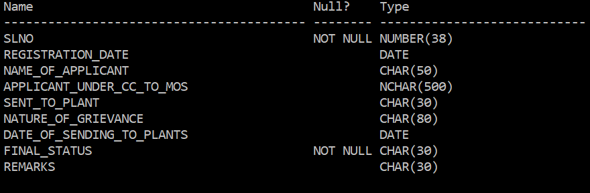

This table contains : SLNO, REGISTRATION DATE , NAME OF APPLICANT, APPLICANT UNDER CC TO MOS, SENT TO PLANT, NATURE OF GRIEVANCE, DATE OF SENDING TO PLANTS, FINAL STATUS, REMARKS.

- Table name : final

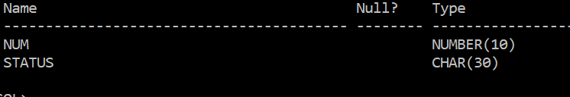

This table contains : NUMBER , STATUS
TOTAL NUMBER OF ROWS CREATED =61

Example:

