# Cycle 2 - 1i1/25 Experiment 13

# 

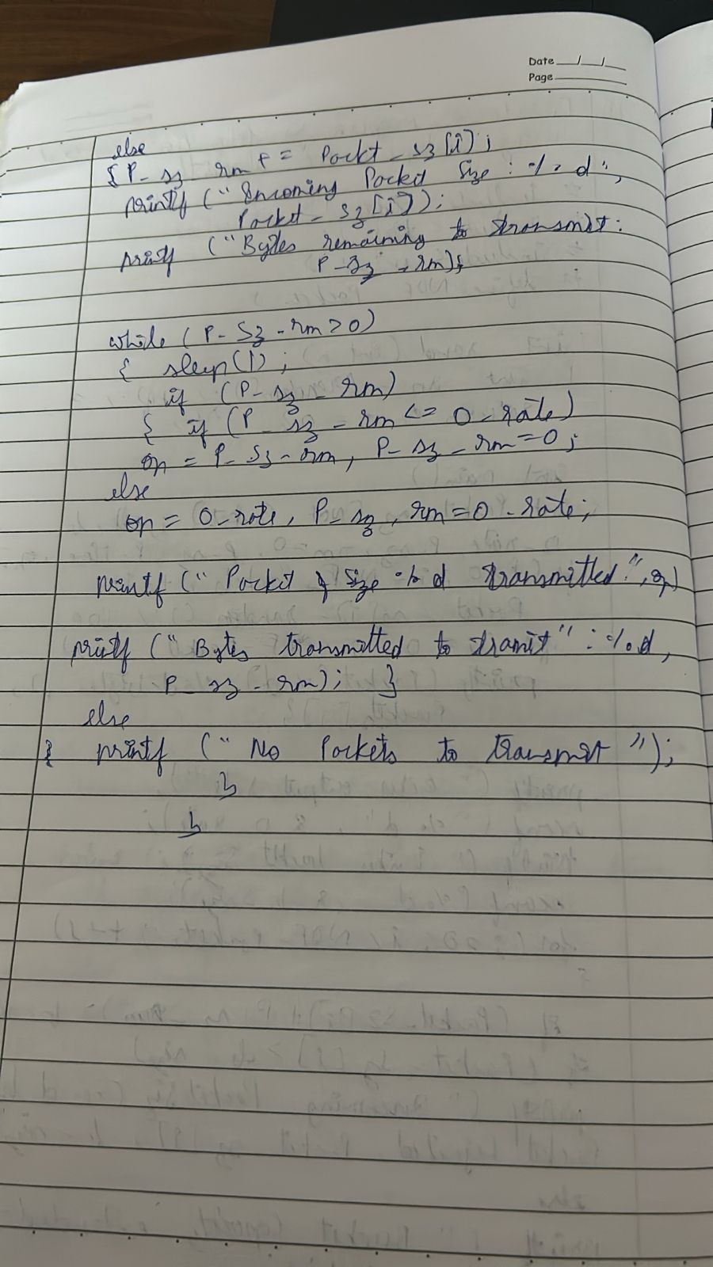

Enter the input message in binary: 1101

The transmitted message is: 11011101000110101101 Enter the received message in binany: 1101

No error in data

Experiment 14

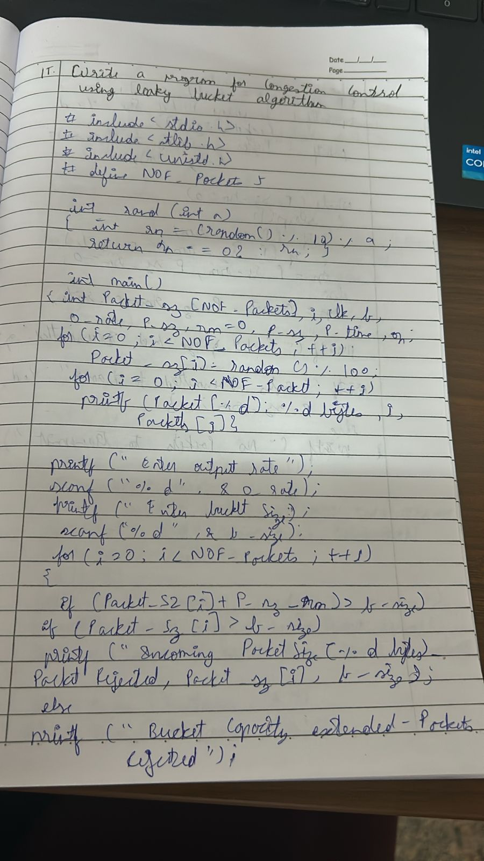



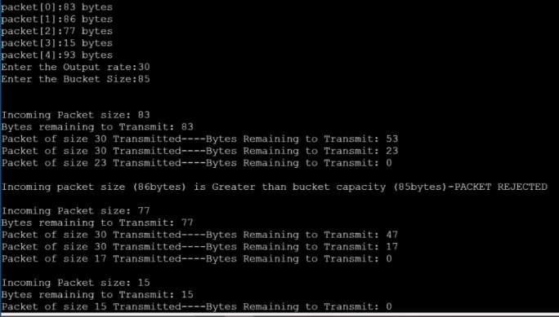



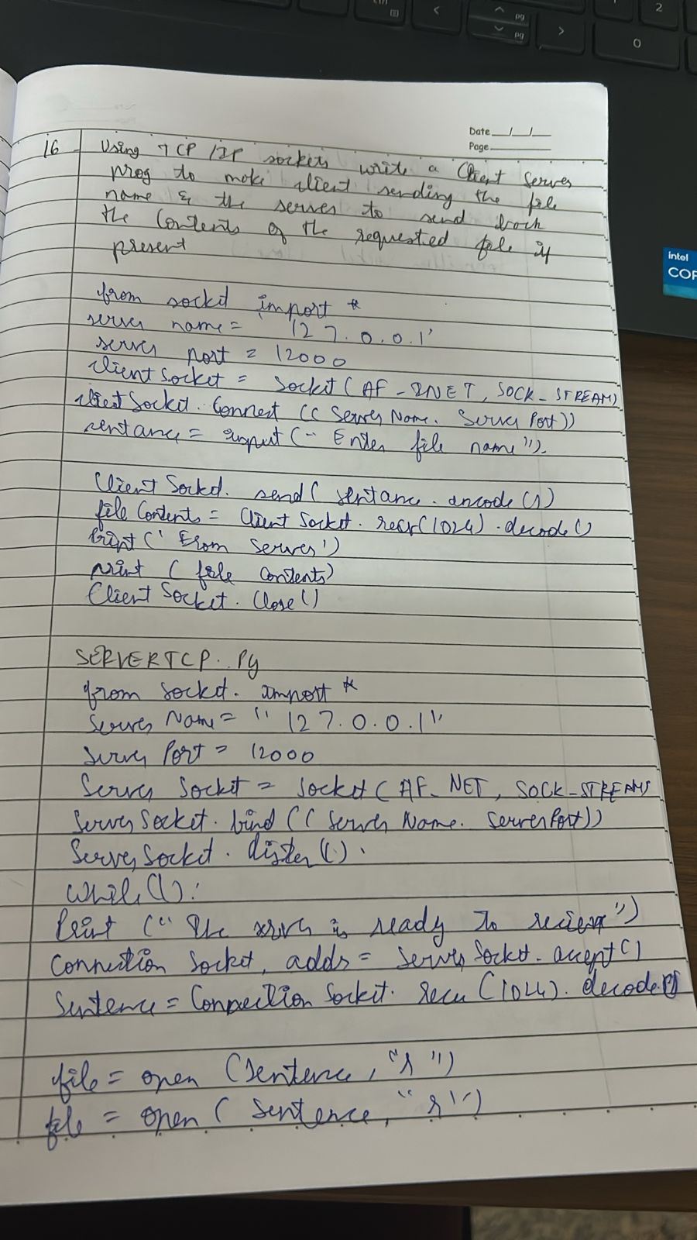

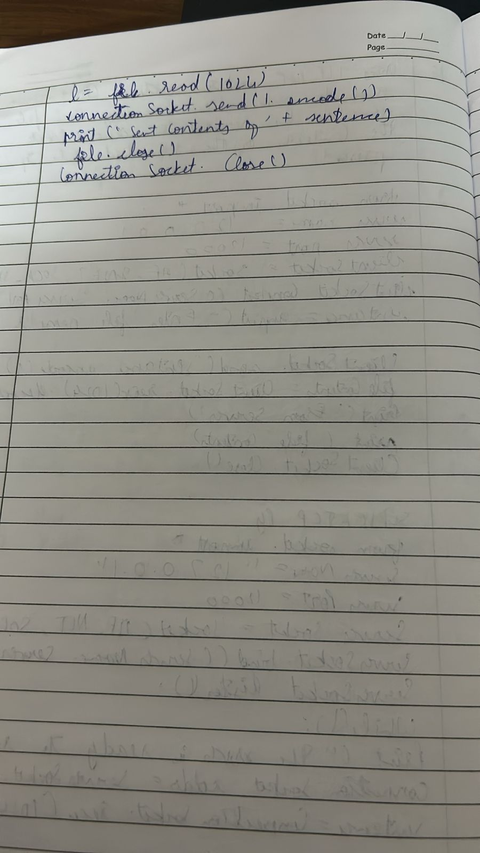

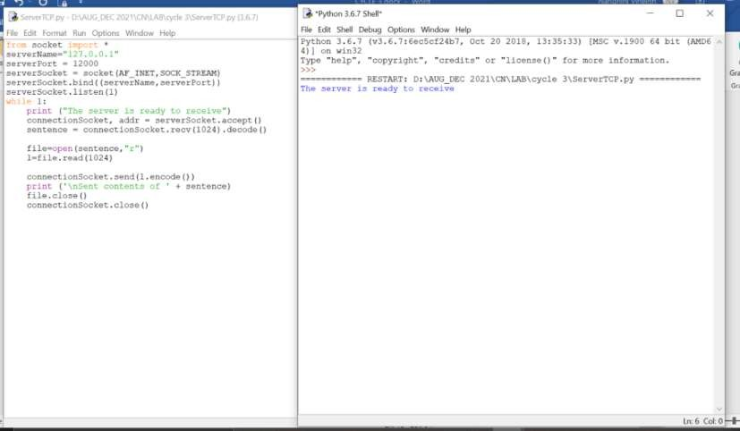



Type ‘hwlp’, ‘w y*lqht’. ‘crwdJto’ o* ‘Ilowase(}’ for morw Lnforoatloo.



Hi}HnD5u0 tGt. • Rona'( n t9rt••G.efiG ) ) "’ “‘“ ”'° ‘’ f1ionentent o ul I ontT*:›cPot . max I t EU1 . deuo&r I) T*oa 8o"- :

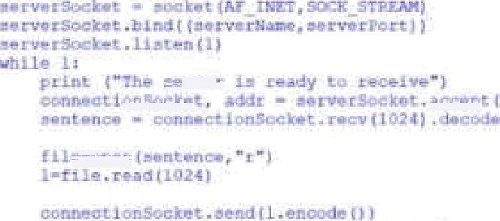





# Experiment 16

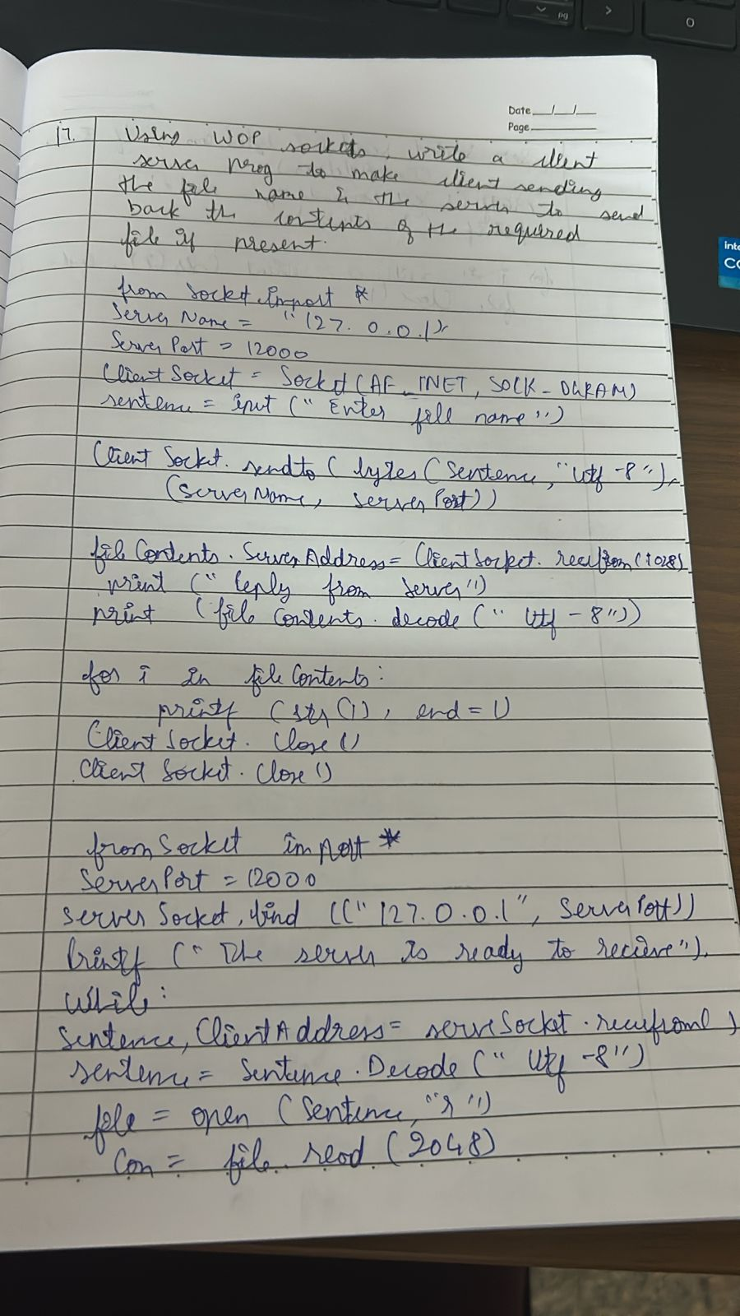

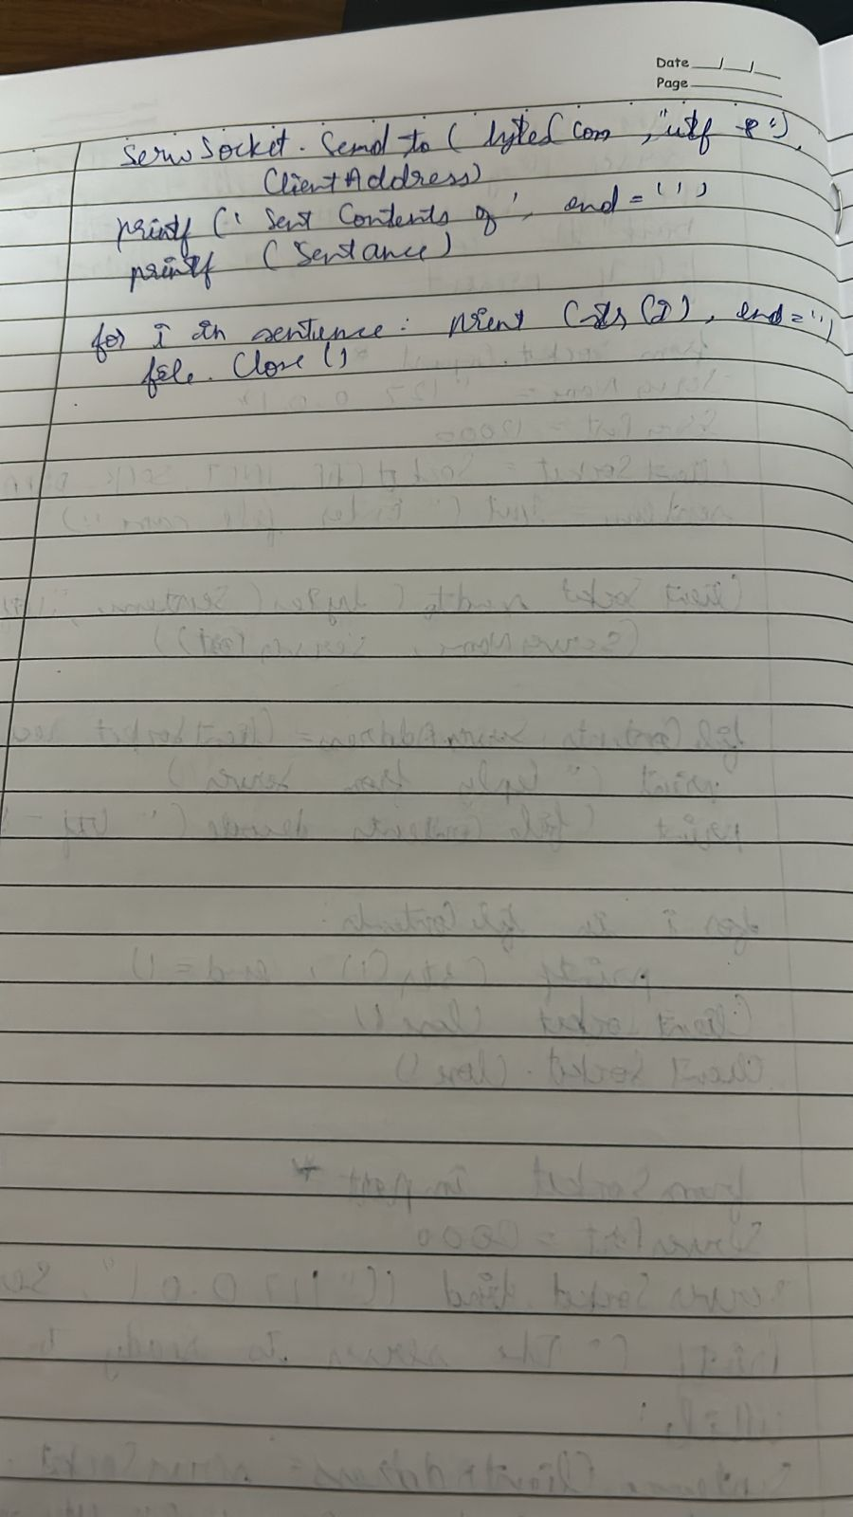

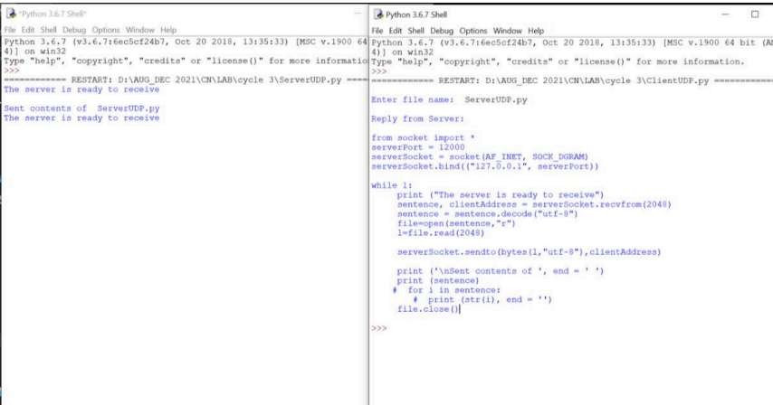

Experiment 17

