Project Description: -

Personal Finance Management System

The Personal Finance Management System is a web-based application designed to help individuals manage their finances effectively. The system allows users to track their income and expenses, create and manage budgets, and set financial goals.

Name Of Team Members:-

2. Diksha Vilas Patil

3. Karan Sampat Mandlik

4. Mansi Rajendra Iste

Project Phase:-

1. Planning:

* **Goal**: Create a tool that simplifies personal finance tracking.
* Define core features: income/expense tracking, and reporting.
* Generating clear and accurate financial reports.

2. Development:

* Write the code for the API using Python and track personal finance income and expenses.
* Fetch the list of available stocks from financial .

3. Testing:

* Validate functionalities like adding, editing, and categorizing transactions.
* Test data accuracy in reports.
* Use tools like Postman to validate the API functionality.

4. Deployment:

* Host the API on a local or cloud server to make it accessible to users. (e.g., AWS..)
* Optimize performance for reliability and scalability.

5. Documentation:

* Prepare a user manual detailing setup and usage.
* Include API documentation if applicable for developers.
* summarize all application features and troubleshooting tips.

Requirements:-

Software:

* Python 3.x
* Postman (for testing)

Libraries:

* http. server
* Json

How to Run the Project:-

1. Clone or download the project files.

2. Open a terminal and navigate to the project directory.

3. Run the following command to start the server:

python tracker.py

4. The server will start on port 8080 by default.

API Endpoints:-

* The HTTP method for your API call. Common methods include:

**GET /transactions**: Retrieve all transactions.

**POST /transactions**: Add a new transaction.

* You can select the method from the dropdown next to the URL input field.

Steps to Test Using Postman:-

Here's how to test an image upload API in Postman: -

1.Enter your API information and client ID.

2.Go to Body.

3.Select Form data.

4.Enter a key and value.

5.For the key, select File.

6.Add the image in the value.

7.Add additional information, such as a name etc. click send

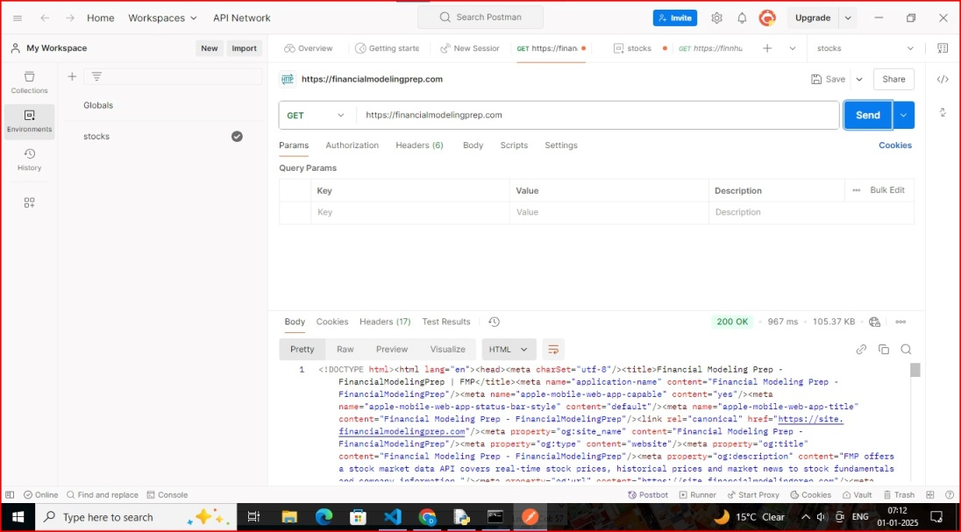

Output:-

