**FIN-Subscription-Menu**

**Dashboard**

**Product**

• Plan

• Addon

• Coupon

• Customer

• Subscriptions

**Customer Portal**

• Types & Status

• Payments

• Credit Notes

• Metered Billing

• Unbilled Charges

**Transactions**

• Types & Status

• Payments

• Credit Notes

**Settings**

• Organization Profile

• Users

• Manage subscriptions

• Preferences

• Currencies

• Templates

• Data Backup

• Dashboard

**Reports**

• Subscription Reports

• Transaction Reports

• Revenue Reports

• Sales Reports

• Activity Reports

**Online Payments**

• Payment Gateways

• Supported Currencies

• Direct Debit Payments

**Email Notifications**

### Home Dashboard

The Home screen is similar to the Dashboard in FIN Subscriptions and is the first screen that your customers see when they log in to the Customer Portal. It gives them an overview of the transactions that have taken place between you and your customers, and will display the following details:

* **Outstanding Invoices:** The total number of outstanding invoices along with the total amount that your customer owes you for all their outstanding invoices. A Pay Now link will be displayed as well, which your customer can use to pay the entire outstanding amount in one go.
* **Available Credits:** The total amount that you owe your customer. This amount is based on a customer’s credit notes and any refunds that you may have initiated.
* **Last Payment Made:** The amount and date of the most recent payment made by your customer. A link to the corresponding invoice will be present as well.
* **My Details:** Your customers can view and update their contact, address, and payment information that’s stored in FIN Subscriptions.
* **Pending Approvals:** The number of estimates & the number of timesheets that your customer has to approve. Clicking on either of these numbers will open a list of the respective transactions that are pending approval. (This will be shown in the Home screen if you’ve integrated with FIN Books.)

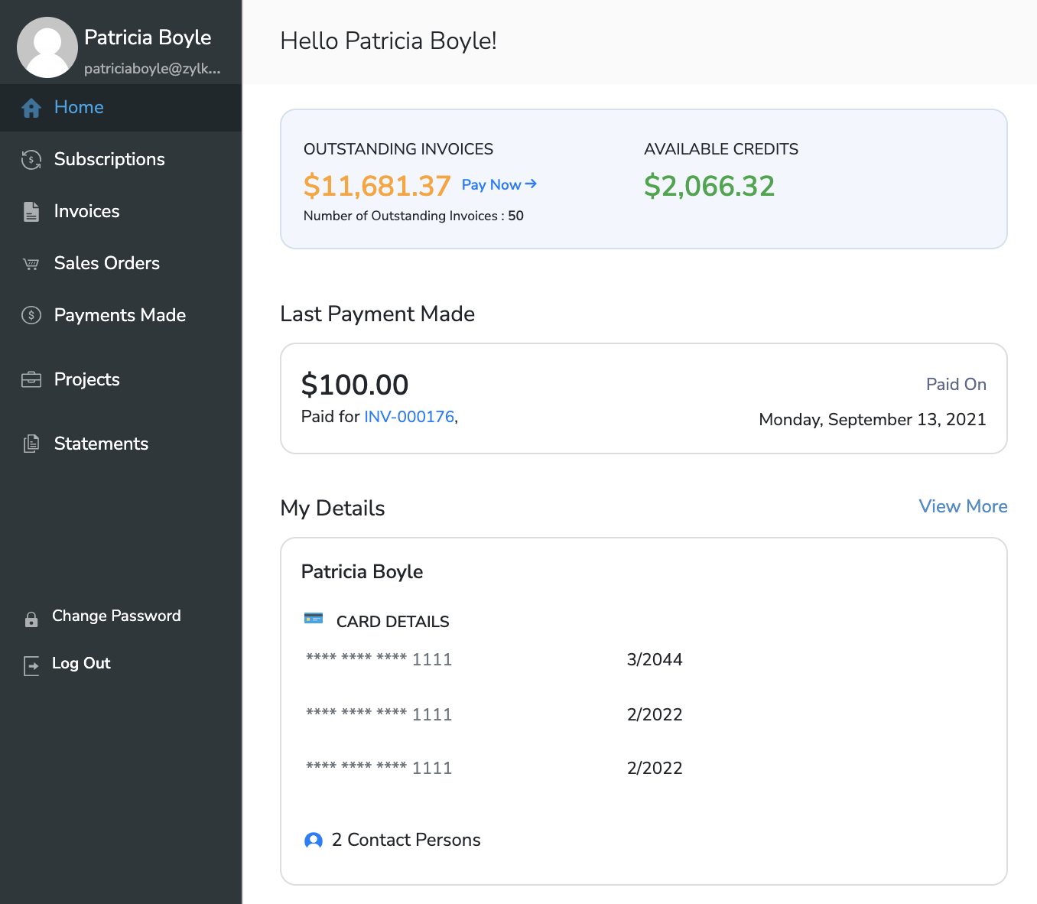

Apart from the details above, your customers will also be able to view your organization’s basic contact details, write reviews and send emails directly to your organization’s email address.

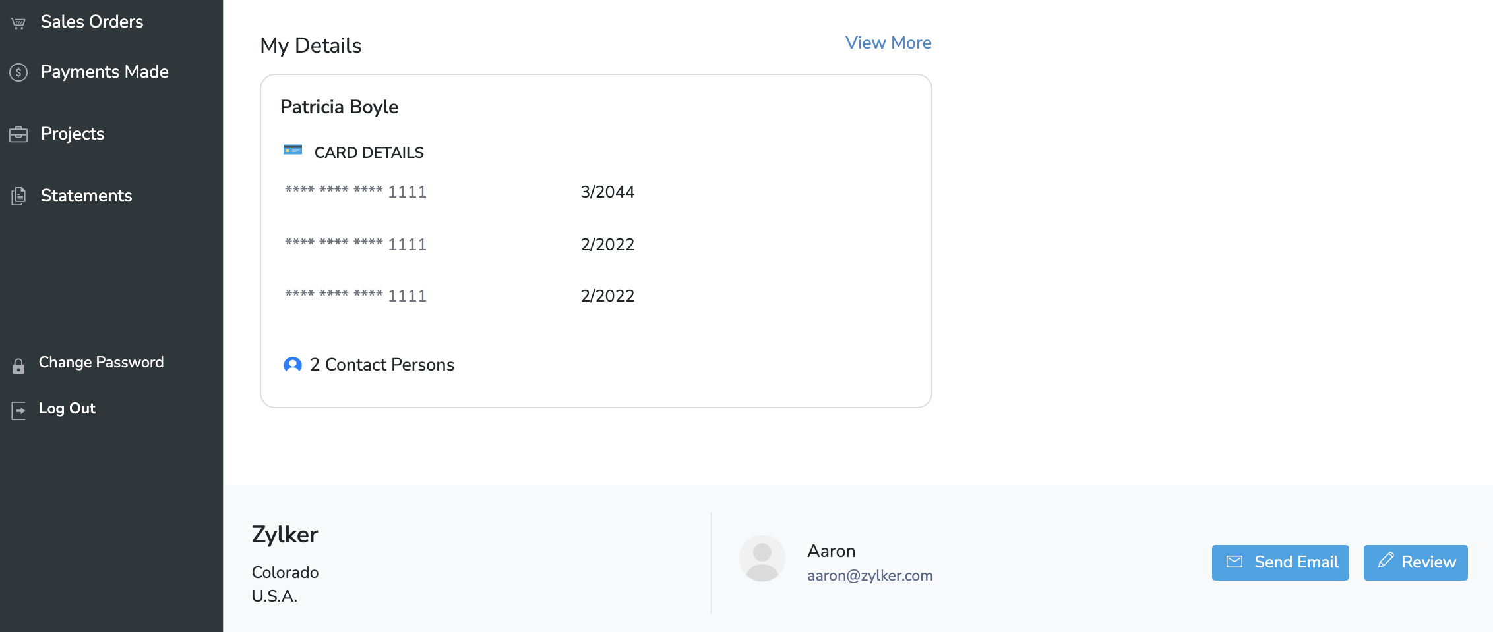

# Dashboard

FIN Subscriptions provides an informative yet clutter free dashboard. All the vital metrics are available right up front. The metrics that are available in the dashboard are:

* A graph that compares Activations vs Net cancellations.
* Number of sign ups, activations, active customers, activations, net cancellations, payment failures and churn rate.
* Activations for the current day, previous day and current month.
* Net revenue for the current month, previous month and the current year.
* MRR, ARPU and LTV trends.
* Subscription summary.

The dashboard provides an overview of the state of your subscription business. Detailed reports can be accessed by drilling down the required report.

Reports are classified into three categories:

* Subscription Reports
* Revenue Reports
* Transaction Reports

### Key Metrics

FIN Subscriptions provides the following key metrics to understand and optimize your subscription business.

* Monthly Recurring Revenue
* Average Revenue Per Unit
* Life Time Value

