# Plan

A plan lets customers know the features you offer and their price. You can clearly mention how much and how often they’ll be charged for a plan. Multiple plans can be created with each one offering a different set of features. Corresponding prices can be set for each plan.

Below are some of the things that will help you better understand plans. You can use the **Plan Operations** section to find out how to create, edit, delete or make a plan inactive. The **Plan Fields** section describes in detail about all the plan fields.

#### Plan Operations

* Creating a plan
* Editing a plan
* Making a plan inactive
* Deleting a plan

#### Plan Fields

* Plan fields
* Naming a plan
* Why do I need plan codes?
* Billing interval
* Billing cycle
* Free trial
* Setup fee
* Account
* Tax

#### Creating a plan

To create a new plan, please follow the below steps.

* Go to the **Products** tab and select the product for which a new plan needs to be created.
* 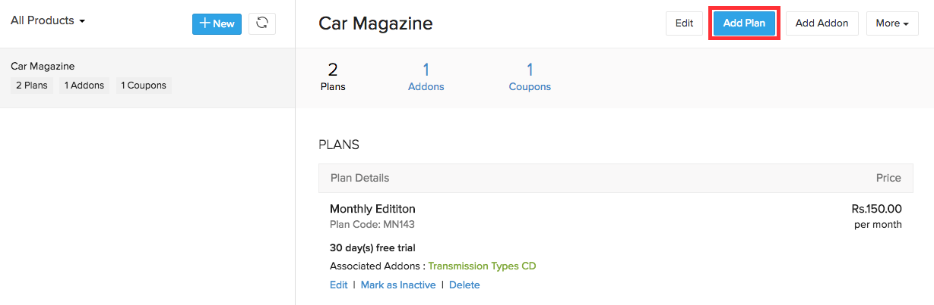Click the **Add Plan** button.

#### Editing a plan

To edit a plan, follow the below steps.

* Go to the **Products** tab and select the product to which the plan belongs.
* Click **Edit** under the respective plan.

Changes made to a plan will take effect only for new subscriptions. The existing subscribers will not be affected.

#### Making a plan inactive

You can make a plan inactive if you decide to do away with a plan, but do not want to delete the plan for the sake of the existing subscribers.

To make a plan inactive, follow the below steps.

* Go to the **Products** tab and select the product to which the plan belongs.
* Click the **Mark as Inactive** button under the respective plan.

Once a plan is made inactive, it can no longer be subscribed to new customers. However, the customers already subscribed to the plan will not be affected in any way.

#### Deleting a plan

Deleting a plan would remove it completely from the system. You will not be able to delete a plan if customers are currently subscribed to it. Follow the below steps to delete a plan.

* Go to the **Products** tab and select the product to which the plan belongs.
* 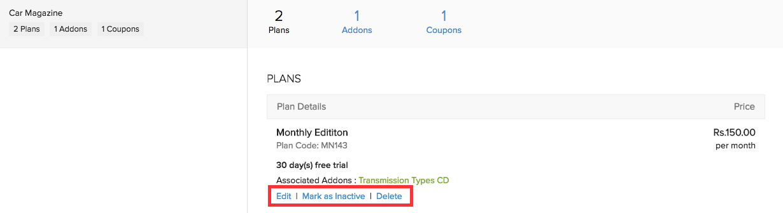Click **Delete** under the respective plan.

### Plan Fields

Here’s what the plan creation form will look like.

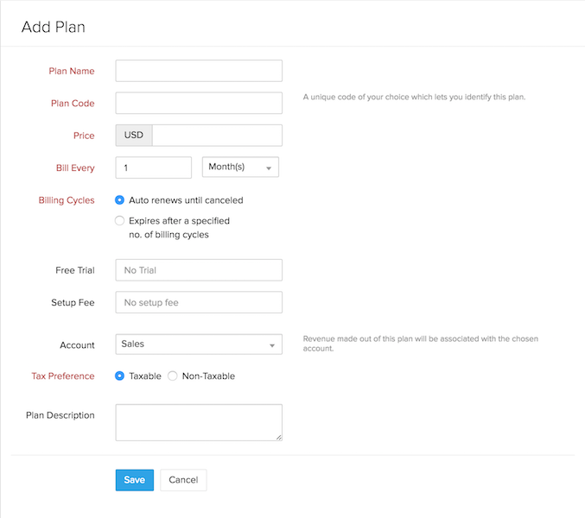

#### Naming a plan

The plan name you choose while creating a plan will be displayed in the invoices you send to customers as well. A plan should be named in a way that you can identify the features it offers without going into its details.

**Basic monthly** is better than **Plan A**.

#### Why do I need plan codes?

The FIN Subscriptions API uses plan codes instead of plan names to identify each of your plans. Plan code is a unique identifier used to refer to a plan when a subscription is created or updated via the API. The advantage here is you can set the plan code yourself rather than using an auto generated unique ID to identify the plan.

#### Billing interval

Billing interval is denoted by the **Bill Every** field. After you’ve set the **Price** of the plan, its billing interval can be set in the **Bill Every** field.

Bill Every 2 Month(s) - The customer would be charged once every 2 months. Bill Every 1 Year(s) - The customer would be charged once a year.

#### Billing cycle

You can specify the number of times the customer needs to be charged.

* If you choose **Auto renews until canceled**, the customer will be charged until the subscription is cancelled by the customer or yourself.
* If you choose **Expires after a specified no. of billing cycles**, you can specify the number of billing cycles after which the plan will expire.

If you want to charge a customer 3 times for one year using a 4 month duration, billing cycle will be set to 3 and billing interval would be Bill Every 4 Month(s).

Billing interval: 4 months

Billing cycle: 3

No. of charges: 3

#### Free trial

You can choose to provide a free trial for any number of days.

#### Setup Fee

If you charge a setup fee for a plan, then this field can be used to enter the setup fee amount. This amount is a one-time charge that your customers will have to pay when they initially subscribe to your service.

**Insight:***The term “Setup Fee” should be considered as an umbrella term for any extra amount that needs to be collected during the first billing cycle. For example, if you collect an initial security deposit, this amount can be entered in the Setup Fee field while creating a plan.*

You can also choose the **account** where the amount for the setup fee should reflect. To do this:

* Click **more fields** at the bottom of the page when creating or editing a plan.
* Select an account from the **Setup Fee Account** dropdown under Account Details.

Now, the amount received for the setup fee will reflect under the chosen account.

#### Account

This is another portion where the seamless integration with FIN Books comes into play. You can store a plan’s revenue in an Income account in FIN Books.

Whenever a customer subscribes to a plan, the corresponding plan’s revenue will be mapped into the account that you choose from the drop down. The drop down displays the list of Income accounts in FIN Books.

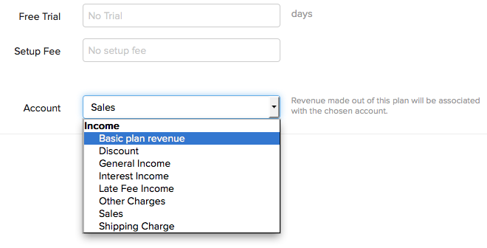

To get an account listed in the drop down, you’ll have to create an Income account (Income/Other Income) in FIN Books.

* Sign in to your FIN Books account.
* Go to the **Accountant** tab and click the **Chart of Accounts** sub-tab.
* Click the **+ New Account** button on the top right corner.
* After naming the account, make sure to select an Income account type. Click **Save**.

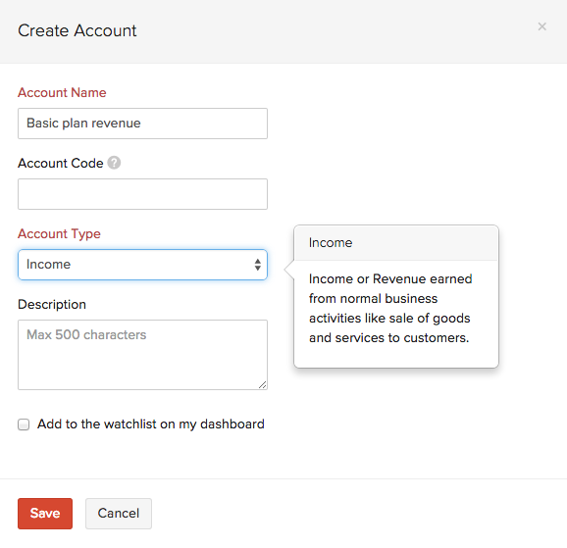

#### Tax

You can add tax to your plan. You can also use tax group for more than one tax.

To get a tax listed in the drop down follow the below steps.

* Go to the **Customers** tab.
* Click the **gear icon** on the top right side and select **Taxes**.
* Now click the **+ New Tax** button.
* Enter the required tax details and click the **Save** button.

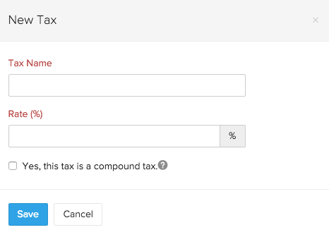

# Coupons

Coupons are used to provide discounts and special offers to customers. These coupons can be applied to a subscription at any time.

You can use the **Coupon Operations** section to know how you can perform operations like creating, editing, deleting and making a coupon inactive. The **Coupon Fields** section describes all the coupon fields.

**Coupon Operations**

* Creating a coupon
* Editing coupon details
* Making a coupon inactive
* Deleting a coupon
* Removing coupon from a subscription

**Coupon Fields**

* Coupon Fields
* Redemption Type
* Associating coupons with selected plans and addons
* Discount Type
* How are discounts deducted?
* Expiry date
* Maximum Redemption

**Creating a coupon**

To create a coupon, please follow the below steps.

* Go to the **Products** tab and select the product for which a coupon is to be created.
* Click the **Add Coupon** button.
* 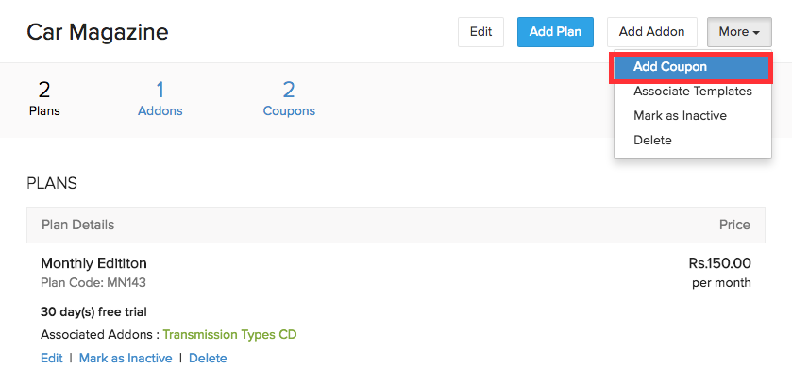Fill out the **Add Coupon** form with the required details and click **Save**.

**Editing coupon details**

You can change the coupon’s name, postpone the expiry date of the coupon and update the Maximum Redemption field. To edit coupon details, please follow the below steps.

* Go to the **Products** tab and click **Show details** in the coupon to be edited.
* Click the **Edit** button to go to the Edit Coupon form.
* Make the required changes and click **Save**.

**Making a coupon inactive**

A coupon can be made inactive if you do not want to apply it to new subscriptions but want subscriptions for which the coupon has already been applied to still make use of the coupon.

To make a coupon inactive, go to the **Products** tab and click **Mark as inactive** on the required coupon.

**Deleting a coupon**

A coupon can be deleted only if it is not associated with any subscriptions.

To delete a coupon, go to the **Products** tab and click **Delete** under the coupon to be deleted.

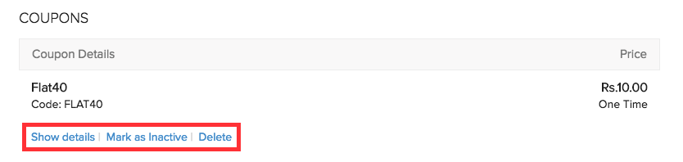

**Removing a coupon from a subscription**

There might be occasions where a coupon needs to be removed from a subscription. This can be achieved by manually removing the coupon from the subscription. Here’s how.

* Go to **Subscriptions** tab and click **Overview**.
* Choose the subscription from which the coupon has to be removed.
* Remove the coupon by clicking the **‘Remove Coupon’** option.

**Coupon Fields**

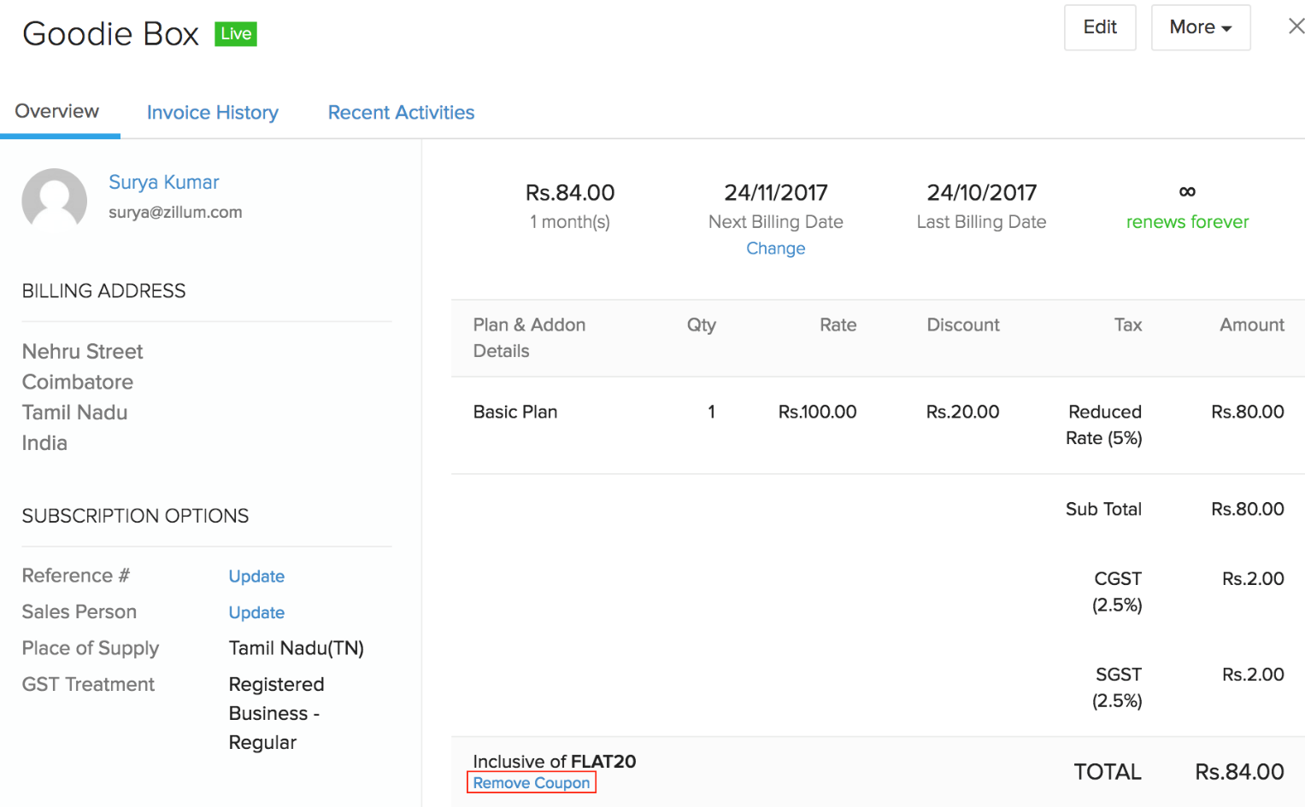The new coupon form looks like this.

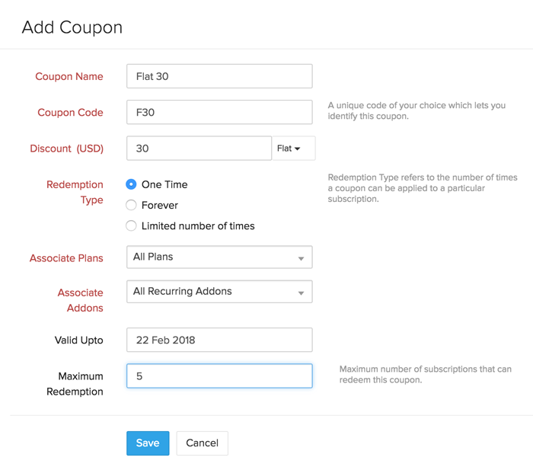

**Redemption Type**

Coupons in FIN Subscriptions are differentiated by their redemption type.

Redemption Type refers to the number of times a coupon can be applied to a particular subscription.

Coupons are of three redemption types.

* One Time
* Forever
* Limited number of times

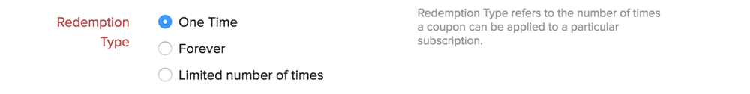

**One Time**

One Time can be chosen as the redemption type when a coupon is to be applied only once for a subscription. In other words, a coupon of *one time* redemption type can be used only once.

**Forever**

Forever can be chosen as the redemption type when a coupon needs to be applied each time an invoice is raised for a subscription.

**Limited number of times**

Limited time coupon can be chosen as the redemption type when you want the coupon to be redeemed for a specific number of times per subscription. This coupon will be automatically removed from the subscription once it has been fully utilized.

**Associating coupons with selected plans and addons**

A coupon can be applied to either all plans and addons or specific plans and addons of your choice.

Coupons are associated with plans and addons at the time of creation of a coupon. You cannot change this association once a coupon is created. However, you can create a new coupon and associate it with the plans and addons of your choice.

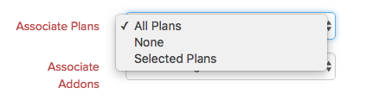 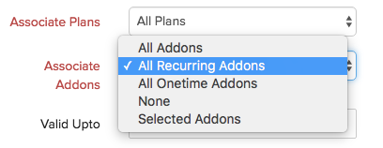

**Discount Type**

You can use coupons to either offer a flat discount or a percentage discount.

*Flat* - If a flat discount is chosen, the specified amount will be deducted from the invoice line item.

Line item cost: $100

Discount: $20

After discount: $80

*Percentage* - If a percentage discount is chosen, the discount will be deducted from the line item.

Line item cost: $100

Discount: 50%

After discount: $50

**How are discounts deducted?**

Discounts will be deducted from the cost of each entity the coupon is associated with.

*Example*

Coupon: Flat10 (Flat discount of $10)

Plans: Plan 1 = $50

Addons: Addon 1 = 20$, Addon 2 = $30

Coupon associated with: Plan 1 and Addon 1

Invoice Total = Plan 1 + Addon 1 + Addon 2

On applying Flat10 coupon, $10 will be deducted from Plan 1 AND Addon 1.

Invoice Total = (Plan 1 - $10) + (Addon 1 - $10) + Addon 2

Note that the *Flat10 coupon does not apply to Addon 2*. This is because the coupon was associated only with Plan 1 and Addon 1 at the time of creation. A new coupon can be created and associated with Plan 1, Addon 1 *and* Addon 2 in case the discount has to be applied to Addon 2 as well.

**Expiry Date**

A coupon cannot be applied to new as well as existing subscriptions beyond this date. However, coupons with forever as the redemption type which are already applied to subscriptions can still be redeemed until they are manually removed.

**Maximum Redemption**

This refers to the maximum number of subscriptions a coupon can be used for.

If Maximum Redemption is set to 2, the coupon cannot be applied to more than 2 subscriptions.

If there isn’t a value set for Maximum Redemption, the coupon can be used for any number of subscriptions.