# **Product**

A product refers to the service you offer your customers. There can be multiple products created if you offer more than one service. Each product can have different plans, addons and coupons associated with it. Below are the some of the things that will help you understand Products better.

* Why do I need a product?
* Creating a product
* Editing a product
* Making a product inactive
* Deleting a product

#### Why do I need a product?

Products can be very useful if you offer more than one kind of service. Consider that you offer a bug tracker and a project management software. You can create a separate product for each of the service you offer with its own set of plans, addons and coupons. This way, you can access reports specific to a product and find out how each product is performing.

#### Creating a product

To create a product, follow the below steps.

* Go to the **Products** tab.
* Click the **+New** button and fill out the new product form.
* Enter a name and a short description about the product.
* Enter a notification email address to which all product related notifications need to be sent. Multiple email addresses need to be comma separated.
* The Redirect URL is a product specific URL to which customers should be redirected to once they complete payment through the hosted payment page.
* 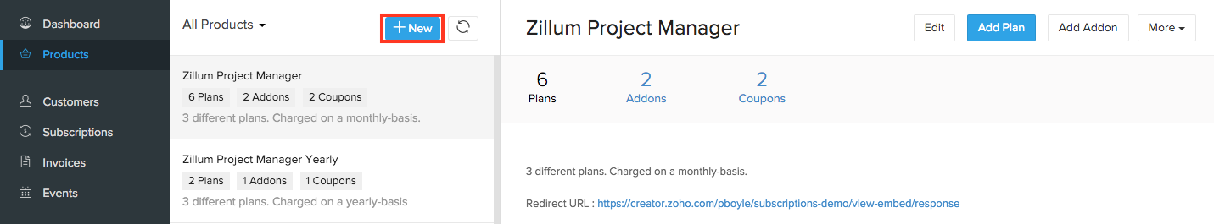Click on **Save**.

#### Editing a product

To edit an already created product,

* Go to the **Products** tab and select the product you want to edit.
* Click on the **Edit** button and make the necessary changes in the Edit Product screen.
* 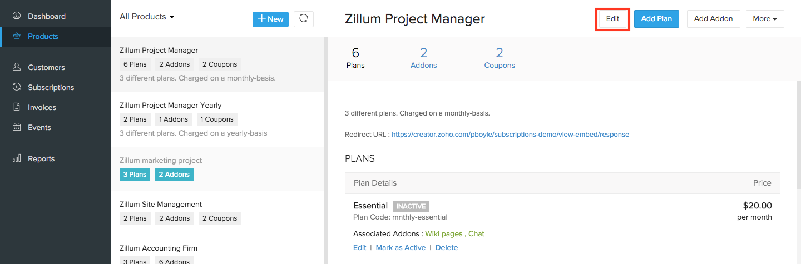Click on **Save**.

#### Making a product inactive

To make a product inactive,

* Go to the **Products** tab and select the product you want to make inactive.
* 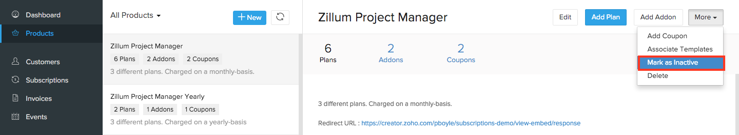Click on **More** button at the top-right corner and select **Mark as Inactive** from the drop down.

#### Deleting a product

To delete a product,

* Go to the **Products** tab and select the product you want to delete.
* Click on **More** button at the top-right corner and select **Delete** from the drop down.

