# Subscriptions

A subscription enables you to charge a customer for a plan of their choice. Below are the list of actions you can perform on subscriptions.

* New Subscription
* Future Subscriptions
* Subscription Term
* Payment mode
* Adding a one time addon
* Adding a charge
* Applying a coupon
* Changing subscription details
* Extending a subscription
* Pause and Resume Subscriptions
* Cancelling a subscription
* Reactivating a subscription
* Reactivating an expired subscription
* Deleting a subscription
* Custom View

### New Subscription

Here’s how you create a new subscription for a customer.

Go to the **Customers** tab and select the customer for whom a new subscription needs to be created and click the **New Subscription** button on the top-right corner.

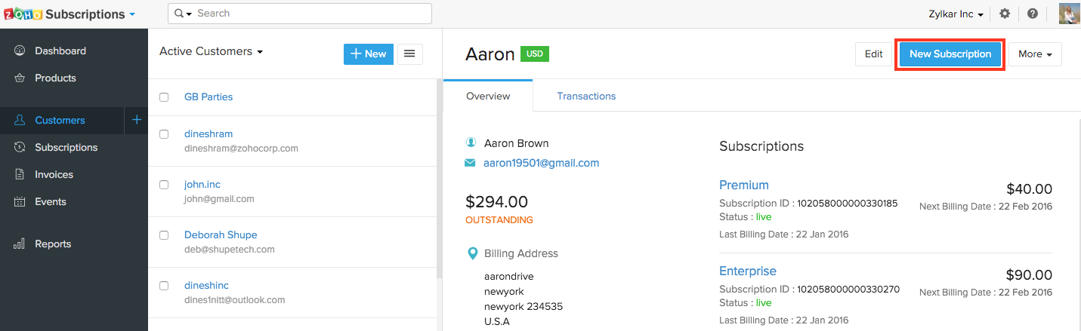

Choose the respective Product and the required plan, addons, addon quantity and coupon. You can also set a reference number for the subscription.

You can only include recurring addons here. Find out how to add a one time addon.

### Future Subscriptions

In a business scenario, you might sometimes want to create subscriptions in a future date and FIN Subscriptions exactly allows you to do that without any struggle.

Future subscriptions can be created like any other subscriptions in FIN Subscriptions. All you have to do is select the date (future date) in the **Starts On** field on which the subscription has to be activated. For subscriptions with a trial period, the subscription trial will start on the selected date.

### Subscription Term

**Starts on** - You can choose to charge a customer from the current date as well as any future date.

**Expires After** - If you want the subscription to expire only when it gets cancelled by either yourself or the customer, check Never Expires. If you want the subscription to expire after a certain duration, make sure Never Expires is unchecked and enter the number of cycles after which the subscription should expire.

**Reference number** - A reference number can be used to identify a subscription as long as the reference number is unique for each subscription.

**Sales Person** - You can associate your subscription with a sales person.

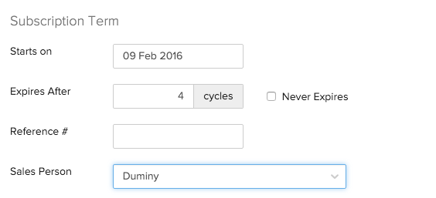

The price of plans, addons and the number of cycles after which a subscription should expire can be exclusive for a subscription. In other words, these values can be changed while creating or editing a subscription and this will not affect the original values set during creation of plan or addon.

### Payment mode

There are two kinds of payment modes - offline and online.

**Online** - If payment is to be made through the customer’s card, make sure that **Collect payment offline** is unchecked.

**Offline** - If payment is to be made by customers through cheques, cash or other means wherein you do not store their card information, check **Collect payment offline**.

Note: At any point, you can change the subscription from Online mode to Offline mode and vice versa.

* **Change from Online to Offline**:

Navigate to the subscription and click on **Change to Offline Mode** under Payment Information.

* **Change from Offline to Online**:

For subscriptions to be changed from offline to online, you must first associate a card with the subscription by clicking on **Associate Payment Options > Associate Card**. Enter the card details and click on **Save and Change to Online**.

### Adding a one-time addon

A separate invoice will be raised for a one-time addon. Here’s how you can add a one-time addon to a subscription.

* Go to the **Customers** tab and select the customer for whom a one-time addon has to be added.
* Click the respective subscription in the Overview section.
* Click the **gear icon** and select **Add One Time Addon**. Do ensure the respective one-time addon is associated with the subscribed plan.

### Adding a charge

You can associate one-time charges to your customers’ subscriptions. These charges will be raised in a separate invoice:

* Go to the **Subscriptions** module from the left sidebar.
* Select the subscription for which you want to add the one-time charge.
* Click the **More** dropdown in the top right corner and select **Add Charge**.
* Enter the amount to be charged, along with the other necessary details.
* Click **Charge**.

### Applying a coupon

A coupon can be applied for a subscription at any time.

But at any point of time, there can be only one coupon applied to a subscription.

To apply a coupon for a subscription, please follow the below steps.

* Go to the **Customers** tab and select the customer for whom a one-time charge has to be added.
* Click the respective subscription in the Overview section.
* Click the **Add Coupon** button. Select the coupon to be applied and click **Save**.

### Changing subscription details

You can change subscription details like billing information, contact person, reference numbers, card details, payment mode and notes.

* Go to the **Customers** tab and select the customer for whom subscription details need to be changed.
* Click the respective subscription in the Overview section.

**Change next billing date** The next renewal date can be postponed. Click **Change** and select any future date. If the next billing date is changed from Jan 1st to Jan 10th, the subsequent billing date would be on Feb 10th.

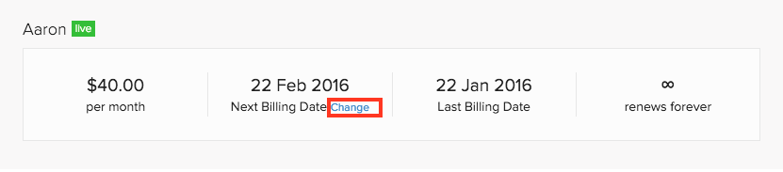

**Reference number** You can add/update a reference number for the subscription at any time.

**Manage contacts** When you click Manage Contacts, you can view the list of email IDs of customers and contact persons. Check the email IDs to which subscription related notifications need to be sent.

**Notes** Add a short note about the subscription.

#### Extending a subscription

When a subscription is about to expire, you can extend the billing cycle(s) instead of creating a new subscription for the customer.

To extend a subscription for your customer, just change the number of billing cycle and the subscription will be updated. This can be done easily from the subscription’s overview page.

* Navigate to the Subscriptions module on the left sidebar.
* Open a Subscription.
* In the Overview tab, click the edit icon below renewals remaining.

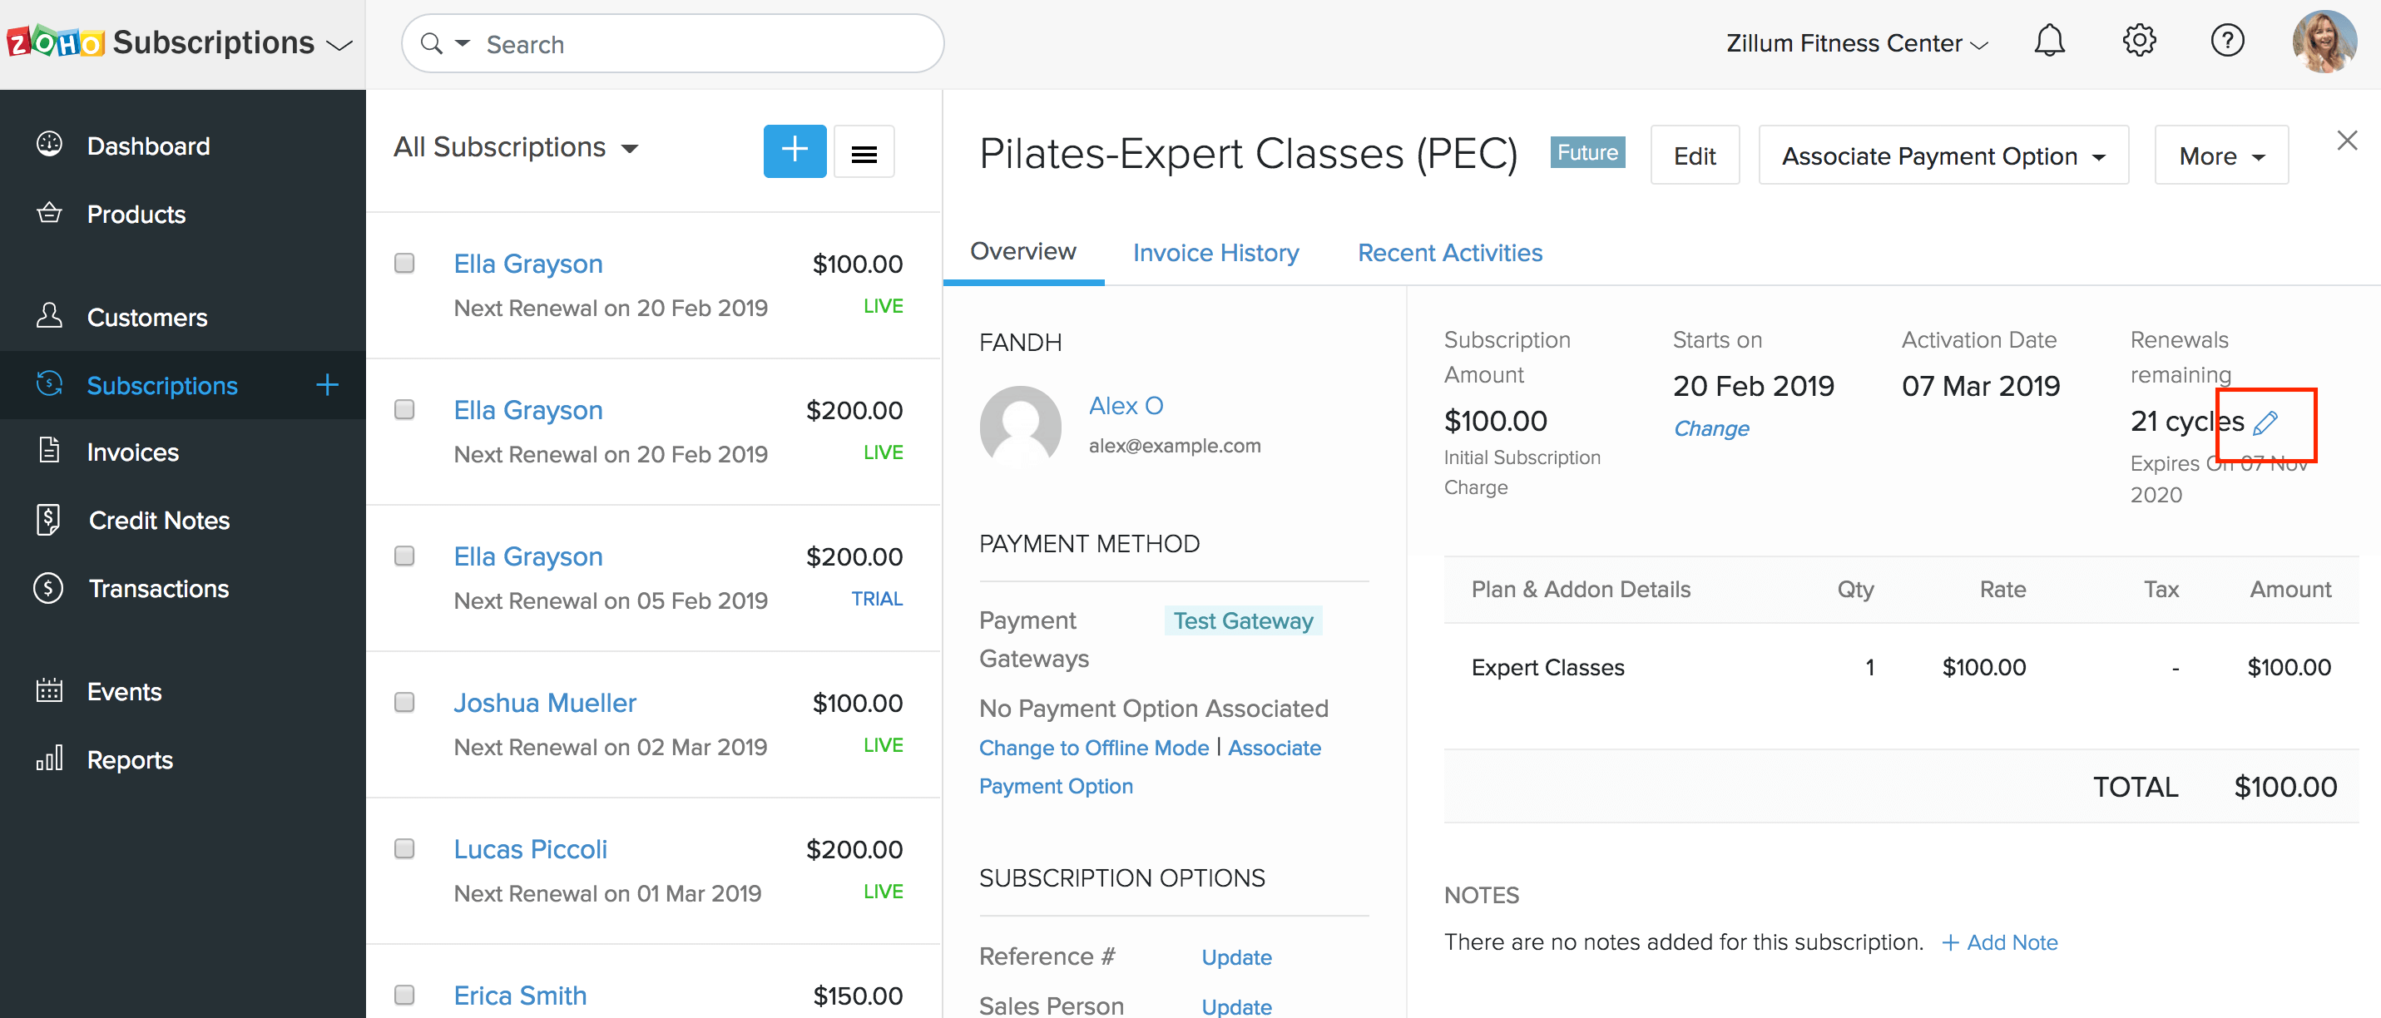

* Change the no. of billing cycles left (or) select **Never Expires** if you want the subscription to renew automatically until you cancel it manually.

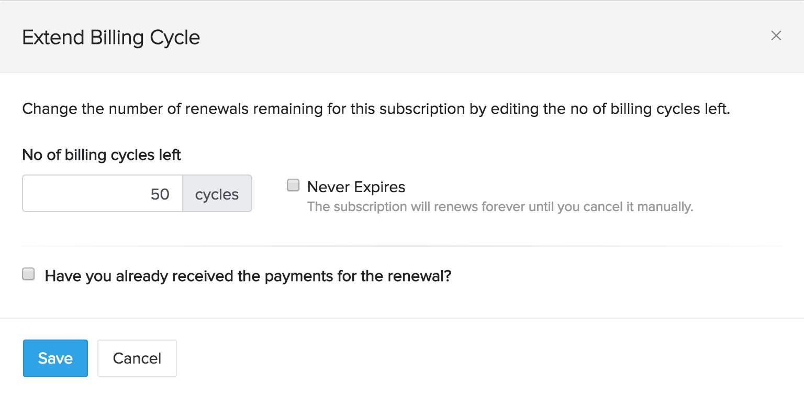

* Click **Save**.

**Note:** You will not be able to extend the following types of subscriptions:

* cancelled
* cancelled at renewal
* dunning subscriptions
* expired subscriptions
* the subscriptions that renews forever.

#### For Offline Subscriptions

If you have already received the payment for extending a subscription, you can record the payment here.

* After entering the number of billing cycles, check **Have you received payments for the renewal?** and enter the details.

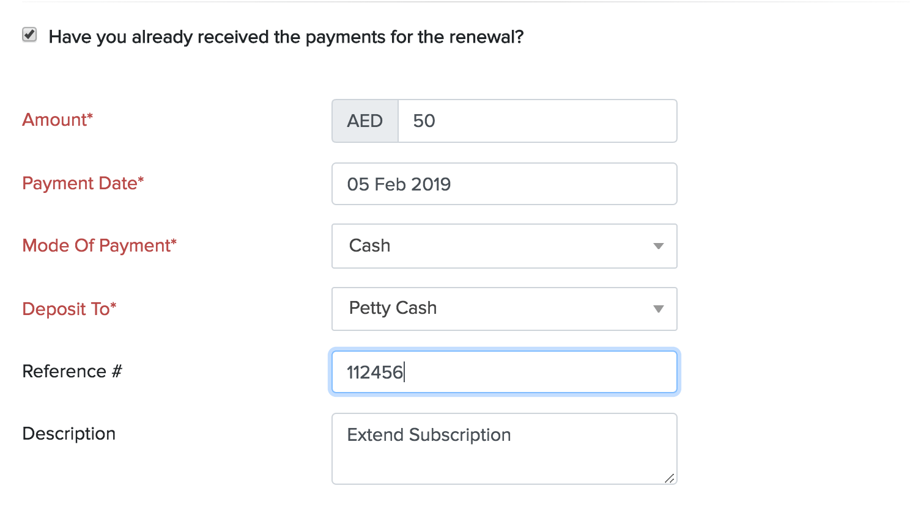

* Click **Save**.

This option is only applicable for offline subscriptions. Also, the payment will be recorded as Excess payments under that customer.

If you want to apply the excess amount to the invoices automatically upon its renewal, enable the **Apply excess payments to offline Subscriptions under Invoice preferences**. After enabling, these excess payments will be applied automatically to invoices that are raised during the next renewal.

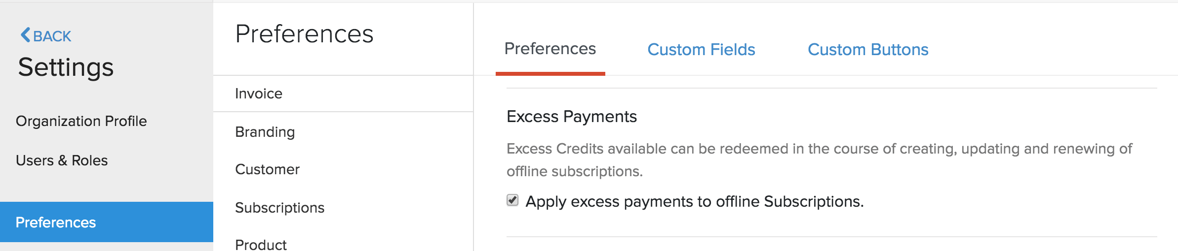

## Pause and Resume Subscriptions

If your customer wants to suspend their subscription temporarily, but doesn’t necessarily want to cancel it, pausing and resuming subscriptions is the way to go. This way, your customer will not be charged for their subscription while it is paused, and can pay for their subscription when they’re ready to resume it.

**When should you pause subscriptions instead of canceling them?**

Pausing subscriptions is recommended over temporarily canceling and re-activating them, because pausing subscriptions **won’t affect your churn reports**. However, it should not be seen as an alternative to actually canceling subscriptions when your customers ask you to do so.

**Scenario:***Larissa gets a box of groceries delivered to her every week on a subscription basis. With the holiday season approaching, she decides to go out of town on a vacation for three weeks. However, she doesn’t want to pay for her grocery subscription during this time and notifies her grocer about this. Her grocer, who uses FIN Subscriptions, simply sets a pause and resume schedule for Larissa’s subscription. Now, Larissa’s weekly grocery box will not be delivered to her when she’s out of town and will automatically resume when she’s back.*

**In this section:**

* Pause Subscriptions
* Resume Subscriptions
* Change Pause and Resume Schedules
* Events for Paused and Resumed Subscriptions

### Pause Subscriptions

**Prerequisite**:

To pause subscriptions, you will have to enable the feature in your organization:

* Go to **Settings** > **Preferences** > **Subscriptions**.
* Mark the **Enable Pause and Resume** option.
* Click **Save**.

Now, the feature has been enabled and you’re ready to pause subscriptions.

When a subscription is in the Paused status, it will not be renewed on its billing date and invoices will not be raised for it.

**Points to note about pausing subscriptions:**

* If a subscription has unbilled charges associated with it, the charges will not be invoiced automatically when the subscription has been paused. You will still be able to invoice them manually.
* **End-of-term changes** to subscriptions, if any, **will be discarded** if the subscription is paused before its billing date.

**Pro Tip:***You can view the end-of-term changes by going to a subscription’s details page and clicking****View Changes****.*

* Paused subscriptions cannot be edited.
* You will not be able to add additional charges or one-time add-ons to paused subscriptions.

**To pause a subscription:**

* Go to the **Subscriptions** module from the left sidebar.
* Select the subscription which you want to pause.
* Click the **More** dropdown in the top right corner and select **Pause Subscription**.

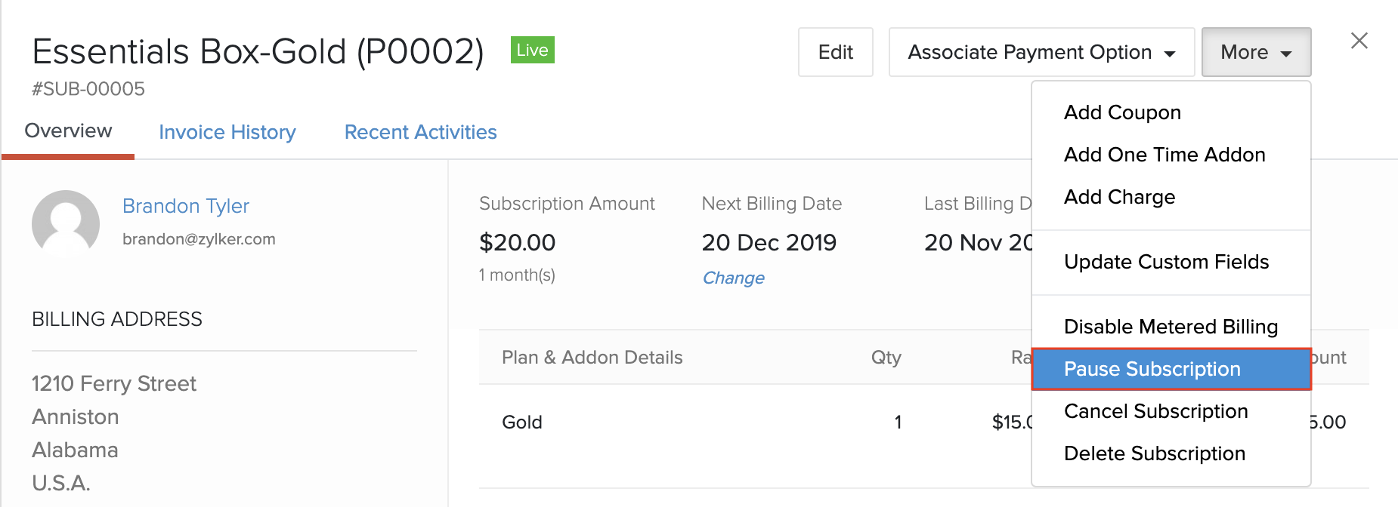

* Select one of the following options to pause your subscription:
  + **Immediately**: The subscription will be paused immediately.
  + **On Scheduled Date**: You will be able to set a date on which the subscription should be paused.
  + **On Next Renewal Date**: The subscription will be paused on the next renewal date, however, it will not be renewed.

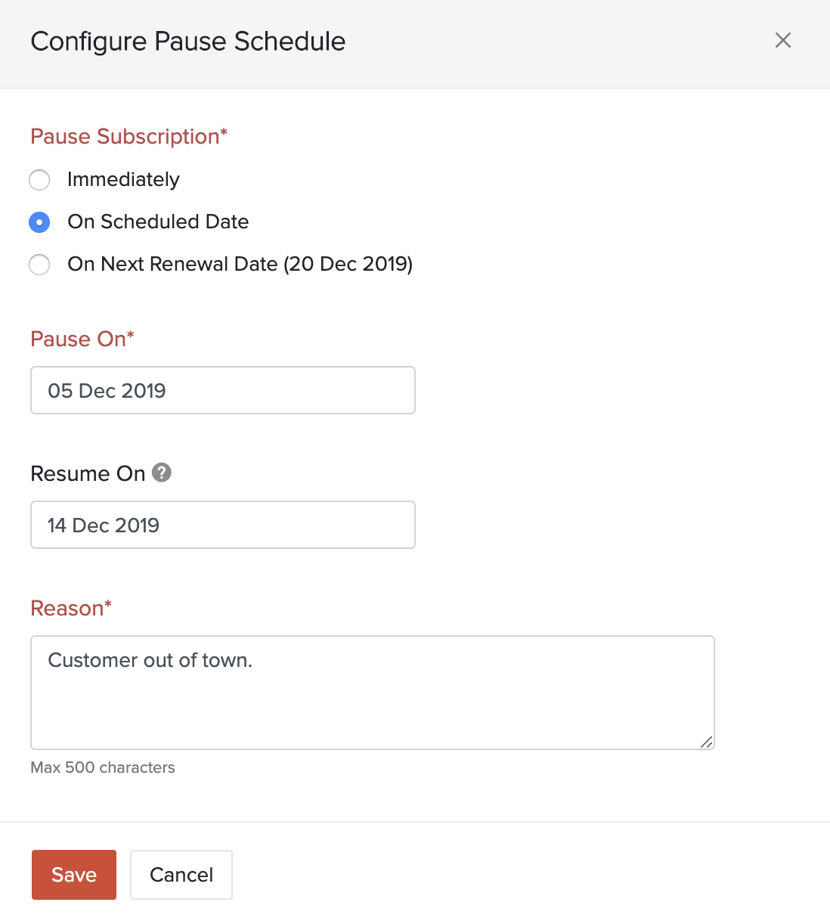

* Select the date on which you want the subscription to resume.

**Warning:***The resume date while pausing a subscription is optional. However, by leaving it empty, the subscription will be paused indefinitely, until you resume it manually.*

* Enter a reason for pausing your subscription. This reason will be displayed in the Recent Activities section.
* Click **Save**.

Now, the subscription will be paused according to the schedule that you’ve configured.

**Warning:***Subscriptions can only be paused if they are in the****Live****status. If a subscription’s status changes on the day that it’s scheduled to pause, the subscription will not be paused. For example, if a subscription’s status changes from****Live****to****Non-renewing****or****Dunning****, on its scheduled pause date, the subscription will not be paused.*

### Resume Subscriptions

**Points to note about resuming subscriptions:**

* If a subscription is resumed after its next billing date:
  + An invoice will be raised for the current cycle’s subscription renewal charges, along with any unbilled charges that were supposed to be invoiced when the subscription was paused.
  + The subscription’s billing date will be changed to the date on which you resume your subscription.
  + If the subscription is auto-charge enabled, an invoice will be raised for the current cycle’s subscription renewal charges, along with any unbilled charges that were supposed to be invoiced when the subscription was paused and a payment attempt will be made. If the payment attempt is susccessful, the subscription will move to the **Live** status, if not, the subscription will move to the **Past Due** status and your Retry Settings will come into play.
* If a subscription is resumed before its next billing date, there will be no change to its billing date and invoices will be raised normally.

If you had set a resume date while **pausing your subscription**, your subscription will resume automatically on this date. However, if you did not do this, and your subscription is paused indefinitely, you will be able to resume the subscription manually. Here’s how:

* Go to the **Subscriptions** module from the left sidebar

**Pro Tip:***Select the****Paused Subscriptions****view filter from the view filter dropdown to easily identify your paused subscriptions.*

* Select the subscription which you want to resume.
* Click the **More** dropdown in the top right corner and select **Resume Subscription**.

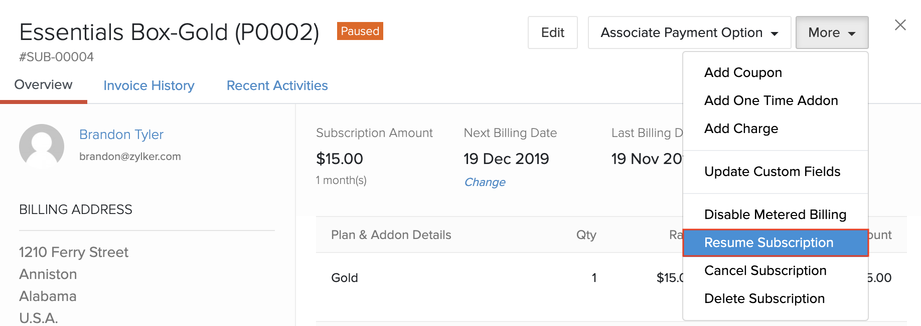

* Configure when you want to resume your subscription. You can choose to resume it immediately or set a date on which it should resume.

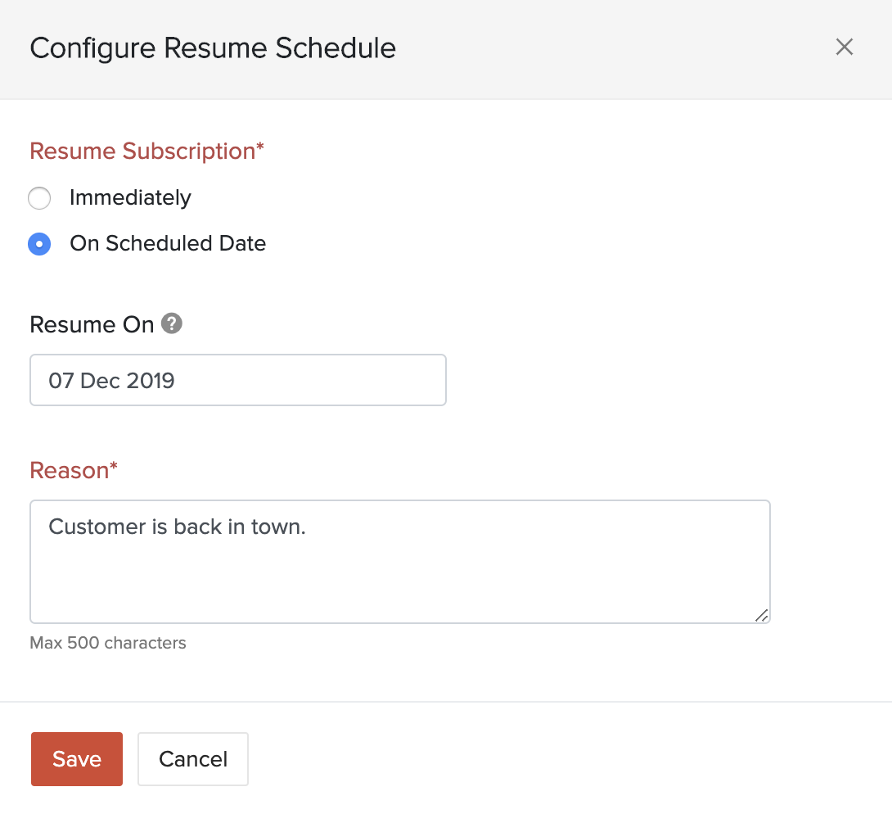

* Click **Save**.

Your subscription will resume according to the schedule that you’ve configured.

### Change Pause and Resume Schedules

You can change the pause and resume schedules for your subscription at any time.

* Go to the **Subscriptions** module and select a subscription.
* Click **Change Schedule** in the subscription’s details page.

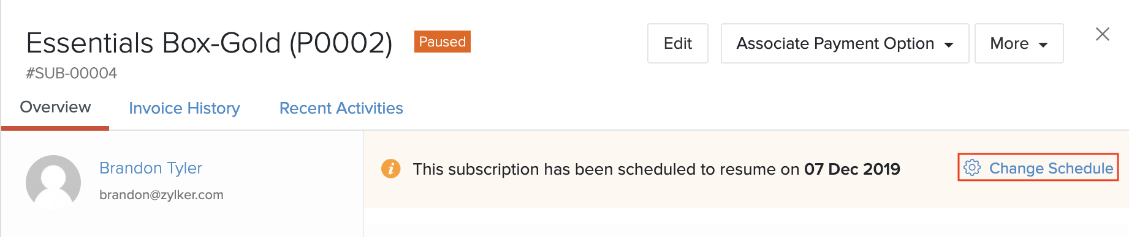

Here, you will be able to change your pause and resume schedules. You can also delete the schedule entirely by clicking **Delete Schedule**.

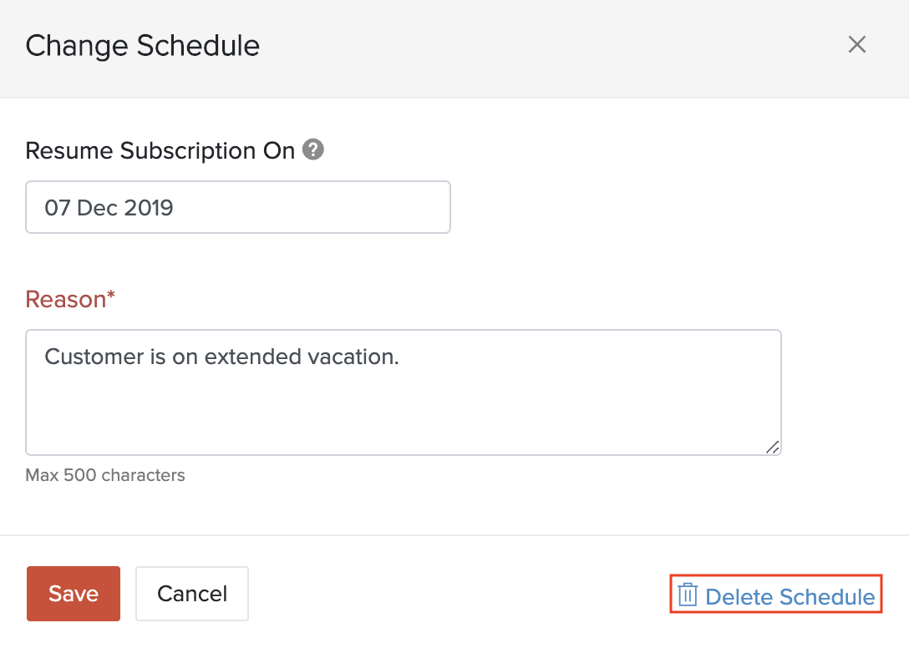

**Insight:***By deleting the schedule, only the configured pause and resume dates will be deleted, and your subscription’s status will remain unchanged. For example, if your subscription is paused and you delete the schedule for your resume date, the subscription will remain paused.*

### Events for Paused and Resumed Subscriptions

You can use automation workflows, such as webhooks, to let your business systems know that a subscription has been paused or resumed in FIN Subscriptions.

You can create webhooks that are triggered when a subscription has been paused or resumed, using the **Subscription Paused** and **Subscription Resumed** events, respectively.

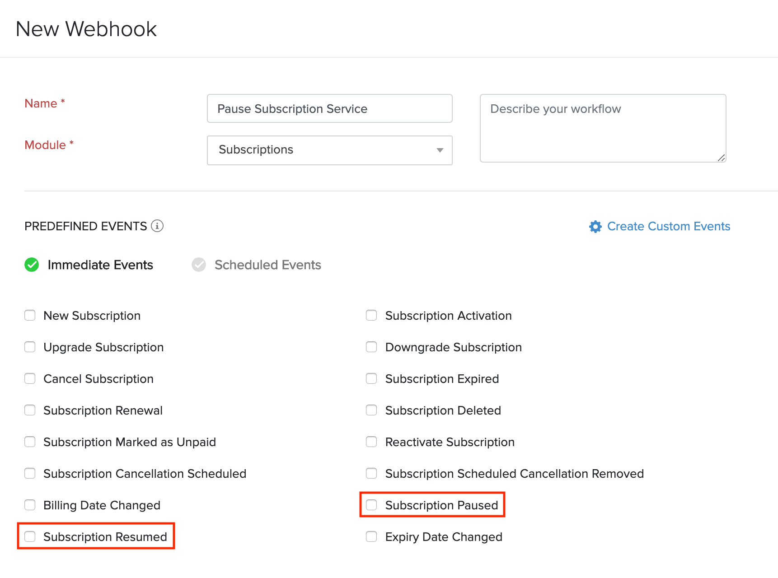

These events can also be used to trigger email alerts, which can be useful to notify your customers when a subscription has been paused or resumed.

### Cancelling a subscription

Churn is inevitable but knowing and tracking the reasons for the downgrades is a crucial measure. We have provided you with an additional key to track your churn. Now you can configure various possible reasons that your customer might have, to cancel your subscription. They can give you their valuable feedback when cancelling through the portal.

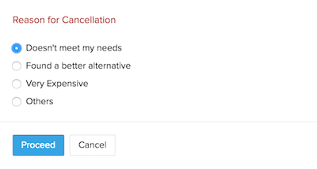

**Where this helps ?**

The churned subscriptions reports, non renewing profiles and much more lets you visualise the cancelled subscriptions and their details. Searching subscriptions with their date and filtering through for cancellations due to a particular reason, might give you insights on your business.

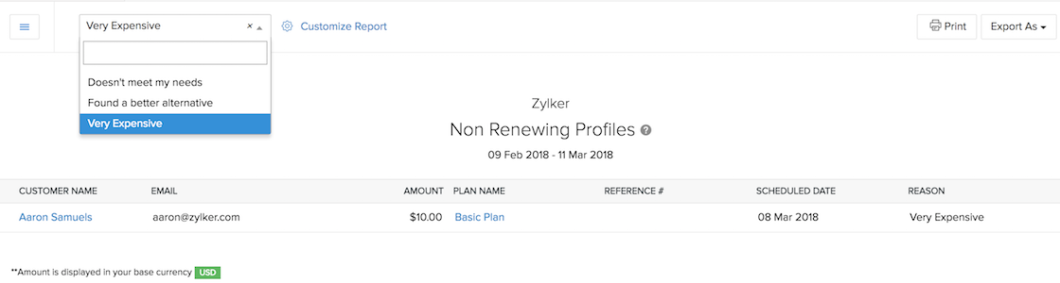

A subscription can be canceled either by you or by your customer.

**By you:**

* Navigate to subscriptions tab and select the subscription that you want to cancel.
* Once selected, click on **More** button at the top and click on **Cancel Subscription** from the drop-down.
* In the pop-up next, you can choose to cancel the subscription immediately or on the next renewal using **Cancel immediately** or **Cancel on next renewal** options respectively.

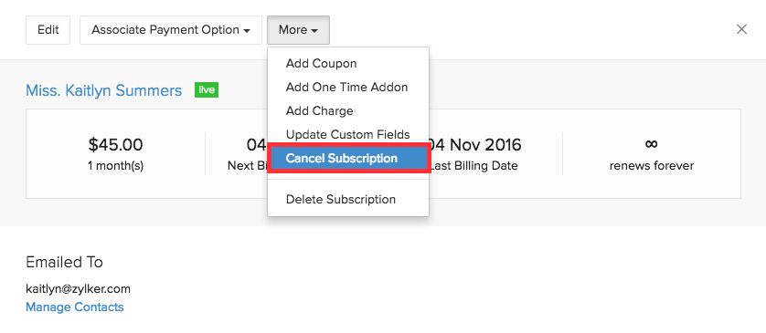

**By your customers:**

A subscription can only be cancelled from Customer Portal, if the cancel subscription option is enabled for them in the portal settings.

To enable the cancel subscription option for your customers,

* Navigate to **Gear icon > More Settings > Preferences > Branding > Portal Settings** and enable the **Cancel Subscription** option using the checkboxes.
* You can choose to allow the customers to cancel the subscription either immediately or on the next renewal using the checkboxes provided.

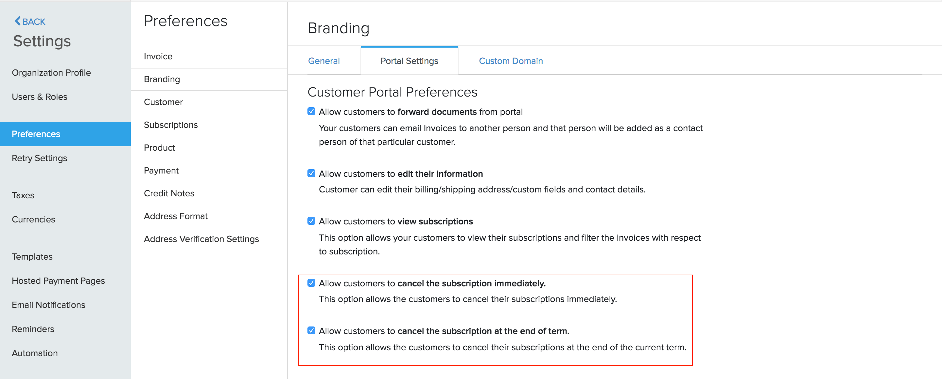

For your customers to cancel a subscription from Customer Portal,

* Log into the Customer Portal and go to the **Subscriptions** tab.
* From the subscription list, Click on the subscriptions that has to be cancelled.
* In the subscription details page next, click on the **Cancel** button at the top-right corner to cancel the subscription.

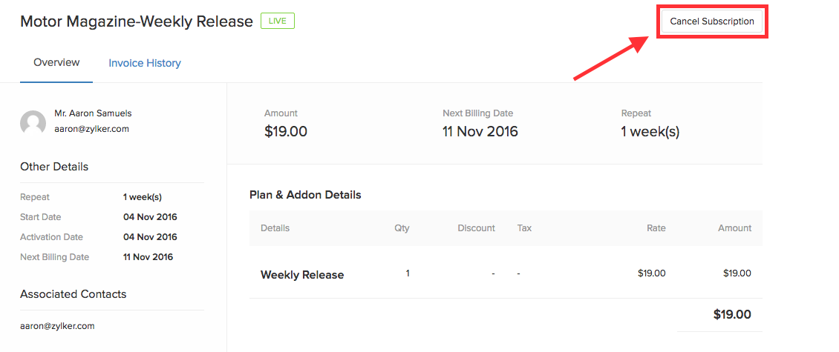

**Pro-Tip:-**

**Cancel immediately** - This will cancel the subscription right away.

**Cancel on next renewal** - This will cancel the subscription at the end of the current term (i.e) the next billing date.

### Reactivating a subscription

If the subscription was cancelled using **Cancel on next renewal**, here’s how you can reactivate the subscription before the term ends.

* Go to the **Customers** tab and choose the respective customer.
* Select the required subscription and click the **Reactivate Subscription** button.

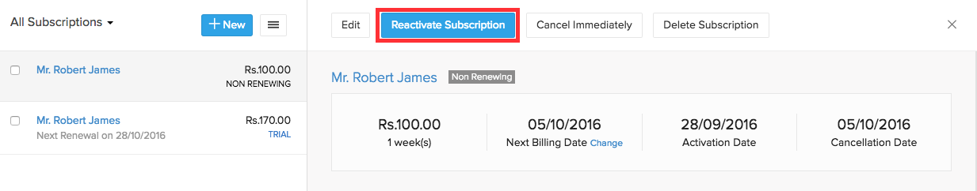

If the subscription was cancelled using the **Cancel immediately** option, follow the below steps to reactivate the subscription.

* Go to the **Customers** tab and choose the respective customer.
* Select the required subscription and click the **Change Subscription** button.
* Make sure the required plan and addons are selected before charging the customer.

### Reactivating an expired subscription

Reactivating an expired subscription allows you to create the same subscription for the same customer without having the need to add the plans, coupons and add-ons again. You can also choose to edit the plans, coupons and add-ons if you wish to.

To reactivate the expired subscription, follow the steps below:

* Navigate to the expired subscription which you would want to reactivate and click on the **Edit** button.
* In the Subscription details page, make the changes to the subscription if needed any, and click on **Continue**.
* Next, click on **Update** in the Subscription Preview page to reactivate the subscription.

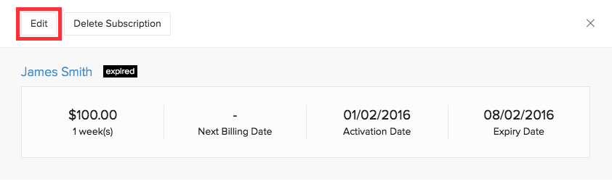

### Deleting a subscription

A subscription in any state can be deleted at any point of time. To delete a subscription,

* Navigate to the subscription details page of the subscription you want to delete.
* Click on **More > Delete Subscription**.

