UCS301 Data Structures
Lab Assignment 2
Name: Diksha Yadav Roll No: 2026010034

Question 1 — Binary Search
Binary Search is a fast search algorithm with a run-time complexity of O(log n), compared to Linear Search's O(n). It works only on a sorted array by repeatedly dividing the search interval in half.
#include <iostream>
using namespace std;

int binarySearch(int arr[], int n, int key) {
int low = 0, high = n - 1;
while (low <= high) {
int mid = low + (high - low) / 2;
if (arr[mid] == key)
return mid;
else if (arr[mid] < key)
low = mid + 1;
else
high = mid - 1; }
return -1; }
int main() {
int arr[] = {2, 5, 8, 12, 16, 23, 38, 45, 56, 72};
int n = sizeof(arr) / sizeof(arr[0]);
int key;
cout << "Enter the element to search: ";
cin >> key;
int result = binarySearch(arr, n, key);
if (result != -1)
cout << "Element " << key << " found at index " << result << endl;
else
cout << "Element " << key << " not found in the array" << endl;
return 0;}
Output:
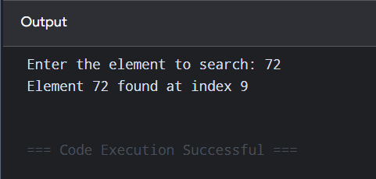

Question 2 — Bubble Sort
Bubble Sort repeatedly steps through the array, compares adjacent elements, and swaps them if they are in the wrong order. Applied here to: 64 34 25 12 22 11 90
#include <iostream>
using namespace std;

void bubbleSort(int arr[], int n) {
for (int i = 0; i < n - 1; i++) {
for (int j = 0; j < n - i - 1; j++) {
if (arr[j] > arr[j + 1]) {
int temp = arr[j];
arr[j] = arr[j + 1];
arr[j + 1] = temp;
}
}
}
}

void printArray(int arr[], int n) {
for (int i = 0; i < n; i++)
cout << arr[i] << " ";
cout << endl;
}

int main() {
int arr[] = {64, 34, 25, 12, 22, 11, 90};
int n = sizeof(arr) / sizeof(arr[0]);
cout << "Original array: ";
printArray(arr, n);
bubbleSort(arr, n);
cout << "Sorted array: ";
printArray(arr, n);
return 0;
}

Output:
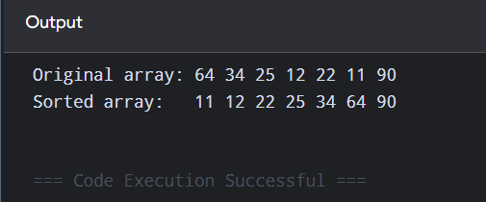

Question 3 — Find a Missing Number in a Sorted Array
Given n-1 distinct integers from the range 1 to n arranged in sorted order, find the one missing number.
(a) Linear Time Approach
Uses the fact that the sum of 1..n is a known formula; subtracting the actual sum from the expected sum gives the missing number in O(n) time.
#include <iostream>
using namespace std;

// Array holds n-1 distinct integers from the range 1..n (one is missing)
int findMissingLinear(int arr[], int n) {
int expectedSum = (n + 1) * (n + 2) / 2;
int actualSum = 0;
for (int i = 0; i < n; i++)
actualSum += arr[i];
return expectedSum - actualSum;
}

int main() {
int arr[] = {1, 2, 3, 5, 6, 7, 8}; // 4 is missing, range is 1 to 8
int n = sizeof(arr) / sizeof(arr[0]);

cout << "Missing number (Linear method): " << findMissingLinear(arr, n) << endl;

return 0;
}

Output:
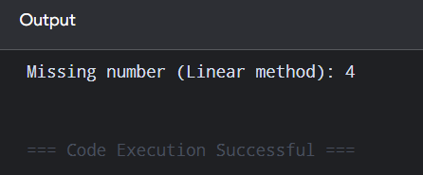

(b) Binary Search Approach
Since the array is sorted, arr[i] should equal i+1 until the missing number is crossed. Binary search locates that crossing point in O(log n) time.
#include <iostream>
using namespace std;

// arr is sorted and holds n-1 distinct integers from range 1..n
int findMissingBinary(int arr[], int n) {
int low = 0, high = n - 1;
while (low <= high) {
int mid = low + (high - low) / 2;
// If value equals its expected value (index+1), nothing
// missing so far -> search the right half
if (arr[mid] == mid + 1) {
low = mid + 1;
} else {
high = mid - 1;
}
}
// The missing number is low + 1
return low + 1;
}

int main() {
int arr[] = {1, 2, 3, 4, 6, 7, 8}; // 5 is missing, range is 1 to 8
int n = sizeof(arr) / sizeof(arr[0]);

cout << "Missing number (Binary Search method): " << findMissingBinary(arr, n) << endl;

return 0;
}

Output:
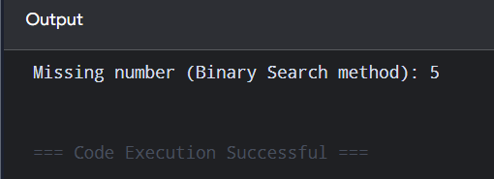

Question 4 — String Related Programs
(a) Concatenate One String to Another
#include <iostream>
#include <string>
using namespace std;

int main() {
string str1, str2;
cout << "Enter first string: ";
getline(cin, str1);
cout << "Enter second string: ";
getline(cin, str2);
string result = str1 + str2; // + concatenates std::string objects
cout << "Concatenated string: " << result << endl;

return 0;
}
Output:
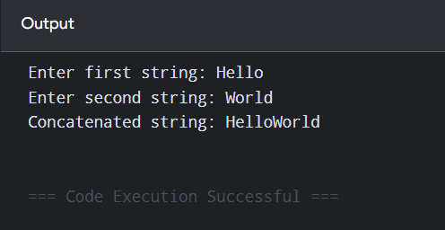
(b) Reverse a String
#include <iostream>
#include <string>
using namespace std;

void reverseString(string &str) {
int start = 0, end = str.length() - 1;
while (start < end) {
char temp = str[start];
str[start] = str[end];
str[end] = temp;
start++;
end--;
}
}

int main() {
string str;
cout << "Enter a string: ";
getline(cin, str);
reverseString(str);
cout << "Reversed string: " << str << endl;
return 0;
}
Output:
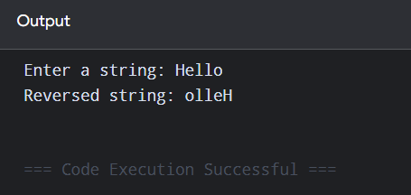
(c) Delete All Vowels from a String
#include <iostream>
#include <string>
#include <cctype>
using namespace std;
string removeVowels(const string &str) {
string result = "";
for (char ch : str) {
char lower = tolower(ch);
if (lower != 'a' && lower != 'e' && lower != 'i' && lower != 'o' && lower != 'u') {
result += ch; // keep only non-vowel characters
} }
return result; }
int main() {
string str;
cout << "Enter a string: ";
getline(cin, str);
cout << "String after removing vowels: " << removeVowels(str) << endl;
return 0;}
Output:
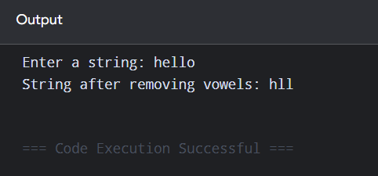
(d) Sort Strings in Alphabetical Order
#include <iostream>
#include <string>
#include <vector>
#include <algorithm>
using namespace std;

int main() {
int n;

cout << "Enter number of strings: ";
cin >> n;
cin.ignore(); // consume leftover newline left by cin >> n

vector<string> words(n);
for (int i = 0; i < n; i++) {
cout << "Enter string " << i + 1 << ": ";
getline(cin, words[i]);
}

// std::sort uses string's own < operator, which compares
// strings alphabetically (lexicographically)
sort(words.begin(), words.end());

cout << "Strings in alphabetical order:" << endl;
for (const string &w : words)
cout << w << endl;

return 0;
}
Output:
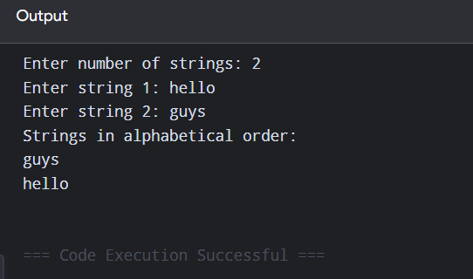
(e) Convert a Character from Uppercase to Lowercase
#include <iostream>
using namespace std;
int main() {
char ch;
cout << "Enter an uppercase character: ";
cin >> ch;
if (ch >= 'A' && ch <= 'Z') {
char lower = ch + 32; // shift by 32 in the ASCII table
cout << "Lowercase character: " << lower << endl;
} else {
cout << "Entered character is not an uppercase letter." << endl;
}
return 0;
}
Output:
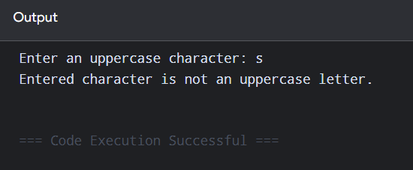

Question 5 — Space-Efficient Storage for Special 2D Matrices
Normally an n x n matrix needs n x n storage. For matrices with a predictable pattern of zeros, only the non-zero elements need to be stored in a compact 1D array, with a formula to map (row, col) to the correct index. One program below demonstrates all five representations: Diagonal, Tri-diagonal, Lower Triangular, Upper Triangular, and Symmetric matrices.
#include <iostream>
#include <vector>
using namespace std;

const int N = 4; // matrix dimension used for demonstration
typedef vector<vector<int>> Matrix;

/* ---------- (a) Diagonal Matrix ----------
Only the n diagonal elements are non-zero.
Stored in a 1D array of size n. */
vector<int> storeDiagonal(const Matrix &mat) {
vector<int> diag(N);
for (int i = 0; i < N; i++)
diag[i] = mat[i][i];
return diag;
}
int getDiagonal(const vector<int> &diag, int i, int j) {
return (i == j) ? diag[i] : 0;
}

/* ---------- (b) Tri-diagonal Matrix ----------
Only the main diagonal and the two diagonals next to it
are non-zero. Stored in a 1D array of size 3n-2. */
vector<int> storeTriDiagonal(const Matrix &mat) {
vector<int> tri;
for (int i = 0; i < N; i++)
for (int j = 0; j < N; j++)
if (j == i - 1 || j == i || j == i + 1)
tri.push_back(mat[i][j]);
return tri;
}
int getTriDiagonal(const vector<int> &tri, int i, int j) {
if (j < i - 1 || j > i + 1) return 0;
// row 0 only has 2 stored entries, every later row has 3
int start = (i == 0) ? 0 : (2 + 3 * (i - 1));
int offset = (i == 0) ? j : (j - i + 1);
return tri[start + offset];
}

/* ---------- (c) Lower Triangular Matrix ----------
Only elements where j <= i are non-zero.
Stored row-wise in a 1D array of size n(n+1)/2. */
vector<int> storeLowerTriangular(const Matrix &mat) {
vector<int> low;
for (int i = 0; i < N; i++)
for (int j = 0; j <= i; j++)
low.push_back(mat[i][j]);
return low;
}
int getLowerTriangular(const vector<int> &low, int i, int j) {
if (j > i) return 0;
int index = i * (i + 1) / 2 + j;
return low[index];
}

/* ---------- (d) Upper Triangular Matrix ----------
Only elements where j >= i are non-zero.
Stored row-wise in a 1D array of size n(n+1)/2. */
vector<int> storeUpperTriangular(const Matrix &mat) {
vector<int> up;
for (int i = 0; i < N; i++)
for (int j = i; j < N; j++)
up.push_back(mat[i][j]);
return up;
}
int getUpperTriangular(const vector<int> &up, int i, int j) {
if (j < i) return 0;
int index = i * N - (i * (i - 1)) / 2 + (j - i);
return up[index];
}

/* ---------- (e) Symmetric Matrix ----------
mat[i][j] == mat[j][i], so only the lower triangle
(including the diagonal) needs to be stored. */
vector<int> storeSymmetric(const Matrix &mat) {
vector<int> sym;
for (int i = 0; i < N; i++)
for (int j = 0; j <= i; j++)
sym.push_back(mat[i][j]);
return sym;
}
int getSymmetric(const vector<int> &sym, int i, int j) {
if (j > i) swap(i, j); // ensure i >= j
int index = i * (i + 1) / 2 + j;
return sym[index];
}

int main() {
Matrix mat = {
{1, 2, 0, 0},
{2, 3, 4, 0},
{0, 4, 5, 6},
{0, 0, 6, 7}
};

vector<int> diag = storeDiagonal(mat);
cout << "Diagonal element (2,2): " << getDiagonal(diag, 2, 2) << endl;

vector<int> tri = storeTriDiagonal(mat);
cout << "Tri-diagonal element (1,2): " << getTriDiagonal(tri, 1, 2) << endl;

vector<int> low = storeLowerTriangular(mat);
cout << "Lower triangular element (3,1): " << getLowerTriangular(low, 3, 1) << endl;

vector<int> up = storeUpperTriangular(mat);
cout << "Upper triangular element (1,3): " << getUpperTriangular(up, 1, 3) << endl;

vector<int> sym = storeSymmetric(mat);
cout << "Symmetric element (0,1) via (1,0): " << getSymmetric(sym, 1, 0) << endl;

return 0;
}
Output:
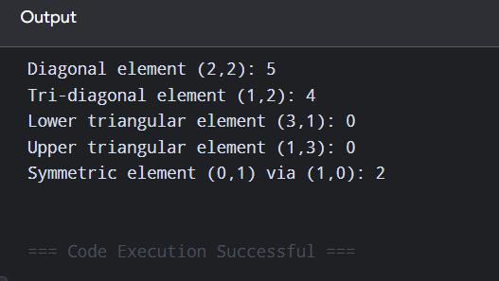

Question 6 — Sparse Matrix Operations Using Triplet Representation
A sparse matrix (mostly zeros) is stored as a list of triplets {row, col, value} for only the non-zero entries, saving space. This program implements transpose, addition, and multiplication directly on the triplet representation.
#include <iostream>
#include <vector>
using namespace std;

// A sparse matrix in triplet form: each non-zero entry is one
// Triplet {row, col, value}. rows/cols are stored alongside.
struct Triplet {
int row, col, value;
};
struct SparseMatrix {
int rows, cols;
vector<Triplet> entries;
};

void printSparse(const SparseMatrix &m) {
cout << "Row\tCol\tValue" << endl;
for (const Triplet &t : m.entries)
cout << t.row << "\t" << t.col << "\t" << t.value << endl;
}

/* (a) Transpose of a sparse matrix */
SparseMatrix transposeSparse(const SparseMatrix &m) {
SparseMatrix result{m.cols, m.rows, {}};
// Scanning column by column keeps the transpose triplets
// sorted by row (i.e. by the original column index)
for (int col = 0; col < m.cols; col++)
for (const Triplet &t : m.entries)
if (t.col == col)
result.entries.push_back({t.col, t.row, t.value}); // swap row/col
return result;
}

/* (b) Addition of two sparse matrices of the same dimensions */
bool addSparse(const SparseMatrix &a, const SparseMatrix &b, SparseMatrix &result) {
if (a.rows != b.rows || a.cols != b.cols) {
cout << "Matrices cannot be added (dimension mismatch)." << endl;
return false;
}
result.rows = a.rows;
result.cols = a.cols;
result.entries.clear();

size_t i = 0, j = 0;
while (i < a.entries.size() && j < b.entries.size()) {
const Triplet &x = a.entries[i], &y = b.entries[j];
if (x.row < y.row || (x.row == y.row && x.col < y.col)) {
result.entries.push_back(x); i++;
} else if (x.row > y.row || (x.row == y.row && x.col > y.col)) {
result.entries.push_back(y); j++;
} else { // same position -> add the values
int sum = x.value + y.value;
if (sum != 0) result.entries.push_back({x.row, x.col, sum});
i++; j++;
}
}
while (i < a.entries.size()) result.entries.push_back(a.entries[i++]);
while (j < b.entries.size()) result.entries.push_back(b.entries[j++]);
return true;
}

/* (c) Multiplication of two sparse matrices */
bool multiplySparse(const SparseMatrix &a, const SparseMatrix &b, SparseMatrix &result) {
if (a.cols != b.rows) {
cout << "Matrices cannot be multiplied (dimension mismatch)." << endl;
return false;
}
result.rows = a.rows;
result.cols = b.cols;
result.entries.clear();

for (int r = 0; r < a.rows; r++) {
for (int c = 0; c < b.cols; c++) {
int sum = 0;
for (const Triplet &x : a.entries) {
if (x.row == r) {
for (const Triplet &y : b.entries) {
if (y.row == x.col && y.col == c)
sum += x.value * y.value;
}
}
}
if (sum != 0) result.entries.push_back({r, c, sum});
}
}
return true;
}

int main() {
// A (3x3): 0 0 3
// 0 5 0
// 7 0 0
SparseMatrix A{3, 3, {{0, 2, 3}, {1, 1, 5}, {2, 0, 7}}};

SparseMatrix T = transposeSparse(A);
cout << "Transpose of A:" << endl;
printSparse(T);

// B (3x3): 0 0 4
// 0 0 0
// 1 0 2
SparseMatrix B{3, 3, {{0, 2, 4}, {2, 0, 1}, {2, 2, 2}}};

SparseMatrix C;
if (addSparse(A, B, C)) {
cout << endl << "A + B:" << endl;
printSparse(C);
}

SparseMatrix D;
if (multiplySparse(A, B, D)) {
cout << endl << "A * B:" << endl;
printSparse(D);
}

return 0;
}
Output:
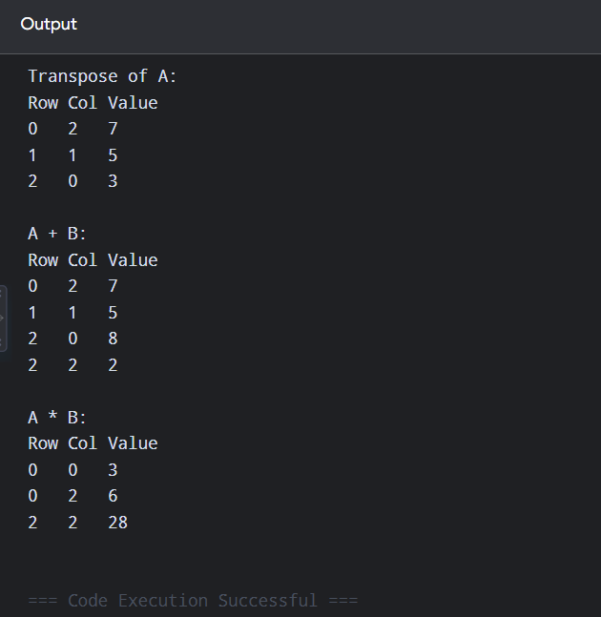

Question 7 — Count Inversions in an Array
A pair (A[i], A[j]) is an inversion if i < j but A[i] > A[j]. Counting inversions with brute force takes O(n^2); the program below uses a merge-sort based approach that counts inversions in O(n log n) while sorting the array.
#include <iostream>
#include <vector>
using namespace std;

// Merges two sorted halves and counts how many elements crossed
// over out of order (these are the "split" inversions)
int mergeCount(vector<int> &arr, vector<int> &temp, int left, int mid, int right) {
int i = left, j = mid + 1, k = left;
int invCount = 0;

while (i <= mid && j <= right) {
if (arr[i] <= arr[j]) {
temp[k++] = arr[i++];
} else {
// arr[i] > arr[j]: arr[j] is smaller than every
// remaining element in the left half, so all of
// them form an inversion with arr[j]
temp[k++] = arr[j++];
invCount += (mid - i + 1);
}
}
while (i <= mid) temp[k++] = arr[i++];
while (j <= right) temp[k++] = arr[j++];

for (i = left; i <= right; i++)
arr[i] = temp[i];

return invCount;
}

// Standard merge sort, accumulating the inversion count
int mergeSortCount(vector<int> &arr, vector<int> &temp, int left, int right) {
int invCount = 0;
if (left < right) {
int mid = (left + right) / 2;
invCount += mergeSortCount(arr, temp, left, mid);
invCount += mergeSortCount(arr, temp, mid + 1, right);
invCount += mergeCount(arr, temp, left, mid, right);
}
return invCount;
}

int main() {
vector<int> arr = {8, 4, 2, 1};
vector<int> temp(arr.size());

int result = mergeSortCount(arr, temp, 0, arr.size() - 1);
cout << "Number of inversions: " << result << endl;

return 0;
}
Output:
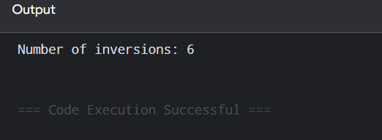

Question 8 — Count Distinct Elements in an Array
Counts how many unique values are present in an array of length n by checking, for every element, whether it has already appeared earlier in the array.
#include <iostream>
#include <vector>
#include <unordered_set>
using namespace std;

int countDistinct(const vector<int> &arr) {
// Inserting every element into a set automatically drops
// duplicates, so the set's final size is the distinct count
unordered_set<int> seen;
for (int x : arr)
seen.insert(x);
return seen.size(); }
int main() {
vector<int> arr = {10, 20, 20, 10, 30, 40, 30};
cout << "Number of distinct elements: " << countDistinct(arr) << endl;
return 0;}
Output:
