**Simple Frontend**

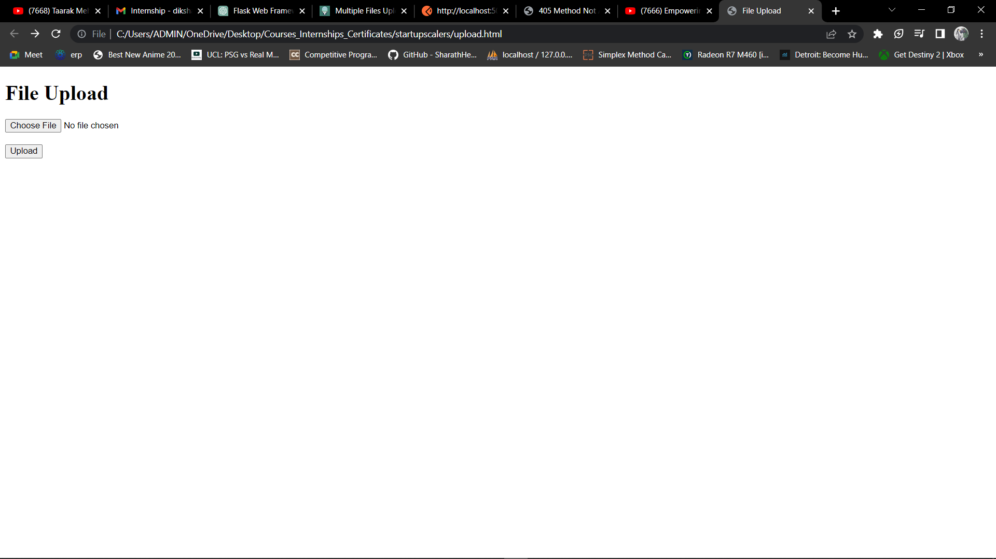

**Select File**  
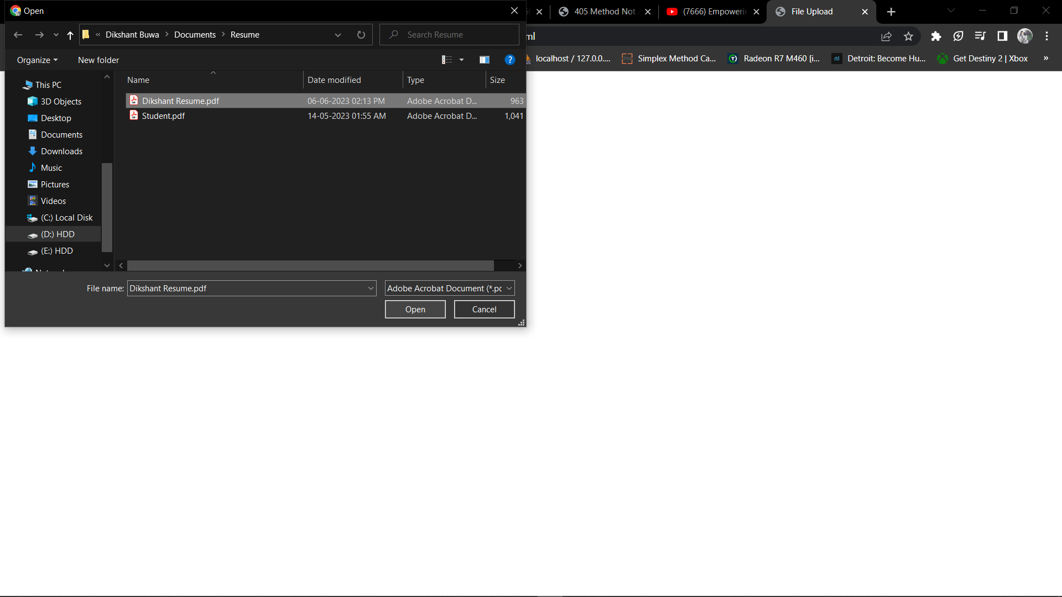

**Click Upload**

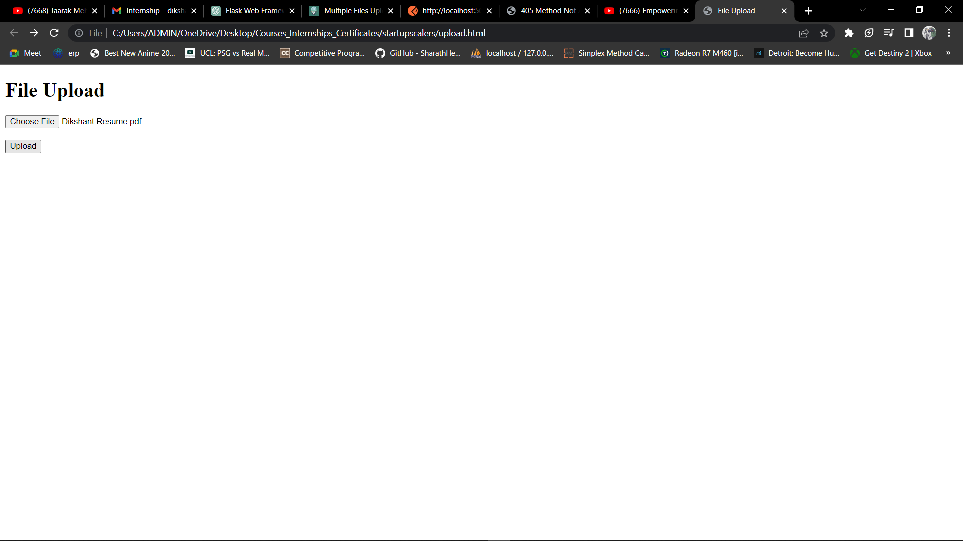

**File Uploaded Successfully**



**Postman:**

File Uploaded Successfully!

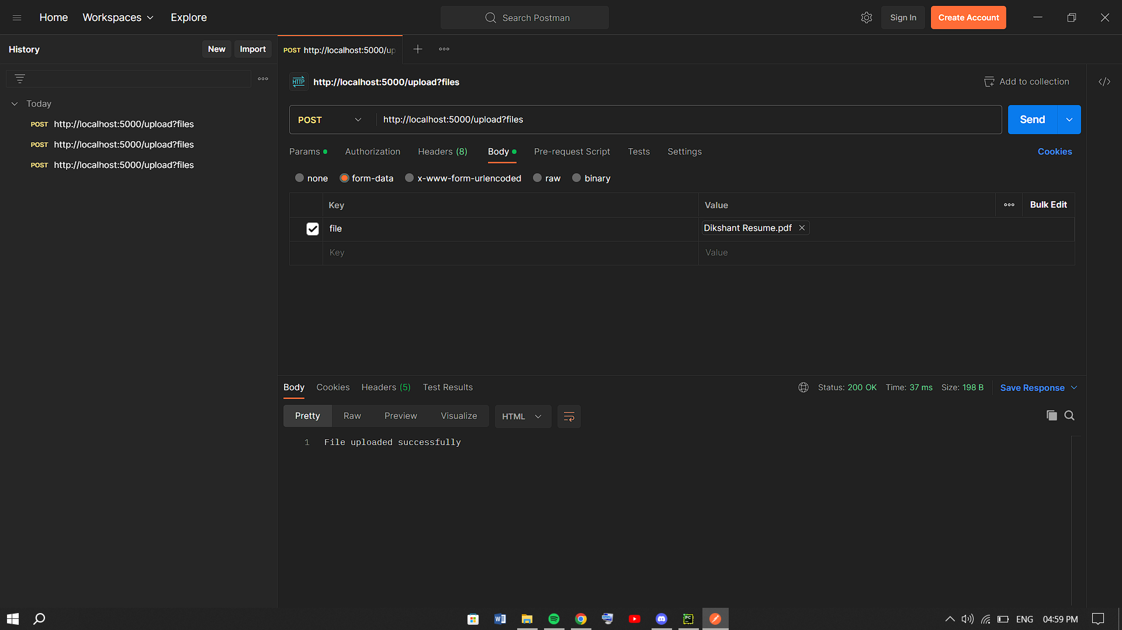

Source code:  
main.py

from flask import Flask, request  
  
app = Flask(__name__)  
@app.route('/upload', methods=['POST'])  
def upload():  
 # Check if a file is present in the request  
 if 'file' not in request.files:  
 return 'No file uploaded', 400  
  
 file = request.files['file']  
  
 # Check if the file is of PDF type  
 if file.filename.endswith('.pdf'):  
 # Save the file to a desired location  
 file.save('uploads/' + file.filename)  
 return 'File uploaded successfully', 200  
 else:  
 return 'Invalid file type. Only PDF files are allowed', 400  
if __name__ == '__main__':  
 app.run(debug=True)

upload.html

<!DOCTYPE html>

<html>

<head>

<title>File Upload</title>

</head>

<body>

<h1>File Upload</h1>

<form action="http://localhost:5000/upload" method="POST" enctype="multipart/form-data">

<input type="file" name="file" accept=".pdf">

<br><br>

<input type="submit" value="Upload">

</form>

</body>

</html>