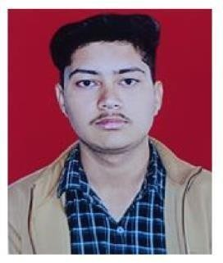

# Dikshant Singh Chib

Email-id : [**dikshantsinghchib73106@gmail.com**](mailto:dikshantsinghchib73106@gmail.com)

Mobile No.: **8755857675**

# https://github.com/DikshantSinghChib/Projects.git

|  |  |  |  |
| --- | --- | --- | --- |
| **ACADEMIC D**  **Year** | **ETAILS**  **Degree/Exam** | **Institute** | **GPA/Marks(%)** |
| Aug, 2022 - Present B.TECH in Computer Science Graphic Era University Dehradun 9.15/10 | | | |
| 2022 | 12th, C.B.S.E | Romex International School | 83.8 % |
| 2020 | 10th, C.B.S.E | Army Public School | 75.6 % |
| **PROJECTS** |  |  |  |

* **Object Detection in video surveillance system** (Sep, 2023 - Dec, 2023) : Developed a machine learning- based object detection system. In this project, I was using cv2 (for reading the frames and performing tasks), random (for generating random colors for boundaries), Yolo v8 (a pre-trained model), and matplotlib.pyplot for plotting the graphs.
* **Video Gesture Recognition** (March , 2024 – June 2024 ) : This involves identifying sign language in real-time videos, charting hands with Matplotlib, making decisions using a Random Forest classifier, and using the sklearn, numpy, cv2, and pickle modules.
* **Video anomaly Detection** (Oct , 2024 – Jan,2025) : Developed a mobile netv2 model for ML . Tensflow will be used for model importation in this project, along with ThreadPoolExecutor for multiprocessing and faster model training, numpy, openCv2, sklearn for test_train_split (a "Holdout validation technique") and Tkinter for creating a Python interface.

**TECHNICAL SKILLS**

* **Languages Python** , **Java** , **c++**(proficient), **C**(proficient).
* **Tools and Frameworks** VS Code,Code block, Git, Github,Google Colab
* **Machine Learning Tools** Numpy, Matplotlib, OpenCV,Tensorflow, Keras,sklearn .
* **Competitive Programmer** Problem-Solving, Algorithms and Data Structures, Problem Analysis and Opti- mization .

**SCHOLASTIC & CO-SCHOLASTIC ACHIEVEMENTS**

* **Leetcode -** Solved 300+ questions.
* **Artificial Intelligence with python -** Training programn by coincent

**CERTIFICATIONS**

# Coursera -

* 1. Python for Everybody (https://coursera.org/verify/Y3Y6LW6R4MUK)
  2. Responsive Website Basics: Code with HTML, CSS, and JavaScript (https://coursera.org/verify/5QLK5F7NXGTT) 3.Introduction to Git and GitHub (https://coursera.org/verify/J56Z854NZA6F)