Observable Trends are

1. Out of the 4 drugs:
   1. Capomulin is effective in curing tumer.
   2. Tumer volume increases with the usage of Ketapril.

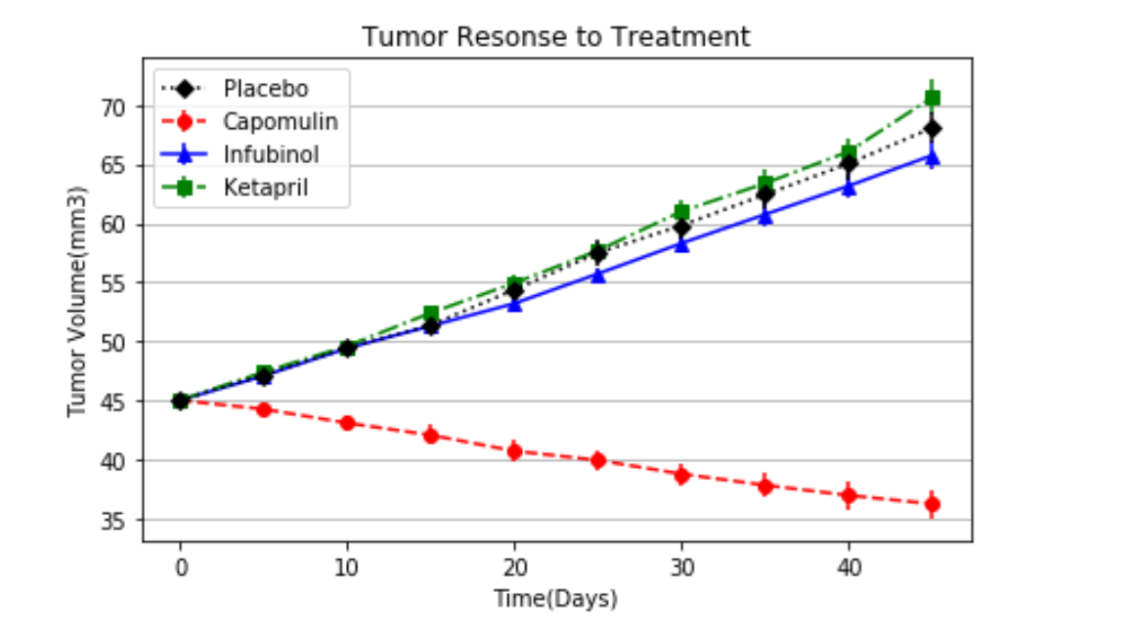

1. Survival rate of Capomulin is far better than other drugs.

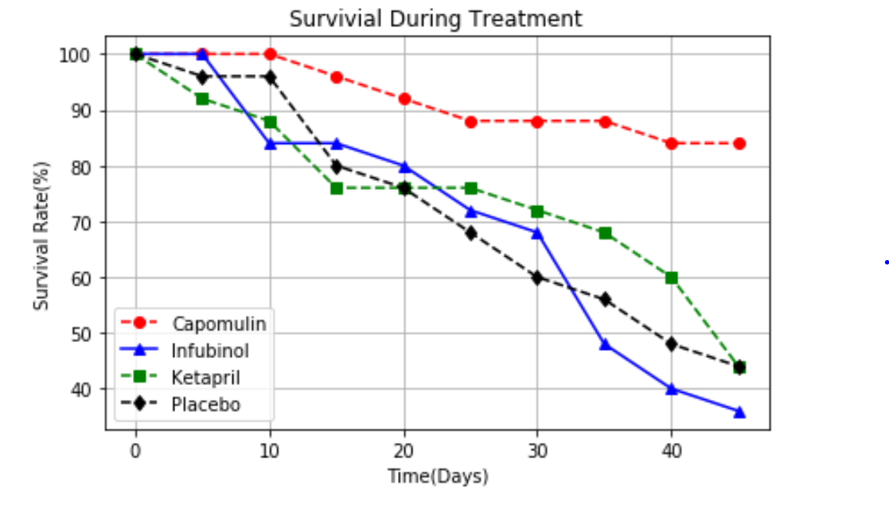

1. Placebo is spreading the Tumor at a large rate until it reaches a specified level whereas Capomulin is spreading it at a lower rate among all.