SMART ELECTRIC CAR CHARGING

Automatic Turn Off: Enhancing Efficiency and Safety in Electric Vehicle Charging

*Dikshant Madai*

BSc (Hons) Computer and Data Science, Sunway College Kathmandu

Birmingham City University, BCU

Kathmandu, Nepal

Dikshant.Madai@mail.bcu.ac.uk

*Abstract* —This is an article on the current and future trends in modern computing, with a specific focus on the Internet of Things (IoT). Modern computing comprises technologies such as IoT, cloud computing, edge computing, and fog computing, with edge computing being critical in enabling efficient computation at the edge of the network. The use of IoT is growing rapidly, with its applications ranging from healthcare, environment, smart cities, business, industry, and infrastructure development. The innovation in the supply chain system of IoT has resulted in improved functionality and processes, leading to various benefits such as increased efficiency, accuracy, real-time monitoring, better decision-making, cost reduction, and customer satisfaction. The article also looks at the current trends of IoT, such as smart homes and cities, the use of IoT in healthcare and the utility infrastructure, and the future trends, including the adoption of 5G technology, blockchain technology, and machine learning to improve IoT security.

Keywords— Iot security;smart electric car charging; IoT;charge automatic turnoff;multimeter;555 Timer

IoT, Fog computing, Edge computing, and Cloud computing are just a few of the cutting edge technologies that make up the fast evolving field of modern computing. (De Donno et al., 2019). Among these, Edge computing plays a critical role in modern computing as it enables computation near the network's edge, allowing for both downstream data from cloud services and upstream data from IoT services to be processed quickly and efficiently (Shi et al., 2016). Another important component of modern computing is Fog computing, which serves as a mediatory layer between Cloud computing and IoT and operates in a distributed manner (Mahmud et al., 2017). To further enhance modern computing and bring seamless connectivity to the world through interconnected smart devices, next-gen technology is needed. This technology is enabled by 5G, which offers fast speeds, low latency, and widespread coverage (Gupta et al., 2020). The growth of modern computing is also fueled by IoT innovations. Additionally, the application of blockchain technology in IoT can provide a decentralized, secure, and sensitive information in a public, transparent ledger that enables transactions to be checked by a network of possibly unreliable parties. (Reyna et al., 2018).

IoT is a rapidly growing technology that is being integrated into various markets, industries and daily life. It offers numerous applications, functions and services, improving the way we live and work (Lampropoulos et al., 2018). The utilization of IoT can be observed in healthcare, environment, smart cities, business, industry and infrastructure development (Souri et al., 2017; Souri et al., 2018). People's usage of IoT in different sectors drives its popularity and acceptance (Chettri & Bera, 2020). By studying the application of IoT, we can improve the technology and generate new ideas for future use (Tun et al., 2020). IoT enables communication between objects by transferring information, leading to limitless possibilities (Redhu et al., 2018; de Almeida et al., 2019).

# *Backgrouind research*

## A. Innovative features in modern computing

## The innovation in the supply chain system of IoT has resulted in improved functionality and processes, leading to various benefits such as increased efficiency, accuracy, real-time monitoring, better decision-making, cost reduction, and customer satisfaction (Cui, 2018). One of the major innovations in this field has been the implementation of Radio-Frequency IDentification (RFID) sensors and devices, which have had a significant impact on the physical communication layer of IoT, logistics, and robotics (Mezzanotte et al., 2021). Additionally, the integration of blockchain technology has brought new perspectives to the security, resilience, and efficiency of digital systems (Ahram et al., 2017). Moreover, the creation of Low Power Wide Area Networks (LPWANs), a brand-new category of wireless network made specifically for Internet of Things applications, allows for effective long-range communication while minimizing power usage and battery life (Chaudhari et al., 2020).

## B. Current trends of IOT

## IoT is currently being used in healthcare for wearable technology, telemedicine, smart biosensors, smart ambulances, and remote patient monitoring. (Wang et al., 2015).The improvement of public utility infrastructure through smart metering and smart-grid systems ( Lloret et al., 2016) is another trend. The easy and affordable idea of smart houses (Park et al.,2017) and smart cities (Mohanty, et al., 2016) and the use of IoT for efficient health management through a smart gym (Zhao et al., 2015) are also prevalent trends. 5G is the next-gen wireless tech with improved speed and connectivity, IoT devices will be a big part of the 5G network (Ejaz et al., 2016). The growth of IoT is being propelled forward significantly by the development of 5G networks. (Wang et al., 2018).

## C. Future trends of IOT

As current technologies like 4G, 3G, 2G, Wi-Fi , and Bluetooth have constraints for low power and low data rate devices, the future of IoT devices is heading toward 5G. (Marcus, 2015; Li et al., 2018; Díaz Zayas et al., 2017). 5G technology is seen as the solution to these limitations (Marcus, 2015). Blockchain technology is seen as a solution for privacy, security, and data integrity issues in smart homes (Moniruzzaman et al., 2020). Data management systems integrating IoT, big data, and cloud computing are improving city operations and quality of life (Soomro et al., 2019). The adoption of disruptive technologies such as IoT, big data, AI, and blockchain has the potential to accelerate the evolution of smart cities (Soomro et al., 2019).

## D. Basic system security

### The three main concerns for IoT data security are confidentiality, integrity, and availability (Mohanty et al., 2020). The security challenges present in different layers of IoT operations such as 6LoWPAN adaptation, transport, routing, and application (Granjal et al., 2015). Blockchain can be a key enabling technology for providing viable security solutions to IoT security problems.( Khan & Salah, 2018). Machine learning is an approach that enables intelligent computation and integration with IoT applications. It can be applied to process and analyze vast amounts of data, predict and alert for fires, and enhance system security. (Al-Garadi et al., 2020) . IoT and Cyber Physical Systems is simpler to secure than IoT, using conventional cryptographic techniques (Gunathilake et al., 2020). By implementing these solutions, individuals, organizations, and governments can help ensure the security of IoT devices and networks, and protect against cyber threats.

# technical development and analysis of smart eletric car charging

Electric vehicles are becoming increasingly popular as a more sustainable mode of transportation. As more people switch to electric vehicles, the demand for charging infrastructure increases. This is where smart electric car charging systems come into play. These systems offer a more efficient and sustainable way of charging electric vehicles.

One of the key features of smart electric car charging systems is the automatic shut-off functionality. This feature is designed to provide a more convenient and efficient charging experience for electric vehicle owners. When the battery is fully charged, the system will automatically shut down, preventing overcharging and prolonging the battery life. This is a crucial feature, as overcharging can lead to reduced battery performance and lifespan, and even pose safety risks.

The smart electric car charging system aligns with several of the United Nations Sustainable Development Goals (SDGs), including Affordable and Clean Energy, Climate Action, Industry, Innovation and Infrastructure, and Sustainable Cities and Communities. By promoting clean energy and reducing emissions, these systems contribute to mitigating the impacts of climate change. They also support innovation and sustainable urban development, as they provide a more sustainable and efficient transportation solution.

The hardware components used in a smart electric car charging system typically include a multimeter, a 555 timer, and a battery. The multimeter is used to measure the voltage flow during charging. When the power is on and the multimeter is connected, the car begins charging. Once the battery is full, the 555 timer detects this and signals to stop the charging process.

A. Truth table

|  |  |  |  |  |  |
| --- | --- | --- | --- | --- | --- |
| Case | Power ON/OFF  (A) | Multimeter  (B) | Battery 5V  (C) | 555 Timer  (D) | OUTPUT  (0) |
| 1 | 0 | 0 | 0 | 0 | 0 |
| 2 | 0 | 0 | 0 | 1 | 0 |
| 3 | 0 | 0 | 1 | 0 | 0 |
| 4 | 0 | 0 | 1 | 1 | 0 |
| 5 | 0 | 1 | 0 | 0 | 0 |
| 6 | 0 | 1 | 0 | 1 | 0 |
| 7 | 0 | 1 | 1 | 0 | 0 |
| 8 | 0 | 1 | 1 | 1 | 0 |
| 9 | 0 | 0 | 0 | 0 | 0 |
| 10 | 1 | 0 | 0 | 1 | 0 |
| 11 | 1 | 0 | 1 | 0 | 0 |
| 12 | 1 | 1 | 1 | 0 | 0 |
| 13 | 1 | 1 | 0 | 0 | 1 |
| 14 | 1 | 1 | 0 | 1 | 1 |
| 15 | 1 | 1 | 1 | 0 | 1 |
| 16 | 1 | 1 | 1 | 1 | 0 |

## Fig.1. Truth table

The table shows all possible combinations of input states and the resulting output states.This truth table shows the possible combinations of input and output states for a circuit that involves a power switch, multimeter, 5V battery, 555 timer, and an output. The inputs are the power switch, multimeter, and battery, while the 555 timer generates an output based on the inputs. The output state is represented as either true or false. When the power is off, regardless of the state of the other inputs, the output is always false. When the power is on and the multimeter and battery are both off, the output is also false. When the multimeter or battery is on, the output is true if the 555 timer is also on, and false if it is off. When all four inputs are on, the output is false.

The initial expression (D) was obtained by combining three different cases

D= $AB\overline{C}\overline{D}+AB\overline{C}D+ABC\overline{D}$

Solving the above expression, a minimum boolean expression was form

D= $AB\overline{D}+AB\overline{C}$

## Boolean expression was develop into logic circuit

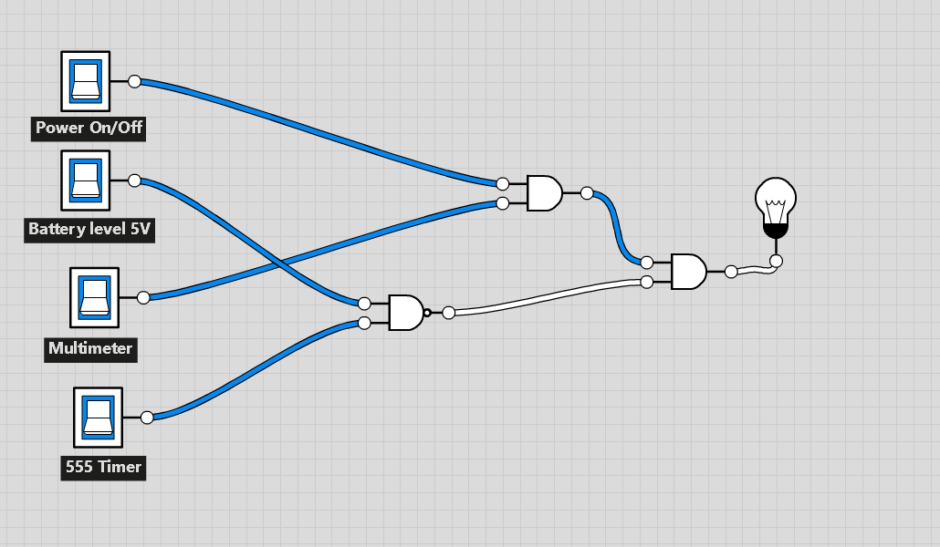

## Fig.1. Boolean expression was develop into logic circuit

This section outlines the necessary hardware components needed to implement the proposed solution for the system. To demonstrate the required connections between these components, Tinkercad was used to provide a clear and labeled diagram. Furthermore, a complete description of each component is presented to provide a comprehensive understanding of their roles in the system.

# technical development of the product

This section outlines the necessary hardware components needed to implement the proposed solution for the system. To demonstrate the required connections between these components, Tinkercad was used to provide a clear and labeled diagram. Furthermore, a complete description of each component is presented to provide a comprehensive understanding of their roles in the system.

*A. Hardware requirement*

Here are some more details about each component:

### Microcontroller:

### A microcontroller is a small computer on a single integrated circuit that is designed to control and manage specific tasks in embedded systems (Bolanakis, 2019). In this case, the Arduino UNO microcontroller is being used to execute the code and perform functions related to smart electric car charging.

### Multimeter:

### A multimeter is an electronic tool used to measure electrical quantities such as voltage, current, and resistance. It typically has two probes that are used to make contact with the electrical circuit being tested, and then displays the results on a screen.

### 555 Timer:

### The 555 timer is an integrated circuit that can be used to create precise and stable time delays, oscillations, and pulse-width modulation (Abrar, 2017). In this case, it is being used as part of a voltage-controlled switch to turn off the charging current to the battery when it reaches a predetermined level.

### 5V Battery:

### A 5V battery is a type of electrical battery that provides a nominal voltage output of 5 volts. In this design implementation, it is being used to store the voltage of the electricity and to inform the 555 timer to stop the charging process when the battery is full.

## B. Component

The component diagram of my device and details discussion

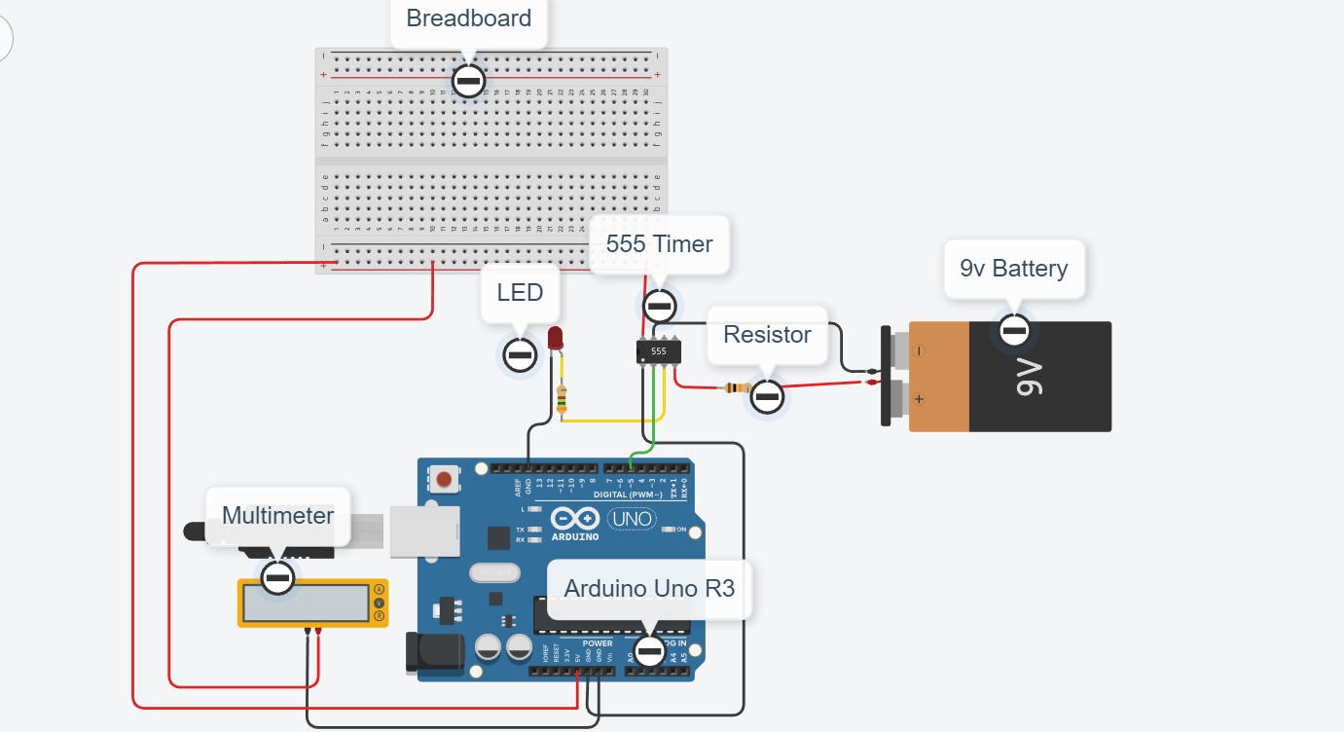

*Fig.2. Smart Electric Car Charging (Automating turnoff if battery is full)*

1| int outputPin = 3;

2| int triggerPin = 5;

3| int resetPin = 4;

4| void setup() {

5| pinMode(outputPin, OUTPUT);

6| pinMode(triggerPin, OUTPUT);

7| pinMode(resetPin, OUTPUT);

8| }

9| void loop() {

10| digitalWrite(triggerPin, HIGH);

11| delay(10);

12| digitalWrite(triggerPin, LOW);

13| if(analogRead(A0) >= 900) {

14| digitalWrite(resetPin, HIGH);

15| digitalWrite(outputPin, LOW);

16| } else {

17| digitalWrite(resetPin, LOW);

18| digitalWrite(outputPin, HIGH);

19| }

20| }

## 

## 

## Fig.3. Arduino coding

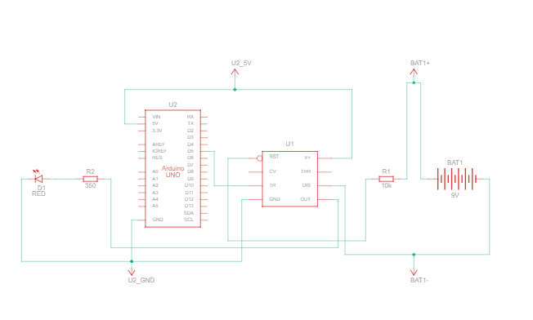

## Fig.4. Schemetic of view Smart Electric Car Charging (Automating turnoff if battery is full)

# security consideration

Security is the practice of protecting systems, devices, and networks from unauthorized access, use, theft, damage, or disruption. This sections provides the details information about the consideration security

### Communication encryption:

### If the charging system is connected to the internet, it's important to ensure that any communication between the system and the cloud is encrypted to prevent unauthorized access to the system and protect data privacy.

### Firewall configuration:

### The charging system should have a properly configured firewall to prevent unauthorized access to the system, and to ensure that only the necessary traffic is allowed in and out.

### User authentication:

### The system should include user authentication to ensure that only authorized users can access the system. This can be achieved by implementing strong password policies or using biometric authentication mechanisms.

### Secure boot:

### The charging system should be designed to have a secure boot process to prevent unauthorized firmware updates or other tampering.

### Regular updates:

### The system should be regularly updated with the latest security patches to address any known vulnerabilities.

### End user awareness:

### Users should be educated on how to use the system securely, including how to properly configure and use the system, and how to recognize and report any security issues.

### Physical security:

### The charging system should be physically secured to prevent unauthorized access or tampering. This can include measures such as installing the system in a locked enclosure, and limiting physical access to the system.

# Conclusiion

## Further to achieve

Investing in a smart electric car charging system with an automatic turnoff feature can provide numerous benefits, such as saving money, extending the battery's lifespan, reducing carbon footprint, and contributing to a more sustainable future. This technology is already available in the market, and several electric vehicle charging systems, such as those from Tesla, ChargePoint, and ClipperCreek, already offer this feature. It is highly recommended that consumers invest in a system with automatic turnoff functionality, as it can help ensure a safe and efficient charging process, extend the battery’s lifespan, save money, and contribute to a sustainable future.

As a manufacturer, it is important to embrace the technological competitiveness of a smart electric car charging system with automatic turnoff feature to gain a competitive edge and appeal to environmentally-conscious consumers while also improving sustainability and profitability. This technology is already available in the market and becoming increasingly popular among electric vehicle owners, with several electric vehicle charging systems, such as those from Tesla, ChargePoint, and ClipperCreek, already offering this feature. Additionally, aftermarket solutions are available to retrofit existing charging systems with this functionality. Implementing this technology can help to optimize the use of energy, reduce waste, and ultimately reduce manufacturing costs, which can improve both profitability and sustainability.

## Further enhancement

Future changes and sensors/devices that could be used to make smart electric car charging even more intelligent include: Vehicle-to-Grid (V2G) Capability, Artificial Intelligence (AI), Wireless Charging, Biometric Sensors, Cloud Connectivity, Energy Storage Systems, and Advanced Metering Infrastructure (AMI).

##### References

1. Al-Garadi, M.A. et al. (2020) “A survey of machine and deep learning methods for internet of things (IOT) security,” IEEE Communications Surveys & Tutorials, 22(3), pp. 1646–1685. Available at: <https://doi.org/10.1109/comst.2020.2988293>.

1. Ahram, T. et al. (2017) “Blockchain Technology Innovations,” 2017 IEEE Technology & Engineering Management Conference (TEMSCON) [Preprint]. Available at: <https://doi.org/10.1109/temscon.2017.7998367>.
2. Bolanakis, D.E. (2019) “A survey of research in Microcontroller Education,” *IEEE Revista Iberoamericana de Tecnologias del Aprendizaje*, 14(2), pp. 50–57. Available at: https://doi.org/10.1109/rita.2019.2922856.
3. Chettri, L. and Bera, R. (2020) “A comprehensive survey on internet of things (IOT) toward 5G Wireless Systems,” IEEE Internet of Things Journal, 7(1), pp. 16–32. Available at: <https://doi.org/10.1109/jiot.2019.2948888>.
4. Chaudhari, B.S. and Zennaro, M. (2020) “Introduction to low-power wide-area networks,” LPWAN Technologies for IoT and M2M Applications, pp. 1–13. Available at: https://doi.org/10.1016/b978-0-12-818880-4.00001-6.
5. Cui, Y. (2018) “Supply Chain Innovation with IOT,” Multi-Criteria Methos and Techniques Applied to Supply Chain Management [Preprint]. Available at: https://doi.org/10.5772/intechopen.74155.
6. De Donno, M., Tange, K. and Dragoni, N. (2019) “Foundations and evolution of modern computing paradigms: Cloud, IOT, Edge, and Fog,” IEEE Access, 7, pp. 150936–150948. Available at: <https://doi.org/10.1109/access.2019.2947652>.
7. de Almeida, I.B. et al. (2019) “5G waveforms for IOT applications,” IEEE Communications Surveys & Tutorials, 21(3), pp. 2554–2567. Available at: <https://doi.org/10.1109/comst.2019.2910817>.
8. Díaz Zayas, A. et al. (2017) “3GPP evolution on LTE connectivity for IOT,” Internet of Things, pp. 1–20. Available at: <https://doi.org/10.1007/978-3-319-61300-0_1>.
9. Ejaz, W. et al. (2016) “Internet of things (IOT) in 5G Wireless Communications,” IEEE Access, 4, pp. 10310–10314. Available at: <https://doi.org/10.1109/access.2016.2646120>.
10. Gupta, N. et al. (2020) “SDNFV 5G-IOT: A framework for the next generation 5G enabled IOT,” 2020 International Conference on Advances in Computing, Communication & Materials (ICACCM) [Preprint]. Available at: <https://doi.org/10.1109/icaccm50413.2020.9213047>.
11. Granjal, J., Monteiro, E. and Sa Silva, J. (2015) “Security for the internet of things: A survey of existing protocols and open research issues,” *IEEE Communications Surveys & Tutorials*, 17(3), pp. 1294–1312. Available at: <https://doi.org/10.1109/comst.2015.2388550>.
12. Gunathilake, N.A., Al-Dubai, A. and Buchana, W.J. (2020) “Recent advances and trends in lightweight cryptography for IOT Security,” 2020 16th International Conference on Network and Service Management (CNSM) [Preprint]. Available at: <https://doi.org/10.23919/cnsm50824.2020.9269083>.
13. Khan, M.A. and Salah, K. (2018) “IOT security: Review, Blockchain Solutions, and open challenges,” Future Generation Computer Systems, 82, pp. 395–411. Available at: <https://doi.org/10.1016/j.future.2017.11.022>.

1. Lampropoulos, G., Siakas, K. and Anastasiadis, T. (2018) “Internet of things (IOT) in industry: Contemporary Application Domains, innovative technologies and intelligent manufacturing,” International Journal of Advances in Scientific Research and Engineering, 4(10), pp. 109–118. Available at: <https://doi.org/10.31695/ijasre.2018.32910>.
2. Lloret, J., Tomas, J., Canovas, A., & Parra, L. (2016). An integrated IoT architecture for smart metering. IEEE Communications Magazine, 54(12), 50-57.Available at: <https://doi.org/10.1089/tmj.2014.0176>.
3. Li, S., Xu, L.D. and Zhao, S. (2018) “5G internet of things: A survey,” Journal of Industrial Information Integration, 10, pp. 1–9. Available at: <https://doi.org/10.1016/j.jii.2018.01.005>.
4. Mohanty, J. et al. (2020) “IOT security, challenges, and solutions: A Review,” Advances in Intelligent Systems and Computing, pp. 493–504. Available at: https://doi.org/10.1007/978-981-15-6353-9_46.
5. Mahmud, R., Kotagiri, R. and Buyya, R. (2017) “Fog computing: A taxonomy, survey and Future Directions,” Internet of Things, pp. 103–130. Avaiable at: <https://doi.org/10.1007/978-981-10-5861-5_5>.
6. Mezzanotte, P. et al. (2021) “Innovative RFID sensors for internet of things applications,” IEEE Journal of Microwaves, 1(1), pp. 55–65. Available at: <https://doi.org/10.1109/jmw.2020.3035020>.
7. Mohanty, S.P., Choppali, U. and Kougianos, E. (2016) “Everything you wanted to know about smart cities: The internet of things is the backbone,” IEEE Consumer Electronics Magazine, 5(3), pp. 60–70. Available at: <https://doi.org/10.1109/mce.2016.2556879>.
8. Marcus, M.J. (2015) “5G and ‘IMT for 2020 and beyond’ [spectrum policy and regulatory issues],” IEEE Wireless Communications, 22(4), pp. 2–3. Available at: <https://doi.org/10.1109/mwc.2015.7224717>.
9. Moniruzzaman, M. et al. (2020) “Blockchain for smart homes: Review of Current Trends and Research challenges,” Computers & Electrical Engineering, 83, p. 106585. Available at: https://doi.org/10.1016/j.compeleceng.2020.106585.
10. Park, E. et al. (2017) “Comprehensive approaches to user acceptance of internet of things in a smart home environment,” IEEE Internet of Things Journal, 4(6), pp. 2342–2350. Available at: <https://doi.org/10.1109/jiot.2017.2750765>.
11. Reyna, A. et al. (2018) “On blockchain and its integration with IOT. challenges and opportunities,” Future Generation Computer Systems, 88, pp. 173–190. Available at: <https://doi.org/10.1016/j.future.2018.05.046>.
12. Redhu, S. et al. (2018) “Joint Data Latency and packet loss optimization for relay-node selection in time-varying IOT Networks,” Proceedings of the 24th Annual International Conference on Mobile Computing and Networking [Preprint]. Available at: <https://doi.org/10.1145/3241539.3267758>.
13. Shi, W. et al. (2016) “Edge comuting: Vision and challenges,” IEEE Internet of Things Journal, 3(5), pp. 637–646. Available at: <https://doi.org/10.1109/jiot.2016.2579198>.
14. Souri, A., Asghari, P. and Rezaei, R. (2017) “Software as a service based CRM providers in the cloud computing: Challenges and technical issues,” Journal of Service Science Research, 9(2), pp. 219–237. Available at: <https://doi.org/10.1007/s12927-017-0011-5>.
15. Souri, A., Rahmani, A.M. and Jafari Navimipour, N. (2018) “Formal verification approaches in the web service composition: A comprehensive analysis of the current challenges for future research,” International Journal of Communication Systems, 31(17). Available at: <https://doi.org/10.1002/dac.3808>.
16. Soomro, K. et al. (2019) “Smart City Big Data Analytics: An advanced review,” WIREs Data Mining and Knowledge Discovery, 9(5). Available at: <https://doi.org/10.1002/widm.1319>.
17. Tun, S.Y., Madanian, S. and Mirza, F. (2020) “Internet of things (IOT) applications for elderly care: A reflective review,” Aging Clinical and Experimental Research, 33(4), pp. 855–867. Available at: <https://doi.org/10.1007/s40520-020-01545-9>.
18. Wang, J.B. et al. (2015) “Wearable sensor/device (Fitbit one) and SMS text-messaging prompts to increase physical activity in overweight and obese adults: A randomized controlled trial,” Telemedicine and e-Health, 21(10), pp. 782–792. Available at: <https://doi.org/10.1089/tmj.2014.0176>.
19. Wang, D. et al. (2018) “From IOT to 5G I-IOT: The next generation IOT-based intelligent algorithms and 5G technologies,” IEEE Communications Magazine, 56(10), pp. 114–120. Available at: <https://doi.org/10.1109/mcom.2018.1701310>.
20. Zhao, Z., Ali Etemad, S. and Arya, A. (2015) “Gamification of exercise and fitness using wearable activity trackers,” Proceedings of the 10th International Symposium on Computer Science in Sports (ISCSS), pp. 233–240. Available at: <https://doi.org/10.1007/978-3-319-24560-7_30>.