Experiment No: 8

Aim: To implement the Blockchain platform Ganache and deploy a simple Solidity smart contract using Metamask and Remix IDE.

Theory:
Ganache is a personal Ethereum blockchain used for testing and development. It allows developers to deploy contracts, develop decentralized applications (DApps), and run tests in a safe and deterministic environment.
Ganache provides:
- Instant mining of blocks
- Pre-funded test accounts
- Transaction history view
- Graphical interface to monitor blockchain activities
It is part of the Truffle Suite and is commonly used with Remix and Metamask for smart contract deployment.

Steps to Connecat Ganache with Metamask and Remix IDE:
- Install Ganache:
  - Download and install Ganache from the Truffle Suite website.
  - Launch it to start a local blockchain network with test Ether accounts.
- Connect Ganache Accounts with Metamask:
  - Open Metamask and switch to a Custom RPC Network.
  - Enter the Ganache RPC server URL (e.g., HTTP://127.0.0.1:7545).
  - Import private keys of Ganache accounts into Metamask.
- Connect Remix IDE with Metamask:
  - Open Remix IDE in the browser.
Choose Injected Web3 as the environment in the “Deploy & Run Transactions” tab.
  - Remix will automatically connect to the Metamask account (linked with Ganache).
- Create a Simple Solidity Smart Contract:
  - Write a Solidity program related to your mini project (e.g., Student Record, Donation Tracker, etc.).
pragma solidity ^0.8.0;
contract SimpleStorage {
uint public data;
function set(uint x) public {
data = x;
}

- Compile and deploy the contract:
Compile using Remix.
  - Deploy via the Metamask account connected to Ganache.
  - Approve the transaction in Metamask.
- Check Transaction Details on Ganache:
  - View mined transactions, block details, and balances in the Ganache interface.
- Interact with the Smart Contract:
  - Use Remix to call contract functions (set() or get()).
  - Observe the state changes and corresponding transactions on Ganache.

Outcome:
- Understood how to link Metamask with Remix IDE for Ethereum smart contract deployment.
- Successfully deployed and interacted with a Solidity smart contract through Ganache.
- Verified all transactions and balances within the Ganache environment.
Implementation:
- FarmerContract.sol:
// SPDX-License-Identifier: GPL-3.0
pragma solidity ^0.8.0;
contract FarmerContract {
struct Batch {
uint256 batchID;
string cropName;
uint256 quantity;
uint256 timestamp;
address farmer;
}
mapping(uint256 => Batch) public batches;
event BatchCreated(
uint256 batchID,
string cropName,
uint256 quantity,
uint256 timestamp,
address farmer
);
function addBatch(uint256 _batchID, string memory _cropName, uint256 _quantity) public {
require(_batchID != 0, "Invalid batch ID");
require(batches[_batchID].batchID == 0, "Batch already exists!");

batches[_batchID] = Batch({
batchID: _batchID,
cropName: _cropName,
quantity: _quantity,
timestamp: block.timestamp,
farmer: msg.sender
});
emit BatchCreated(_batchID, _cropName, _quantity, block.timestamp, msg.sender);
}
function getBatch(uint256 _batchID) public view returns (
uint256,
string memory,
uint256,
uint256,
address
) {
Batch memory b = batches[_batchID];
require(b.batchID != 0, "Batch does not exist!");
return (b.batchID, b.cropName, b.quantity, b.timestamp, b.farmer);
}
}

- DistributorContract.sol:
// SPDX-License-Identifier: GPL-3.0
pragma solidity ^0.8.0;
interface IFarmerContract {
function getBatch(uint256 _batchID) external view returns (
uint256,
string memory,
uint256,
uint256,
address
);
}
contract DistributorContract {
struct ReceivedBatch {
uint256 batchID;
string cropName;
uint256 quantity;
uint256 timestamp;
address farmer;
address distributor;
}
mapping(uint256 => ReceivedBatch) public receivedBatches;
IFarmerContract public farmerContract;
event BatchReceived(
uint256 batchID,
string cropName,
uint256 quantity,
address farmer,
address distributor,
uint256 timestamp
);
constructor(address _farmerContractAddress) {
farmerContract = IFarmerContract(_farmerContractAddress);
}
function receiveBatch(uint256 _batchID) public {
(
uint256 id,
string memory cropName,
uint256 quantity,
, // ignore farmer timestamp
address farmer
) = farmerContract.getBatch(_batchID);
require(id != 0, "Batch does not exist in FarmerContract");
require(receivedBatches[_batchID].batchID == 0, "Batch already received!");
receivedBatches[_batchID] = ReceivedBatch({
batchID: id,
cropName: cropName,
quantity: quantity,
timestamp: block.timestamp,
farmer: farmer,
distributor: msg.sender
});
emit BatchReceived(id, cropName, quantity, farmer, msg.sender, block.timestamp);
}
function getReceivedBatch(uint256 _batchID) public view returns (
uint256,
string memory,
uint256,
uint256,
address,
address
) {
ReceivedBatch memory rb = receivedBatches[_batchID];
require(rb.batchID != 0, "Batch not received!");
return (
rb.batchID,
rb.cropName,
rb.quantity,
rb.timestamp,
rb.farmer,
rb.distributor
);
}
}

- RetailerContract.sol:
// SPDX-License-Identifier: GPL-3.0
pragma solidity ^0.8.0;
interface IDistributorContract {
function getReceivedBatch(uint256 _batchID) external view returns (
uint256,
string memory,
uint256,
uint256,
address,
address
);
}
contract RetailerContract {
struct RetailBatch {
uint256 batchID;
string cropName;
uint256 quantity;
uint256 timestamp;
address farmer;
address distributor;
address retailer;
}
mapping(uint256 => RetailBatch) public retailBatches;
IDistributorContract public distributorContract;
event BatchReceivedAtRetailer(
uint256 batchID,
string cropName,
uint256 quantity,
address farmer,
address distributor,
address retailer,
uint256 timestamp
);
constructor(address _distributorContractAddress) {
distributorContract = IDistributorContract(_distributorContractAddress);
}

function receiveFromDistributor(uint256 _batchID) public {
(
uint256 id,
string memory cropName,
uint256 quantity,
, // ignore distributor timestamp
address farmer,
address distributor
) = distributorContract.getReceivedBatch(_batchID);
require(id != 0, "Batch does not exist in DistributorContract");
require(retailBatches[_batchID].batchID == 0, "Batch already received at Retailer!");
retailBatches[_batchID] = RetailBatch({
batchID: id,
cropName: cropName,
quantity: quantity,
timestamp: block.timestamp,
farmer: farmer,
distributor: distributor,
retailer: msg.sender
});
emit BatchReceivedAtRetailer(
id,
cropName,
quantity,
farmer,
distributor,
msg.sender,
block.timestamp
);
}
function getRetailBatch(uint256 _batchID) public view returns (
uint256,
string memory,
uint256,
uint256,
address,
address,
address
) {
RetailBatch memory rb = retailBatches[_batchID];
require(rb.batchID != 0, "Batch not received at retailer!");

return (
rb.batchID,
rb.cropName,
rb.quantity,
rb.timestamp,
rb.farmer,
rb.distributor,
rb.retailer
);
}
}

- CustomerContract.sol:

// SPDX-License-Identifier: GPL-3.0

pragma solidity ^0.8.0;

interface IRetailerContract {

function getRetailBatch(uint256 _batchID) external view returns (

uint256,

string memory,

uint256,

uint256,

address,

address,

address

);

}

contract CustomerContract {

struct PurchasedBatch {

uint256 batchID;

string cropName;

uint256 quantity;

uint256 timestamp;

address farmer;

address distributor;

address retailer;

address customer;

}

mapping(uint256 => PurchasedBatch) public purchasedBatches;

IRetailerContract public retailerContract;

event BatchPurchased(

uint256 batchID,

string cropName,

uint256 quantity,

address farmer,

address distributor,

address retailer,

address customer,

uint256 timestamp

);

constructor(address _retailerContractAddress) {

retailerContract = IRetailerContract(_retailerContractAddress);

}

function purchaseFromRetailer(uint256 _batchID) public {

(

uint256 id,

string memory cropName,

uint256 quantity,

, // ignore retailer timestamp

address farmer,

address distributor,

address retailer

) = retailerContract.getRetailBatch(_batchID);

require(id != 0, "Batch does not exist in RetailerContract");

require(purchasedBatches[_batchID].batchID == 0, "Batch already purchased!");

purchasedBatches[_batchID] = PurchasedBatch({

batchID: id,

cropName: cropName,

quantity: quantity,

timestamp: block.timestamp,

farmer: farmer,

distributor: distributor,

retailer: retailer,

customer: msg.sender

});

emit BatchPurchased(

id,

cropName,

quantity,

farmer,

distributor,

retailer,

msg.sender,

block.timestamp

);

}

function getPurchasedBatch(uint256 _batchID) public view returns (

uint256,

string memory,

uint256,

uint256,

address,

address,

address,

address

) {

PurchasedBatch memory pb = purchasedBatches[_batchID];

require(pb.batchID != 0, "Batch not purchased!");

return (

pb.batchID,

pb.cropName,

pb.quantity,

pb.timestamp,

pb.farmer,

pb.distributor,

pb.retailer,

pb.customer

);

}

}

Output:

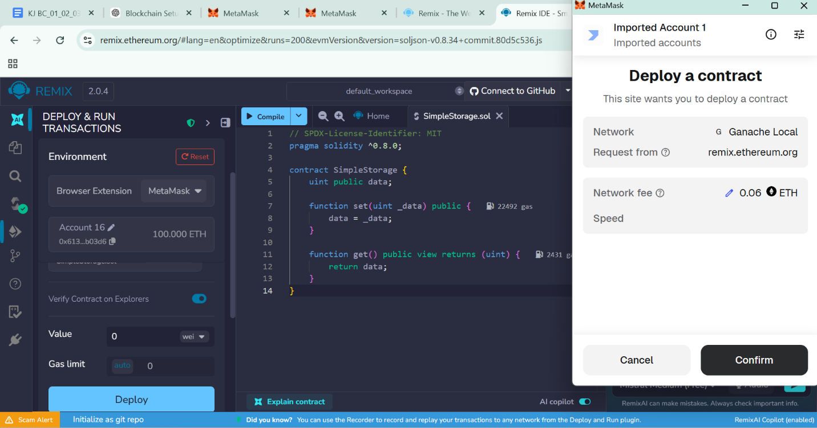

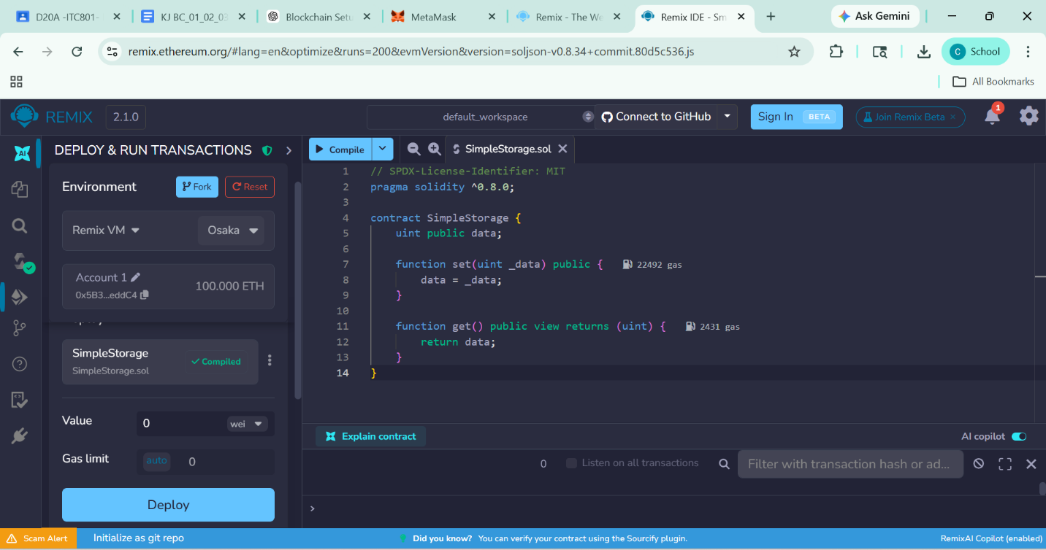

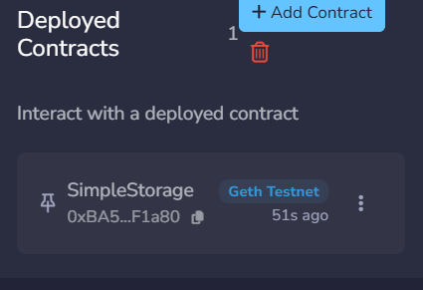

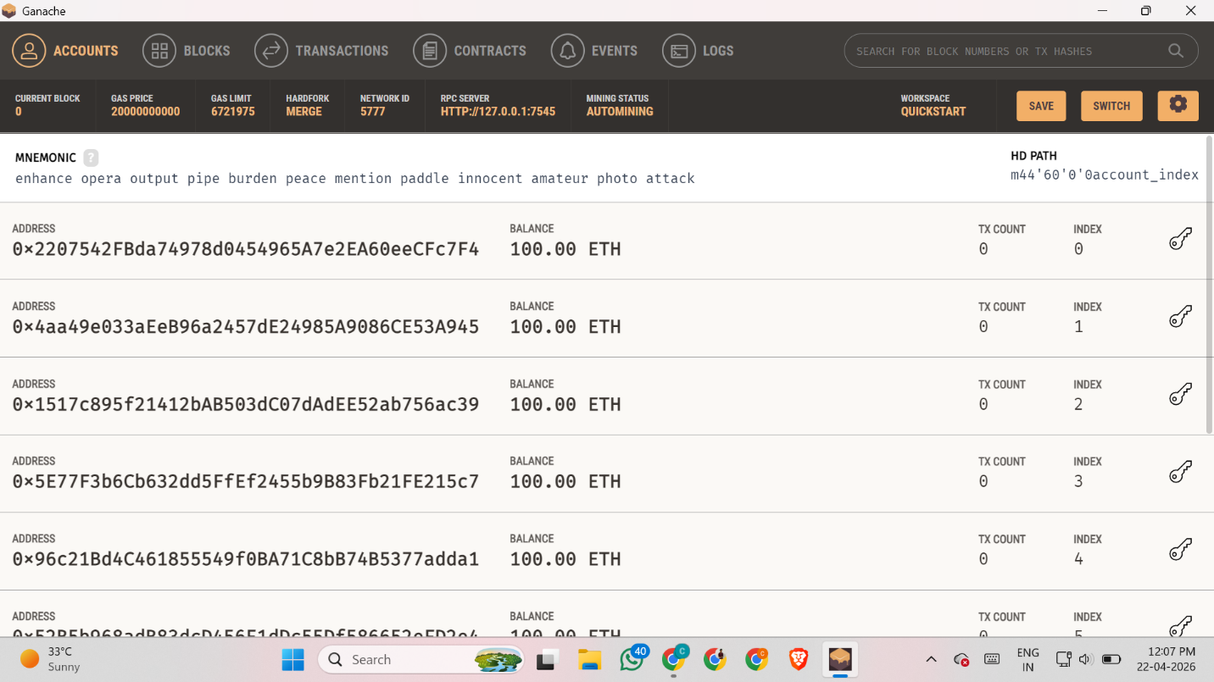

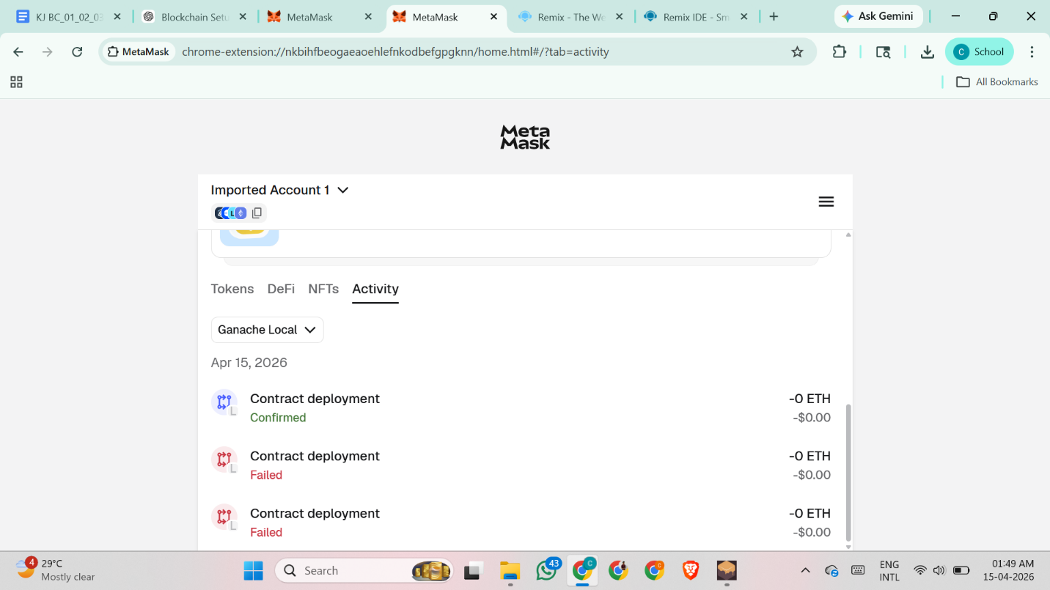

Conclusion:
Ganache provides a simple and powerful environment to simulate a local Ethereum blockchain. By integrating it with Metamask and Remix, developers can deploy, test, and debug smart contracts efficiently before moving to a public network.

