EXPERIMENT NO: - 01
Name:- Diksha Utekar Class:- D15A Roll:No: - 63

AIM: - Installation and Configuration of Flutter Environment.
Step 1: Go to the official Flutter website: https://docs.flutter.dev/get-started/install
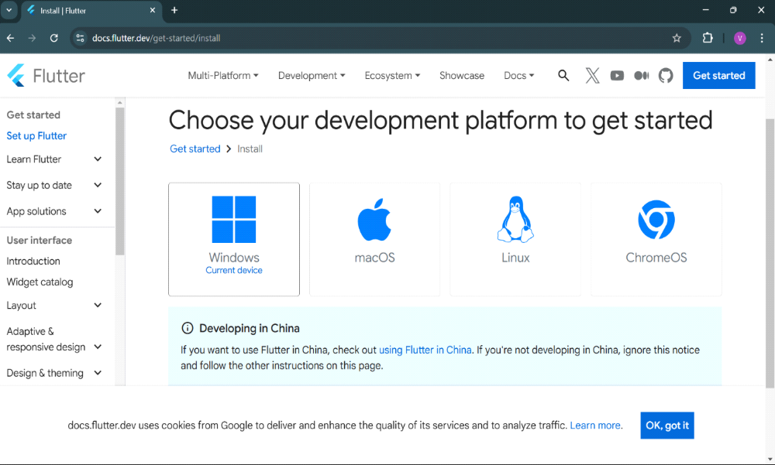
Step 2: To download the latest Flutter SDK, click on the Windows icon > Android
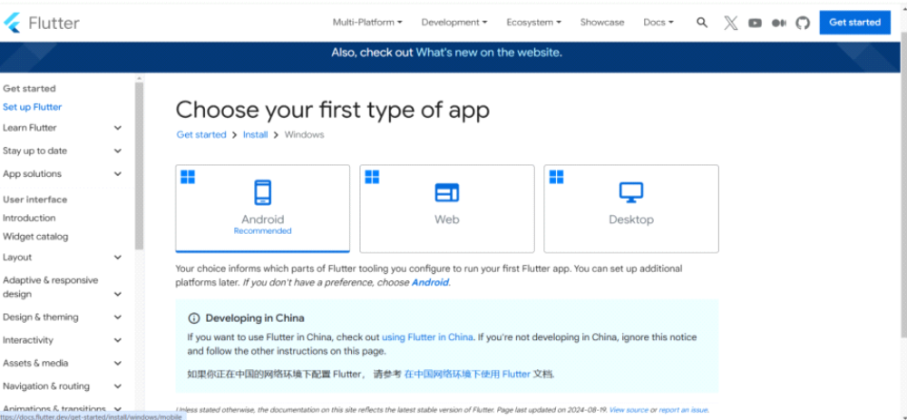

Step 3: For Windows, download the stable release (a .zip file).
Step 4: Extract the ZIP file to a folder (e.g., C:\flutter)
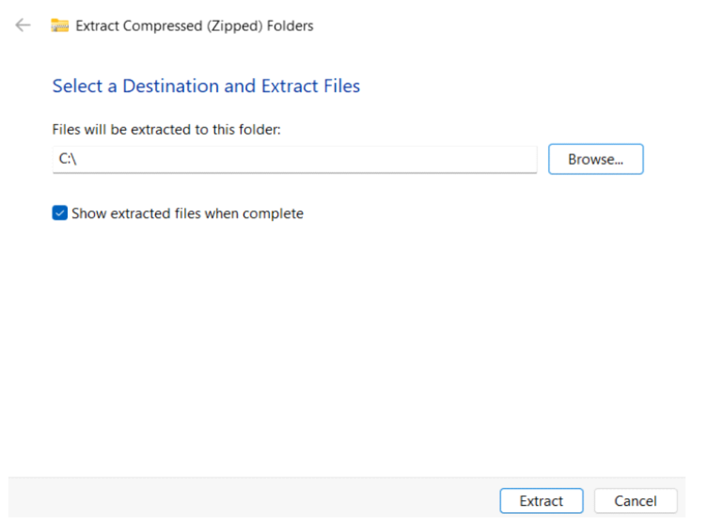
Step 5 :- Add Flutter to System PATH Right-click on the Start Menu > System > Advanced system settings > Environment Variables. Under System Variables, find Path and click Edit. Add the full path to the flutter/bin directory (e.g., C:\flutter\bin).
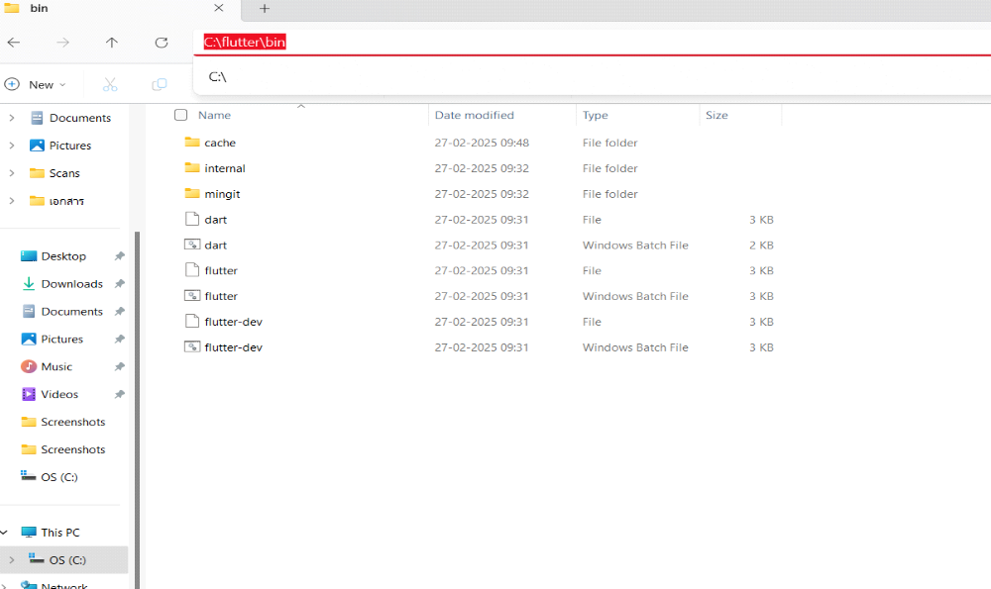

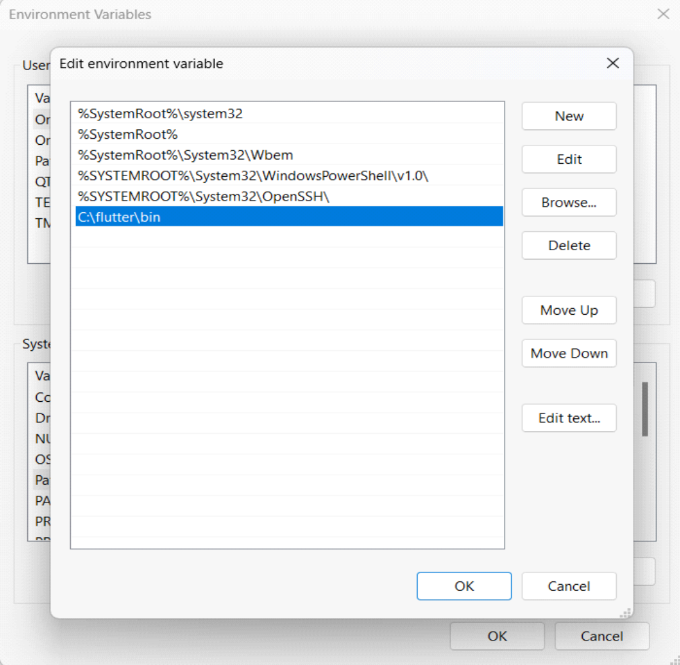

Step 6 : - Now, run the $ flutter command in command prompt
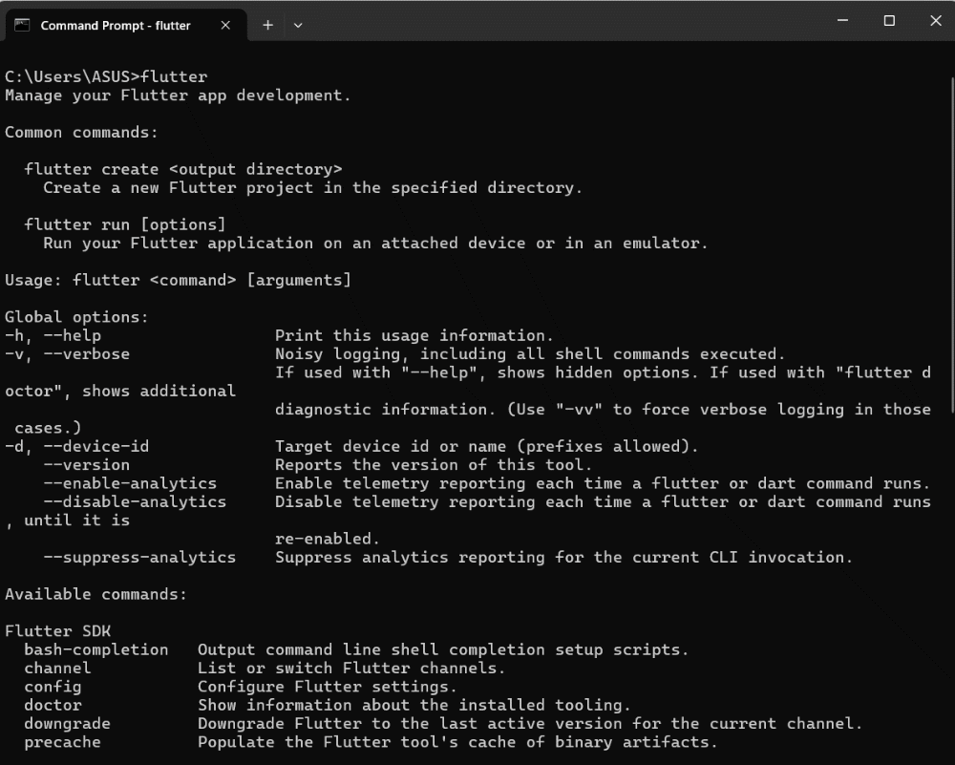

Step 7:- Run the $ flutter doctor command. This command checks for all the requirements of Flutter app development and displays a report of the status of your Flutter installation
Step 8 : - Go to Android Studio and download the installer
Step 8.1: - When the download is complete, open the .exe file and run it. You will get the following dialog box
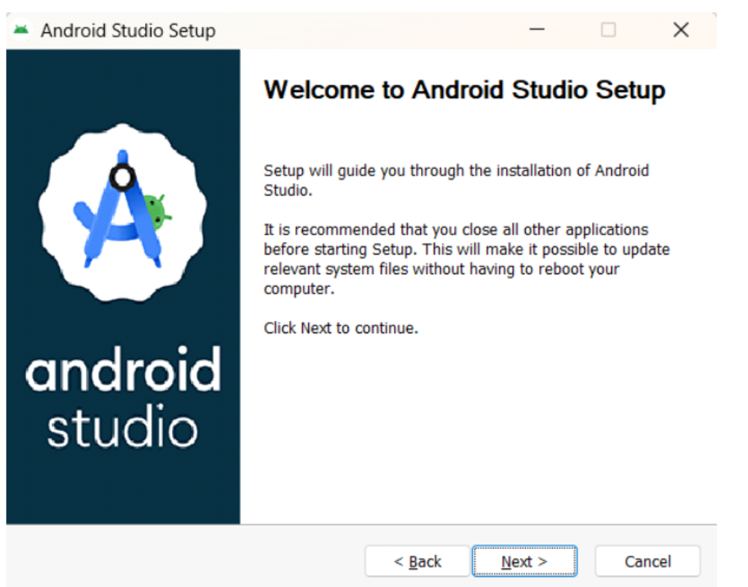
Step 8.2: - Select all the Checkboxes and Click on ‘Next’ Button.
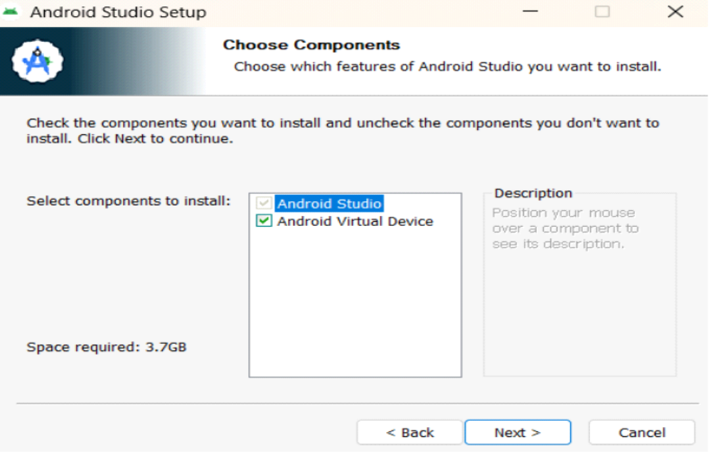

Step 8.3: - Change the destination as per your convenience and click on ‘Next’ Button.
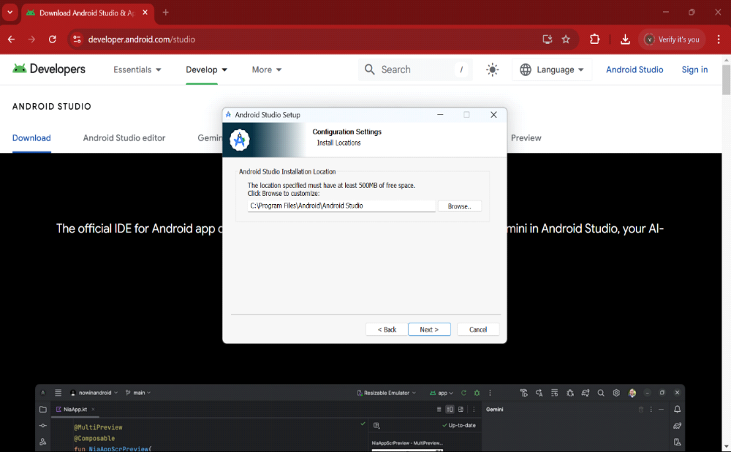

Step 8.4: - Follow the steps of the installation wizard. Once the installation wizard completes, you will get the following screen.
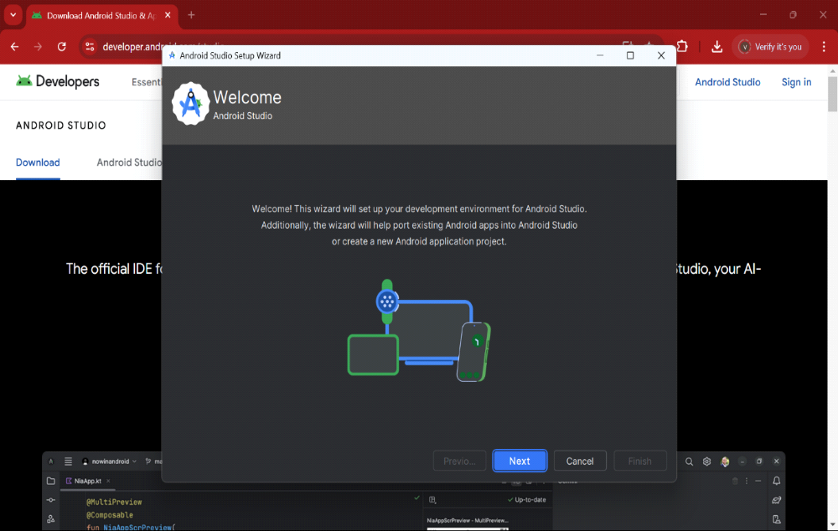

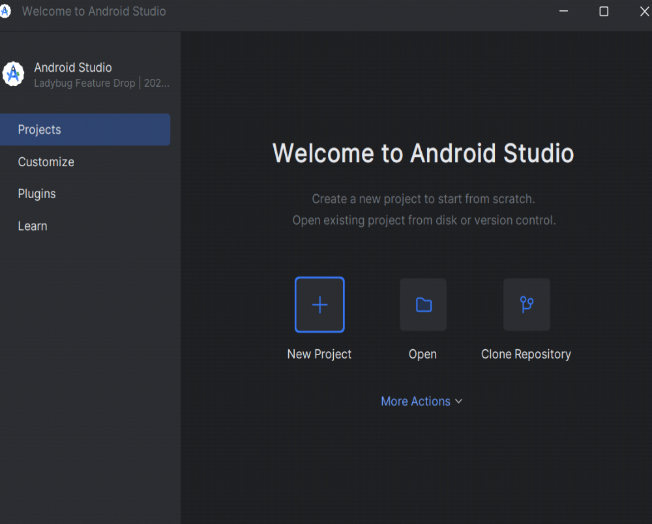

Step 8.5: - Go to Preferences > Appearance & Behavior > System Settings > Android SDK. Select the SDK Tools tab and check Android SDK Command-line Tools and Install it.
Step 9: - Open a terminal and run the following command
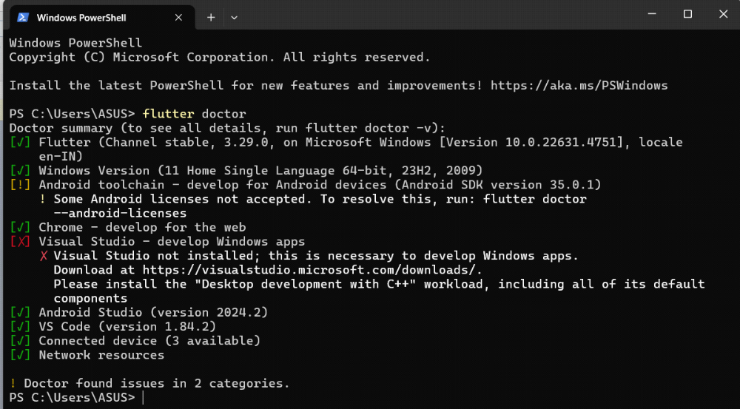

Step 10: - Next, you need to set up an Android emulator. It is responsible for running and testing the Flutter application
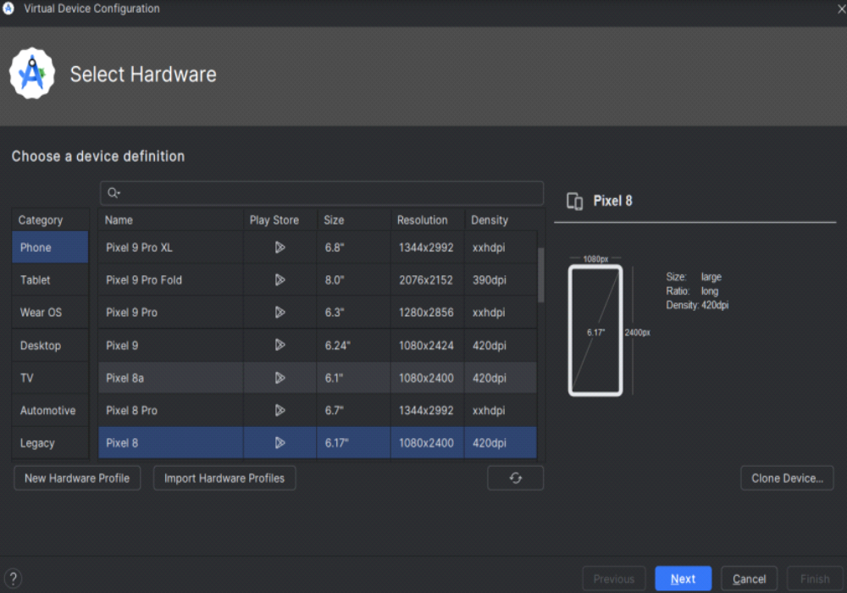
Step 10.1: - Open Android Studio and go to Tools > AVD Manager. Create a new virtual device.
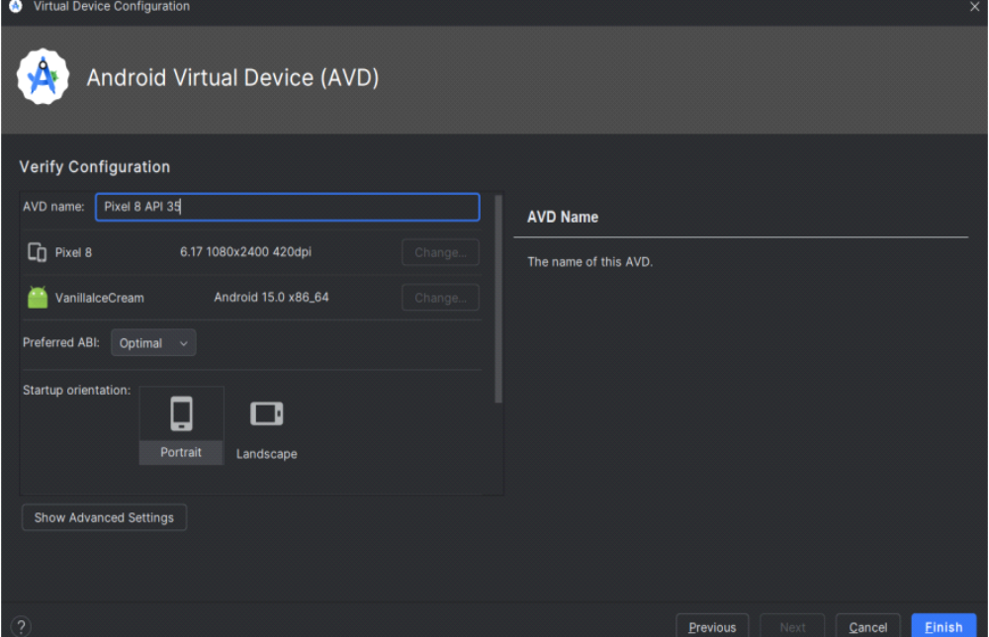
Step 10.2: - Click on the icon pointed into the red color rectangle. The Android emulator displayed as below screen
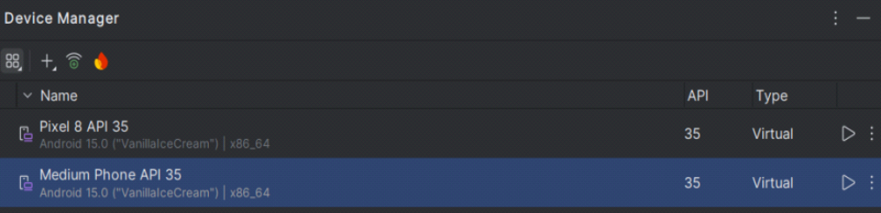
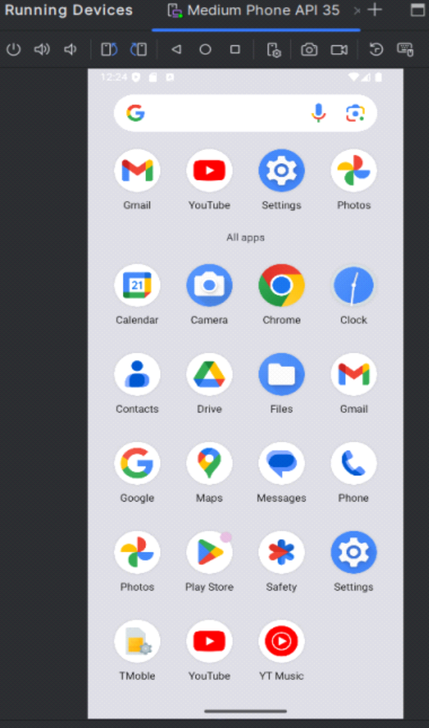

Step 11: - Now, install Flutter and Dart plugin for building Flutter application in Android Studio. These plugins provide a template to create a Flutter application, give an option to run and debug Flutter application in the Android Studio itself
Step 11.1: - Open the Android Studio and then go to File->Settings->Plugins. Now, search the Flutter plugin. If found, select Flutter plugin and click install
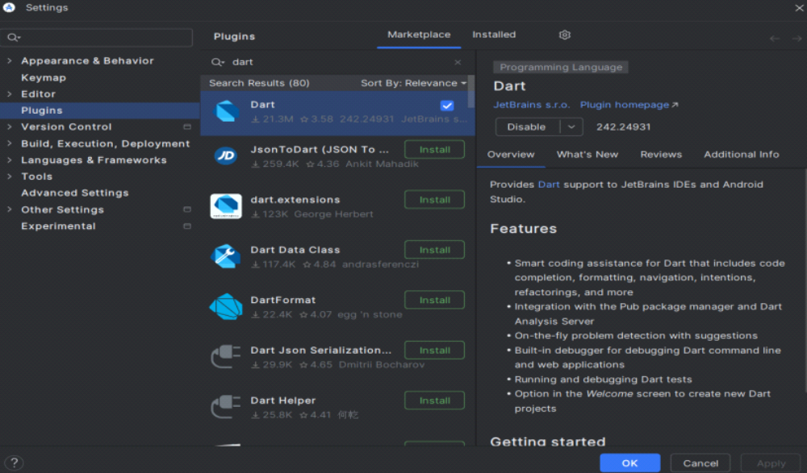
Step 11.2: - Restart the Android Studio
Step 12: - Go to File > New Project > Create Flutter Project, then select the project name and location, and click Next to proceed.
