create table json_tab(str string);

load data inpath 'home/hduser/test.json' into table json_guru;

select * from json1;

select get_json_object(str,'$.ecode') as ecode, get_json_object(str,'$.ename') as ename ,get_json_object(str,'$.sal') as salary from json_tab;

CREATE TABLE my_table (field1 **string**, field2 **int**,

field3 **string**, field4 **double**)

ROW FORMAT SERDE 'org.apache.hadoop.hive.contrib.serde2.JsonSerde' ;

Add the Jar :- ADD JAR /path-to/hive-json-serde.jar;

load the file :- load data inpath 'folder/to/json/data.json' **into** my_table;

1) Create table employees (Id INT, Name STRING, Age INT, Address STRING, Salary FLOAT, Department STRING)

> Row format delimited

> Fields terminated by ',';

2) load data local inpath '/home/hduser/Employees.txt' into TABLE employees;

3) select * from employees;

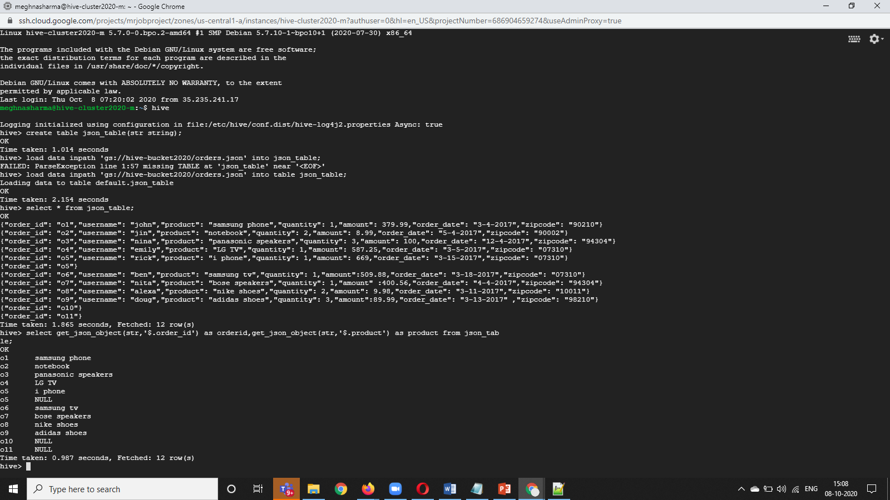

**XML TO HIVE TABLE**

In this, we are going to load XML data into Hive tables, and we will fetch the values stored inside the XML tags.

**Step 1)** Creation of Table "xmlsample " with str column with string data type.

Create table xmlsample(str string);

Load data local inpath ‘test.xml’ into xmlsample;

**Step 2)** Using [XPath](https://www.guru99.com/xpath-selenium.html) () method we will be able to fetch the data stored inside XML tags.

Select xpath(str,’text()’), xpath(str,

1. Using XPATH( ) method we are fetching the values stored under /emp/esal/ and /emp/ename/
2. Values present Inside XML tags. In this step, we are displaying actual values stored under XML tags in table "xmlsample "

**Step 3)** In this step, we will fetch and display the Raw XML of table "xmlsample."