# SAFE TRADE A STOCK RECOMMENDER

**Submitted by**

**V.R.DikshitReddy 212219040026**

**E.GaneshReddy 212219040028**

**D.V.V.Somasekhar 212219040024**

**Degree**

**BACHELOR OF ENGINEERING in**

**COMPUTER SCIENCE AND ENGINEERING**

**SAVEETHA ENGINEERING COLLEGE(AUTONOMOUS)**

**JANUARY 2021**

**ABSTRACT**

Business and finance sector is today the leader of the world's economy, stock market trading is a major practice in the finance sector. The project is implemented LSTM using Keras API of google’s Tensorflow to predict values of stock while training the algorithm on past data. We concentrated on predicting the trend observed in the value of a stock for the next 20 days from the day of prediction. It is basically a technique where one tries to predict the future value of current stocks of a company to avoid the loss or perhaps gain profit. This project will demonstrate a machine learning approach to predict the same using various quantities mentioned later in this report. Python is the programming language used for better reach and understanding. We propose a Machine Learning Algorithm which will be trained from different datasets of some companies available from the past to make near effective predictions. Stock market prediction is a technique to determine the upcoming worth of a corporation’s stock or other financial instrument traded on an exchange. A noticeable consequential gain is the sole purpose of stock market prediction, and, of course, to avoid significant losses. Some individuals may disagree with the authenticity of results that these predictions considering the efficient market hypothesis that these predictions cannot be made on the presently available data, thus concluding it as inherently unpredictable. But there are numerous tools and technologies that help to gain future trends’ information, thus resulting in effective profits. The proposed method identifies frames with 85.5% accuracy.

**INTRODUCTION**

Business and finance sector is today the leader of the world’s economy, stock

market trading is a major practice in the finance sector. Financial exchange predictions are always trickier when it comes to stock market predictions. It is basically a technique where one tries to predict the future value of current stocks of a company to avoid the loss or perhaps gain profit. This project will demonstrate a machine learning approach to predict the same using various quantities mentioned later in the report. Python is the programming language used for better reach and understanding. We propose a Machine Learning Algorithm which will be trained from different datasets of some companies available from the past to make near effective predictions. Stock market prediction is a technique to determine the upcoming worth of a corporation’s stock market prediction, and of course, to avoid significant losses. Some individuals may disagree with the authenticity of results that these predictions considering the efficient market hypothesis that these predictions cannot be made on the presently available data, thus concluding it as inherently unpredictable. But there are numerous tools and technologies that help to gain future trend’s information, thus resulting in effective profits.

**Overview of the Project**

Stock price prediction is a popular yet challenging task and deep learning provides the means to conduct the mining for the different patterns that triggers its dynamic movement.

This project can predict the best stock to buy or sell.

It provides and efficient solution for easy investment in the stock and most important thing: the audience will not miss any point of your presentation.

Business and finance sector is today the leader of the world’s economy, stock market trading is a major practice in the finance sector. We propose a Machine Learning Algorithm which will be trained from different datasets of some companies available from the past to make near effective predictions.

As financial institutions begin to embrace artificial intelligence, machine learning is increasingly utilized to help make trading decisions. Although there is an abundance of stock data for machine learning models to train on, a high noise to signal ratio and the multitude of factors that affect stock prices are among the several reasons that predicting the market difficult. At the same time, these models don’t need to reach high levels of accuracy because even 60% accuracy can deliver solid returns. One method for predicting stock prices is using a long short-term memory neural network (LSTM) for times series forecasting.

LSTMs are an improved version of recurrent neural networks (RNNs). RNNs are analogous to human learning. When humans think, we don’t start our thinking from scratch each second. For example, in the sentence “Bob plays basketball”, we know that Bob is the person who plays basketball because we retain information about past words while reading sentences. Similarly, RNNs are networks with loops in them, which allow them to use past information before arriving at a final output. However, RNNs can only connect recent previous information and cannot connect information as the time gap grows. This is where LSTM’s come into play; LSTM’s are a type of RNN that remember information over long periods of time, making them better suited for predicting stock prices.

It has never been easy to invest in a set of assets, the abnormally of financial market does not allow simple models to predict future asset values with higher accuracy. Machine learning, which consist of making computers perform tasks that normally requiring human intelligence is currently the dominant trend in scientific research. This article aims to build a model using Recurrent Neural Networks (RNN) and especially Long-Short Term Memory model (LSTM) to predict future stock market values. The main objective of this paper is to see in which precision a Machine learning algorithm can predict and how much the epochs can improve our model.

**Scope and Objective**

Stock market consists of various buyers and sellers of stock. Stock market prediction means determining the future scope of market. A system is essential to be built which will work with maximum accuracy and it should consider all important factors that could influence the result. Various researches have already been done to predict stock market prices. The research is done over business and computer science domain. Sometime the stock market does well even when the economy is falling because there are various reasons for the profit or loss of a share. Predicting the performance of a stock market is tough as it takes into account various factors. The main aim is to identify the sentiments of investors. It is usually difficult as there must be rigorous analysis of national and international events. It is very important for an investor to know the current price and get a very close estimation of the future price.

Our objective is to identify the best possible algorithm for predicting future stock market performances. The successful prediction of the stock market will have a very positive impact on the stock market institutions and the investors also.

There are some mechanisms for stock price prediction that comes under technical analysis:

1. **Statistical method**

Statistical methods were widely used before the advent of machine learning. The popular techniques are ARIMA, ESN and Regression. The main features of statistical approach is linearity and stationarity. An analysis of statistical approaches like Linear Discriminant Analysis(LDA), regression algorithms and Quadratic Discriminant Analysis(QDA) is done. An analysis of widely used technique called ARIMA model is done. An approach to use time series as input variables is Auto-Regressive Moving Average (ARMA). ARMA model combines Auto Regressive models. ARIMA can reduce non stationary series to a stationary series and is also an extension to ARMA models.

1. **Pattern Recognition**

This method focuses on pattern detection. It studies data rigorously and identifies a pattern. Traders find buy and sell signals in Open-High- Low-Close Candlestick charts. A study is done on pattern of stock prices that can help in predicting the future of a stock. An analysis of pattern is done in by studying charts to develop predictions of stock market. A comparison of market price and its history to chart patterns for predicting future stock prediction is done.

1. **Machine learning**

Machine learning is used in many sectors. One of the most popular being stock market prediction itself. Machine learning algorithms are either supervised or unsupervised. In Supervised learning, labelled input data is trained and algorithm is applied. Classification and regression are types of supervised learning. It has a higher controlled environment. Unsupervised learning has unlabelled data but has lower controlled environment. It analyses pattern, correlation or cluster.

1. **Sentiment analysis**

Sentiment analysis is an approach that is used in relation to the latest trends. It observes the trends by analysing news and social trends like tweet activity. A study is done on using segment signals from text to improve efficiency of models to analyze trends in stock market.

Stock market prediction seems a complex problem because there are many factors that have yet to be addressed and it doesn’t seem statistical at first. But by proper use of machine learning techniques, one can relate previous data to the current data and train the machine to learn from it and make appropriate assumptions. Machine learning as such has many models but this paper focuses on two most important of them and made the predictions using them.

1. **Regression Based Model** 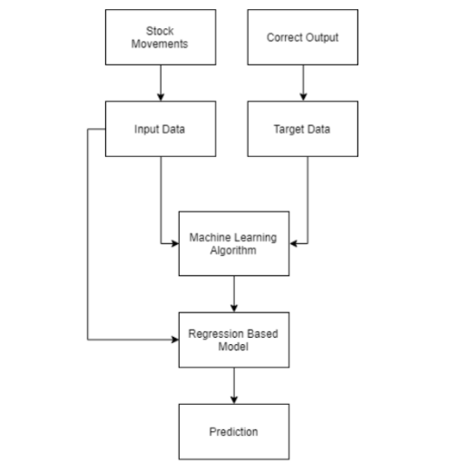
2. **Long Short Term Memory(LSTM) Model**

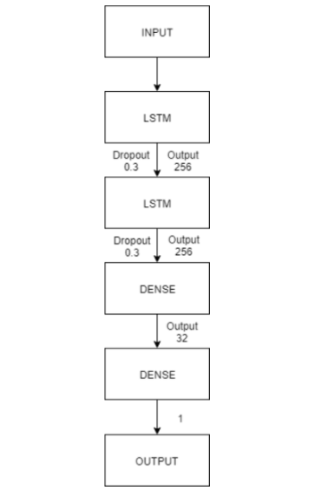

Two techniques have been utilized LSTM and Regression, on the prediction of the stock dataset. Both the techniques have shown an improvement in the

accuracy of predictions, thereby yielding positive results. Use of recently introduced machine learning techniques in the prediction of stocks have yielded promising results and thereby marked the use of them in profitable exchange schemes. It has led to the conclusion that it is possible to predict stock market with more accuracy and efficiency using machine learning techniques.

**Existing System**

In the existing system, SVM and Backpropagation Algorithm there is no which won't do dropout process. Because of this, unwanted data have been processed which leads to wastage of time and memory space. The prediction of future stock price by SVM and Backpropagation Algorithm is less efficient because of processing unwanted data. The SVM and Backpropagation Algorithm which is used in the existing system is not that effective in handling non-linear data. So, in our proposed future stock price prediction is done using LSTM (Long ShortTerm Memory) which is a higher accurate value for the next day than SVM and Backpropagation Algorithm.

**Proposed System**

In the proposed system we try to find the accurate value of the next day closing value that helps the investors to invest or sell their shares. Long Short Term Memory (LSTM) is an artificial neural network in the field of deep learning. LSTM is an advance Neural network with having a memory cell that stores a small amount of data for further references. LSTM has feedback links that make it a "general-purpose computer". LSTM can also process an entire series of data not only single value like image. Because of the dropout process which takes place in the LSTM algorithm, it is comparatively faster than SVM and Backpropagation. LSTM algorithm is more suitable in predicting the future stock price than the SVM and Backpropagation algorithm because of removing the undesired data. The time and memory consumption are also reduced when compared to the exciting system due to the dropout process. LSTM algorithm is more proper in handling non-linear data. We predict the 10-company stock price and store them in a tabular format and visualize the.

Deals with the classification of brain tumor accurately from the source, big data based on Hadoop framework with SVM classifier.

The proposed methodology consists of the following modules:

1. Elimination of Secondary attributes
2. Clustering and Classification

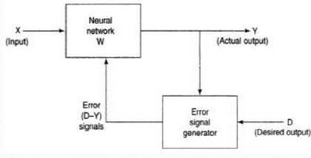

**Experiment Analysis**

As the integration of the same is higher with other dependencies so leaving one dependencies compromises the level of accuracy. Accuracy is not the term used over in stock as the actual prediction is not possible for any fiscal days it keeps on changing and turning the tables day and night. Having higher component assets and the dependencies makes it more feasible and flexible in nature causing it even harder to predict. The approx value are taken into consideration and the hit or profit or the gain rate is calculated for the same.

In the project various high level machine learning algorithms are implemented and integrated and the output is generated from the same making a user visible with the outputs in the form of graph which makes it easier for them to see and interpret what’s the scenario and they can decide on the same to invest and get the benefit out of it.



**CONCLUSION**

To conclude stock is an unpredictable mechanism which follows the segments of chain and the dependencies of the same are unpredictable. It is defined to be a curve which keeps on changing and turning the price from low to high and vice-versa.

As the integration of the same is higher with other dependencies so leaving dependencies compromise the level of accuracy. Accuracy is not the term used over in stock as the actual prediction is not possible for any fiscal days it keeps on changing and turning the tables day and night. Having higher component assets and the dependencies makes it more feasible and flexible in nature causing it even harder to predict. The approximate values are taken into consideration and the hit or profit or the gain rate is calculated for the same.

In the project various high level machine learning algorithms are implemented and integrated and the output is generated from the same making a user visible with the outputs in the form of graph which makes it easier for them to see and interpret what’s the scenario and they can decide on the same to invest and get the benefit out of it.

The proposed software takes the raw set of data from the dataset or the .csv file and process it. The cleaning and cleansing of data is done and then further processed to gain the effective outcomes. After the computational mean the output is displayed in the screen in the form of graph.

Stocks are important to a business because they can help the corporation quickly gain a lot of capital, raise the prestige of the company with the public since people can now invest in the company, and allow the initial investors to sell off shares and earn money on their investments. We provide an efficient solution for easy investment in the stock market, so that a layman can also benefit without having prior knowledge of technicalities that a stock market carries. The Website is named as **SafeTrade** and it helps people invest smartly, the number of various examples belonging to each class were identified and plotted.

**Software Description:**

## **Numpy:**

Fundamental package for scientific computing in Python3, helping us in creating and managing n-dimensional tensors. A vector can be regarded as a 1-D tensor, matrix as 2-D, and so on.

## 

## **Pandas:**

Used for data manipulation and analysis. In particular, it offers data structures and operations for manipulating numerical tables and time series. Pandas allows us to analyse big data and make conclusions based on statistical theories. Pandas can clean messy data sets, and make them readable and relevant. Relevant data is very important in data science.

**Tensorflow:**

[TensorFlow](https://www.tensorflow.org/) is an end-to-end open source platform for machine learning. It has a comprehensive, flexible ecosystem of [tools](https://www.tensorflow.org/resources/tools), [libraries](https://www.tensorflow.org/resources/libraries-extensions), and [community](https://www.tensorflow.org/community) resources that lets researchers push the state-of-the-art in ML and developers easily build and deploy ML-powered applications.

TensorFlow was originally developed by researchers and engineers working on the Google Brain team within Google's Machine Intelligence Research organization to conduct machine learning and deep neural networks research. The system is general enough to be applicable in a wide variety of other domains, as well.

TensorFlow provides stable [Python](https://www.tensorflow.org/api_docs/python) and [C++](https://www.tensorflow.org/api_docs/cc) APIs, as well as non-guaranteed backward compatible API for [other languages](https://www.tensorflow.org/api_docs).

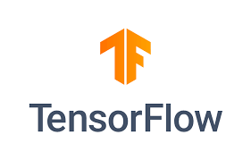

**References**

[1] [A Novel Algorithmic Trading Strategy Using Data-Driven Innovation](https://ieeexplore.ieee.org/document/9308360/) Publisher: IEEE – 2020 Author : Md.Erfanul

[2] [Stock Price Prediction Model Based on RBF-SVM Algorithm](https://ieeexplore.ieee.org/document/9361804) Publisher: IEEE – 2021 Author : Zixuan Liu

[3] [Stock Market Analysis using Supervised Machine Learning](https://ieeexplore.ieee.org/document/8862225)

Publisher: IEEE – 2018 Author: Kunal Pahwa, Neha Agarwal

[4] [Stock Market Prediction Using Linear Regression and SVM](https://ieeexplore.ieee.org/document/9404733)

Publisher: IEEE – 2020 Author: Bhawna Panwar, Gaurav

[5] [Deep Learning-Based Stock Price Prediction Using LSTM and Bi-Directional LSTM Model](https://ieeexplore.ieee.org/document/9257950) Publisher: IEEE – 2020 Author: Md. Arif Istiake Sunny, Mirza Mohd