AI-Based Content Moderation System for Social Media

1. Introduction
In today's digital landscape, social media platforms serve as the primary communication channels for billions of users worldwide, facilitating instant connection, information sharing, and community building across geographical and cultural boundaries. However, this unprecedented scale of user-generated content has created profound challenges that demand sophisticated, intelligent solutions. An AI-Based Content Moderation System for Social Media represents a transformative technological advancement designed to automatically detect, flag, and manage harmful, inappropriate, or policy-violating content with real-time efficiency and nuanced understanding.
This system leverages state-of-the-art natural language processing (NLP), computer vision, and deep learning algorithms to maintain platform safety, protect user experience, and ensure strict compliance with evolving community standards and legal requirements. By seamlessly combining automated detection capabilities with human oversight mechanisms, the system creates a hybrid moderation approach that is simultaneously scalable and accurate—addressing the fundamental tension between processing volume and decision quality that has plagued content moderation for years.
The foundational challenge that this system addresses is multifaceted. The explosive growth of user-generated content, measured in hundreds of millions of posts daily across major platforms, far exceeds what traditional manual moderation teams can realistically handle. Simultaneously, the diversity of harmful content types—including hate speech, misinformation, adult content, harassment, spam, and coordinated inauthentic behavior—requires different detection strategies and cultural understanding. Moreover, the need for rapid response times to protect vulnerable users and minimize platform harm introduces stringent latency requirements that make manual-only approaches impractical.
The architecture of our system comprises multiple intelligent, specialized components working in concert. At its core sits a sophisticated Natural Language Processing engine for granular text analysis, complemented by a Computer Vision module capable of analyzing both static images and video content. A context-aware neural network provides the crucial element of understanding user intent, conversation history, and cultural nuances that distinguish genuine discourse from harmful behavior. A real-time classification pipeline ensures decisions are made with millisecond latency, while an intelligent escalation system routes complex, ambiguous cases to human moderators for final judgment. This multi-layered approach ensures security and effectiveness at every level while maintaining exceptional ease of use for end-users and administrators alike.
From an operational perspective, the system manages the complete content moderation lifecycle with sophistication and care. It continuously analyzes text posts, images, videos, and user interactions with concurrent processing capabilities. It performs sentiment analysis, toxicity scoring, hate speech identification with cultural context awareness, misinformation flagging with source credibility assessment, adult content detection across modalities, and harassment pattern recognition through behavioral analysis. The system doesn't simply flag content—it assigns nuanced confidence scores to each detection, enabling intelligently prioritized routing of high-risk content while minimizing false positives that could unfairly restrict legitimate speech. For administrators and moderators, the system provides comprehensive analytics dashboards, intelligent moderation queues optimized for review efficiency, user flagging patterns with trend analysis, and sophisticated case management tools.
Ultimately, the AI-Based Content Moderation System represents a significant advancement in platform safety, combining the raw processing power and consistency of machine learning with the contextual judgment and ethical reasoning of human moderators. It directly addresses the critical, ongoing need for scalable content governance by automating routine decisions with high confidence, while preserving human expertise for nuanced edge cases that demand contextual understanding. This balanced approach ensures both robust user safety and fair, equitable speech protection—creating digital spaces where communities can thrive safely.

1.1 Problem Statement & Motivation
Modern social media platforms face an unprecedented crisis in content moderation. With platforms like Facebook, TikTok, and Twitter processing hundreds of millions of posts daily, the sheer volume of content makes comprehensive manual review impossible. A single platform might employ thousands of human moderators, yet they can only review a tiny fraction of all content. Meanwhile, the psychological toll on human moderators exposed to graphic, disturbing, and traumatic content has become a significant ethical concern and legal liability.
The current landscape reveals critical gaps: (1) Most harmful content goes unmoderated simply due to scale, (2) Response times to reported content often exceed 24 hours, during which harm continues to spread, (3) Moderation decisions lack consistency across different regions, languages, and cultural contexts, (4) User appeals to moderation decisions have low resolution rates, creating frustration and distrust, and (5) Emerging forms of harm—like coordinated inauthentic behavior and algorithmic amplification of misinformation—remain largely unaddressed by traditional moderation approaches.
These challenges create ripple effects throughout society. Misinformation spreads faster than corrections, influencing elections and public health decisions. Harassment campaigns drive individuals from platforms and sometimes to real-world harm. Hate speech radicalizes vulnerable individuals and creates hostile environments for targeted communities. The absence of effective content moderation directly undermines the democratic potential of social media while contributing to polarization, radicalization, and real-world violence.

1.2 AI Tools & Technologies Used
The implementation of this content moderation system leverages a carefully selected suite of cutting-edge AI frameworks and development tools, each chosen for specific strengths in their respective domains:
- Claude Code – Advanced AI development environment for system architecture, code generation, and intelligent debugging
- TensorFlow & PyTorch – Industry-standard deep learning frameworks for building and training neural networks at scale
- OpenAI GPT Models – Transformer-based language models for contextual understanding and semantic analysis
- Computer Vision APIs (OpenCV, YOLOv5) – Specialized libraries for real-time image and video processing
- Get Shit Done (GSD) – Project management and development workflow automation
- Hugging Face Transformers – Pre-trained models library for rapid deployment of NLP capabilities

1.3 Functional Requirements
The system must fulfill these essential operational requirements to effectively moderate content at enterprise scale:
- Content Analysis & Classification – Analyze and categorize content across multiple modalities
- Toxicity Detection – Identify toxic language and hostile communication patterns
- Hate Speech & Harassment Identification – Detect targeted abuse and coordinated attacks
- Misinformation & False Claims Detection – Flag unverified or demonstrably false information
- Adult Content Detection (Image & Video) – Automatically identify explicit and adult-oriented material
- Multi-Language Support – Handle content moderation across 50+ languages and dialects
- User Reporting & Appeals Management – Enable user reports and fair appeal processes
- Moderation Queue Management – Intelligently prioritize content for human review
- Real-Time Content Monitoring – Process and flag violations as they occur
- Analytics & Reporting Dashboards – Provide visibility into moderation metrics and trends

1.4 Non-Functional Requirements
Beyond functional capabilities, the system must meet stringent technical and operational criteria:
- Performance: Process 100,000+ posts per minute globally with sub-500ms latency for content flagging
- Accuracy: Achieve 95%+ precision in content classification while maintaining recall above 85%
- Scalability: Handle millions of concurrent users globally with elastic resource allocation
- Reliability: Maintain 99.9% uptime with automatic failover and redundancy across regions
- Security: Protect user data with military-grade encryption and GDPR, CCPA, LGPD compliance
- Usability: Provide intuitive dashboards for moderators and administrators with minimal training
- Fairness: Minimize algorithmic bias and ensure equitable content treatment across demographics

1.5 Key Actors & Stakeholders
The system serves multiple stakeholder groups, each with distinct needs and responsibilities:
- End Users: Submit content daily (text, images, videos) and depend on safe platform environments
- Content Moderators: Review flagged content, make nuanced decisions, and handle edge cases
- Administrators: Configure policies, manage moderator teams, monitor system health
- Appeal Reviewers: Hear user challenges to moderation decisions and ensure fairness
- Platform API: External interfaces enabling content submission, retrieval, and status updates
- Legal & Compliance Teams: Ensure adherence to regional laws and regulatory requirements

2. UML Diagrams & System Design

2.1 Use Case Diagram
The Use Case Diagram illustrates the interactions between various actors and the Content Moderation System, establishing the functional boundary and scope of our solution. The primary actors include End Users who post content, Moderators who review flagged content with expert judgment, Administrators who configure system policies and manage organizational settings, and the Platform API which serves as the external system interface for integrated platforms.
The core use cases represent the essential workflows. Content Submission allows users to post text, images, or videos to the platform. Content Analysis automatically processes submissions through our intelligence pipeline. Content Flagging marks potentially violating content for review. Review Flagged Content allows moderators to examine flagged items with full context. Appeal Resolution enables users to contest moderation decisions through structured processes. Policy Configuration allows administrators to define and adjust moderation rules, thresholds, and cultural guidelines.
These use cases interact through carefully designed relationships. Include relationships show dependencies where one use case automatically triggers another—for example, Content Analysis automatically triggers Content Flagging if violations are detected with sufficient confidence. Extend relationships show optional processes, such as Appeal Resolution that may extend the Review Flagged Content use case for contested decisions. The system boundary clearly delineates what falls within our moderation system versus what remains the responsibility of platform operators.

Diagram Elements:
- Actors: End User, Moderator, Administrator, Platform API – representing all system participants
- Use Cases: Submit Content, Analyze Content, Flag Content, Review Flagged Content, Make Decision, Appeal Decision, Configure Policies
- Include Relationships: Automatic content analysis triggering when violations are detected
- Extend Relationships: Appeal processes extending review workflows for contested decisions
- System Boundary: Defines the scope of Content Moderation System responsibilities
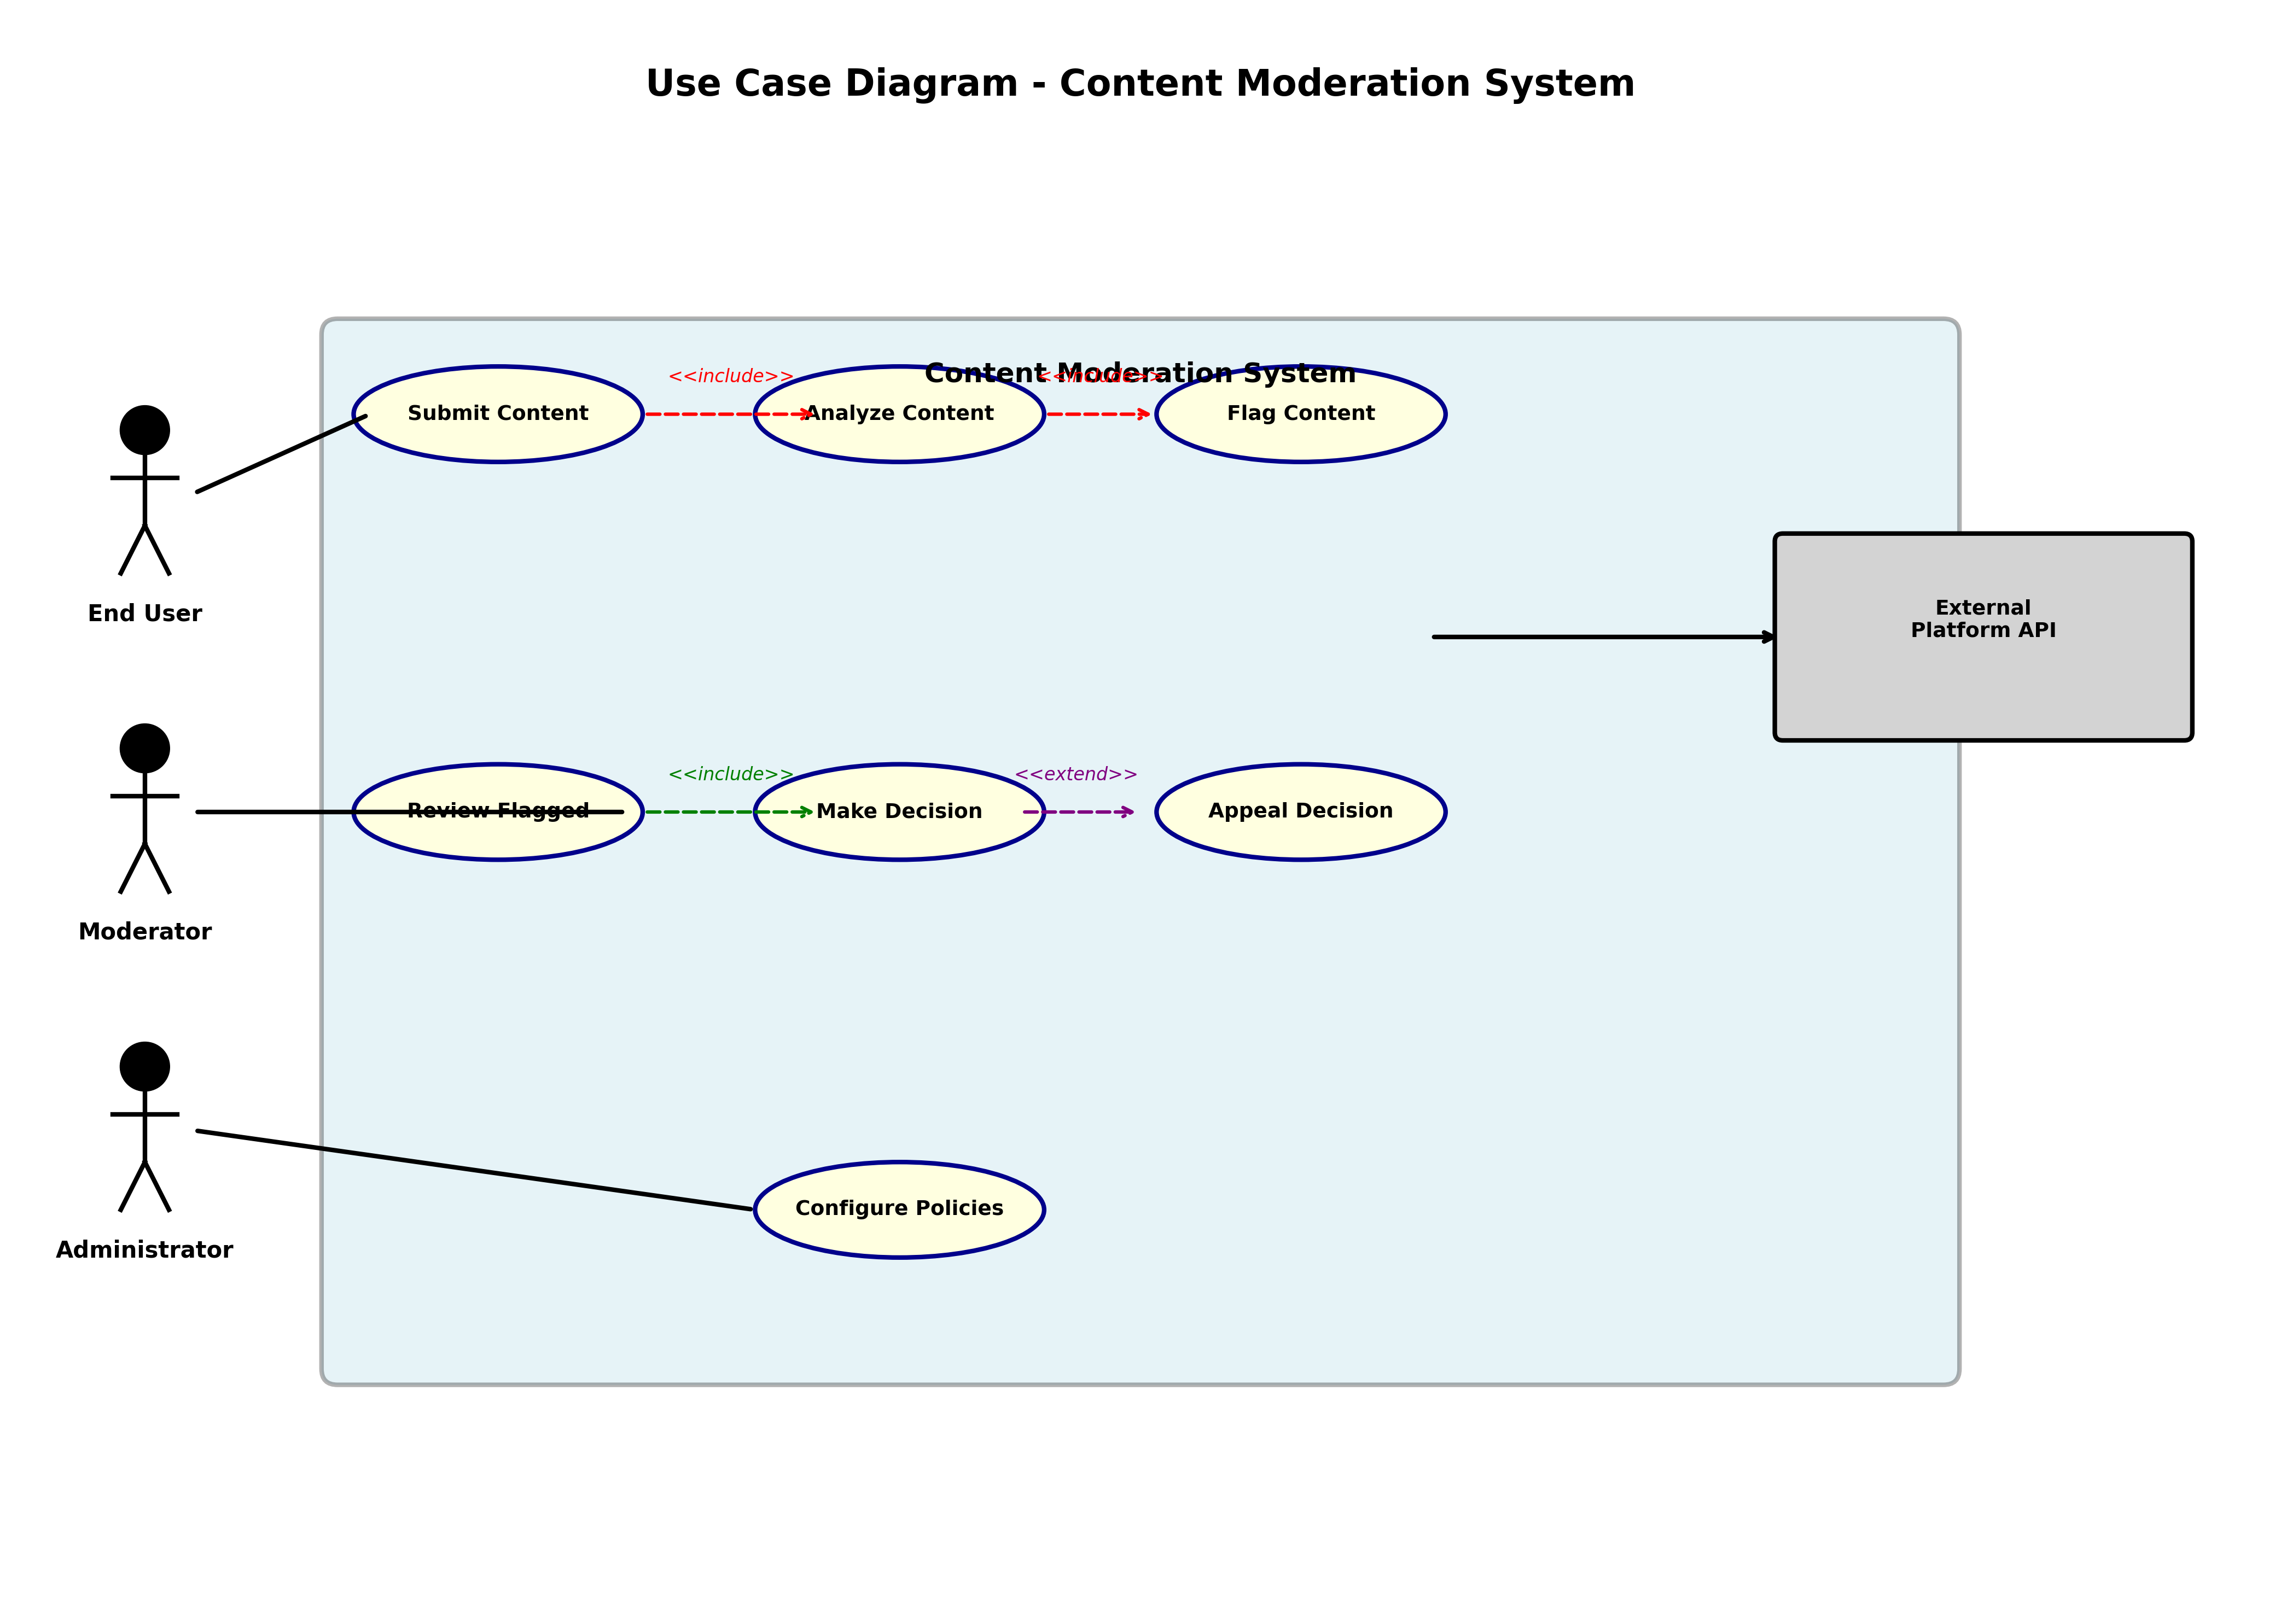
Figure 2.1: Use Case Diagram - System Actors and Interactions

2.2 Activity Diagram
The Activity Diagram represents the complete workflow of content moderation from initial submission through final action and notification. This diagram captures the dynamic behavior of our system, showing both sequential and parallel processing paths that enable efficient handling of millions of content items daily.
The process initiates when a user submits content to the platform. Rather than processing content sequentially, our system intelligently uses parallel processing to maximize efficiency. Four analysis streams execute simultaneously: Text Analysis applies NLP models to understand linguistic content, Image Analysis uses computer vision to evaluate visual material, Video Analysis extracts and evaluates frames from video content, and Metadata Extraction gathers contextual information about the post and poster.
These parallel streams converge at a Classification step where the system integrates results and determines whether content violates policy. A critical decision node asks: "Content Violates Policy?" This decision point branches the workflow into two paths. If the answer is no, content is immediately published to the platform, allowing legitimate expression to flow freely. If yes, the system assigns a severity score reflecting the seriousness of the violation. High-severity content is immediately routed to the Moderation Queue for urgent human review. Medium-severity content joins a standard queue for timely review. Low-confidence flags are either sent for human verification or automatically approved based on thresholds.
Content in the Moderation Queue undergoes Human Review by trained moderators who can Approve content (overriding the system), Reject it (confirming the system decision), or Mark it for Further Investigation if edge cases require escalation. Finally, all actions are logged in the System Audit Log for compliance and continuous improvement, and users are notified of any violations, sanctions, or appeals decisions.

Process Stages:
- Initialization: User submits content to platform with metadata
- Parallel Processing: Simultaneous Text Analysis, Image Analysis, Video Analysis, Metadata Extraction
- Classification: System integrates results and assigns violation probability scores
- Decision Branch: Content Violates Policy? Yes → Route to Queue; No → Publish Content
- Resolution: Human Review for uncertain cases, Logging for audit trails, Notification to users
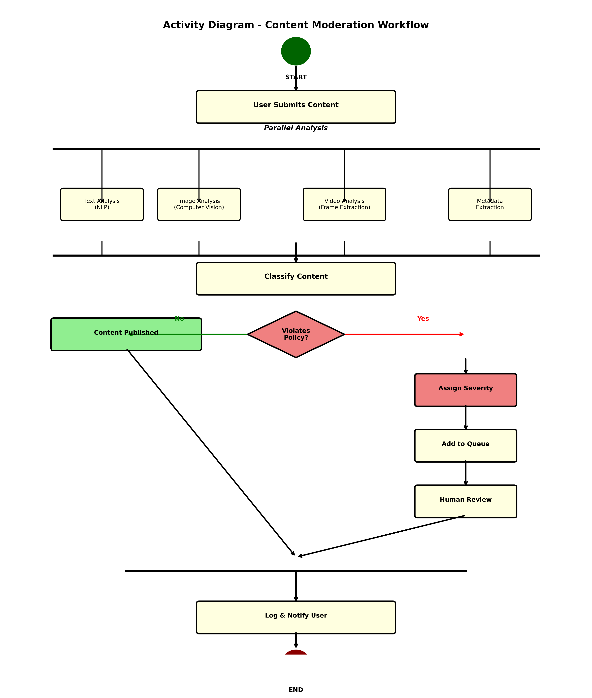
Figure 2.2: Activity Diagram - Content Moderation Workflow

2.3 Class Diagram
The Class Diagram defines the core data structures and their relationships within our content moderation system, establishing the object model that supports all system operations. Understanding these classes and their interactions is fundamental to grasping how the system stores, processes, and manages moderation data.
The Content class serves as the central entity, representing any user-generated material: posts, images, videos, or comments. Each Content instance carries essential attributes including a unique contentId, the userId of its creator, the content type (TEXT, IMAGE, VIDEO), timestamp of creation, the actual text content, URLs to associated media, and engagement metrics. The ContentAnalysisResult class captures the output of our analysis pipeline, storing the violationType detected, a confidence score reflecting certainty, a severity rating, and the specific flag reason explaining the decision. Multiple analysis results can be associated with a single content item since different detection models may identify different violations.
The User class represents platform participants, storing userId, username, account creation date, content submission history, and a reportCount tracking moderation reports filed by or against the user. The Moderator class represents our human review team, containing moderatorId, name, areas of expertise, and their assigned review queue. ModerationDecision represents the final human judgment, storing the decision identifier, responsible moderator, the action taken (APPROVE, REJECT, WARN_USER, SUSPEND_ACCOUNT), reasoning, and timestamp. The Appeal class enables user recourse, tracking appealId, originating userId, appeal reason, and resolution status.
Relationships show that a Content item can have multiple ContentAnalysisResults (1 to many), multiple ModerationDecisions (1 to many), and is created by exactly one User (many to 1). Moderators create ModerationDecisions (1 to many). Appeals relate to ModerationDecisions and can result in new Decisions. The system uses structured Enumerations for ContentType (TEXT, IMAGE, VIDEO, MIXED), ViolationType (HATE_SPEECH, MISINFORMATION, ADULT_CONTENT, HARASSMENT, SPAM, OTHER), and ModerationAction (APPROVE, REJECT, WARN_USER, SUSPEND_ACCOUNT).

Key Classes and Relationships:
- Content: Core entity representing user-generated posts, images, or videos with full metadata
- ContentAnalysisResult: Result of automated analysis with violation flags and confidence scores
- User: User profile with submission history, report information, and account metadata
- Moderator: Human moderator with expertise areas and assigned review queues
- ModerationDecision: Final decision by moderators with specific actions and detailed reasoning
- Appeal: User appeals against moderation decisions with resolution tracking
- Enumerations: ContentType (TEXT, IMAGE, VIDEO), ViolationType (HATE_SPEECH, etc.), ModerationAction
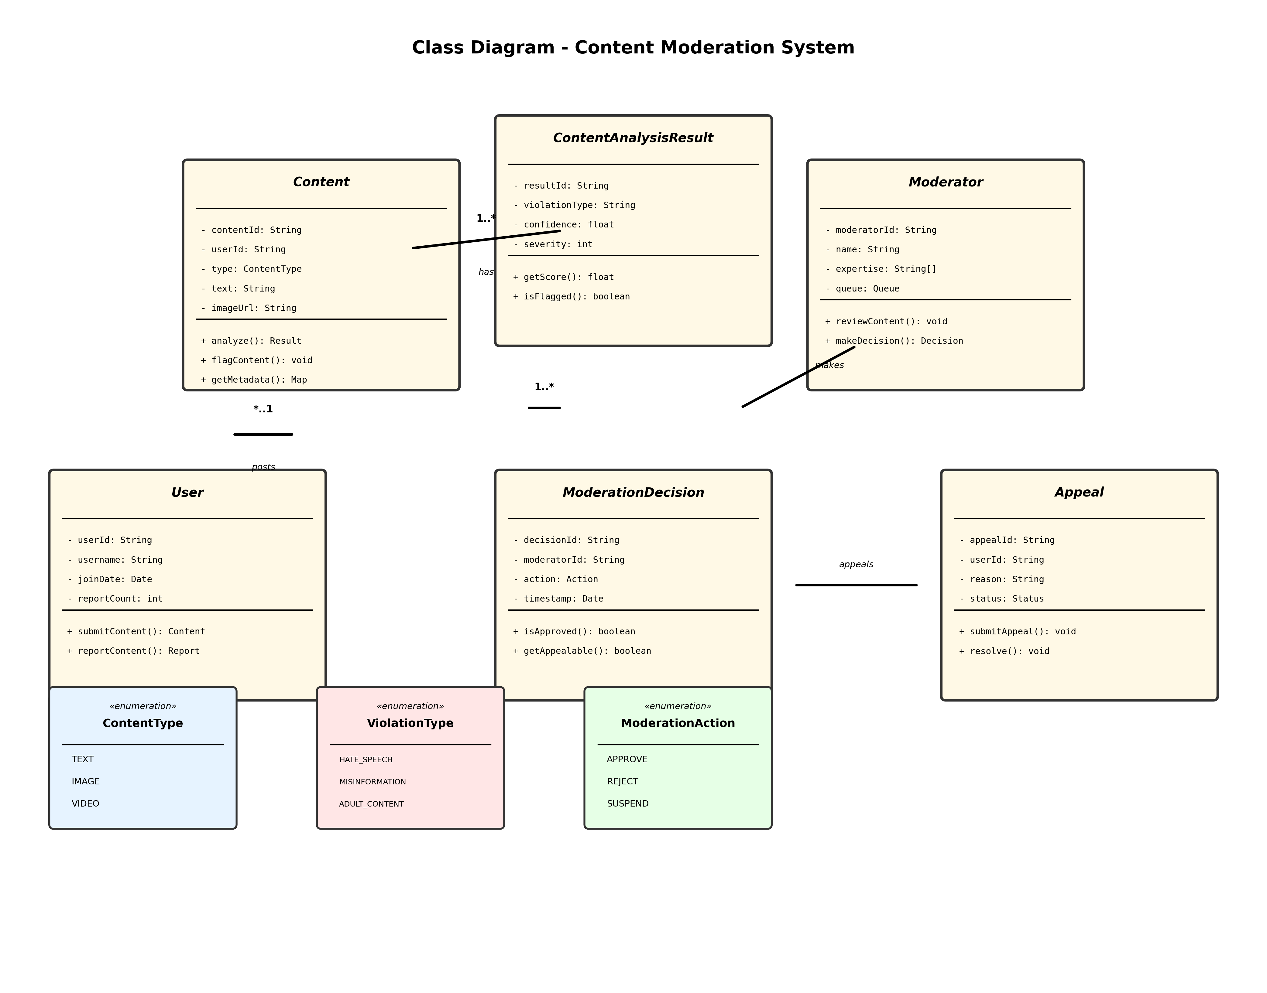
Figure 2.3: Class Diagram - Data Model and Relationships

2.4 Component Diagram
The Component Diagram illustrates the physical organization of the system into major architectural blocks, showing how different services communicate and collaborate. This view is essential for understanding deployment, scalability, and system resilience.

System Layers:
- Input Layer: Content Receiver, Request Validator, Parser – Handle and validate incoming submissions
- Processing Layer: NLP Engine, Vision Engine, Context Analyzer, Classifier, Scorer – Multi-modal analysis
- Decision Layer: Decision Engine, Queue Manager, Action Executor – Make decisions and execute actions
- Data Layer: Content DB, User DB, Decision DB, Cache (Redis) – Persist and retrieve data efficiently
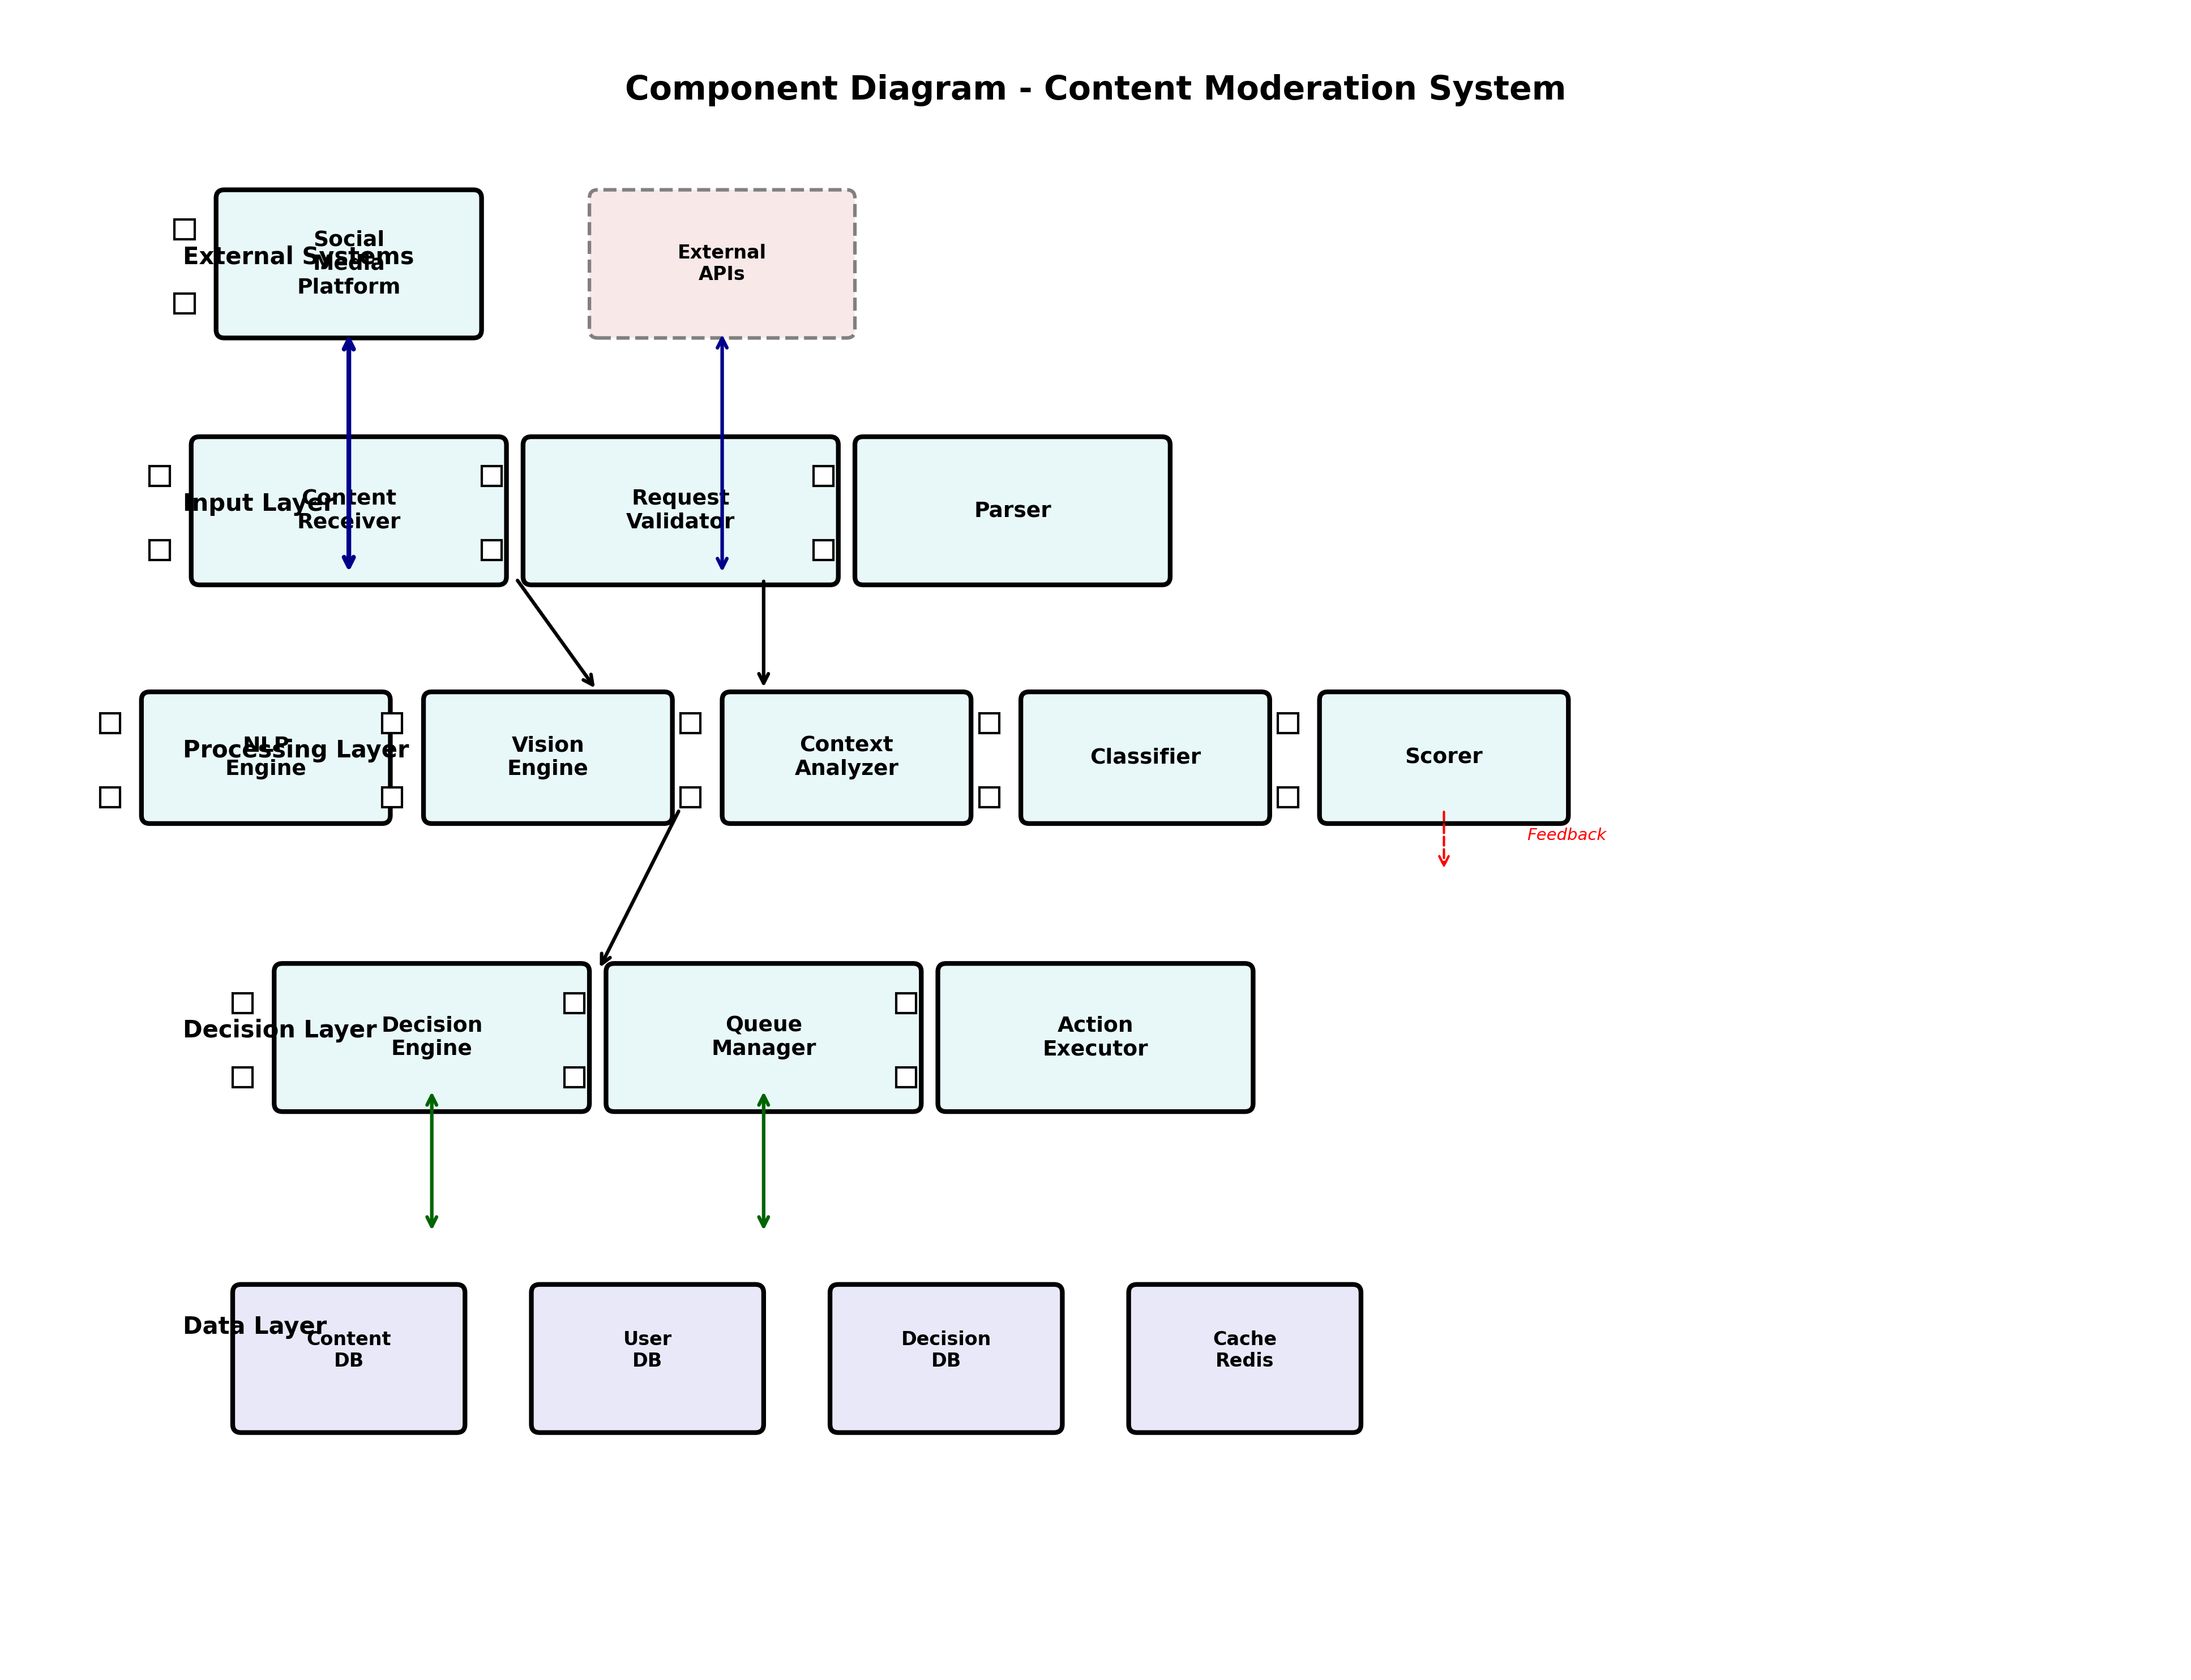
Figure 2.4: Component Diagram - System Architecture

2.5 Sequence Diagram
The Sequence Diagram illustrates the temporal flow of messages between system objects during a representative content moderation scenario. This diagram demonstrates the choreography of components and the critical timing relationships that enable real-time moderation.

Interaction Flow:
- User submits content to Platform with context metadata
- Platform queues content and confirms receipt
- Content Analyzer performs comprehensive multi-modal analysis
- Decision Engine evaluates results and generates confidence scores
- High-risk content automatically routed to Moderator queue
- Moderator reviews context and makes informed decision
- System logs decision and notifies user of outcome
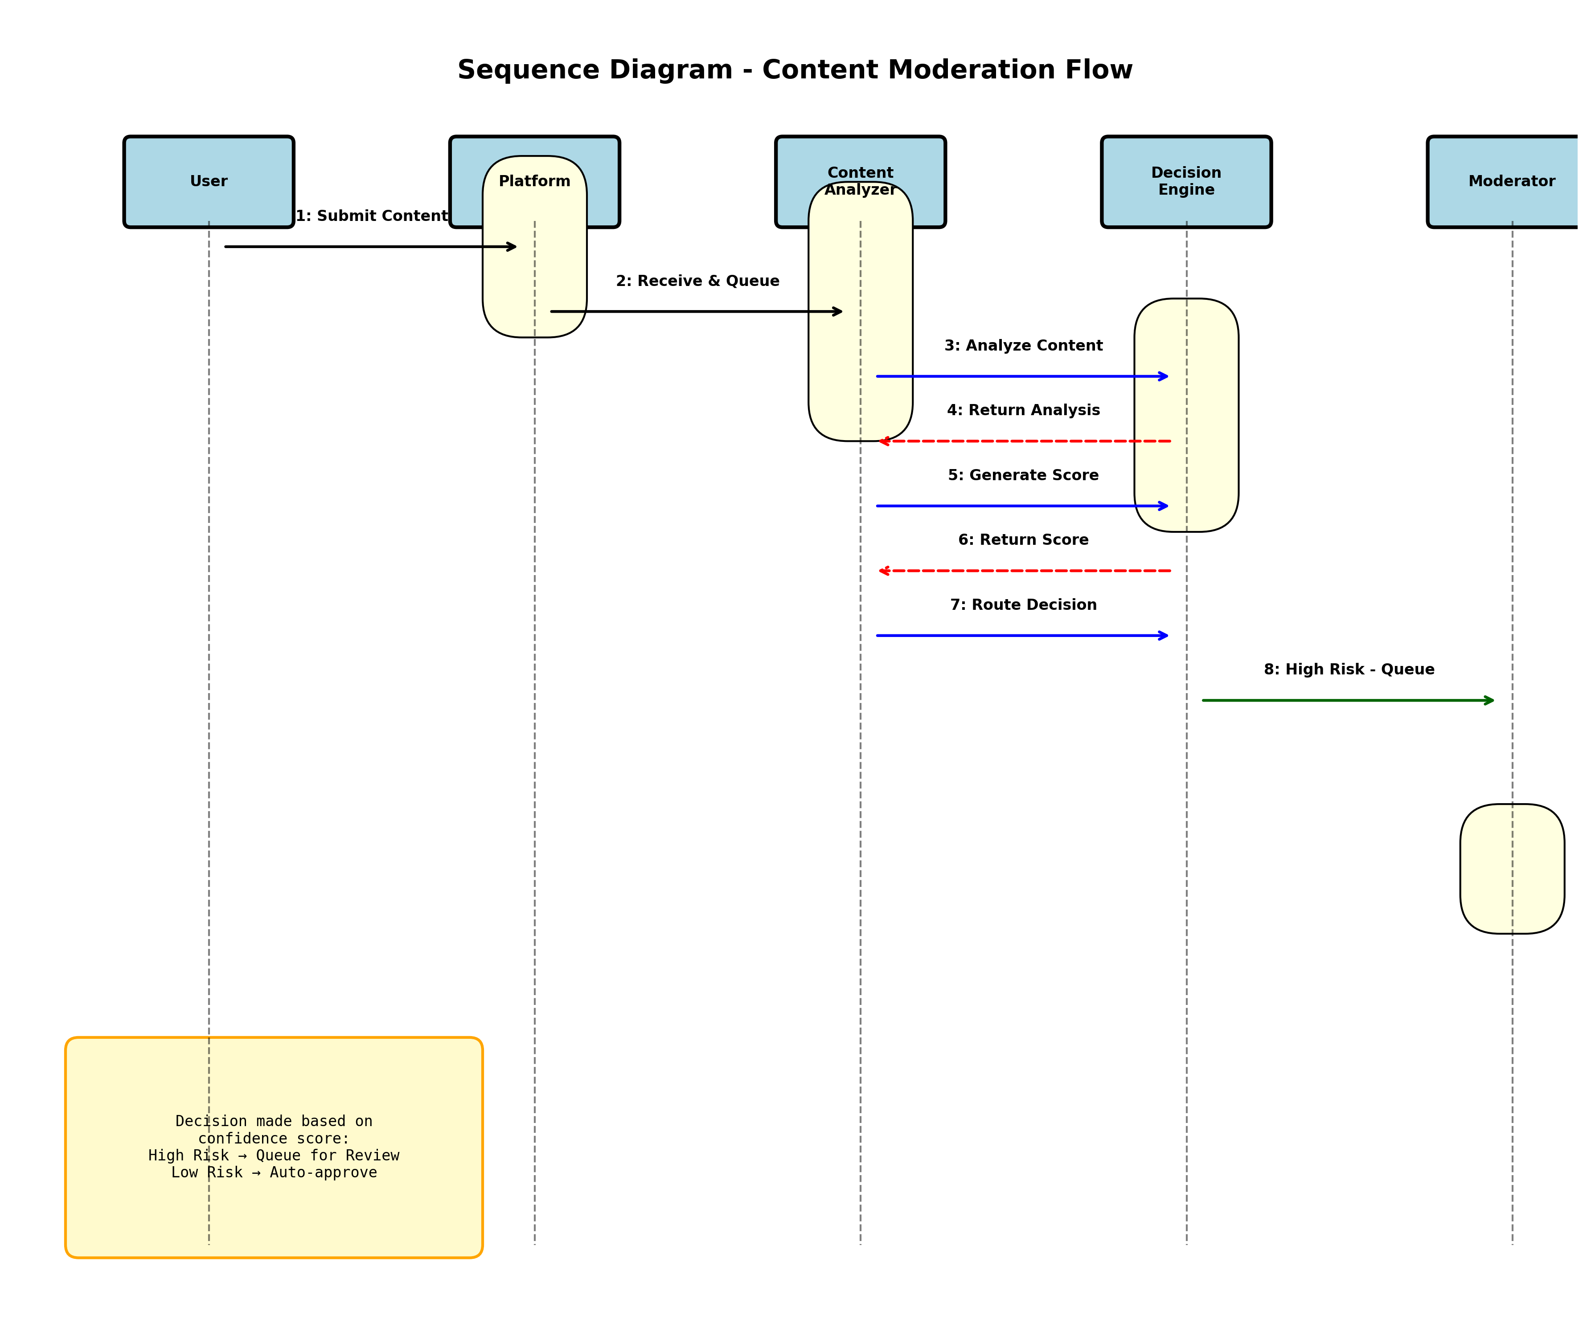
Figure 2.5: Sequence Diagram - Message Flow and Timing

3. System Architecture & Design Patterns
The AI-Based Content Moderation System is architected using proven patterns and technologies designed for scale, reliability, and maintainability. The layered microservices approach enables independent scaling of different components based on actual demand patterns.

3.1 Architecture Overview
Our system follows a modern layered microservices architecture with clear separation of concerns. Each layer handles specific responsibilities and communicates with adjacent layers through well-defined interfaces. This design enables teams to develop, test, and deploy components independently while maintaining system coherence.

3.2 Detailed Architecture Layers:
- Frontend Layer: React-based web dashboard for moderators and administrators with real-time monitoring, comprehensive search, and detailed analytics
- API Gateway: RESTful and GraphQL endpoints with authentication, rate limiting, request validation, and request logging
- Content Processing Pipeline: Multi-engine architecture processing content in parallel with specialized engines
- Decision Engine: Consolidates analysis results, applies business rules, computes violation scores, and routes decisions
- Data Layer: Distributed database with caching, audit trails, and compliance logging
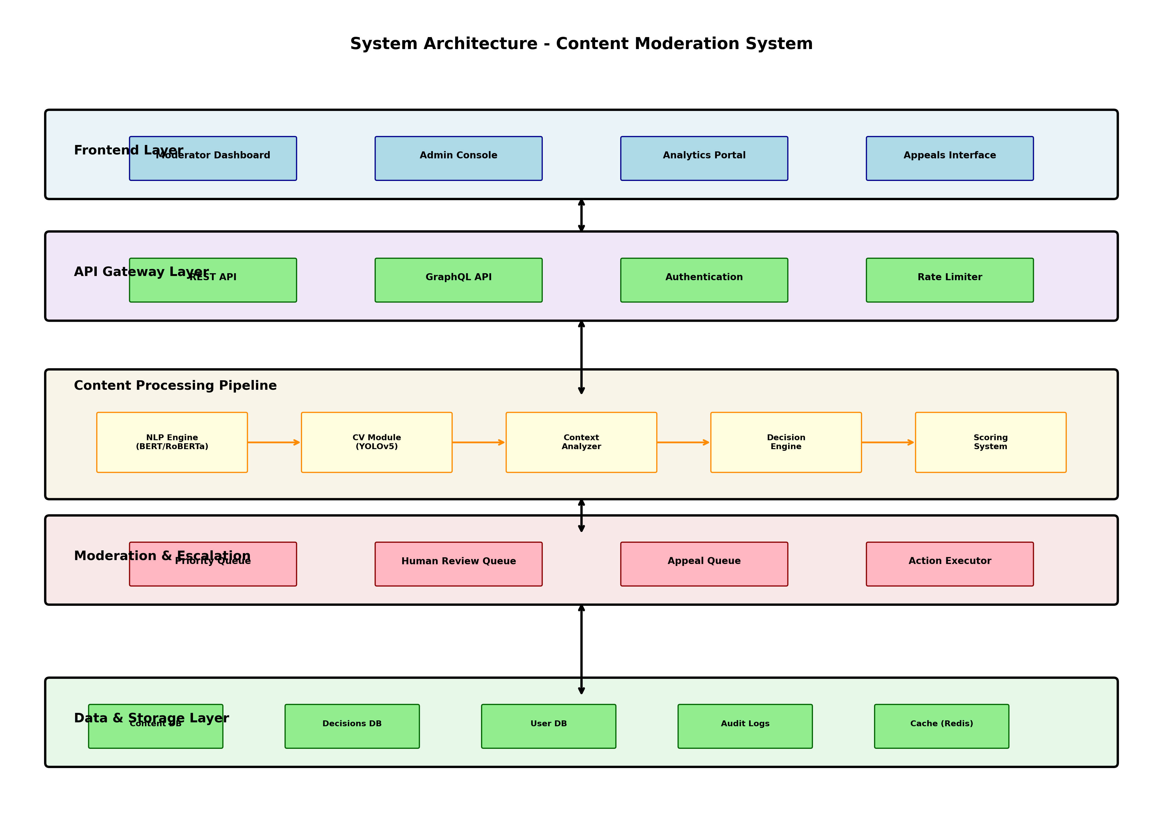
Figure 3: System Architecture Diagram - Complete System Overview

4. System Components & Technical Capabilities
Each component within our system has been carefully designed to excel at its specific responsibility while integrating seamlessly with other components. The following sections detail the major components, their capabilities, and their role within the larger system.

4.1 Natural Language Processing Engine
The Natural Language Processing (NLP) Engine forms the cognitive core of our text analysis capabilities. It processes all text-based content using transformer-based models fine-tuned for moderation tasks. Rather than using generic language models, we employ models specifically trained on moderation datasets to recognize harmful patterns, context, and intent.

Capabilities:
- Toxicity Detection: Identifies hostile language with confidence scoring and contextual analysis
- Hate Speech Identification: Recognizes targeted abuse with cultural context awareness and linguistic nuance
- Misinformation Flagging: Detects unverified claims and false information with source credibility assessment
- Multi-Language Support: Handles content moderation across 50+ languages and dialect variations seamlessly
- Sarcasm & Humor Detection: Reduces false positives by understanding figurative language and cultural references
- Continuous Learning: Improves from moderation feedback and evolving language patterns

4.2 Computer Vision Module
The Computer Vision Module handles the analysis of all visual content—both static images and video material. Modern social media relies heavily on visual communication, making this component critical to comprehensive content moderation. The module combines multiple specialized deep learning architectures to detect different types of policy violations.

Capabilities:
- Adult Content Detection: Identifies explicit imagery with high accuracy and minimal false positives
- Violence & Gore Detection: Recognizes graphic violence and disturbing imagery automatically
- Face Recognition & Privacy: Detects faces and enables privacy-preserving blurring when needed
- Optical Character Recognition (OCR): Extracts and analyzes text within images for comprehensive coverage
- Video Analysis: Efficiently processes video frames with temporal analysis to detect policy violations
- Object Detection: Identifies dangerous items and dangerous activities in visual content

4.3 Context-Aware Neural Network
The Context-Aware Neural Network represents a significant advancement in moderation sophistication. Rather than judging content in isolation, it understands the full context of who posted it, to whom, with what relationship history, and within what conversation. This contextual awareness is critical for reducing false positives and making fair decisions.

Capabilities:
- User History Analysis: Examines posting patterns, previous sanctions, and community standing
- Behavioral Pattern Recognition: Identifies harassment, coordinated attacks, and abusive campaigns
- Cultural Context Understanding: Recognizes legitimate discourse that might otherwise trigger false positives
- Relationship-Based Analysis: Understands dynamics between posters and targets for harassment detection
- Coordinated Inauthentic Behavior: Identifies synchronized campaigns and fake engagement patterns

4.4 Moderation Queue Management System
The Moderation Queue Management System optimizes the critical human review workflow. With millions of flagged items daily, intelligent routing and prioritization are essential to ensure that the most harmful content receives immediate attention while lower-risk items are handled efficiently.

Capabilities:
- Priority-Based Queue Management: Routes highest-severity violations to front of queue automatically
- Skill-Based Moderator Assignment: Matches content to moderators with relevant expertise and language skills
- Load Balancing: Distributes work evenly across moderation teams based on capacity and skills
- Appeal Queue Management: Handles user appeals with structured workflows and escalation paths
- Performance Metrics & SLA Tracking: Monitors resolution times and maintains service level agreements

5. Future Enhancements & Roadmap
While the current system represents a significant advancement in content moderation technology, continuous improvement remains essential as harmful actors adapt and platforms evolve. Our roadmap includes several transformative enhancements designed to further improve effectiveness and fairness.
In the near term (next 6 months), we plan to implement real-time federated learning capabilities, enabling the system to improve continuously from moderation feedback without centralizing sensitive user data. We will also expand multi-modal analysis to better understand complex content combining text, images, and video. Enhancement of cross-platform coordination will enable us to identify coordinated harm across multiple social media services.
Medium-term initiatives (6-12 months) include developing specialized models for emerging harm types like deepfakes and manipulated media, implementing explainability interfaces so moderators understand exactly why the system flagged content, and deploying causal inference models to detect influence operations more reliably.
Long-term vision (12+ months) encompasses developing human-in-the-loop learning systems that ensure moderation improves through human feedback, implementing fairness audits across demographic groups to ensure equitable enforcement, and creating transparency tools enabling users to understand moderation decisions affecting their accounts.

6. Conclusion
The AI-Based Content Moderation System for Social Media represents a transformative approach to one of the most challenging problems facing the digital world. By combining sophisticated artificial intelligence with human judgment, the system achieves what neither approach alone could accomplish: scalable moderation that maintains both effectiveness and fairness.
The system's multi-layered architecture, sophisticated machine learning models, and emphasis on human oversight create a solution capable of protecting billions of users while respecting legitimate expression. As social media continues to evolve and new forms of harm emerge, this system provides the technological foundation for adaptive, intelligent, and human-centered moderation that can grow and improve alongside the platforms it protects.
Ultimately, content moderation is not simply a technical problem—it is a societal challenge requiring technology, human expertise, cultural understanding, and ethical commitment. This system represents that comprehensive approach, designed not just to flag and remove bad content, but to foster healthier, safer digital communities where diverse voices can be heard and respected.

