**Week-7**

create database supplier__cs058;

use supplier__cs058;

create table supplier(

sid varchar(20),

sname varchar(20),

city varchar(20),

primary key(sid)

);

create table parts(

pid varchar(20),

pname varchar(20),

color varchar(20),

primary key(pid)

);

create table catlog(

sid varchar(20),

pid varchar(20),

cost varchar(20),

primary key(sid,pid),

foreign key(pid)references parts(pid),

foreign key(sid)references supplier(sid)

);

insert into supplier values(10001,'acme widget','bangalore');

insert into supplier values(10002,'johns','kolkata');

insert into supplier values(10003,'vimal','mumbai');

insert into supplier values(10004,'reliance','delhi');

insert into parts values(20001,'book','red');

insert into parts values(20002,'pen','red');

insert into parts values(20003,'pencil','green');

insert into parts values(20004,'mobile','green');

insert into parts values(20005,'charger','black');

insert into catlog values(10001,20001,10);

insert into catlog values(10001,20002,10);

insert into catlog values(10001,20003,30);

insert into catlog values(10001,20004,10);

insert into catlog values(10001,20005,10);

insert into catlog values(10002,20001,10);

insert into catlog values(10002,20002,20);

insert into catlog values(10003,20003,30);

insert into catlog values(10004,20003,40);

**1.Find the pnames of parts for which there is some**

**Supplier.**

select pname from parts where pid IN (select pid from catlog);

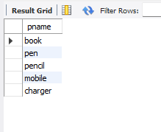

**2.Find the snames of suppliers who supply every part.**

select sname from

(select c.sname,count(distinct a.pid) as cnt from catlog a

left join parts b on a.pid=b.pid

left join supplier c on c.sid=a.sid group by 1) a

where cnt=(select count(distinct a.pid) from catlog a

left join parts b on a.pid=b.pid);

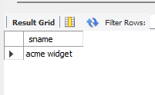

**3.Find the snames of suppliers who supply every red part.**

select distinct sname from

(select c.sname,b.pname,b.color from catlog a

left join parts b on a.pid=b.pid

left join supllier c on c.sid=a.sid )a

where color='red';

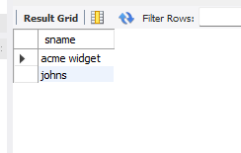

**4.Find the pnames of parts supplied by Acme Widget Suppliers and by**

**no one else.**

select A.pname from parts A

left join catlog B on A.pid=B.pid

left join supllier C on B.sid=C.sid where lower(c.sname)='acme widget'

and a.pname not in (select A.pname from parts A

left join catlog B on A.pid=B.pid

left join supllier C on B.sid=C.sid where lower(c.sname)<>'acme

widget')

;

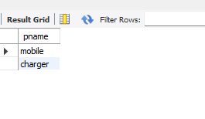

**5.Find the sids of suppliers who charge more for some part than the**

**average cost of that part (averaged over all the suppliers who supply**

**that part).**

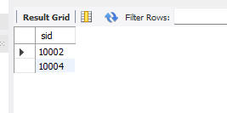

**6.For each part, find the sname of the supplier who charges the most**

**for that part.**

select pid,sname from

(select A.pid,C.sname,cost,rank() over(partition by pid order by cost

desc) as rnk from parts A

left join catlog B on A.pid=B.pid

left join supllier C on B.sid=C.sid)A where rnk=1 and cost is not null

order by sname;

