**MODULE -1**

**Welcome to Service Now**

Hands-on Practice

-In this learning path you may engage in different types of hands-on practice using ServiceNow. There are no-pressure, guided "Now You Try" activities that you can find at the end of a lesson. Then you will be able to engage in knowledge checks where you can test what you've learned in each lesson. Finally, you will engage in tasks that require validation, which are part of the course ****simulator****. See below to learn a little more the hands-on practice you will experience in this course.

**What is an instance?**

-When you are accessing ServiceNow, you are accessing an ****instance**** of the Platform. An organization can have several instances (e.g., Development, Quality Assurance (QA), Test, and Production) and each instance is a single implementation of the ServiceNow Platform. In this course, we provide a (simulator) instance for you to play around in the Platform as you go through each lesson.

-To access the Platform, a user navigates to a secure, unique URL: ****https//<instance-name-here>.service-now.com**** from a supported web browser.

****Instance Preferences****

****User Preferences****

****-****Next Experience offers global preferences to customize your instance UI. Select the User menu, then Preferences to customize the behavior of the Next Experience across your instance. You can customize the following preference types:

* Display
* Accessibility
* Notifications

**Next Experience, Navigation, and Access -**

-In ServiceNow, the Next Experience user interface is the main way for users to interact with the applications and information in a ServiceNow instance. You can access all applications and modules within the Platform, as well as select your user preferences, all from the banner frame! Speaking of preferences, you can personalize your instance and customize the display accessibility and notifications in the Platform. You have also seen all the common user interfaces you’ll experience while in this course. Have questions throughout? You can always refer to ServiceNow Product Documentation or the Developer site to learn more and practice in an instance, any time. Familiarize yourself with all the wonderful resources ServiceNow has to offer. Try the Next Experience UI yourself by heading to the next activity.

-Next Experience provides the tools you need to navigate your instance and set your preferences. With Next Experience, you can:

* ****Onboard****: Get acquainted with the UI
* ****Generate visualizations of your work****: See where you can start working and navigate to your tasks
* ****Explore useful features****: Explore additional features and resources in the Platform

**Instance UI-**

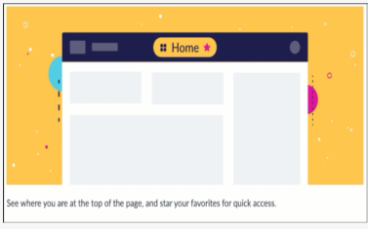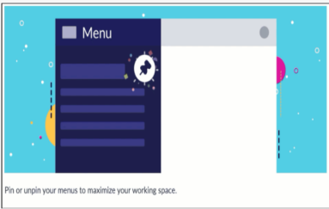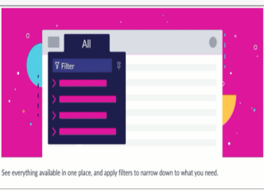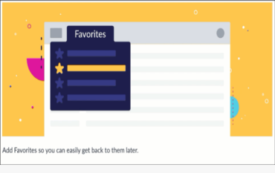

**Next Experience features and menus**

1. **ALL MENU**

-The ALL menu provides access to all applications and modules they contain. An ****application**** is a group of modules (or pages) that provide related information and functionality in an instance. For example, you'll work in the Incident application in this course, which contains modules for creating and viewing incidents.

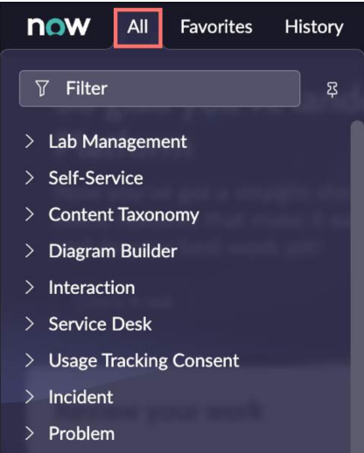

1. **Filter Navigator**

-The Filter Navigator is where you can quickly navigate to applications and modules. Simply begin by typing the application or module name (all, or part of, any module name). For example, if you were to search Service Catalog, you can start to type, "Service Cat" and all applications with the keyword will display.

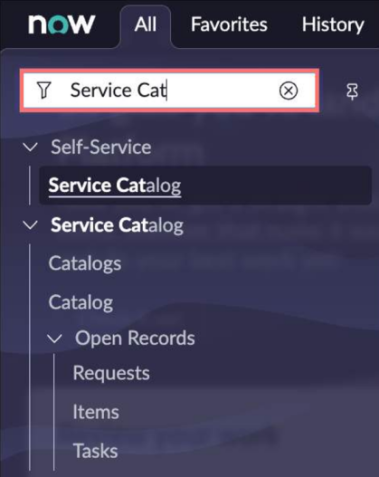

1. **Pinning Menus**

-With Next Experience, when you select a menu, it will display as a temporary semi-transparent menu. If you want the menu to persist, select the *Pin* icon. This will place (pin) the menu to your content frame. You can also un-pin the menu by selecting the Pin icon again.

****NOTE:**** The position of the components on your screen may vary depending on your region.

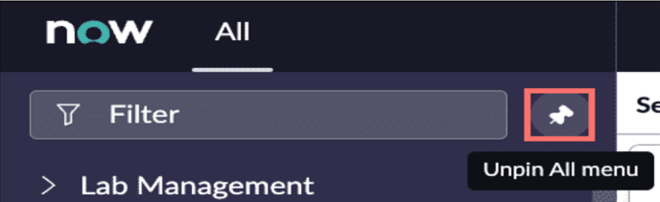

**4. Adding And Customizing Favorites**

-Selecting the star icon next to an application or module will create a *Favorite* menu item. Favorites can be re-ordered, edited, or removed from the menu by selecting the ****Edit**** (pencil) icon.

- To re-order a favorite item, select the pencil icon first to edit it, then click and drag the item (or select the icon with six dots) to whichever order you'd like!

-To change the name, color, and icon of a favorited item, select the item and change one or all three options!

-While editing a favorited item, don't forget to Save your edits (select ****Save edits****) before exiting the *Edit your favorites* window.

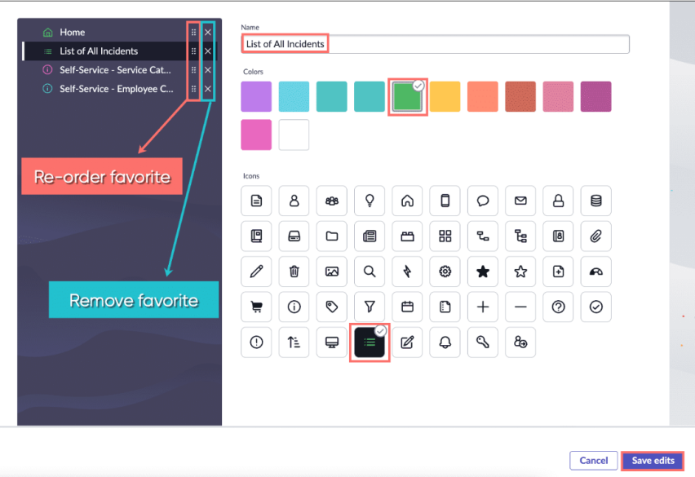

**5. History menu**

-Select the *History* menu, then select any recent activity to open the item in the Content Frame. By default, the maximum number of items displayed in the History tab is 30.

-The system creates history entries for many types of content including lists, records, and homepages. Some content types are not tracked in the history, such as UI pages and other non-standard interfaces.

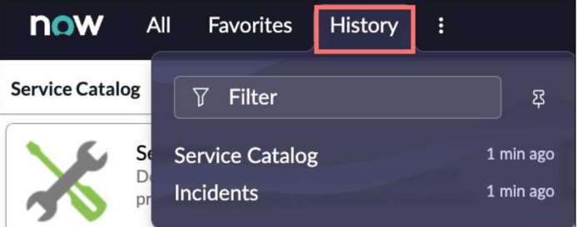

1. **Workspaces menu**

-Agents, case managers, helpdesk professionals, and managers use workspaces to help find, research, and resolve issues. There are different workspaces for different environments. For example, Agents can use IT Service Management (ITSM) workspaces or Customer Service Management (CSM) workspaces depending on the request.

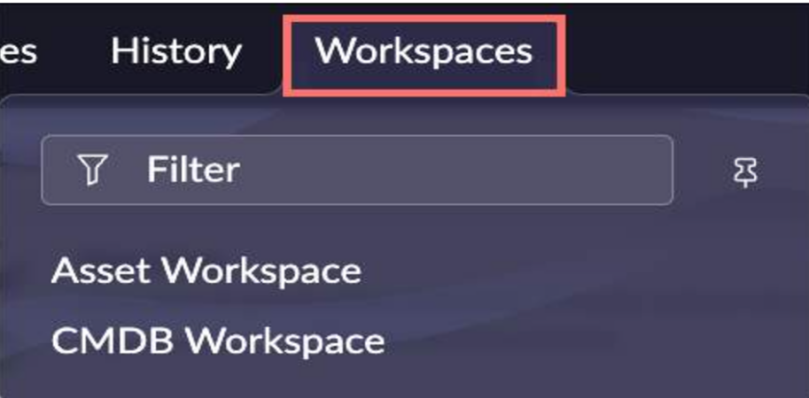

**Common User Interfaces**

1. ****Workspaces****

-A ****workspace**** is a suite of tools displayed in a single-pane view that help resolve customer problems and provide answers to questions they may have. Agents, case managers, help desk professionals, and managers use these tools to find, research, and resolve issues.

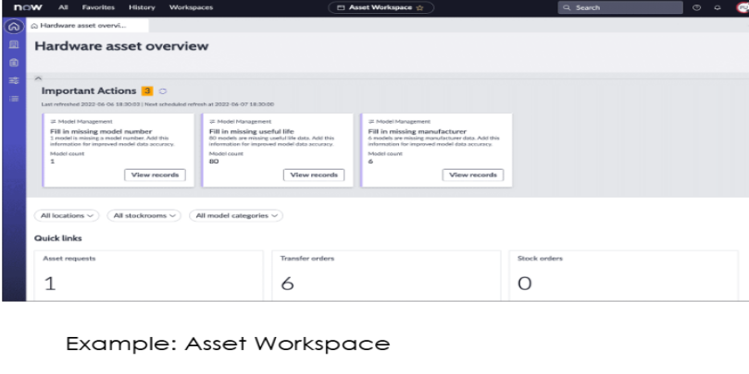

1. ****Lists****

-The ****list**** view displays records from a table in the Platform. With personalization and filtered lists, you can easily locate records and view activity associated with those records.

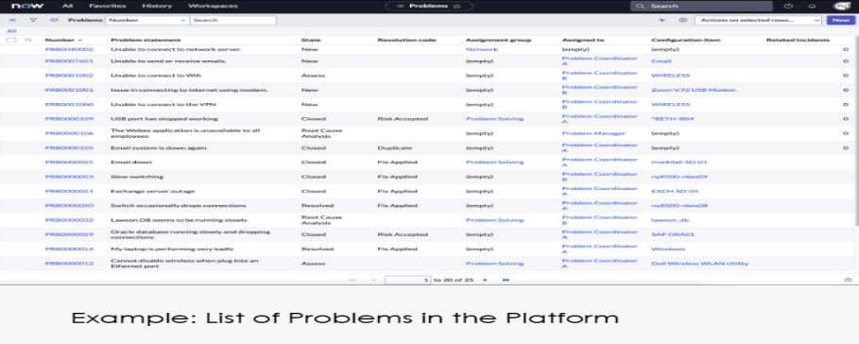

1. ****Forms****

-A ****form**** displays fields from one record, where users can view and edit the record data. The specific information depends on the type of record displayed. The form can also contain sections and ****Related Lists****(records in tables that have a relationship to the current record). Easily access forms by using ****Global Search****.

-The ****Global Search****is located at the top of your instance. Refer back to the Next Experience Unified Navigation lesson for more information.

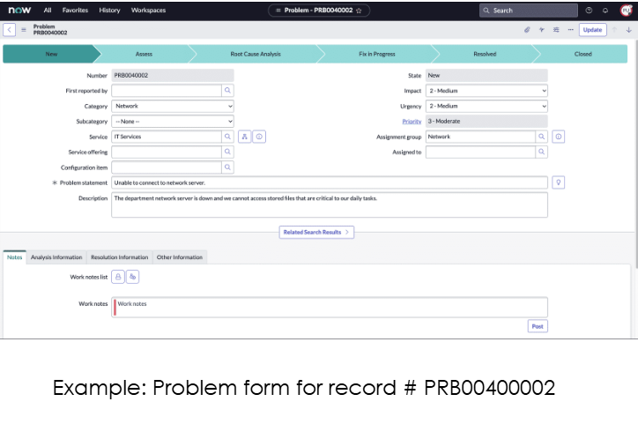

1. ****Dashboards****

-A dashboard is a custom arrangement of widgets and enables you to display multiple performance analytics and reporting on a single screen. If you have access to the dashboard, you can share it with multiple users. Navigate to ****Self Service > Dashboards**** to view the different dashboards in your instance.

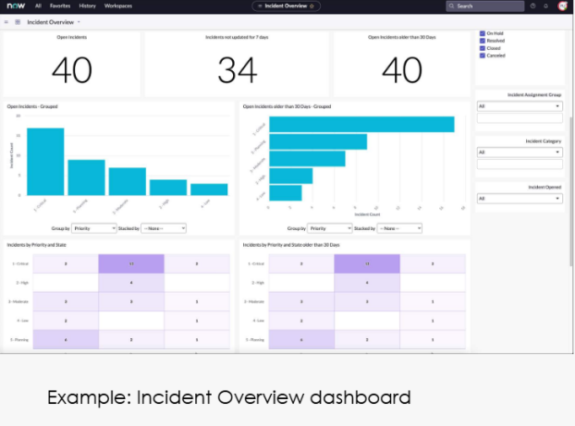

1. ****Knowledge Articles****

-Knowledge articles are uploaded to the Platform in specific categories to help platform users receive information or help about their job role or function. Articles live in Knowledge Bases (groups of articles set up by System Administrators). You may request a Knowledge Base by navigating to ****All > Self-Service > Service Catalog****. Then, select ****Can We Help You?**** Finally, select ****Request Knowledge Base****

.

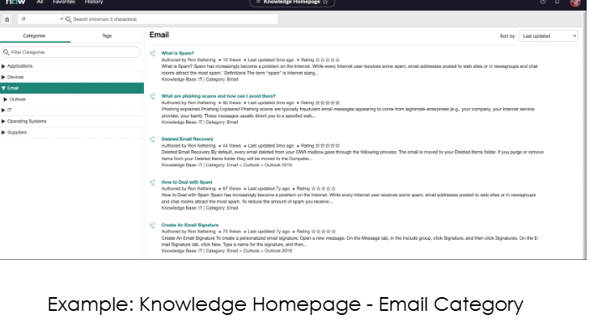

1. ****Service Catalog****

-Navigate to ****Self-Service > Service Catalog**** to access this application that provide customers with self-service opportunities. Customers can view and request catalog items (services and product offerings).

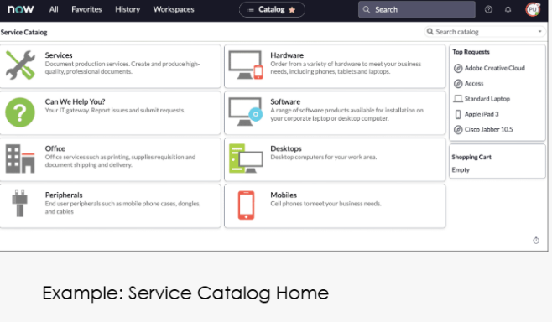

**USEFUL RESOURCES**

**-NowLearning**

**-ServiceNow Community**

**-ServiceNow Global Events**

**-ServiceNow Developer site**

**Lists**

-A ****list**** displays a set of records from a table. You can identify table data in the form of ****rows**** and ****columns****. Each row represents one ****record****. Each column represents one ****field****.Lists can be filtered and customized to display the information you need.

**List views and sort controls**

A ****view**** is a version of a customized list or form which defines which fields appear and in what order. Your list views may vary depending on your role in the Platform. For list views, the number of records displayed for the table does not change. However, the fields and their order may differ.Default view on the list of Incidents Viewsenable users to quickly display the same list or form in multiple ways. To switch between different views of columns on a list (as shown to your left), open the ****List controls**** menu and select ****View****. Then select the name of the desired view. If the view is anything other than the Default view, the view name appears in brackets beside the table list title (ex. Incidents View: Mobile).

A list that is displayed to a user for the first time will be sorted by one of the following:

* The ****order**** field, if one is present in the table
* The ****number**** field, if one is present in the table
* The ****name**** field, if one is present in the table

To ****sort**** in ascending or descending order, select the ****caret**** (up or down arrow) icon next to the column name. You may also sort a column by selecting the ****Column options****icon(three vertical dots) and sort (a to z) or (z to a). Select the left and right arrows below to toggle between the different sort options.

**LIST ANATOMY**

**Title bar**: Displays the list title and view name (when not on the default view), as well as search list values. The filter icon allows you to create custom filters on your list. The gear icon allows you to personalize the list.

****Breadcrumbs****:Offers a quick form of filter navigation. Breadcrumbs are created by using the condition builder to apply filters to a list (see next lesson, "Filters and Tags").

****Column header search****: Provides a search within a specific column.

**Column headers:** Displays the title (field on a form) of the column.

**Field values**: Right-click on a field value to access additional actions

**MORDERNIZED WORK EXPERIENCE**

* 1. **KNOWLEDGE CHECK**

1. **What are some of the ways to interact with ServiceNow paltform?**

**--> workspaces**

**-->Forms**

**-->Lists**

**-->Service catlog**

**-->DashBoard**

**-->Knowledged bases**

1. **What are the features of employee center?**

**-->Easy to configure options**

**-->easy scalability**

**-->customizable portal pages**

**-->unified browser for all content types**

**-->built-in extensibility**

**-->Integreated workflows**

**-->Pre-enabled widgets**

**-->Curated pages for popular topics**

**-->employee-centric navigation**

**-->Intranet-like engagement and communication**

**POWER OF SERVICENOW**

* 1. **Baseline Implementation**

**Baseline implementation is a set of installed applications on servicenow instance,before any configuration or customization has been done.**

* 1. **Instance**

**Instance is is a copy of ServiceNow environment that is specific to a customer.**

**There are prod and Non-prod environment:**

* **Production:**
* **Prod- where employess do their work and support their organizations**
* **Non-Production:**
* **Develeopment- where persona such as admins and implementationw configure and build applications.**
* **Test- where persona such as implementers test their change befor moving into production.**

**SERVICE PROTAL FUNDAMENTALS**

A Service Portal provides an alternative user experience to the standard platform interface. The Service Portal application offers the tools needed to configure, customize, and extend portal components to create an online experience similar to what your users are used to in other consumer products.  
  
**What we learn:**

* Explore all aspects of the Service Portal application
* Learn how to re‑configure an existing portal
* Review the Service Portal framework
* Discover the baseline Employee Center portal
* Create new Service Portals, Themes, Pages, and Menus
* Understand how to use and create Widgets
* Re‑use existing Portal components
* Explore using AI Search as the search engine in a Service Portal
* Configure other aspects of the platform to enhance a Service Portal
* Create a Guided Tour within a Service Portal
* Discover the User Experience Analytics dashboard to better understand Service Portal usage metrics.

These objectives are achieved through a combination of demos, lecture, and group discussions. Lab exercises woven throughout the class walk you through building your own Service Portal from scratch.

****Prerequisites:****  
Although all scripts are provided for lab exercises, participants will find them easier to interpret and read if they have a basic understanding of:

* Scripting in ServiceNow
* AngularJS
* Bootstrap
* CSS
* HTML

### **Objective**

Learn how to use the Service Portal application to configure, customize, and extend components to create a Service Portal.

**SERVICE NOW EMPLOYEE PORTAL**

**This comes with two variations :**

* **Employee Center**

It is the multi-department service portal for delivering services available baseline to all customers. So this is going to handle the basic standard tasks of doing things like making it easy for users to report issues, to request items or services, have to-do lists, and finding answers to questions that they have. That's available to all baseline customers.

* **Employee Center Pro**

There is also Employee Center Pro, which elevates the service delivery by incorporating into it additional employee communication and engagement. So this allows you to have those communication channels with your users and employees, keeping them up to date on news and events, accessing those to-do lists, but also incorporating external tasks into those to-do lists.

**Note:** Employee Center Pro is available on the store. It can come packaged as part of the HR license or we can get a separate license if we just want to incorporate Employee Center Pro into our instance.

Employee Center is really the starting point going forward for building out additional employee-based portals to the update to the user interface using Ull6, we were using the standard SP, or Service Portal, as the startin for customers to build out portals, especially for their employees. With the updated Ul to the next experience.

So if I just go into the Employee Center Portal, it opens in a new browser tab. And here we can see what the screenshot was showing us from the e-book. We have our mega menu here with selections from HR, IT, workplace, and legal. We have the recommended and popular topics widgets, as well as our quick links and footer widget, active items, and because this is all about the user experience, my tasks, my requests, my favorites, as well as my profile.

To navigate to other resources, I can either use the mega menu or the popular topics widget. If I go into something like software, I have a breadcrumb here that tells me where I am, how did I get here. I have some visuals. I have some key topic areas, and then I have my ability to browse various resources. Several of these are articles, but we can also see that we have catalog items here as well.

So we have a universal ability to browse across the instance as opposed to having to navigate separately to knowledge bases, having to navigate separately to the service catalog. Instead, all of the resources that real software are all listed here. And I can filter them by articles or by request. I can sort them by most popular or And I can set different layouts if I would prefer to see this in a list view with a little bit of a description field, and here I can mark my favorites.

**WHAT IS A THEME:**

**If you require more customization than the branding editor provides ,then we can create a theme.**

* **Defines header and footer to display on every page.**

**TO CREATE A NEW THEME:**

* **Create a custom style properties in the CSS variable field**
* **Identify the header and the footer**
* **Create once and use multiple times**



