Contents

Covid Data: Report and Analysis 2
1. Dataset used 2
2. Summary Statistics 3
3. Storyline 4
3.1. Confirmed Corona cases vs Corona Deaths 4
3.2. Comparison between New Cases and New Deaths for the Top 5 countries 5
3.3. Comparison between New Cases and Recovery Cases for the Top 5 countries 6
3.4. Relationship between confirmed cases and deaths 8
3.5. Cumulative Fatality Rate (Deaths/Confirmed) over time 9
3.6. Pandemic Spread Rate 10
4. Conclusion 11

Table of Figures

Figure 1Top 10 countries by CFR% 3
Figure 2 Monthly CFR and recovery % 3
Figure 3 Comparison of Confirmed cased and Death cases 4
Figure 4 Comparison between New Cases and New Deaths for the Top 5 countries 5
Figure 5 Comparison between New Cases and Recovery Cases for the Top 5 countries 7
Figure 6 Relationship between confirmed cases and deaths 8
Figure 7 CFR trend and relationship between life expectancy and CFR 9
Figure 8 Pandemic Spread Rate 10

Covid Data: Report and Analysis

Dataset used
- country_wise_latest.csv
Contains global daily cumulative COVID-19 statistics over time, including confirmed cases, deaths, and recoveries, and is mainly used to analyse global trends, derive monthly CFR and recovery rates.

- day_wise.csv
This dataset is useful for cross-country comparisons and identifying most affected countries at a specific time.

- full_grouped.csv
Includes daily COVID-19 data grouped by country, with confirmed, deaths, recovered, and active cases. It enables time-series analysis at the country level, such as comparing trends between countries.

- worldometer_data.csv
Summarises country-level COVID-19 statistics reported by Worldometer, including cases, deaths, recoveries, tests, and population indicators and is useful for understanding the relative burden across countries.

- 2019.csv
Represents pre-pandemic baseline data from 2019, often used as a reference or comparison period. It helps contextualise COVID-19 impacts by comparing pre-COVID conditions with pandemic-period data.

Summary Statistics
- full_grouped.csv: Country specific summary statistics
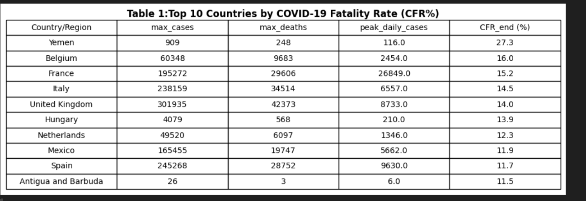
Figure 1Top 10 countries by CFR%
Yemen has the highest COVID-19 fatality rate (27.3%), likely due to limited healthcare resources. High mortality rates in European countries during peak times emphasize the need to consider testing coverage and healthcare capability.
- day_wise.csv: Monthly global summary Statistics of CFR and recovery rates
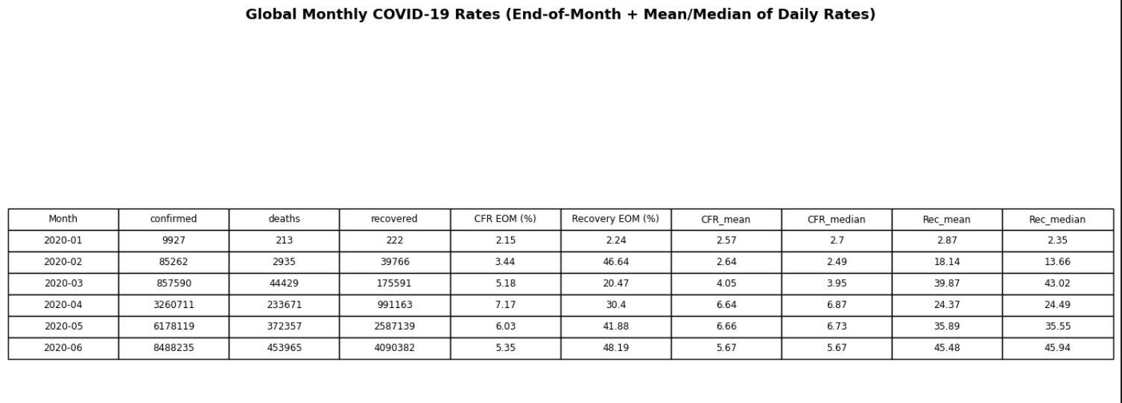
Figure 2 Monthly CFR and recovery %
The global CFR peaked at ≈7.2% between January and April 2020, representing the early severity of the pandemic, and subsequently decreased, showing better reporting and management. With steady monthly rates and few outliers, recovery rates increased dramatically from March. The CFR declined after April, demonstrating improvements in clinical management.

Storyline

Confirmed Corona cases vs Corona Deaths
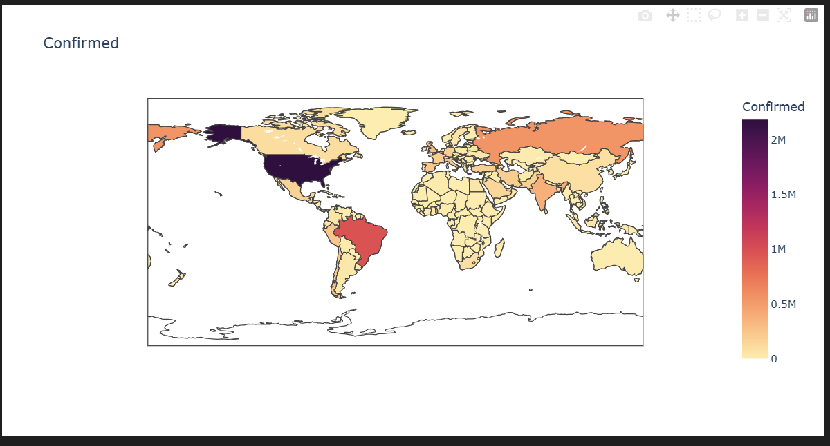
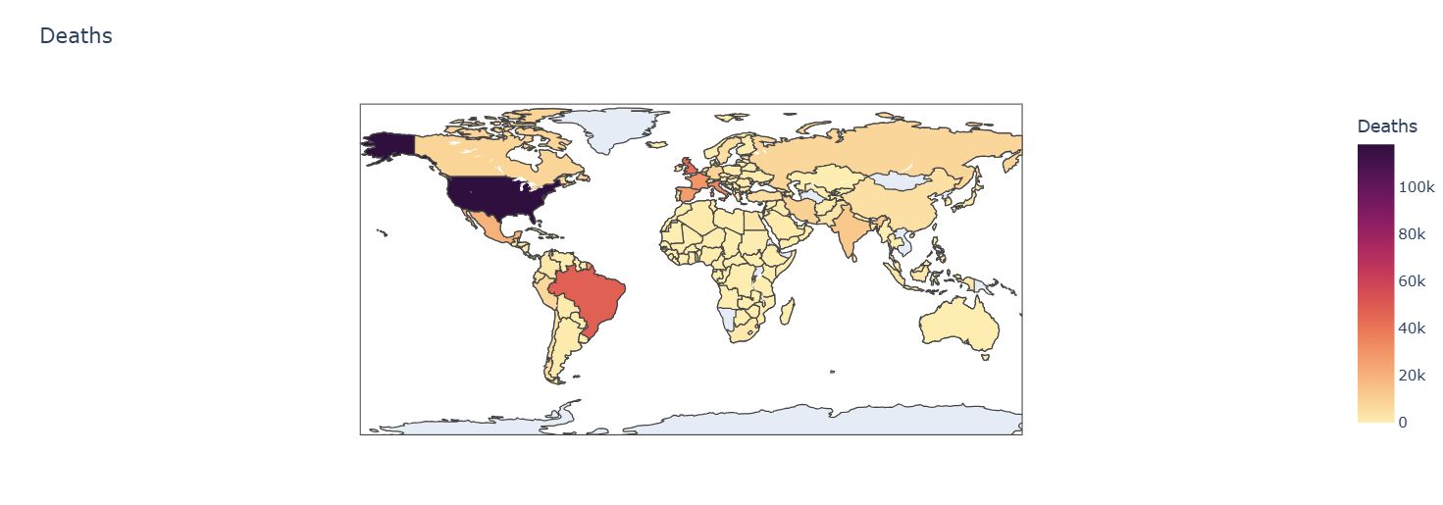
Figure 3 Comparison of Confirmed cased and Death cases
Maps indicate that nations with the most COVID-19 cases, particularly the U.S. and Brazil, also have the highest fatalities, reflecting global transmission and varied healthcare effectiveness. Darker areas show significant burdens, while some regions report high cases with lower mortality, possibly due to younger populations or better management.

Comparison between New Cases and New Deaths for the Top 5 countries
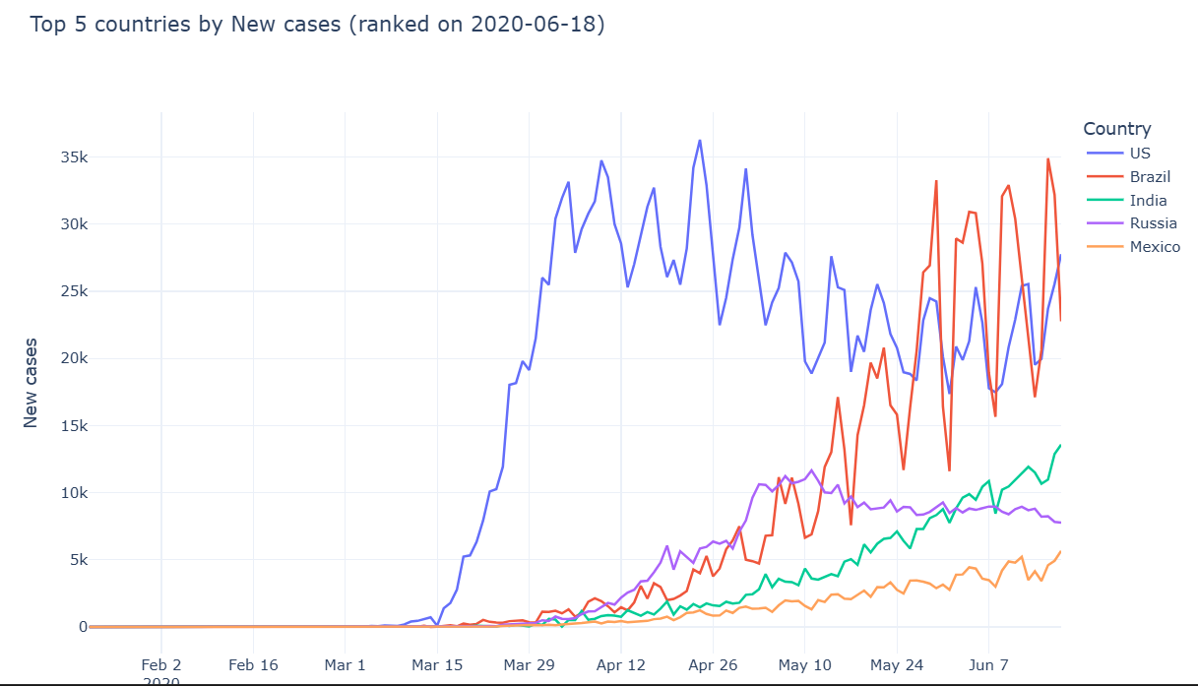
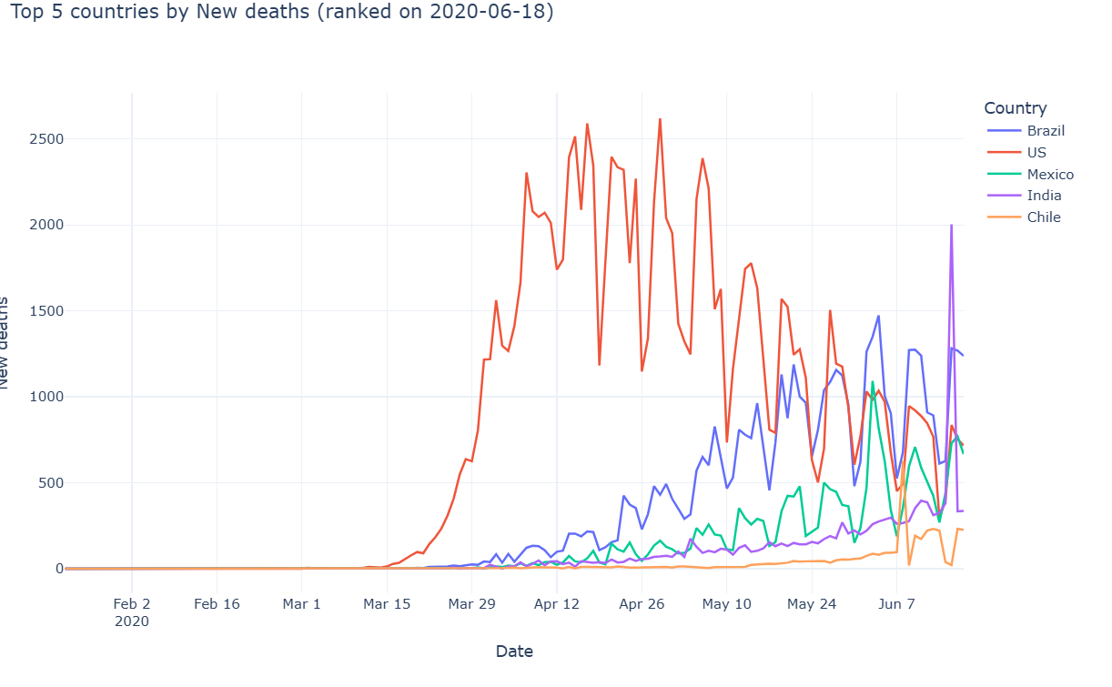
Figure 4 Comparison between New Cases and New Deaths for the Top 5 countries
According to the plots, the United States experienced the greatest increase in COVID-19 cases between April and May of 2020, showing broad transmission prior to control measures. The pandemic's epicenter shifted to emerging economies, as seen by the subsequent sharp surges in Brazil and India. Globally, new cases rose sharply, while deaths increased more slowly, signaling improved clinical care and diagnostics.

Comparison between New Cases and Recovery Cases for the Top 5 countries

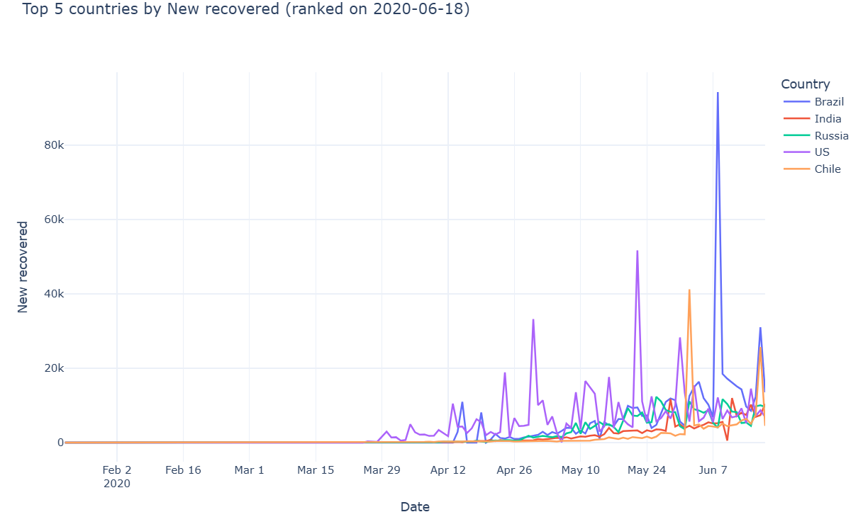
Figure 5 Comparison between New Cases and Recovery Cases for the Top 5 countries
April marked the biggest and earliest COVID-19 outbreak in the United States, followed by notable rises in Brazil and India. Mexico and Russia both saw modest increases. Recoveries lag new cases, with surges in the U.S. and Brazil probably reflecting changes in reporting, underscoring both national reporting standards and recovery delays.

Relationship between confirmed cases and deaths
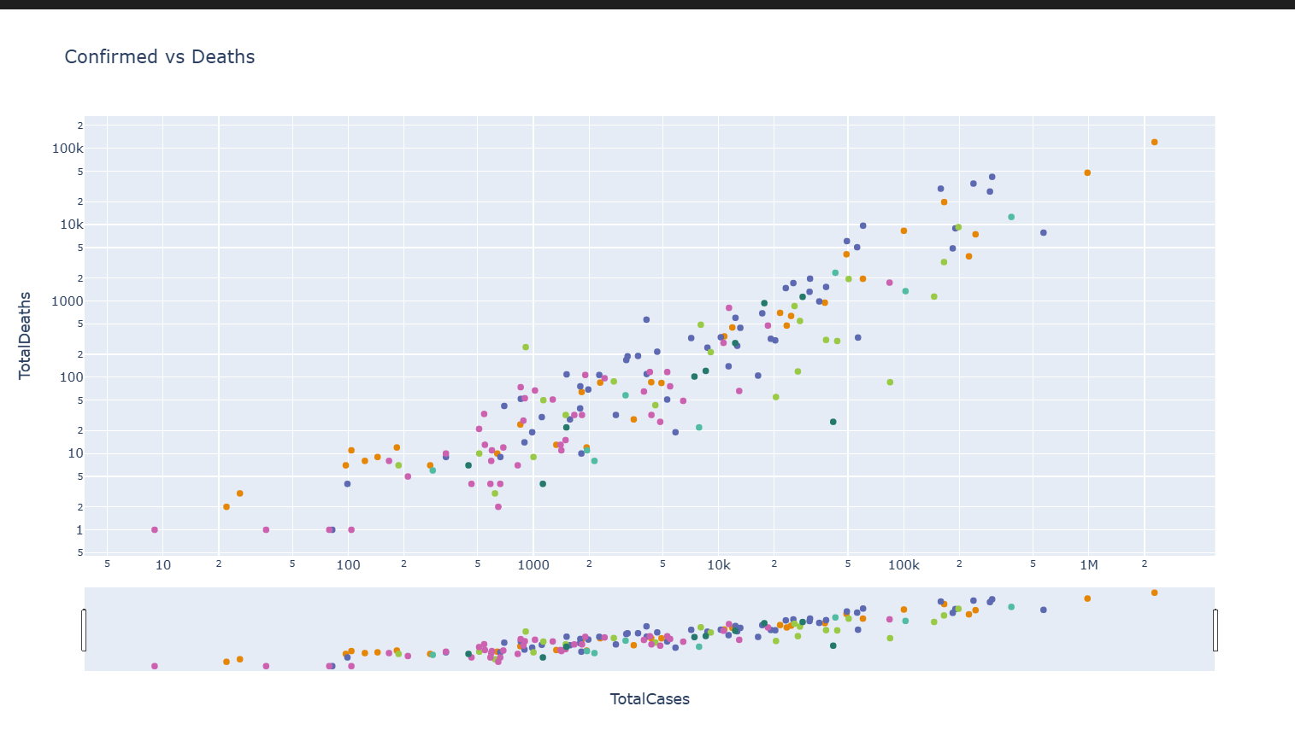
Figure 6 Relationship between confirmed cases and deaths
A rising trend shows that deaths typically increase with verified cases, as evidenced by 156 data points clustering along a diagonal line. Some nations, however, show varying fatality rates. The plot highlights how healthcare systems, reporting accuracy, and regional factors influence fatality outcomes.

Cumulative Fatality Rate (Deaths/Confirmed) over time
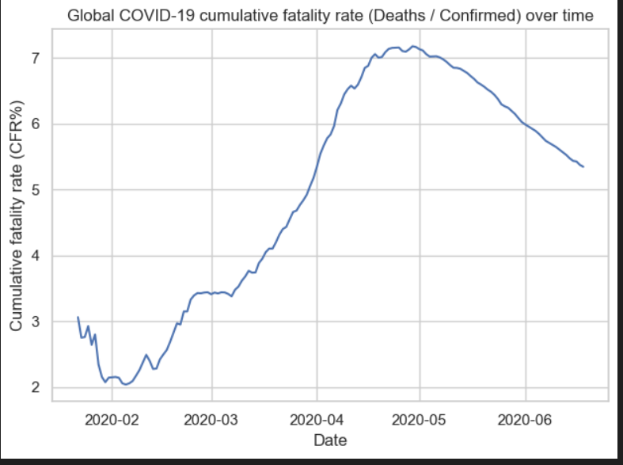
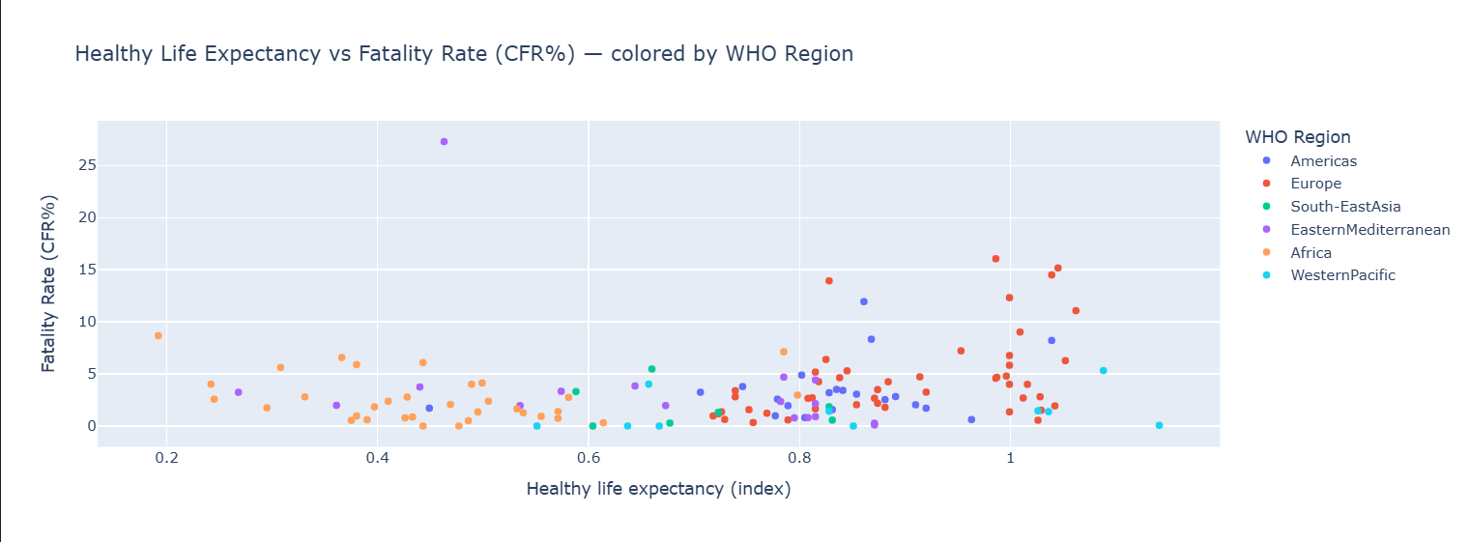
Figure 7 CFR trend and relationship between life expectancy and CFR
The first graph, illustrates better diagnostics and medical solutions, shows the global COVID-19 cumulative fatality rate (CFR%) climbing from 3% in early 2020 to over 7% in mid-April before falling to 5.5% by June. The second picture highlights the impact of age distribution and healthcare systems by comparing life expectancy and CFRs by nation. It shows no discernible pattern, but greater CFRs are observed in countries with lower life expectancies, especially in Africa.

Pandemic Spread Rate
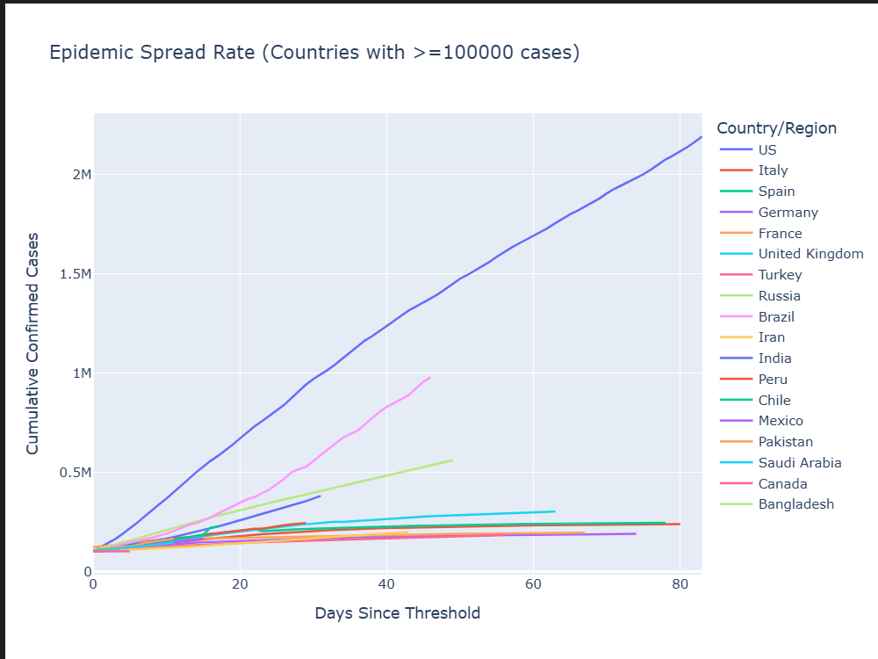
Figure 8 Pandemic Spread Rate
The line graph illustrates COVID-19 spread rates in countries with over 100,000 cases, plotting days since the threshold. The U.S. (blue line) has the steepest curve, indicating the fastest spread, with over 2 million cases in under 80 days. Brazil, Russia, and India also show notable growth, while Italy, Germany, and Spain indicate improved management after initial rapid expansion. This highlights significant variations in spread rates across countries.

Conclusion
This analysis summarizes the global COVID-19 pandemic, highlighting a strong link between infection and mortality rates influenced by reporting, testing, healthcare capacity, and demographics. While recovery rates rose, the global case fatality rate peaked in early 2020 and later declined with improved management. Initially, cases shifted from the U.S. and Europe to developing nations like Brazil and India. Visualizations show faster case growth than fatalities, highlighting the need for early intervention and a robust health system in public health emergencies.

