INTRODUCTION

Dataset Description

Two datasets covering airline activities from 2021 to 2023 are used in the analysis. Each row in the first dataset, which comprises 730 daily observations for 2021–2022, represents a single day and contains the following information: date, passenger fractions by route type (domestic, European, and intercontinental), passenger class (standard/economy and business/club), revenue fractions, and additional-services revenue. About 30,000 sampled passenger trips from 2023 are included in the second dataset. The date, ticket price, cost of extra services, distance travel, geographic location, and travel class are all included in each row, which represents a single trip. When combined, the datasets enable the calculation of ticket prices, passenger revenues, and ancillary service revenues over a three-year period.

Formulas Used
- Daily Revenue Calculation
- For 2021–2022, daily revenues were calculated from the revenue fractions supplied in Dataset1:
$R_{d}$= $f_{d}$×$R_{year}$

where:
- $R_{d}$= daily revenue (EUR),
- $f_{d}$= daily revenue fraction,
- $R_{year}$= total annual revenue from Table 1.

- Economy-class daily revenue:
$$R_{STD}=R_{Dom,STD}+R_{Eur,STD}+R_{Int,STD}$$
- Business-class daily revenue:
$$R_{BUS}=R_{Dom,BUS}+R_{Eur,BUS}+R_{Int,BUS}$$

- Fourier Series Approximation
The smoothed curves in Figure 1 were generated using the first eight terms of the Fourier series returned by scrfft.py:
$$S(x)=\sum_{k=0}^{7}{\left[a_{k}cos⁡(2πf_{k}x)+b_{k}sin⁡(2πf_{k}x)\right]}$$
where:
- $a_{k}$and $b_{k}$are Fourier coefficients,
- $f_{k}$is the corresponding frequency.

- Average Ticket Price
Average ticket prices were calculated as:
$$P_{avg}=\frac{\text{Total Revenue}}{\text{Total Passengers}}$$
- For 2023:
$$P_{avg}=\frac{∑(Price+Extra)}{N}$$
where $N$is the number of journeys.

- Additional Services Revenue Fractions
The fractions of annual revenue generated by additional services were calculated using:
$$F=\frac{R_{AS}}{R_{Annual}}$$
where:
- $R_{AS}$= annual revenue from additional services,
- $R_{Annual}$= annual ticket revenue.

Figure 1. Daily Revenue Generated by Economy and Business Passengers (2021–2023)

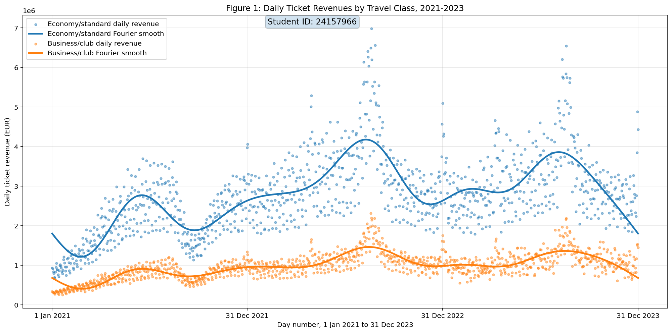

The daily ticket sales from business/club and economy/standard passengers between January 1, 2021, and December 31, 2023, are shown in Figure 1. The solid lines display Fourier-series approximations based on the first eight terms of the revenue data, while the scatter spots depict the actual estimated daily revenues. Over the course of the three years, economy-class passengers continuously produced substantially higher revenues than business-class passengers, which is consistent with their higher percentage of overall passenger traffic. Both travel categories show distinct seasonal trends, with revenue peaks happening when demand for travel is higher, especially in the middle of 2022 and 2023. Recurring annual cycles are revealed by the Fourier-smoothed curves, which display lower revenues during slower times and larger revenues throughout the summer and holiday tourism seasons.

Figure 2. Average Ticket Prices by Weekday (2021–2023)
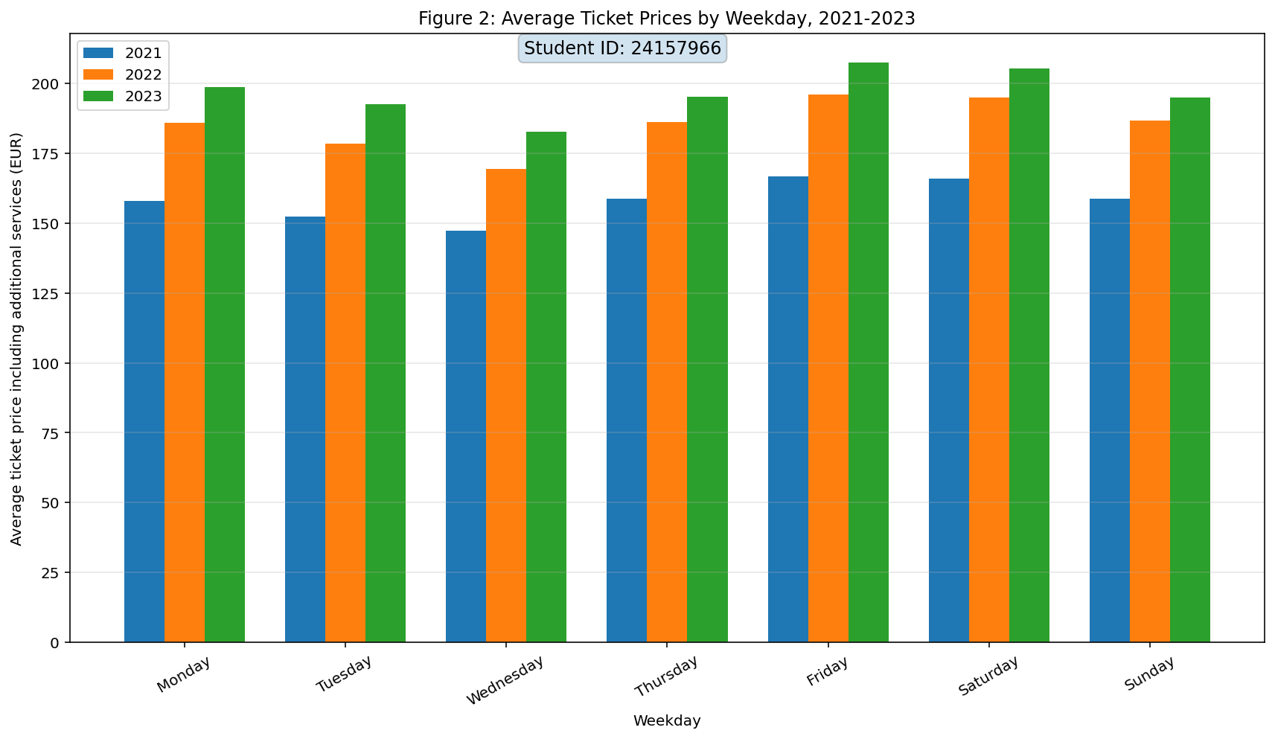
The average ticket costs for weekdays in 2021, 2022, and 2023—including extra services—are contrasted in Figure 2. Over the course of the three years, there is a definite upward tendency, with average prices rising steadily every day of the week from 2021 to 2022 and again from 2022 to 2023. In all three years, Wednesday had the lowest average ticket prices, while Friday and Saturday often had the highest prices, suggesting higher demand for weekend and leisure travel. The variations across weekdays have remained largely stable over time, indicating that the airline raised total fare levels while keeping a similar pricing structure. The 2023 values are the highest of the week, surpassing €200 on Friday and Saturday. The 2023 values are the highest throughout the week, exceeding €200 on both Friday and Saturday, which may reflect increased travel demand, inflationary effects, higher operating costs, and a greater contribution from additional services.

Figure 4. Weekly Distribution of European Ticket Prices
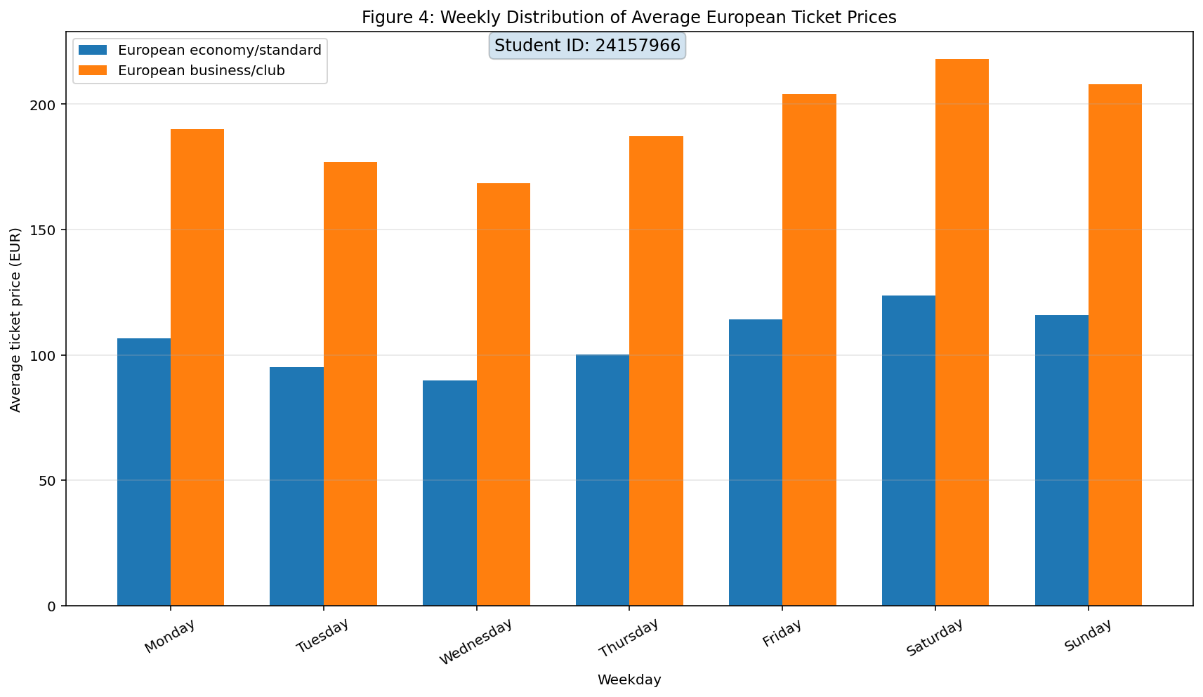

Figure 4 uses data from 2021 to 2023 to compare the average ticket prices for European economy/standard and business/club travel on different days of the week. Every weekday, business-class tickets are constantly more expensive than economy-class ones; they usually cost between €170 and €220, while economy-class tickets cost between €90 and €125. The weekly patterns for both travel classes are similar, with Wednesday having the lowest average fares and Friday and Saturday having the highest. This implies that when the weekend approaches, there is a greater demand for travel to Europe, which raises the cost of both cabin classes. The price gap between economy and business travel remains relatively stable throughout the week, indicating that fare differentiation by travel class is a major determinant of ticket price. Overall, the figure demonstrates clear weekday effects in European ticket pricing and highlights the substantial premium passengers pay for business-class travel.

Conclusion
The analysis of the airline datasets from 2021 to 2023 shows notable increases in revenue creation, passenger volume, and ticket pricing throughout that time. Both economy and business passengers' daily revenues exhibit significant seasonal fluctuations in Figure 1, with discernible peaks during times of higher travel demand. Even though both travel classes followed similar seasonal trends, economy-class passengers made significantly more money overall due to their higher passenger volumes. The Fourier-series approximations effectively smoothed the short-term swings while capturing the underlying long-term revenue trends.
Figure 2 shows that from 2021 to 2023, average ticket prices (including extra services) rose steadily on all weekdays. This points to a confluence of growing demand for travel, growing operational expenses, and inflationary pressures in the airline sector. Weekly pricing trends stayed mostly consistent, with higher prices being seen on weekends and toward the conclusion of the week.
The contrast between business travel and the European economy is evident in Figure 4. While both classes showed similar weekday tendencies, business-class tickets were continuously substantially more expensive than economy-class tickets, suggesting that demand has a similar impact on both market groups. Due to a rise in leisure and business travel during the weekends, Friday and Saturday had the highest costs.
The calculated ancillary-service revenue fractions further demonstrate the growing importance of non-ticket revenue streams. Additional services accounted for approximately 7.24% of annual revenue in 2021, 6.64% in 2022, and 12.33% in 2023. The substantial increase in 2023 suggests that ancillary products such as baggage fees, seat selection, and onboard services became a more significant contributor to airline profitability.
Overall, the findings show that airline operations grew and recovered significantly between 2021 and 2023. All travel segments saw a growth in ticket prices, passenger demand, revenues, and the importance of auxiliary services as a source of income. These results imply that the airline benefited from the ongoing recovery of the aviation industry while effectively adjusting to shifting market conditions.

