Using Autoencoders for Feature Extraction in Image Classification: A Case Study on Breast Cancer Detection

Introduction
Breast cancer is a leading cause of death for women globally, with 627,000 fatalities reported by the WHO in 2018. It primarily affects women in the USA and has four forms, including Ductal Carcinoma in Situ, a pre-stage detected in breast milk ducts. Up to 70–80% of cases of breast cancer are diagnosed as the second kind, which is the most common type (S. Ranjana , A. Meenakshi, 2025).

Machine learning and deep learning are increasingly vital for medical image analysis, particularly in disease detection. Accurately identifying patterns in noisy medical images poses significant challenges, especially with histopathology images for breast cancer diagnosis due to tissue variation and picture quality issues.
Convolutional neural networks (CNNs) excel in image classification, but input feature quality significantly affects their performance. Noisy or redundant image information can hinder generalization and model efficacy. Enhancing feature representation is essential for reliable medical applications.
Autoencoders, an unsupervised neural network, effectively learn condensed data representations by encoding images into a lower-dimensional space and reconstructing them, aiding feature extraction for classification. This project uses a convolutional autoencoder to enhance breast cancer image classification, evaluating reconstruction quality, feature learning, and classification performance on a histopathology dataset.

Literature Review
The current research on deep learning-based picture denoising and feature learning served as the inspiration for this project. Convolutional neural networks may efficiently reduce noise while maintaining crucial structural details in medical pictures, as shown by studies like Lung CT Image Denoising Using Block Matching 3D (Department of Computer Science and Engineering, DSCE, India, 2022) and Extracting and Composing Robust Features with Denoising Autoencoders (Vincent, 2023). The intricacy of histopathology data and the requirement for reliable feature extraction methods are also highlighted by study by A Dataset for Breast Cancer Histopathological Image Classification.

Dataset Used
Breast histopathology photos, which are microscopic pictures of breast tissue samples taken by biopsy, make up the dataset used in this project. Hematoxylin and Eosin (H&E), a popular staining method in medical imaging that emphasizes cellular features, is usually used to stain these images. Cell nuclei are stained blue or purple by hematoxylin, whereas cytoplasm and extracellular materials are stained pink by eosin.

This project uses a dataset of breast histopathology photos from biopsy samples, typically stained with Hematoxylin and Eosin. Each image is a 50×50 pixel patch from larger whole-slide images, highlighting cell structures and aiding in the differentiation of normal and cancerous tissue despite the complex textures that can be challenging to interpret.

Code and Implementation

Autoencoders
Figure 1: Autoencoder Architecture 1
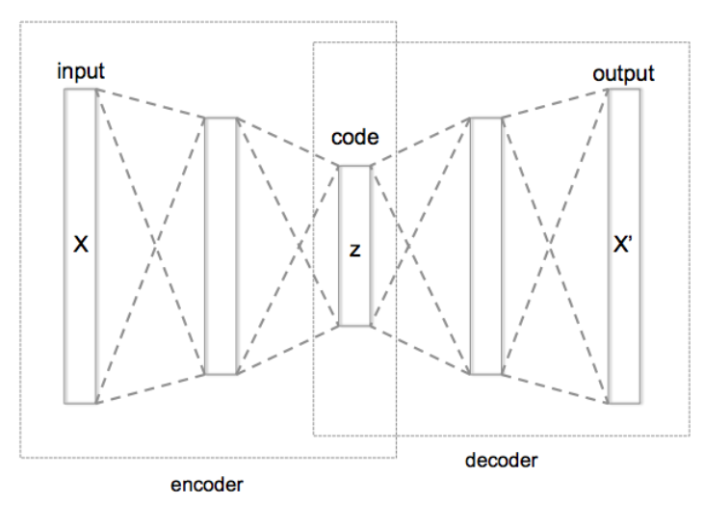
Figure 2 Auto Encoders Architecture 2
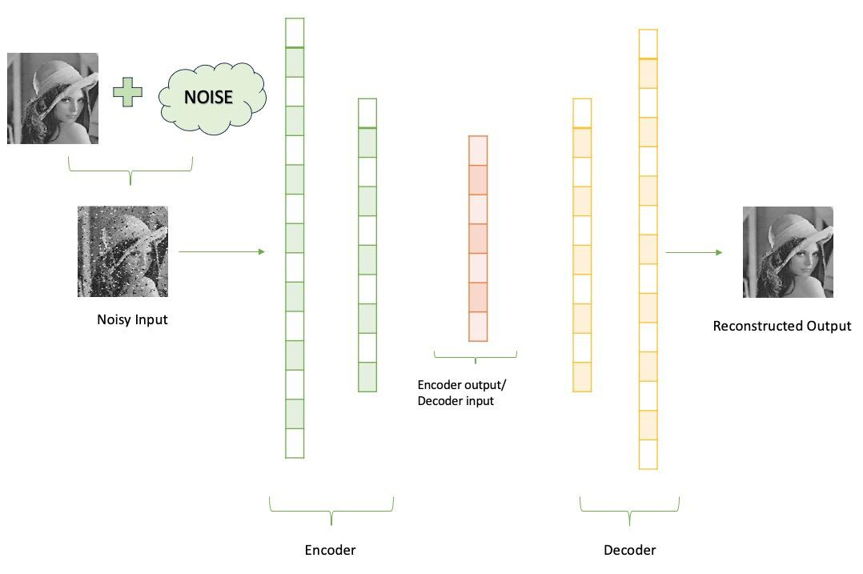
Neural networks that learn to compress data into a compact form and then reconstruct it to nearly resemble the original input are known as autoencoders. They include an:
Encoder that uses dimensionality reduction to capture significant characteristics.
Decoder that uses this compressed representation to reconstruct the data.
Using loss functions like Mean Squared Error and Binary Cross-Entropy, the model trains by minimizing reconstruction error. These are used in jobs where obtaining effective data representations is crucial, like noise removal, error detection, and feature extraction (Geeks for Geeks, 2025).
This research uses a denoising autoencoder, as shown in the diagram, to analyze breast cancer images. A clean histopathological image is artificially enhanced with noise, then compressed by the encoder, which captures key tissue features while eliminating noise. The decoder reconstructs the image from this compressed representation, minimizing the difference from the original. The encoder is later reused for feature extraction in cancer classification, enhancing detection of important tissue characteristics. (Geeks for Geeks, 2025).
In this project, the learned encoder is later reused as a feature extractor for classification, enabling improved detection of cancerous patterns by focusing on essential tissue characteristics rather than noisy variations.

Encoders
It compresses the input data into a smaller, more manageable form by reducing its dimensionality while preserving important information. Its three layers are as follows:
Input Layers: The original data enters the network through the input layer. Images, text characteristics, or any other type of structured data can be included.

Hidden Layers: These layers alter the incoming data in several ways. The size and complexity of the data are gradually decreased as each hidden layer uses weights and activation functions to identify significant patterns.
Output (Latent Space): A compressed vector referred to as the latent representation or encoding is produced by the encoder. This vector helps remove noise and redundancy by condensing the key characteristics of the incoming data (Geeks for Geeks, 2025).

Bottleneck (Latent Space)
The most compressed form of the input data is represented by the network's smallest layer. It acts as a bottleneck for information, forcing the network to give priority to the most important elements. Better generalization and effective data encoding are made possible by this compact form, which aids the model in learning the underlying structure and important patterns of the input (Geeks for Geeks, 2025).

Decoder
It is responsible for taking the compressed representation from the latent space and reconstructing it back into the original data form.
- Hidden Layers: These layers progressively expand the latent vector back into a higher-dimensional space. Through successive transformations decoder attempts to restore the original data shape and details
- Output Layer: The final layer produces the reconstructed output which aims to closely resemble the original input. The quality of reconstruction depends on how well the encoder-decoder pair can minimize the difference between the input and output during training (Geeks for Geeks, 2025).

Methodologies

Input Images → Add Noise → Autoencoder Training
↓
Encoder (Feature Extraction)
↓
Latent Representation (7×7×128)
↓
Decoder (Reconstruction)
↓
Reconstructed Images → Evaluation

Data Preprocessing
- Images are resized to 50×50×3
- Pixel values are normalized to [0,1]
- Artificial noise is added (e.g., Gaussian noise) to simulate real-world distortions
- Dataset is split into: Training set, Validation set and Testing set

Autoencoder Architecture
- The encoder compresses the input image into a lower-dimensional latent representation.

Layer | Filters | Kernel | Stride | Padding | Output Shape
Conv2D | 32 | 3×3 | 1 | Same | 50×50×32
MaxPooling | - | 2x2 | 2 | Same | 25x25x32
Conv2D | 64 | 3x3 | 1 | Same | 25x25x64
MaxPooling | - | 2x2 | 2 | Same | 13x13x64
Conv2D | 128 | 3x3 | 1 | Same | 13x13x128
MaxPooling | - | 2x2 | 2 | Same | 7x7x128

Decoder
- The decoder reconstructs the image from the latent representation.

Layer | Filters | Kernel | Stride | Operation
Conv2D | 128 | 3×3 | 1 | same
UpSampling | - | 2×2 | 2 | scale ↑
Conv2D | 64 | 3×3 | 1 | same
UpSampling | - | 2×2 | 2 | scale ↑
Conv2D | 32 | 3×3 | 1 | same
UpSampling | - | 2×2 | 2 | scale ↑
Conv2D | 16 | 3×3 | 1 | same
Cropping | - | - | - | trim
Conv2D | 3 | 3×3 | 1 | sigmoid

- Up sampling increases spatial resolution
- Convolution refines reconstructed features
- Cropping ensures output matches input size
- Final sigmoid activation scales pixel values to [0,1]

Model Training
- Loss Function: Binary Crossentropy
- Optimizer: Adam
- Metric: Mean Absolute Error (MAE)
- Epochs: 15
- Callbacks:
  - EarlyStopping: Used for preventing overfitting
  - ModelCheckpoint: saves best model

Feature Extraction
After training:
- The encoder part is extracted
- Output from layer encoded_features is used as feature representation
Input Image → Encoder → 7×7×128 features
These features contain compressed, noise-reduced information.

Evaluation
The model is evaluated using:
- Reconstruction loss (training vs validation)
- Visual comparison:
  - Noisy images
  - Original images
  - Reconstructed images
This helps assess how well the model preserves important structures while removing noise.

Classifier
Image → Encoder → Feature Map → CNN layers → GlobalAveragePooling → Dense → Output
- Building a classifier model on top of the encoder, where the enocoder are used as an feature extractor.
- The encoded images are fed into the GlobalAveragePooling instead of the Flatten layer, as to prevent overfitting and produces fewer parameters for better generalization.

Fine Tuning
Initial Setup
- The encoder is initially frozen to act as a fixed feature extractor
- The classifier head is trained on top of the encoded features
- Baseline performance is evaluated on the test set

Step 1: Unfreeze the Encoder
- Set:
encoder.trainable = True
- This allows the encoder weights to be updated during training
- Enables the model to adapt learned features specifically for the classification task

Step 2: Recompile the Model
- The model is recompiled after changing trainable layers
- Configuration:
  - Optimizer: Adam
  - Learning rate: 1e-5 (very small for stable updates)
  - Loss function: Binary Crossentropy
  - Metrics: Accuracy and AUC

Step 3: Fine-Tuning Training
- Train the full model (encoder + classifier) using:
  - Training dataset (train_cls_ds)
  - Validation dataset (val_cls_ds)
- Apply:
  - Callbacks (e.g., EarlyStopping, ModelCheckpoint)
  - Class weights to handle class imbalance
Step 4: Controlled Learning
- A low learning rate ensures:
  - Previously learned features are not destroyed
  - Gradual and stable updates
  - Better convergence

Step5: Evaluation After Fine-Tuning
- Evaluate the model again on the test dataset
- Compare performance before and after fine-tuning:
  - Loss
  - Accuracy
  - AUC (Area Under Curve)
Step 6: Prediction and Analysis
- Generate prediction probabilities on the test set
- Convert probabilities to class labels using threshold (0.5)
- Compute the following of the model:
  - Precision
  - Recall
  - F1-score
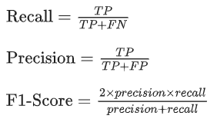
- Analyse improvements in detecting cancer cases

Model Outputs
Figure 3 Reconstructed images from Autoencoder
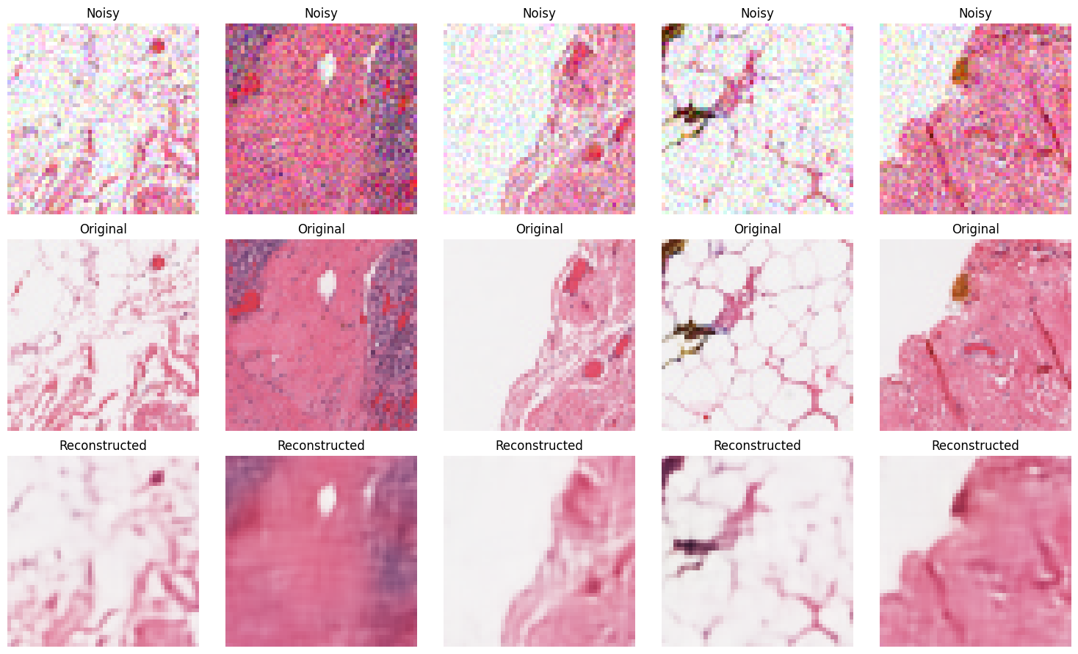
By contrasting three steps of image processing—noisy inputs (top row), original clean images (middle row), and reconstructed outputs (bottom row)—the figure shows how well the denoising autoencoder performs. While the original images reveal the genuine underlying histopathological patterns, the noisy images exhibit large pixel-level disturbances that mask essential tissue features. The reconstructed images show that the autoencoder has effectively trained to eliminate a large portion of the noise and retrieve the crucial structural characteristics of the tissue, including texture distributions and cell borders. The general morphology and important patterns are maintained, despite the modest blurring of some small features, which suggests a loss of high-frequency information.

Figure 4 Classifier Accuracy and AUC
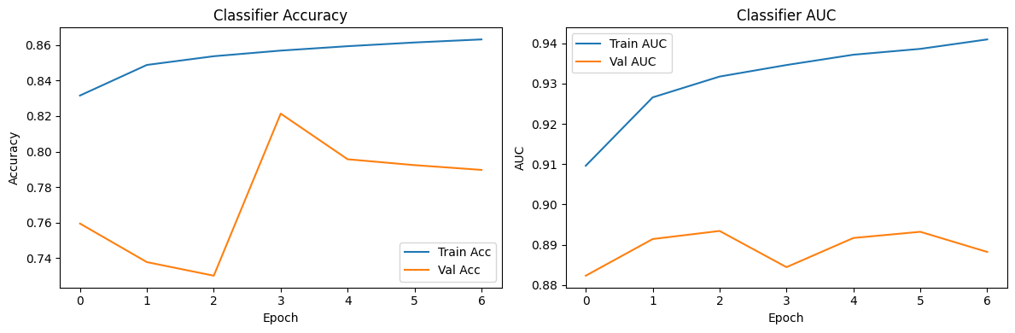
The charts show classifier accuracy and AUC during training and validation. Training accuracy rises from 0.83 to 0.86, but validation accuracy first declines, peaks at epoch 3, then drops, indicating overfitting. The AUC plot shows training AUC improves above 0.94, while validation AUC remains stable between 0.88 and 0.89, highlighting the model's lack of generalization to unseen data.

 | precision | recall | f1-score | support
0 | 0.9352 | 0.7737 | 0.8468 | 30822
1 | 0.5964 | 0.8619 | 0.7050 | 11957

Figure 5 Confusion Matrix
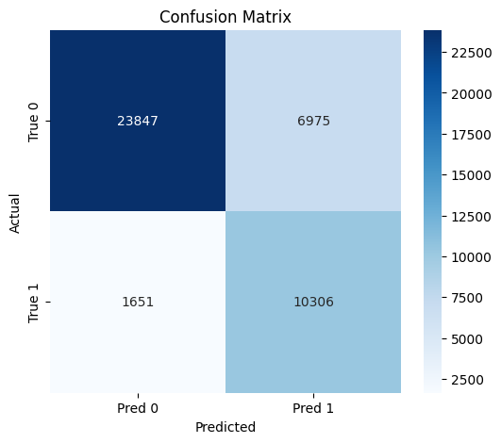
The classifier's ability to differentiate between non-cancerous (class 0) and malignant (class 1) data is summarized by the confusion matrix. Strong overall prediction power is demonstrated by the model's accurate identification of 10,306 malignant cases (true positives) and 23,847 non-cancerous instances (true negatives). Nevertheless, there are 1,651 false negatives, in which real cancer cases are overlooked, and 6,975 false positives, in which non-cancerous samples are mistakenly categorized as carcinogenic. False negatives are more serious from a medical standpoint because they indicate cancer diagnoses that were overlooked, and the comparatively lower number here indicates that the model is successful in identifying cancer. However, the greater proportion of false positives suggests that the model is cautious and occasionally overpredicts cancer, which may result in needless follow-up testing.
Overall, the confusion matrix shows a good balance with high sensitivity and acceptable specificity, making the model suitable for assisting in medical screening tasks.

Figure 6 ROC Curve
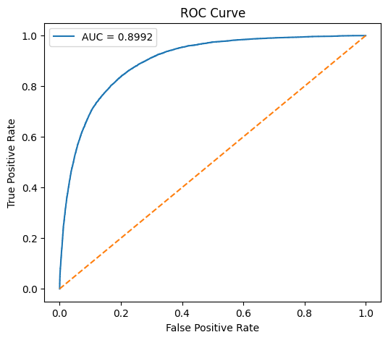

The ROC curve shows how well the classifier can differentiate between samples that are malignant and those that are not at various decision levels. Strong discriminative performance is indicated by the model's curve, which is located considerably above the diagonal baseline and plots the true positive rate (sensitivity) against the false positive rate. The model has a good chance of accurately ranking a randomly selected malignant sample higher than a non-cancerous one, according to the reported AUC value of 0.8992. The model can reach great sensitivity while maintaining relatively low false alarms, which is especially crucial in medical diagnosis, as evidenced by the rapid ascent of the curve at low false positive rates.

Figure 7 Classifier Prediction Output
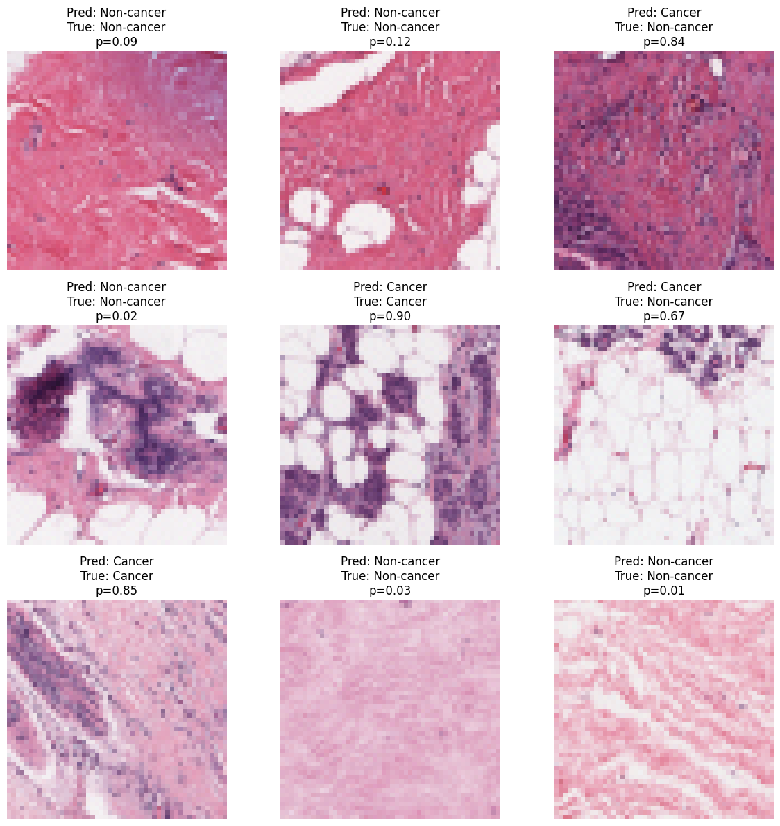

Several photos are accurately identified with high confidence, including non-cancer instances with very low probabilities (e.g., 0.01–0.12) and cancer cases with probabilities around 0.85–0.90. This suggests that the model has acquired significant patterns for class differentiation. Nevertheless, some misclassifications are also noted, especially false positives (e.g., p = 0.67 and p = 0.84), which occur when non-cancerous pictures are identified as cancer with a high degree of confidence. Visual similarities between benign and malignant tissue architecture, such as dense cell areas or uneven textures that resemble cancerous patterns, are probably the cause of these inaccuracies.

Ethical Considerations
Medical decision-making in breast cancer diagnosis using machine learning raises significant ethical issues, particularly concerning false negatives that can delay crucial treatment, posing serious risks to patients. Reducing false negatives is more critical than addressing false positives, which mainly cause anxiety.

The dataset's bias is another major problem. The model may perform poorly on underrepresented groups, resulting in unequal healthcare outcomes, if the training data is not representative of varied patient populations. Thus, assessing model fairness and guaranteeing dataset diversity are crucial actions.

Interpretability and transparency are essential as deep learning models often function as "black boxes," hindering medical practitioners' understanding and potentially eroding confidence in clinical decision-making.

Concerns about permission and data privacy also need to be addressed. Sensitive patient information is frequently found in medical imaging datasets, thus it's critical to make sure that all data used is appropriately anonymized and collected with the necessary authorization in accordance with data protection laws.
Medical experts should not be replaced by models; these should serve as tools to aid clinical judgment and enhance diagnostics, not automate them.

Conclusion
This project proved that combining a convolutional denoising autoencoder with a classification model improves breast cancer detection in histopathology images. The autoencoder effectively learned to reconstruct clean images from noisy inputs, capturing key structural features and reducing noise. This enhanced the classifier's ability to distinguish between cancerous and non-cancerous samples, with notable performance gains after fine-tuning. Evaluation metrics like accuracy and AUC reflected the model's effectiveness, particularly in handling class imbalance.
In summary, the study underscores the value of feature learning in medical imaging and shows that integrating denoising autoencoders with classifiers boosts predictive performance. Future work may involve advanced architecture, larger datasets, and better interpretability techniques for clinical applications.

References
Department of Computer Science and Engineering, DSCE, India, 2022. [Online]
Available at: https://www.int-jecse.net/article/LUNG+CT+IMAGE+DENOISING+USING+BLOCK+MATCHING+3D%252C+CNN+RESIDUAL+LEARNING+AND+BATCH+NORMALIZATION_1942/?download=true&format=pdf#:~:text=There%20is%20a%20nexus%20between%20patient%20dose%20and%20picture%20noise%20in%20io
[Accessed 23 03 2026].
Geeks for Geeks, 2025. Geeks for Geeks. [Online]
Available at: https://www.geeksforgeeks.org/machine-learning/auto-encoders/
[Accessed 24 3 2026].
S. Ranjana , A. Meenakshi, 2025. Research gate. [Online]
Available at: https://www.researchgate.net/publication/389867640_Breast_Cancer_Detection_using_Convolutional_Autoencoder_with_Hybrid_Deep_Learning_Model
[Accessed 24 3 2026].
Vincent, P., 2023. [Online]
Available at: https://www.cs.toronto.edu/~larocheh/publications/icml-2008-denoising-autoencoders.pdf
[Accessed 24 03 2026].

Appendix
Project Link: https://github.com/Dikshyant15/ML_individual_assignment/tree/main

