Name: Dil Humyra Sultana Borna
Student ID: 139166227

Activity 9 (Software Development Life Cycle)
=======================================

Answer 1: The software development lifecycle (SDLC) is the cost-effective and time-efficient process that development teams use to design and build high-quality software. I would apply the five steps of the Software Development Life Cycle (SDLC) to the "INITIALS" project-
- Planning: Firstly, I would define project goals for creating a desktop application that draws my initials “H” and “S” using straight lines. Then requirements such as male should have their initials drawn in blue, while female should have theirs drawn in pink. Secondly, I would create a project plan outlining timelines, resources, and responsibilities. Then I would Determine the technologies to be used.

- Designing: After finishing the planning, I would develop a system architecture based on the project requirements and a pseudo code. Also, would design the user interface (UI) and plan how to draw initials using straight lines and decide on the colors to represent male and female initials. during the design phase.

- Coding: After designing, I would implement the GUI using Windows Desktop Application template in Visual Studio. Write code according to the specifications and design guidelines to handle the input and drawing initials. I would follow C++ coding standards and best practices wherever possible. Would Implement logic to differentiate between male and female initials to use appropriate colors.

- Testing: Completing the coding part, I need to test the system to ensure it handles various input scenarios correctly. To test the code, I would need to develop test cases based on the requirements and design such as different initials and genders. Identify and fix bugs or issues found during testing. Ensure that the software meets quality standards and fulfills the specified requirements.

- Deploying: The final part is preparing the software for deployment by packaging it into an executable file. Distribute the application, either through direct download or installation Perform a final round of testing and monitor feedback, address any issues that arise post-deployment.
For the "INITIALS" project, these steps would involve activities and throughout these steps, would bring success to draw the colorful initials of the name.

Answer 2: Here is the screenshot of the pink color initials-
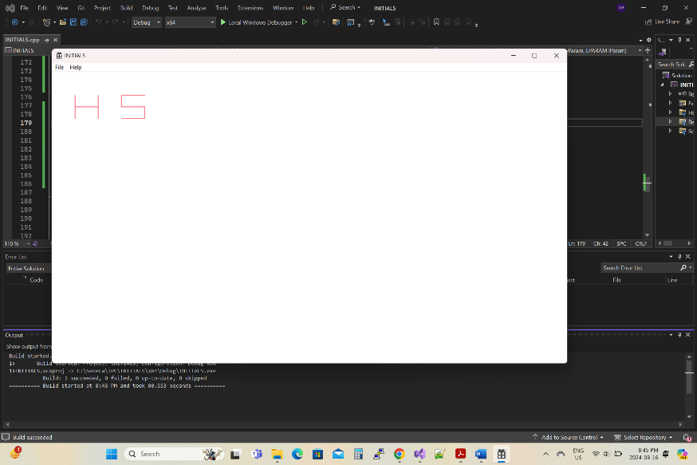

Answer 3: Here is the coding for the letters drawing-
// Positioning the pen into the device context
SelectObject(hdc, hPen);

// Drawing the letter "H" using straight lines
MoveToEx(hdc, 50, 50, NULL);
LineTo(hdc, 50, 100);
MoveToEx(hdc, 50, 75, NULL);
LineTo(hdc, 100, 75);
LineTo(hdc, 100, 100);
LineTo(hdc, 100, 50);

// Drawing the letter "S" using straight lines
MoveToEx(hdc, 150, 50, NULL);
LineTo(hdc, 200, 50);
MoveToEx(hdc, 150, 50, NULL);
LineTo(hdc, 150, 75);
MoveToEx(hdc, 150, 75, NULL);
LineTo(hdc, 200, 75);
MoveToEx(hdc, 200, 75, NULL);
LineTo(hdc, 200, 100);
MoveToEx(hdc, 200, 100, NULL);
LineTo(hdc, 150, 100);

Answer 4: Here is the screenshot of the drawing of a grey filled rectangle behind the initial’s “H” and “S” and the drawing coding –
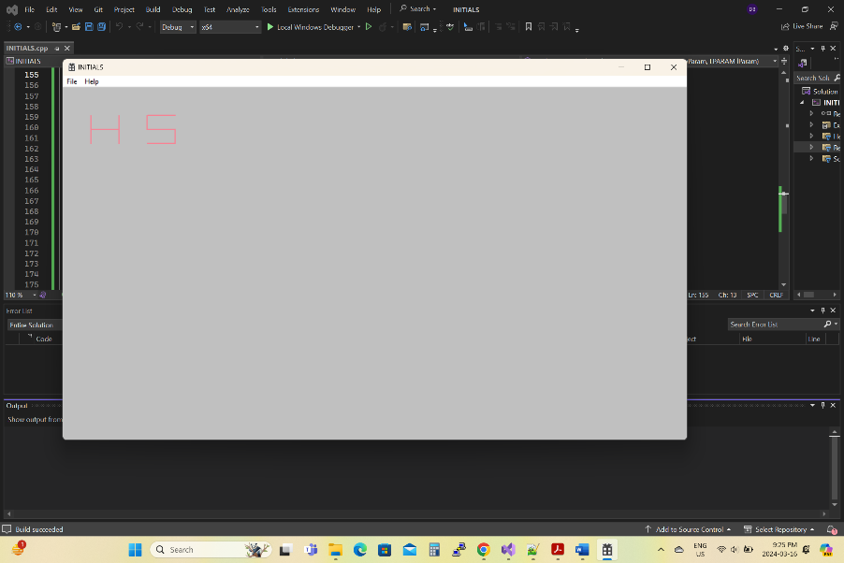

// Positioning the pen into the device context
SelectObject(hdc, hPen);

// Defining the dimensions of the rectangle
int rectLeft = 0;
int rectTop = 0;
int rectRight = 1150;
int rectBottom = 2150;

// Creating a RECT variable and initialize it with the dimensions
RECT rect = { rectLeft, rectTop, rectRight, rectBottom };

//Selecting Grey color for the rectangle in the brush
HBRUSH hBrush = CreateSolidBrush(RGB(192, 192, 192));

// Fill the rectangle with grey color
FillRect(hdc, &rect, hBrush);

